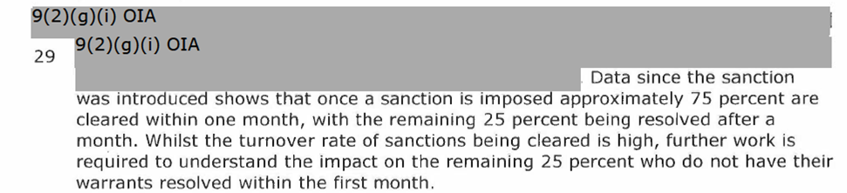

**Two: The number of warrants to arrest sanctions applied, during the period 1 January 2013 to 31 August 2021, broken down by sanction type and year**

|  |  |  |
| --- | --- | --- |
| **Year** | **Reduced Rate** | **Suspension** |
| **2013** | 126 | 267 |
| **2014** | 498 | 1,008 |
| **2015** | 495 | 1,161 |
| **2016** | 609 | 1,428 |
| **2017** | 678 | 1,725 |
| **2018** | 702 | 1,875 |
| **2019** | 852 | 2,592 |
| **2020** | 912 | 3,342 |
| **2021** | 549 | 2,214 |
| **Total** | **5,418** | **15,612** |

**Notes:**

* This is a count of notifications, not clients. A client may have had multiple notifications.
* WTA sanctions started from July 2013, so calendar year 2013 only includes data from July 2013 to

December 2013.

* Calendar year 2021 only includes data to end of August 2021.
* The period for sanctions imposed is the same as the WTA notifications, i.e. January 2013 to 31 August

2020.

* To protect confidentiality the Ministry of Social Development uses processes to make it difficult to identify an individual person or entity from published data.
* These data tables have had random rounding to base three applied to all cell counts in the table.
* The impact of applying random rounding is that columns and rows may not add exactly to the given column or row totals.
* The published counts will never differ by more than two counts.