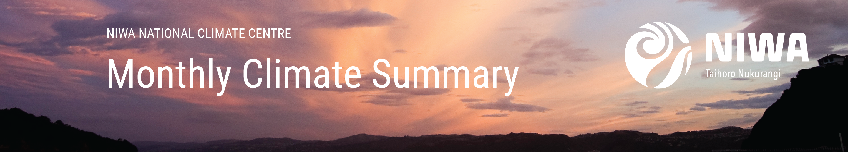

Aotearoa New Zealand Climate Summary: June 2021 Issued: 5 July 2021

New Zealand’s warmest June on record
Temperature | It was New Zealand’s warmest June on record, with the nationwide average temperature 2.0°C above average. This is just the 13th occasion since 1909 that a month achieved an anomaly of >1.9˚C relative to the 1981-2010 average. Temperatures were above average (0.51-1.20°C above average) or well above average (>1.20°C above average) throughout the country. Twenty-four locations observed their warmest June on record.
Rainfall | Rainfall was above normal (120-149% of normal) or well above normal (>149% of normal) for eastern parts of Northland, inland Bay of Plenty, eastern Waikato, Wairarapa, northern Canterbury, southeastern Otago and western Southland. Rainfall was below normal (50-79% of normal) or well below normal (<50% of normal) for parts of Central Otago, South and Mid Canterbury, Nelson, Tasman, inland Whanganui, Gisborne and eastern Bay of Plenty.
Soil Moisture | At the end of the month, soil moisture levels were lower than normal for inland parts of Otago. Soil moisture levels were higher than normal for eastern parts of Canterbury and Marlborough. Near normal soil moisture levels were typical for the remainder of the country.

Click on the link to jump to the information you require:
Overview
Temperature
Rainfall
June 2021 climate in the six main centres
Highlights and extreme events

Overview
June 2021 mean sea level air pressure was above normal to the east of Aotearoa New Zealand. This was associated with more northeasterly air flows than usual over the country. The prevalence of these air flows, occasional low pressure systems that transported warm, humid air down from the sub-tropics, and ongoing background warming from climate change meant it was a very warm start to winter throughout the country. Temperatures were above average (0.51-1.20°C above average) or well above average (>1.20°C above average) throughout New Zealand. Overall, the nationwide average temperature in June 2021 was 10.6°C. This was 2.0°C above the 1981-2010 June average, making it New Zealand’s warmest June since NIWA’s seven station temperature series began in 1909.
There were considerable spatial differences in monthly rainfall totals observed over the country in June. In the North Island, rainfall was above normal (120-149% of normal) or well above normal (>149% of normal) for eastern parts of Northland, inland Bay of Plenty, eastern Waikato, and the Wairarapa. In contrast, rainfall was below normal (50-79% of normal) or well below normal (<50% of normal) for parts of inland Whanganui, Gisborne and eastern Bay of Plenty. For the South Island, rainfall was above normal or well above normal for northern Canterbury, southeastern Otago and western Southland. Rainfall was below normal or well below normal for parts of Central Otago, South and Mid Canterbury, Nelson, and Tasman. Rainfall was typically near normal (80-119% of normal) for remaining areas of New Zealand. By the end of June, soils were drier than normal for inland parts of Otago, and wetter than normal for eastern parts of Canterbury and Marlborough. Soil moisture levels were typically near normal for remaining parts of the country.
Further Highlights:
- The highest temperature was 22.0°C, observed at Hastings on 26 June, and Leigh on 19 June.
- The lowest temperature was -7.4°C, observed at Middlemarch on 19 June.
- The highest 1-day rainfall was 162 mm, recorded at Arthurs Pass on 25 June.
- The highest wind gust was 191 km/h, observed at Cape Turnagain on 28 June.
- Of the six main centres in June 2021, Auckland was the warmest and sunniest, Tauranga was the wettest, Christchurch was the coldest and driest, and Dunedin was the least sunny.
- Of the available, regularly reporting sunshine observation sites, the sunniest four locations in 2021 so far are Taranaki (1331 hours), Bay of Plenty (1299 hours), Marlborough (1291 hours) and Hawke’s Bay (1277 hours).
For further information, please contact:
Gregor Macara
Climate Scientist
Tel. 04 386 0509

Temperature: An exceptionally warm month for the country
Winter got off to a very warm start in New Zealand – it was the country’s warmest June on record. The warmth was widespread, with every long-term monitoring station observing either above or well above average mean temperatures. It was particularly warm in Motueka, where the mean temperature of 10.8°C was 3.2°C higher than the town’s 1981-2010 average.
Record or near-record mean air temperatures for June were recorded at:
Location | Mean  air temp. (ºC) | Departure from normal (ºC) | Year records began | Comments
High records or near-records
Kaitaia | 14.8 | 2.0 | 1948 | Highest
Whangaparāoa | 14.1 | 1.5 | 1982 | Highest
Auckland (Whenuapai) | 12.7 | 1.5 | 1945 | Highest
Tauranga | 13.1 | 2.1 | 1913 | Highest
Whakatāne | 12.4 | 2.5 | 1974 | Highest
Taupō | 10.2 | 2.8 | 1949 | Highest
Motu | 9.1 | 2.6 | 1990 | Highest
Martinborough | 11.0 | 2.4 | 1986 | Highest
Gisborne | 12.5 | 2.3 | 1905 | Highest
Whakatu | 11.2 | 2.4 | 1965 | Highest
Waipawa | 10.1 | 1.9 | 1945 | Highest
Mahia | 13.2 | 2.4 | 1990 | Highest
Levin | 11.7 | 2.4 | 1895 | Highest
Porirua | 12.0 | 2.2 | 1968 | Highest
Wellington (Kelburn) | 11.7 | 2.0 | 1927 | Highest
Wellington (Airport) | 12.6 | 2.1 | 1962 | Highest
Westport | 11.4 | 2.1 | 1937 | Highest
Hokitika | 10.5 | 2.3 | 1866 | Highest
Greymouth | 10.8 | 2.0 | 1947 | Highest
Haast | 10.8 | 2.7 | 1949 | Highest
Puysegur Point | 10.3 | 1.7 | 1978 | Highest
Motueka | 10.8 | 3.2 | 1956 | Highest
Culverden | 8.1 | 2.3 | 1928 | Highest
Medbury | 8.7 | 2.8 | 1927 | Highest
Kerikeri | 13.8 | 1.7 | 1945 | 2nd-highest
Leigh | 15.4 | 2.0 | 1966 | 2nd-highest
Whitianga | 13.0 | 1.9 | 1962 | 2nd-highest
Rotorua | 10.5 | 1.9 | 1964 | 2nd-highest
Taumarunui | 10.5 | 2.4 | 1947 | 2nd-highest
Mt Ruapehu Chateau | 5.5 | 1.9 | 2000 | 2nd-highest
Ngawi | 13.1 | 1.8 | 1972 | 2nd-highest
Hicks Bay | 13.9 | 2.0 | 1969 | 2nd-highest
Hastings | 11.1 | 2.3 | 1965 | 2nd-highest
Paraparaumu | 11.9 | 2.2 | 1953 | 2nd-highest
Palmerston North | 11.6 | 2.3 | 1928 | 2nd-highest
Upper Hutt (Trentham) | 11.2 | 2.5 | 1939 | 2nd-highest
Ohakune | 8.6 | 2.3 | 1962 | 2nd-highest
Tākaka | 10.6 | 2.2 | 1978 | 2nd-highest
Arapito | 11.1 | 2.0 | 1978 | 2nd-highest
Franz Josef | 9.7 | 2.3 | 1953 | 2nd-highest
Brothers Island | 12.6 | 1.5 | 1997 | 2nd-highest
Waiau | 8.0 | 2.3 | 1974 | 2nd-highest
Windsor | 7.2 | 1.7 | 2000 | 2nd-highest
Dunedin (Musselburgh) | 8.8 | 1.5 | 1947 | 2nd-highest
Cape Reinga | 14.7 | 1.2 | 1951 | 3rd-highest
Whangārei | 14.1 | 1.7 | 1967 | 3rd-highest
Auckland (Western Springs) | 13.5 | 1.8 | 1948 | 3rd-highest
Tūrangi | 9.3 | 1.9 | 1968 | 3rd-highest
Masterton | 10.2 | 2.3 | 1906 | 3rd-highest
Dannevirke | 10.4 | 1.9 | 1951 | 3rd-highest
Reefton | 8.2 | 2.3 | 1960 | 3rd-highest
Milford Sound | 7.9 | 2.2 | 1934 | 3rd-highest
Nelson | 10.5 | 2.4 | 1862 | 3rd-highest
Cape Campbell | 11.6 | 1.4 | 1953 | 3rd-highest
Rangiora | 8.3 | 1.8 | 1965 | 3rd-highest
Akaroa | 9.9 | 1.8 | 1978 | 3rd-highest
Waimate | 8.0 | 1.7 | 1908 | 3rd-highest
Oamaru | 7.8 | 0.7 | 1967 | 3rd-highest
Gore | 7.0 | 1.7 | 1907 | 3rd-highest
South West Cape | 9.2 | 1.4 | 1991 | 3rd-highest
Kaikohe | 13.3 | 1.5 | 1973 | 4th-highest
Lower Retaruke | 9.8 | 1.7 | 1966 | 4th-highest
Wairoa | 12.1 | 2.1 | 1964 | 4th-highest
Whanganui | 12.1 | 1.7 | 1937 | 4th-highest
Blenheim | 10.3 | 1.8 | 1932 | 4th-highest
Ranfurly | 4.7 | 1.9 | 1897 | 4th-highest
Manapouri (West Arm Jetty) | 5.7 | 1.8 | 1971 | 4th-highest
Clyde | 5.6 | 1.8 | 1978 | 4th-highest
Alexandra | 5.9 | 2.2 | 1929 | 4th-highest
Roxburgh | 7.3 | 2.1 | 1950 | 4th-highest
Nugget Point | 8.0 | 1.2 | 1970 | 4th-highest
Low records or near-records
None observed

Record or near-record mean maximum air temperatures for June were recorded at:
Location | Mean maximum  air temp. (ºC) | Departure from normal (ºC) | Year records began | Comments
High records or near-records
Whangārei | 18.3 | 2.0 | 1967 | Highest
Whakatāne | 16.9 | 1.7 | 1974 | Highest
Tūrangi | 14.1 | 2.1 | 1968 | Highest
Mahia | 15.5 | 2.2 | 1990 | Highest
Palmerston North | 15.4 | 2.1 | 1928 | Highest
Levin | 15.6 | 2.3 | 1895 | Highest
Ohakune | 13.3 | 3.3 | 1962 | Highest
Hokitika | 14.6 | 2.3 | 1866 | Highest
Haast | 14.0 | 2.4 | 1949 | Highest
Motueka | 15.9 | 2.6 | 1956 | Highest
Medbury | 13.6 | 2.0 | 1927 | Highest
Kerikeri | 17.9 | 1.3 | 1945 | 2nd-highest
Leigh | 18.2 | 2.2 | 1966 | 2nd-highest
Whitianga | 17.4 | 1.8 | 1962 | 2nd-highest
Matamata | 16.3 | 2.4 | 1999 | 2nd-highest
Tauranga | 16.8 | 1.7 | 1913 | 2nd-highest
Rotorua | 14.4 | 2.0 | 1964 | 2nd-highest
Taupō | 14.4 | 2.7 | 1949 | 2nd-highest
Motu | 13.0 | 2.0 | 1990 | 2nd-highest
Auckland (Māngere) | 16.9 | 1.7 | 1959 | 2nd-highest
Taumarunui | 15.4 | 2.6 | 1947 | 2nd-highest
New Plymouth | 15.5 | 1.4 | 1944 | 2nd-highest
Martinborough | 15.4 | 2.1 | 1986 | 2nd-highest
Whakatu | 17.0 | 2.6 | 1965 | 2nd-highest
Paraparaumu | 15.3 | 2.0 | 1953 | 2nd-highest
Porirua | 15.0 | 1.8 | 1968 | 2nd-highest
Stratford | 14.2 | 2.1 | 1960 | 2nd-highest
Westport | 14.9 | 1.8 | 1937 | 2nd-highest
Arapito | 15.2 | 1.7 | 1978 | 2nd-highest
Franz Josef | 14.2 | 2.1 | 1953 | 2nd-highest
Puysegur Point | 12.6 | 1.7 | 1978 | 2nd-highest
Gore | 11.3 | 2.5 | 1907 | 2nd-highest
South West Cape | 11.2 | 1.4 | 1991 | 2nd-highest
Mt Ruapehu Chateau | 9.0 | 1.7 | 2000 | 3rd-highest
Hicks Bay | 16.7 | 1.7 | 1969 | 3rd-highest
Waipawa | 15.3 | 2.2 | 1945 | 3rd-highest
Wellington (Airport) | 14.7 | 1.6 | 1962 | 3rd-highest
Upper Hutt (Trentham) | 14.8 | 1.8 | 1939 | 3rd-highest
Reefton | 12.6 | 2.5 | 1960 | 3rd-highest
Greymouth | 14.3 | 1.8 | 1947 | 3rd-highest
Milford Sound | 11.4 | 2.0 | 1934 | 3rd-highest
Brothers Island | 14.1 | 1.2 | 1997 | 3rd-highest
Kaikohe | 16.0 | 1.2 | 1973 | 4th-highest
Whangaparāoa | 16.2 | 1.1 | 1982 | 4th-highest
Port Taharoa | 16.2 | 1.1 | 1973 | 4th-highest
Lower Retaruke | 14.2 | 1.5 | 1966 | 4th-highest
Hāwera | 14.6 | 1.7 | 1977 | 4th-highest
Whanganui | 15.6 | 1.5 | 1937 | 4th-highest
Tākaka | 15.6 | 1.5 | 1978 | 4th-highest
Windsor | 12.9 | 1.7 | 2000 | 4th-highest
Low records or near-records
None observed
Record or near-record mean minimum air temperatures for June were recorded at:
Location | Mean minimum  air temp. (ºC) | Departure from normal (ºC) | Year records began | Comments
High records or near-records
Kerikeri | 10.1 | 2.4 | 1945 | Highest
Motu | 5.1 | 3.1 | 1990 | Highest
Martinborough | 6.7 | 2.7 | 1986 | Highest
Gisborne | 8.0 | 2.8 | 1905 | Highest
Mahia | 10.9 | 2.6 | 1990 | Highest
Porirua | 9.1 | 2.8 | 1968 | Highest
Wellington (Kelburn) | 9.7 | 2.5 | 1927 | Highest
Wellington (Airport) | 10.5 | 2.6 | 1962 | Highest
Upper Hutt (Trentham) | 7.7 | 3.3 | 1939 | Highest
Westport | 7.9 | 2.3 | 1937 | Highest
Haast | 7.6 | 3.1 | 1949 | Highest
Puysegur Point | 8.0 | 1.7 | 1978 | Highest
Motueka | 5.7 | 3.9 | 1956 | Highest
Cape Campbell | 9.7 | 1.8 | 1953 | Highest
Culverden | 3.5 | 3.6 | 1928 | Highest
Medbury | 3.8 | 3.7 | 1927 | Highest
Rangiora | 3.8 | 2.7 | 1965 | Highest
Lincoln | 4.6 | 2.8 | 1881 | Highest
Waimate | 3.5 | 2.4 | 1908 | Highest
Dunedin (Musselburgh) | 5.6 | 1.6 | 1947 | Highest
Queenstown | 3.1 | 3.0 | 1871 | Highest
Cromwell | 2.2 | 2.8 | 1949 | Highest
Alexandra | 1.9 | 3.3 | 1929 | Highest
Roxburgh | 3.9 | 3.3 | 1950 | Highest
Kaitaia | 11.9 | 2.7 | 1948 | 2nd-highest
Leigh | 12.6 | 1.7 | 1966 | 2nd-highest
Whitianga | 8.9 | 2.2 | 1962 | 2nd-highest
Tauranga | 9.4 | 2.5 | 1913 | 2nd-highest
Whakatāne | 7.9 | 3.3 | 1974 | 2nd-highest
Castlepoint | 10.0 | 1.8 | 1972 | 2nd-highest
Ngawi | 10.8 | 2.0 | 1972 | 2nd-highest
Waipawa | 5.0 | 1.8 | 1945 | 2nd-highest
Paraparaumu | 8.6 | 2.5 | 1953 | 2nd-highest
Palmerston North | 7.8 | 2.5 | 1928 | 2nd-highest
Levin | 7.9 | 2.7 | 1895 | 2nd-highest
Hokitika | 6.5 | 2.5 | 1866 | 2nd-highest
Greymouth | 7.4 | 2.3 | 1947 | 2nd-highest
Secretary Island | 8.6 | 1.7 | 1985 | 2nd-highest
Nelson | 6.5 | 3.1 | 1862 | 2nd-highest
Brothers Island | 11.1 | 1.7 | 1997 | 2nd-highest
Waiau | 2.9 | 3.0 | 1974 | 2nd-highest
Waipara West | 4.7 | 1.6 | 1973 | 2nd-highest
Wānaka | 2.4 | 2.5 | 1955 | 2nd-highest
Windsor | 1.6 | 1.7 | 2000 | 2nd-highest
Ranfurly | -0.3 | 1.9 | 1897 | 2nd-highest
Manapouri (West Arm Jetty) | 3.4 | 1.8 | 1971 | 2nd-highest
Nugget Point | 5.4 | 1.2 | 1970 | 2nd-highest
Cape Reinga | 12.7 | 1.5 | 1951 | 3rd-highest
Whangaparāoa | 12.0 | 1.9 | 1982 | 3rd-highest
Taupō | 6.0 | 2.9 | 1949 | 3rd-highest
Masterton | 5.5 | 3.0 | 1906 | 3rd-highest
Hicks Bay | 11.0 | 2.2 | 1969 | 3rd-highest
Hastings | 5.9 | 2.8 | 1965 | 3rd-highest
Waiouru | 3.7 | 2.4 | 1962 | 3rd-highest
Arapito | 7.1 | 2.3 | 1978 | 3rd-highest
Franz Josef | 5.3 | 2.6 | 1953 | 3rd-highest
Lake Tekapo | 0.4 | 2.5 | 1927 | 3rd-highest
Timaru | 4.0 | 2.1 | 1885 | 3rd-highest
Tara Hills | 0.0 | 2.0 | 1949 | 3rd-highest
Oamaru | 3.7 | 1.1 | 1967 | 3rd-highest
Te Anau | 3.4 | 2.4 | 1963 | 3rd-highest
Clyde | 1.4 | 2.4 | 1978 | 3rd-highest
South West Cape | 7.2 | 1.3 | 1991 | 3rd-highest
Whangārei | 10.6 | 1.9 | 1967 | 4th-highest
Auckland (Western Springs) | 9.9 | 1.9 | 1948 | 4th-highest
Pukekohe | 9.3 | 1.9 | 1969 | 4th-highest
Mt Ruapehu Chateau | 1.9 | 1.9 | 2000 | 4th-highest
Dannevirke | 6.6 | 2.0 | 1951 | 4th-highest
Wairoa | 7.3 | 2.2 | 1964 | 4th-highest
Whanganui | 8.7 | 1.8 | 1937 | 4th-highest
Milford Sound | 4.6 | 2.7 | 1934 | 4th-highest
Blenheim | 5.6 | 2.3 | 1932 | 4th-highest
Kaikōura | 7.5 | 1.3 | 1963 | 4th-highest
Arthurs Pass | 2.3 | 3.1 | 1973 | 4th-highest
Mt Cook Village | 0.8 | 1.9 | 1929 | 4th-highest
Middlemarch | 0.3 | 1.2 | 2000 | 4th-highest
Lauder | 0.4 | 2.3 | 1924 | 4th-highest
Low records or near-records
None observed

Rainfall: A dry month for South Canterbury and wet in eastern Northland
It was a particularly dry month for parts of South Canterbury, where Timaru recorded just 12 mm of rainfall (31% of normal). It was similarly dry in Ranfurly, where 10 mm of rainfall was recorded (34% of normal). New Zealand’s wettest location relative to normal was Kaikohe. The town recorded 298 mm of rainfall, which is 196% of normal for June. No locations observed record or near-record high or low rainfall totals for June.
Record or near-record June rainfall totals were recorded at:
Location | Rainfall total (mm) | Percentage of normal | Year records began | Comments
High records or near-records
None observed
Low records or near-records
None observed

June climate in the six main centres
Both Tauranga and Wellington observed their warmest June on record, with Dunedin observing its second-warmest June on record. Rainfall was typically near normal for New Zealand’s main centres. The exception was Auckland where rainfall was below normal. Of the six main centres in June 2021, Auckland was the warmest and sunniest, Tauranga was the wettest, Christchurch was the coldest and driest, and Dunedin was the least sunny.
June 2021 main centre climate statistics:
Temperature
Location | Mean temp. (ºC) | Departure from normal (ºC) | Comments
Aucklandª | 13.4 | +1.6 | Well above average
Tauranga^{b} | 13.1 | +2.1 | Highest on record
Hamilton^{c} | 11.0 | +1.6 | Well above average
Wellington^{d} | 11.7 | +2.0 | Highest on record
Christchurch^{e} | 8.2 | +1.8 | Well above average
Dunedin^{f} | 8.8 | +1.5 | 2nd-highest on record
Rainfall
Location | Rainfall (mm) | % of normal | Comments
Aucklandª | 93 | 79 | Below normal
Tauranga^{b} | 136 | 119 | Near normal
Hamilton^{c} | 127 | 101 | Near normal
Wellington^{d} | 128 | 93 | Near normal
Christchurch^{e} | 54 | 94 | Near normal
Dunedin^{f} | 57 | 98 | Near normal
Sunshine
Location | Sunshine (hours)
Aucklandª | 128
Tauranga^{b} | 124
Hamilton^{g} | 100
Wellington^{d} | 85
Christchurch^{e} | 87
Dunedin^{f} | 75
ª Māngere ^{b} Tauranga Airport ^{c} Hamilton Airport ^{d} Kelburn ^{e} Christchurch Airport ^{f} Musselburgh ^{g} Ruakura

Highlights and extreme events

Temperatures
Relatively warm and humid northerly airflows prevailed over much of New Zealand during the first half of June, delivering periods of high temperatures for the time of year. Twenty-two locations observed record or near-record high daily maximum temperatures between 5-14 June.
The highest temperature was 22.0°C, observed at Hastings on 26 June, and Leigh on 19 June.
The lowest temperature was -7.4°C, observed at Middlemarch on 19 June.
Record or near-record daily maximum air temperatures for June were recorded at:
Location | Extreme maximum (°C) | Date of extreme temperature | Year records began | Comments
High records or near-records
Taumarunui | 20.6 | 9th | 1947 | Highest
Porirua | 19.5 | 9th | 1968 | Highest
Ohakune | 19.1 | 14th | 1962 | Highest
Puysegur Point | 18.1 | 5th | 1978 | Highest
Five Rivers | 19.5 | 5th | 1982 | Highest
Hokitika | 18.6 | 21st | 1866 | Equal highest
Matamata | 20.0 | 10th | 1999 | 2nd-highest
Whakatāne | 20.1 | 9th | 1975 | 2nd-highest
Tūrangi | 19.2 | 9th | 1968 | 2nd-highest
Westport | 18.6 | 8th | 1937 | 2nd-highest
Arapito | 19.6 | 8th | 1978 | 2nd-highest
Manapouri (Airport) | 18.1 | 5th | 1963 | 2nd-highest
Stratford | 18.3 | 9th | 1960 | Equal 2nd-highest
New Plymouth | 19.1 | 9th | 1944 | 3rd-highest
Haast | 17.3 | 8th | 1949 | 3rd-highest
Ranfurly | 18.1 | 5th | 1897 | 3rd-highest
Lumsden | 18.6 | 5th | 1982 | 3rd-highest
South West Cape | 16.4 | 5th | 1991 | Equal 3rd-highest
Leigh | 22.0 | 19th | 1966 | 4th-highest
Taupō | 18.2 | 9th | 1949 | 4th-highest
Levin | 20.0 | 6th | 1895 | 4th-highest
Te Anau | 16.9 | 5th | 1963 | 4th-highest
Clyde | 19.2 | 5th | 1978 | 4th-highest
Rotorua | 17.8 | 9th | 1964 | Equal 4th-highest
Mt Ruapehu Chateau | 14.1 | 14th | 2000 | Equal 4th-highest
Low records or near-records
Secretary Island | 7.0 | 28th | 1989 | 2nd-lowest
Port Taharoa | 10.7 | 29th | 1974 | 3rd-lowest
Five Rivers | 0.4 | 19th | 1982 | 3rd-lowest
Lumsden | 0.5 | 19th | 1982 | 4th-lowest

Record or near-record daily minimum air temperatures for June were recorded at:
Location | Extreme minimum (°C) | Date of extreme temperature | Year records began | Comments
High records or near-records
Porirua | 14.3 | 14th | 1972 | Highest
Wellington (Kelburn) | 14.1 | 27th | 1931 | Highest
Secretary Island | 13.9 | 13th | 1988 | Highest
Motueka | 13.2 | 7th | 1972 | Highest
Windsor | 9.7 | 14th | 2000 | Highest
Dannevirke | 14.2 | 27th | 1951 | Equal highest
Mahia | 14.2 | 27th | 1990 | Equal highest
Martinborough | 14.7 | 27th | 1986 | 2nd-highest
Wellington (Airport) | 14.9 | 27th | 1972 | 2nd-highest
Upper Hutt (Trentham) | 14.7 | 27th | 1972 | 2nd-highest
Stratford | 12.8 | 27th | 1972 | 2nd-highest
Hāwera | 14.5 | 27th | 1977 | 2nd-highest
Tākaka | 13.0 | 27th | 1978 | 2nd-highest
Culverden | 13.7 | 26th | 1930 | 2nd-highest
Palmerston North | 13.9 | 27th | 1940 | Equal 2nd-highest
Whanganui | 14.2 | 27th | 1972 | Equal 2nd-highest
Brothers Island | 14.2 | 27th | 1997 | Equal 2nd-highest
New Plymouth | 15.6 | 27th | 1944 | 3rd-highest
Napier | 16.0 | 27th | 1940 | 3rd-highest
Haast | 12.8 | 14th | 1949 | 3rd-highest
Arapito | 13.1 | 27th | 1978 | Equal 3rd-highest
Blenheim | 13.8 | 26th | 1947 | Equal 3rd-highest
Whangaparāoa | 15.1 | 14th | 1982 | 4th-highest
Takapau Plains | 12.7 | 27th | 1972 | 4th-highest
Ngawi | 15.9 | 14th | 1972 | 4th-highest
Motu | 10.9 | 15th | 1990 | Equal 4th-highest
Hokitika | 13.0 | 26th | 1866 | Equal 4th-highest
Low records or near-records
None observed

Rain and slips
On 20 June, heavy rainfall caused flooding in Tokomaru Bay, with four homes and the local school seriously damaged by the floodwaters. Extensive damage was reported on many district roads in Gisborne, while SH35 around the East Cape was closed due to a slip. Farther south, several roads in the Wairarapa were closed due to flooding, including the main route into Martinborough over the Waihenga Bridge. Heavy rain also caused flooding and road closures in parts of Marlborough near Blenheim. Road closures included Queen Charlotte Drive at Wedge Point, Old Renwick Rd, Jacksons Rd and Taylor Pass Rd. Blenheim sports fields were also closed for several days due to surface water.
The highest 1-day rainfall was 162 mm, recorded at Arthurs Pass on 25 June.

Record or near-record June extreme 1-day rainfall totals were recorded at:
Location | Extreme 1-day rainfall (mm) | Date of extreme rainfall | Year records began | Comments
Hanmer Forest | 111 | 20th | 1905 | Highest
Secretary Island | 121 | 24th | 1985 | 3rd-highest
South West Cape | 36 | 13th | 1991 | 3rd-highest
Martinborough | 51 | 20th | 1924 | 4th-highest
Waipara West | 47 | 20th | 1973 | Equal 4th-highest

Wind
On 29 June, the East by West ferry across Wellington Harbour was cancelled because of wind, and large swells entering the harbour. Interislander and Bluebridge ferry sailings between the North and South Islands were also cancelled.
The highest wind gust was 191 km/h, observed at Cape Turnagain on 28 June.
Record or near-record June extreme wind gusts were recorded at:
Location | Extreme wind gust (km/h) | Date of extreme gust | Year records began | Comments
Secretary Island | 161 | 5th | 1994 | Highest
Lincoln | 96 | 29th | 1999 | Highest
Dargaville | 102 | 29th | 1997 | 2nd-highest
Westport | 119 | 28th | 1973 | 2nd-highest
Rangiora | 93 | 29th | 1999 | 2nd-highest
Port Taharoa | 107 | 29th | 1978 | Equal 2nd-highest
Queenstown | 89 | 5th | 1972 | Equal 2nd-highest
Bromley | 91 | 29th | 1972 | 3rd-highest
Farewell Spit | 100 | 28th | 1973 | Equal 3rd-highest
Oamaru | 83 | 29th | 1984 | Equal 3rd-highest
Kaikohe | 83 | 6th | 1986 | 4th-highest
Palmerston North | 85 | 28th | 1991 | 4th-highest

Snow and ice
From 28-29 June, a heavy snowfall occurred in parts of Southland and Otago. On 28 June, Northern Southland College was closed because of snow on the roads near Lumsden, making it too dangerous for the school bus to operate. On 29 June, all schools in Queenstown were closed, with flights at the airport cancelled. Approximately 10-15 cm of snow was reported in many parts of the Wakatipu Basin. Snow also settled in parts of Central Otago, Banks Peninsula, and in Stratford and Midhirst in Taranaki. Many State Highways throughout the country were closed temporarily as a result of the snowfall.

Lightning, hail, and tornadoes
On 19 June, a likely tornado caused extensive damage in Papatoetoe, Auckland. Approximately 240 homes were impacted, with roofs torn off, windows smashed, and power lines downed. Containers were toppled over at Ports of Auckland's South Auckland Freight Hub, killing one worker and injuring at least two others.

Cloud and fog
On 15 June, fog caused flight delays and cancellations at Christchurch and Dunedin Airports. The fog and low cloud remained about Dunedin for most of the day, meaning there were only two flight arrivals and departures there for the day, respectively.

For further information, please contact:
Gregor Macara
Climate Scientist, NIWA Wellington
Tel. 04 386 0509

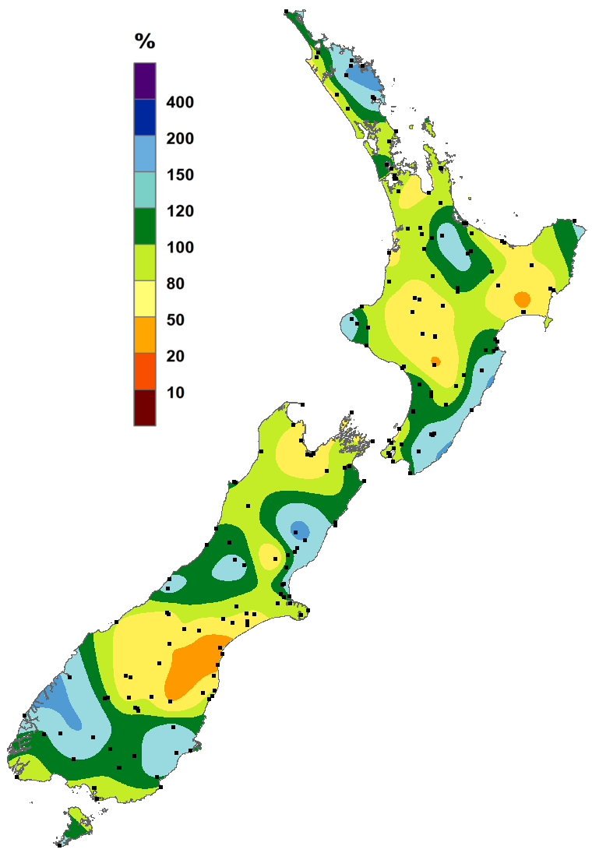 | 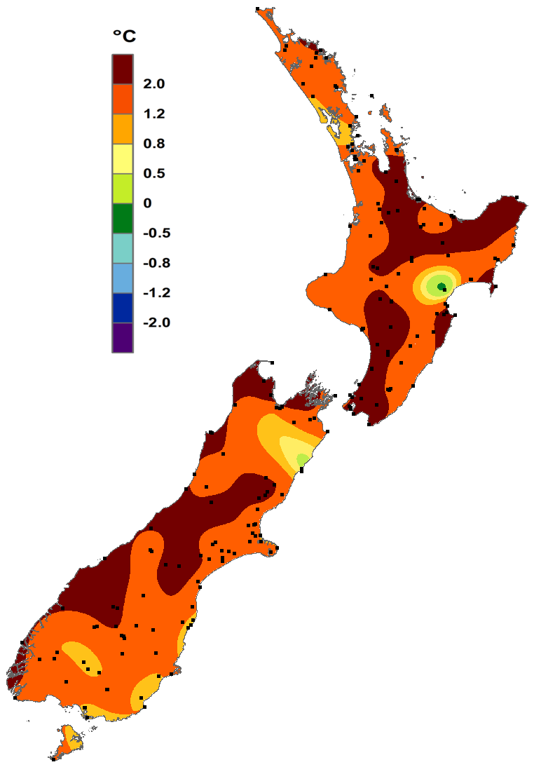
June rainfall  Expressed as a percentage of the 1981-2010 normal. | June temperature  Expressed as a departure from the 1981-2010 average in degrees Celsius. Note, missing data from a climate station at Tutira (Hawke’s Bay) was identified. This has resulted in an inaccurate illustration of June temperature for this area of New Zealand. An updated map was not available for this summary’s publication.
https://www.niwa.co.nz/our-science/climate
© Copyright NIWA 2021.
All rights reserved. Information presented in this summary is based on data available at the time of publication, which is subject to ongoing quality assurance procedures.

The rankings (1st, 2nd, 3rd.etc) in all Tables in this summary are relative to climate data from a group of nearby stations, some of which may no longer be operating. The current climate value is compared against all values from any member of the group, without any regard for homogeneity between one station’s record, and another. This approach is used due to the practical limitations of performing homogeneity checks in real-time.

