New Zealand Climate Summary: 2020 Issued: 12 January 2021

2020: New Zealand’s 7th-warmest year on record
Temperature | Annual temperatures were above average (+0.51°C to +1.20°C above the annual average) across much of the North Island, and parts of every South Island region. Near average (within -0.50°C to +0.50°C of average) temperatures occurred in Southland, eastern and inland Otago, coastal Canterbury, West Coast, Marlborough, coastal parts of the lower North Island, and the Central Plateau. 2020 was the 7th-warmest year on record for New Zealand, based on NIWA’s seven-station series which began in 1909.
Rainfall | Annual rainfall was below normal (50-79% of normal) across many northern, eastern and inland parts of the North Island, and parts of Marlborough, Canterbury and eastern Otago. Rainfall was near normal (80-119% of normal) for most remaining areas of the country including eastern parts of Northland, the Central Plateau, western and southern parts of the North Island, Nelson, West Coast, inland Otago and Southland.
Soil moisture | A dry start to the year contributed to drier than normal soils across much of the country during summer. By the end of February, severe meteorological drought was in place across Northland, Auckland, much of Waikato, western Bay of Plenty, East Cape, and southern Marlborough, while meteorological drought was found from Gisborne to Bay of Plenty and south to Manawatū-Whanganui and eastern Taranaki. Soil moisture levels returned to near normal for many areas during the middle of the year, but by the end of spring drier than normal soils were present for northern parts of the North Island and southern parts of the South Island. By the end of December, soils were drier than normal for the upper North Island, but wetter than normal for coastal areas from Taranaki through to Wellington, the Nelson-Tasman region and northern Otago.
Sunshine | The Bay of Plenty experienced New Zealand’s highest annual sunshine total during 2020 (2704 hours recorded at Whakatāne).

Click on the following links to jump to the information you require:
Overview
The year in review
Monthly temperature maps
Monthly rainfall maps
Observations and statistics
Annual temperature
Annual rainfall
2020 climate in the six main centres
Significant weather and climate events in 2020

Overview
2020 was Aotearoa New Zealand’s 7th-warmest year on record. The nationwide average temperature for 2020, calculated using stations in NIWA’s seven-station temperature series which began in 1909, was 13.24°C (0.63°C above the 1981–2010 annual average). New Zealand’s hottest year on record remains 2016, when the nationwide average temperature was 13.45°C (0.84°C above the 1981–2010 annual average). Based on the seven-station series, 2020 featured six months with above average temperatures (greater than +0.50°C of average), six months with near average temperatures (within -0.50°C to +0.50°C of average), and no months with below average temperatures (less than -0.50°C of average). It has now been 47 months since New Zealand has had a month with below average temperatures (the last such month was January 2017). Furthermore, six of the past eight years have been amongst New Zealand’s hottest on record. This trend is consistent with the overall pattern of global warming.
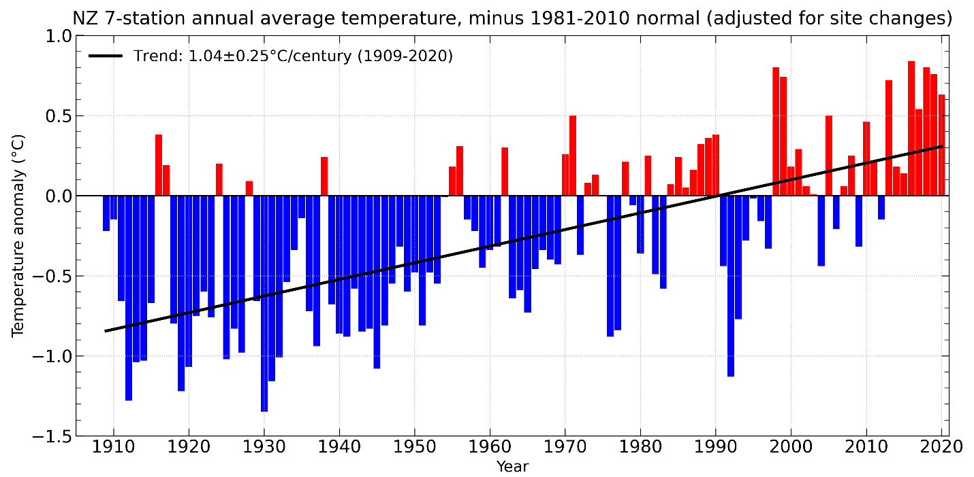
Historical nation-wide annual temperature anomalies (degrees above or below the 1981-2010 normal) from NIWA’s seven-station temperature series which begins in 1909. Six of the past eight years have been among New Zealand’s warmest on record.
The hottest spell of the year took hold over New Zealand from late-January to early-February, with several locations observing their highest daily maximum and daily minimum temperatures on record. The highest temperature of 2020 was recorded on 31 January at Gisborne. The maximum temperature there reached 38.2°C, which is New Zealand’s 5th-highest January temperature on record, and the country’s 19th-equal hottest temperature on record for all months. This period of warmth coincided with the latter stages of an extended dry spell for many areas of the country. Several locations observed dry spells of at least 40 days (see Drought and low rainfall section of this summary for further details). Most notably, a 64-day dry spell was recorded in Blenheim. It lasted from 20 December 2019 to 21 February 2020, making it the longest dry spell on record at the town.
From late-March to late-April, high pressure prevailed over the country, delivering mild and very dry conditions for many areas. Several locations in Wairarapa, coastal Marlborough and coastal North Canterbury recorded less than 5 mm of rain during April. It was a continuation of the dry start to the year for parts of Northland, Auckland, Waikato, Bay of Plenty and Hawke’s Bay, where January-April rainfall totals were less than 40% of normal, respectively. A key contributing factor to the year’s dry start was a near-record positive Indian Ocean Dipole. This persisted from late-2019 into early-2020, preventing plumes of tropical moisture (known as “atmospheric rivers”) from forming north of the country. Atmospheric rivers are an important moisture source for New Zealand, but these were largely non-existent over the country in late-summer and early-autumn.
Winter was much wetter than usual in northern parts of the North Island, which saw soil moisture levels return to near normal after the persistent dryness observed earlier in the year. Seasonal snow experienced a marked mid-winter hiatus, with very little snowfall at most of NIWA’s high elevation observation sites from late-July through much of August. At the end of August, the depth of accumulated snow at Mueller Hut near Mt Cook was the lowest in 10-years of record, with less than 45% of average depth. Several ski areas in Canterbury struggled to operate throughout the season due to a lack of snow. This was largely as a result of abnormally warm temperatures, with New Zealand observing its warmest winter on record. New snowfall in late-winter and early-spring brought snow depths up to average for the time of year at most of NIWA’s high elevation observation sites. It took until late-September for the coldest outbreak of the year to occur. Snow fell to sea level in Southland and Otago during this time, and daytime temperatures on 29 September struggled to exceed 0°C for coastal parts of these regions.
October and November were warm months for the country, with the former month featuring mostly dry conditions. A large fire fanned by strong winds struck Lake Ōhau Alpine Village in early October, which destroyed approximately 50 homes. In contrast to the dryness of October, November was quite a wet month for much of the country. An exceptional heavy rain event occurred in Napier, with 242 mm of rain recorded on 9 November. It was the city’s 2nd-wettest day on record, with records beginning in 1870. Napier ended the month with 325 mm of rain: 601% (i.e., 6 times) of normal for November. A lack of rainfall contributed to dry conditions in December for northern parts of the North Island, with water restrictions introduced for several towns in the Far North, and Tauranga establishing a ban on the use of sprinklers.
For 2020 overall, the New Zealand region had an average mean sea level pressure (MSLP) of 1015.4 hPa, 1.3 hPa above the long-term 1981-2010 average. This was the 6th-highest annual MSLP value observed in the New Zealand region since records began in 1948. The Southern Annular Mode (SAM), a ring of Southern Hemisphere climate variability, was positive 61% of the time during 2020. The positive SAM phase is associated with higher than normal air pressure around New Zealand, which tends to bring more tranquil weather conditions to the country. However, Wellington was an exception in September: the monthly mean wind speed was 24.8 km/h, making it the city’s highest monthly mean wind speed since October 2009.
Early in the year, the El Niño Southern Oscillation (ENSO) phase was neutral. This phase persisted through May, before an increase in tropical trade winds contributed to cooling ocean temperatures about the equatorial Pacific. Accordingly, a La Niña Watch was put into place in June, which transitioned to a La Niña Alert in August as the atmosphere began to respond to the changes in the tropical Pacific Ocean. For New Zealand, air flow anomalies transitioned to northeasterly during winter, which persisted in the North Island through spring — a traditional hallmark of La Niña. In October, La Niña conditions were officially acknowledged and continued through the end of the year.

Section 1: The year in review
The monthly sequence of New Zealand climate was as follows:

January 2020: A month of two halves regarding temperature, very dry for many
The first half of the month was relatively cold, with many locations on track to observe record or near-record low temperatures. However, much warmer conditions prevailed during the second half of the month due to frequent northerly and northwesterly airflow. Overall, temperatures were above average (0.51-1.20°C above average) in parts of interior Canterbury and Otago, northern Tasman, eastern Northland, Coromandel, Bay of Plenty, Gisborne and Hawke’s Bay. Small portions of below average temperatures (0.51-1.20°C below average) were experienced in coastal Westland and south Canterbury, western Waikato and southern parts of the Wellington region. It was a very dry January with much of the country observing rainfall below (50-79% of normal) to well below (<50% of normal) normal. Parts of upper North Island and upper and eastern South Island received less than 10% of their normal January rainfall. By the end of January, soil moisture levels were lower than normal for the entire North Island and much of the South Island. Meteorological drought was present in much of the upper North Island, with severe meteorological drought in northern Auckland, southern Northland, and the Aupouri Peninsula according to NIWA’s New Zealand Drought Index.

February 2020: Dry in the North Island; flooding in the lower South Island
February was very dry across the North Island with most locations observing well below normal rainfall. Some locations in Northland and the central North Island received less than 10% of their normal February rainfall. Well below normal rainfall also occurred across Nelson and Marlborough. Rainfall was generally below normal from Taranaki to Kapiti Coast as well as much of Tasman and northern Canterbury. Conversely, rainfall was above normal (120-149% of normal) or well above normal (>149% of normal) across much of the lower West Coast, Otago, and Southland. Heavy rainfall early in the month caused severe flooding in Fiordland, Otago and inland Southland, particularly along the Mataura River. It was a warm month across New Zealand, with above average to well above average (>1.20°C above average) temperatures observed across nearly all of the North Island as well as much of the upper and central South Island. At the end of the month, severe meteorological drought was in place across Northland, Auckland, much of Waikato, western Bay of Plenty, East Cape, and southern Marlborough, while meteorological drought was found from Gisborne to Bay of Plenty and south to Manawatū-Whanganui and eastern Taranaki.

March 2020: Dry for many locations; temperatures near to below average
March was dry for many locations in New Zealand, with below normal to well below normal rainfall observed in much of the upper North Island, Hawke’s Bay, Tasman, Nelson, much of Marlborough, and large parts of Otago. Conversely, rainfall was above normal or well above normal in the lower North Island, northern Canterbury, and a small portion of western Waikato. Temperatures were near average (±0.50°C of average) across a vast majority of the North Island, Tasman, and West Coast. Below average and isolated well below average (<1.20°C below average) temperatures were observed across much of the eastern and lower South Island. Meteorological drought receded significantly during March, but remained in place at the end of the month across parts of Northland, Auckland, and far northern Waikato. In addition, severe meteorological drought was found across the Coromandel Peninsula.

April 2020: Very dry for many parts of New Zealand
Rainfall was well below normal or below normal for most of the North Island, Nelson, Tasman, Marlborough, Canterbury and eastern parts of Central Otago. Several locations in Wairarapa, coastal Marlborough and coastal North Canterbury received less than 5 mm of rain for the entire month. Rainfall was above normal for some western parts of the South Island and Oamaru. Temperatures were above average for parts of Waikato, Bay of Plenty, Gisborne, Hawke’s Bay, Wairarapa, Manawatū, Canterbury, eastern Central Otago and Southland. At the end of the month, soil moisture levels were considerably lower than normal for most of the North Island, as well as northern parts of the South Island. Soils were also drier than normal for many eastern parts of the South Island.

May 2020: Warm and dry for the middle and lower South Island
Rainfall was below normal or well below normal for locations in the middle and lower South Island, with increasing dryness toward the east of these areas. Parts of the upper South Island observed above normal or well above normal rainfall. In the North Island, rainfall was below normal for many locations between the upper Waikato and lower Manawatū-Whanganui. Most locations in the Auckland and Wellington regions experienced near or above normal May rainfall, while rainfall in Northland was below normal to the west and above normal to the east. Temperatures were above average or well above average for many locations in the middle and lower South Island as well as the western parts of the Tasman District. Temperatures were also above average along the eastern margins of the North Island. Isolated areas around lower Marlborough and between Taumarunui and Tūrangi observed below average temperatures. At the end of the month, soils were drier than normal for many northern, central and eastern parts of the North Island, as well as eastern, inland and southern parts of the South Island.

June 2020: Warm start to winter for much of the country
It was New Zealand’s 5th-warmest June on record. Temperatures were above average or well above average throughout the North Island, as well as northern, central and western parts of the South Island. Rainfall was above normal or well above normal for parts of Northland, Auckland, Bay of Plenty, Gisborne, Hawke’s Bay, western Taranaki, Wellington, eastern Canterbury, and inland parts of Otago. Rainfall was below normal or well below normal for southern, western and northwestern parts of the South Island, inland parts of Manawatū-Whanganui, and western parts of Waikato. At the end of the month, soil moisture levels were lower than normal for eastern and inland parts of Otago, south Canterbury, and inland parts of Manawatū-Whanganui.

July 2020: Very wet in Northland, dry for many remaining areas
Rainfall was well above normal or above normal for Northland, western Otago and inland parts of Southland. Rainfall was below normal or well below normal for parts of all remaining North Island regions, and much of the northern, eastern and inland areas of the South Island. Temperatures were above average or near average for most of the country. Above average temperatures were mostly observed in central and northwestern parts of the South Island, and northern, western and southern parts of the North Island. At the end of the month, soil moisture levels were lower than normal for eastern parts of Otago and Canterbury (south of Ashburton).

August 2020: A warm and dry finish to winter
It was New Zealand’s 4th-warmest August on record. Temperatures were above average or well above average for most of the country. It was a particularly dry month for eastern and inland parts of Canterbury and North Otago, where less than 20% of normal August rainfall was recorded. Rainfall was below normal or well below normal in parts of almost every region. Rainfall was above normal or well above normal in Northland and northern Auckland. At the end of the month, soil moisture levels were lower than normal in eastern parts of the South Island, and southern parts of the North Island. Soils were considerably drier than normal in eastern parts of south Canterbury and north Otago.

September 2020: Dry for northern North Island, wet for much of South Island
Rainfall was well below normal for much of Northland, Auckland, Coromandel Peninsula, and Bay of Plenty. Below normal rainfall was observed in much of Waikato, East Cape, Gisborne and coastal parts of northern Taranaki. Above normal or well above normal rainfall was observed in much of the South Island and the southern North Island including Southland, western and central Otago, north Canterbury, the northern West Coast, Wellington, Wairarapa, the Kapiti Coast and Manawatū-Whanganui. Temperatures were near average for most of the country. Temperatures were above average in eastern parts of Otago, Canterbury, Hawke’s Bay and Gisborne, as well as northern parts of Tasman and Marlborough. At the end of the month, soil moisture was lower than normal for eastern parts of Otago and Canterbury from Dunedin to Christchurch, as well as parts of Northland, Auckland, coastal Bay of Plenty and East Cape. Soil moisture was higher than normal in parts of western Otago and eastern Marlborough.

October 2020: A warm and dry month for much of New Zealand
Rainfall was well below normal for parts of Northland, Auckland, northern Waikato, Bay of Plenty, Gisborne, Wairarapa, Marlborough, and central Canterbury. Below normal rainfall was observed in nearly all remaining portions of the North Island, as well as Nelson and northern Canterbury. Conversely, above normal rainfall was widespread across the West Coast, Fiordland, much of Southland, and Stewart Island. Temperatures were above average or well above average across all of the North Island and nearly all of the South Island, except for parts of eastern Otago where temperatures were near average. At the end of the month, soil moisture was lower than normal across the northern third of the North Island, Wairarapa, Marlborough, and central Canterbury south to eastern Otago. Soil moisture was considerably lower than normal in coastal Bay of Plenty, East Cape, Wairarapa, and central Canterbury. Soil moisture was higher than normal in interior Manawatū-Whanganui, northern Tasman, and Southland.

November 2020: Wet and warm for much of New Zealand
Over double the normal November rainfall total (>200% of normal) was recorded for parts of Waikato, Bay of Plenty, central North Island, Hawke’s Bay, Taranaki, Wellington, Nelson and Tasman. Other areas that experienced above or well above normal rainfall were the remainder of the North Island except for the Far North, East Cape, and western Waikato. Most of Marlborough, Canterbury and Buller also experienced above or well above normal rainfall. Well below normal rainfall was experienced in much of Southland, Fiordland, and the southern half of the West Coast. Temperatures were well above average for areas of eastern Northland, Auckland, Coromandel, Bay of Plenty, Taranaki, Gisborne, and the West Coast. For most other parts of New Zealand, temperatures were above average, except for Wellington, Marlborough and parts of Canterbury which had near average temperatures. By the end of November, soil moisture levels were higher than normal for most of the North Island south of Hamilton, as well as Nelson and Tasman. Soil moisture levels were lower than normal for much of Northland to northern Waikato and the southern half of the South Island.

December 2020: A dry and mild end to the year
Well below normal rainfall was experienced in much of the upper and eastern North Island while coastal Taranaki and Manawatū-Whanganui saw near normal (80-119% of normal) or above normal rainfall. In the South Island, rainfall was largely well below or below normal, with the exception of a few locations in coastal Canterbury and Stewart Island that saw above normal rainfall. Temperatures were near average for much if the country. The exceptions were small pockets of above average temperatures in Northland, Coromandel, the Bay of Plenty and Tasman. At the end of the month, soil moisture levels were lower than normal for the upper North Island and higher than normal for coastal areas from Taranaki through to Wellington, for the Nelson-Tasman region and for northern Otago.

Section 2: Monthly temperature (in °C, as a departure from the 1981-2010 monthly averages)
January  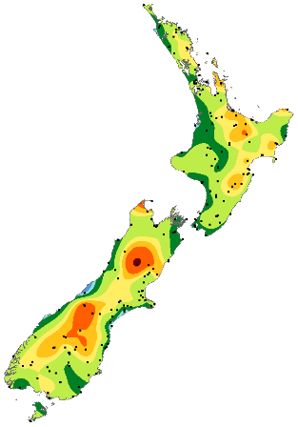 | February  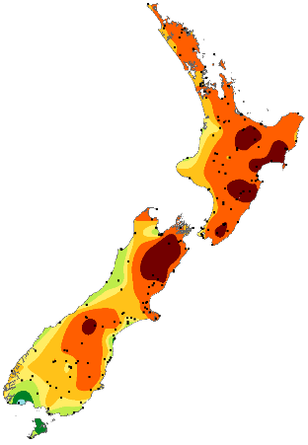 | March  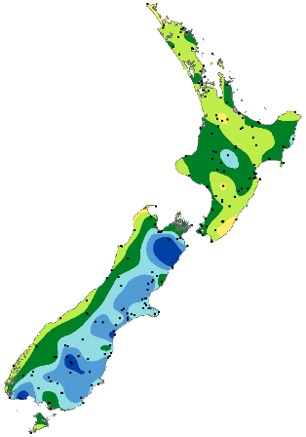 | April  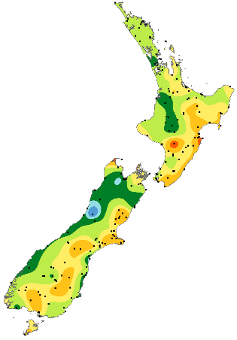 | May  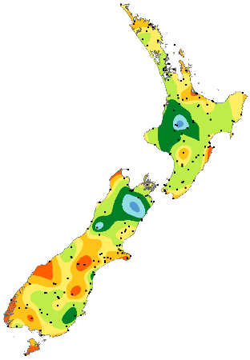 | June  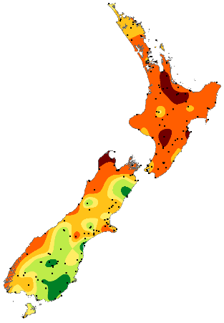 | 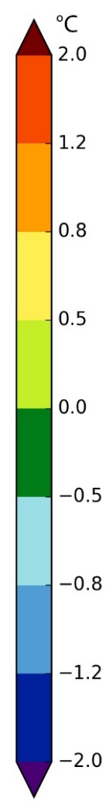
July  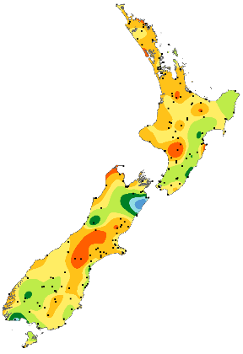 | August  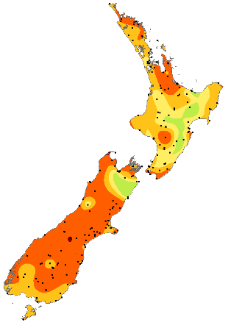 | September  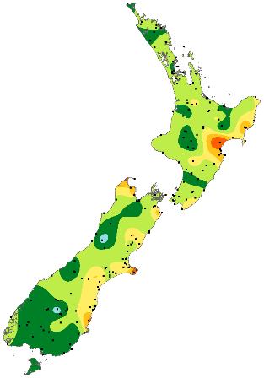 | October  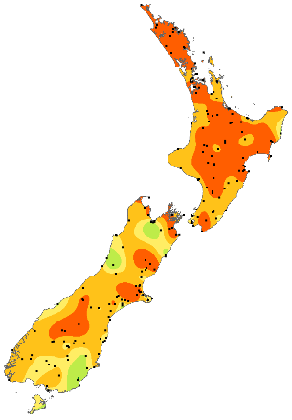 | November  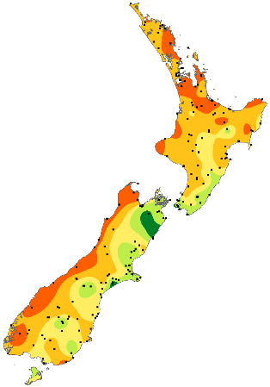 | December  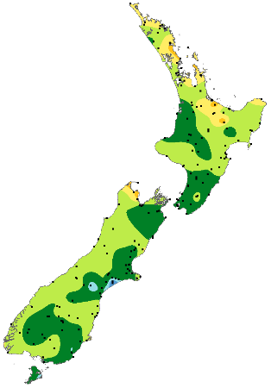
Figure 1: Monthly temperature anomalies (compared to the 1981-2010 monthly averages) for each month of 2020.

Section 3: Monthly rainfall (as a percentage of the 1981-2010 monthly normals)

January  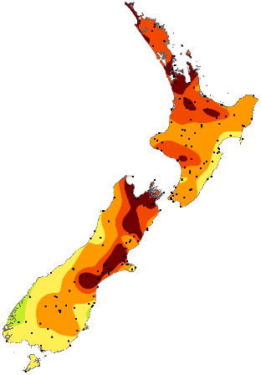 | February  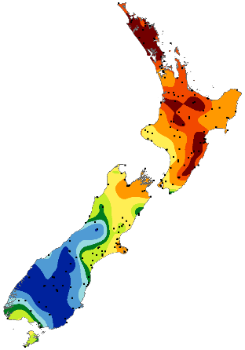 | March  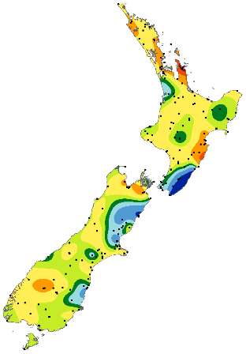 | April  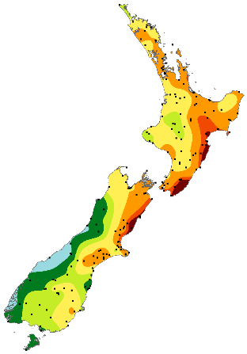 | May  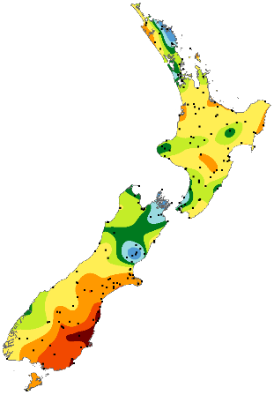 | June  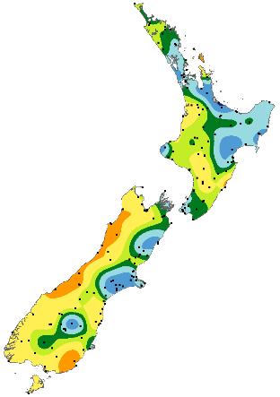 | 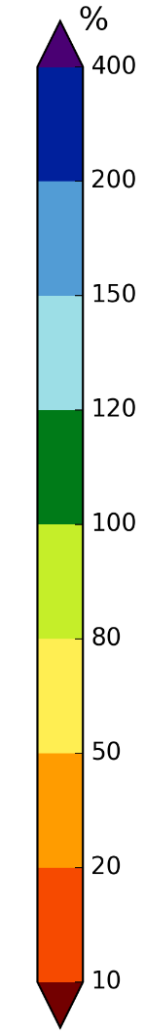
July  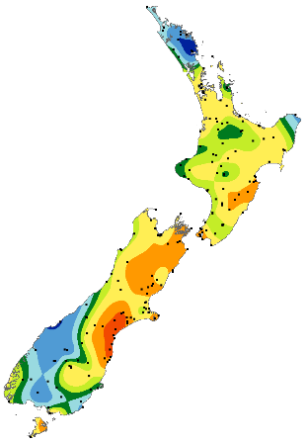 | August  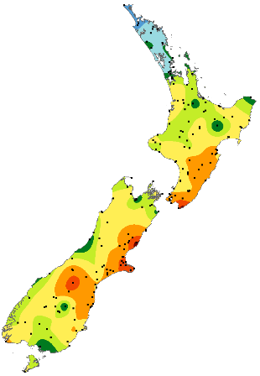 | September  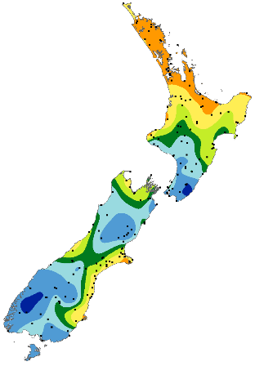 | October  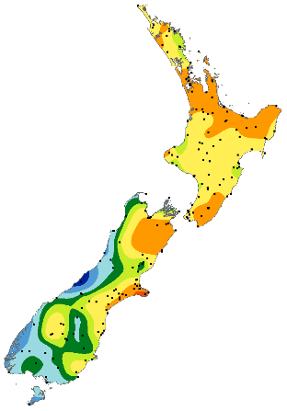 | November  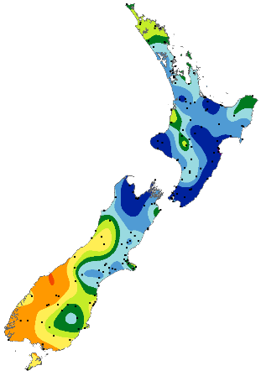 | December  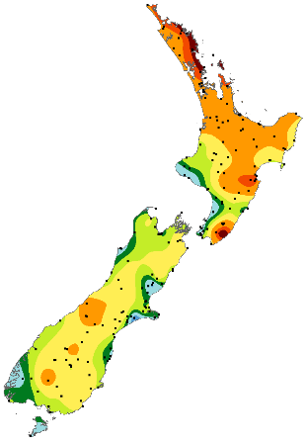
Figure 2: Monthly rainfall as a percentage of each 1981-2010 monthly normal for each month of 2020.

Section 4: Observations and statistics
Based on data available at the time of writing, NIWA analyses of month-by-month records show:

- The nationwide average temperature for 2020 was 13.24°C (0.63°C above the 1981–2010 annual average). Using NIWA’s seven-station temperature series, 2020 was the 7th-warmest year on record since records began in 1909.
- Leigh recorded the highest annual average temperature for 2020 with 16.9°C, followed by Whangārei and Kaitaia with 16.6°C.
- The highest air temperature of the year was 38.2°C, recorded at Gisborne on 31 January. This was followed by 37.4°C at Napier and 37.3°C at Wairoa, which both occurred on 2 February.
- The lowest air temperature of the year was -12.3°C recorded at Middlemarch, followed by -10.7°C at Ophir and -9.9°C at Clyde. These temperatures were all observed on 14 June.
- The top three daily rainfall totals from regularly reporting gauges in 2020 were 509 mm at Milford Sound on 3 February, 327 mm at Mueller Hut on 4 February, and 289 mm at North Egmont on 24 May.
- The top three daily rainfall totals from regularly reporting gauges in 2020 excluding high elevation stations were: 509 mm at Milford Sound on 3 February, 262 mm at Kaihohe on 17 July, and 251 mm at Whangārei on 17 July.
- Of all the regularly reporting gauges, the wettest locations in 2020 were: Cropp River (West Coast, 975 metres above sea level) with 11,532 mm, Tuke River (West Coast, 975 metres above sea level) with 10,584 mm, and Haast River (West Coast, 58 metres above sea level) with 8,340 mm.
- Of the regularly reporting gauges, the wettest locations in 2020 excluding high elevation stations were:
Milford Sound with 7,421 mm, Pigeon Creek with 4,269 mm, and Arthur’s Pass with 4,181 mm.
- The lowest rainfall recording locations for 2020 were Hakataramea Valley with 205 mm, Alexandra with 314 mm, and Bromley (eastern Christchurch) with 317 mm.
- The Bay of Plenty experienced New Zealand’s highest annual sunshine total during 2020 (2704 hours recorded at Whakatāne), followed by the wider Nelson region (2632 hours - Richmond) and Marlborough (2603 hours - Blenheim).
- The highest confirmed wind gust for 2020 was 198 km/h recorded at Cape Turnagain on 31 January.
- Of the six main centres in 2020, Auckland was the warmest, Dunedin was the coolest, Wellington was the wettest, Christchurch was the driest, Tauranga was the sunniest and Dunedin was the least sunny.

Ranked annual total rainfall, mean temperatures and sunshine hours for the stations available at time of writing are displayed on the following five pages. Some sites have missing days of data. The number of missing days is indicated by a superscript number next to the annual value in the tables below.
Location | Rainfall (mm)
CROPP AT WATERFALL | 11532
TUKE AT TUKE HUT | 10584
CROPP AT CROPP HUT | 8841¹⁵
HAAST AT CRON CK | 8340
DOON AT MIDDLE ARM | 8216
IVORY GLACIER CWS | 7721
MILFORD SOUND EWS | 7421
HOKITIKA AT PRICES FLAT | 7355
HOKITIKA AT COLLIERS CK | 7039
HOKITIKA RAPID CK | 6959
WIAHO AT DOUGLAS HUT | 6786
HAAST AT ROARING BILLY | 6000
WHATAROA AT SHB | 5517
MT PHILISTINE EWS | 5198
RAKAIA AT LAKE RAMSAY | 5037
GODLEY AT EADE HUT | 4727
PIGEON CREEK CWS | 4269¹
ARTHUR’S PASS AWS | 4181¹¹
ARTHUR’S PASS EWS | 4062
FRANZ JOSEF EWS | 3980¹⁴
MANAPOURI, WEST ARM JETTY EWS | 3864
MT COOK EWS | 3696⁸
HAAST AWS | 3390¹⁷
ALBERT BURN | 3051⁵
MURCHISON MTNS EWS | 3012
HOKITIKA AERO | 2825¹
HOKITIKA AWS | 2716²
HOKITIKA EWS | 2588¹
PUYSEGUR POINT AWS | 2471¹⁷
WAITUTU CWS | 2462
MAHANGA EWS | 2435
MT RUAPEHU, CHATEAU EWS | 2320
GREYMOUTH AERO EWS | 2254
EGLINTON, KNOBS FLAT CWS | 2181
WESTPORT AERO AWS | 2146³
WESTPORT EWS | 2093
MT COOK AERO AWS | 2014¹¹
UPPER RAKAIA EWS | 1965
ARAPITO EWS | 1894
STRATFORD EWS | 1812
AWAKINO EWS | 1697⁶
KERIKERI AERODROME AWS | 1673
MOTU EWS | 1628
REEFTON EWS | 1547
KERIKERI EWS | 1486
KAIKOHE AWS | 1478⁷
SOUTH WEST CAPE AWS | 1443¹⁵
RUSSELL CWS | 1418
NEW PLYMOUTH AWS | 1415⁵
WHANGĀREI AERO AWS | 1395
TE PUKE EWS | 1333
WHITIANGA EWS | 1333
WHITIANGA AERO AWS | 1308¹¹
WELLINGTON, KELBURN 2 | 1285
TE KUITI EWS | 1268
PUREORA FOREST CWS | 1266
WELLINGTON, KELBURN AWS | 1262⁵
MANAIA, MOTUMATE STM | 1260
WHANGĀREI EWS | 1256
TAUMARUNUI EWS | 1243
LOWER RETARUKE CWS | 1233
TŪRANGI 2 EWS | 1209²
TROUNSON CWS | 1178
UPPER HUTT, TRENTHAM EWS | 1172¹
HICKS BAY AWS | 1171¹²
MAUNGARAKI 3 | 1153
WHATAWHATA 2 EWS | 1150
AKITIO EWS | 1145
PARAPARAUMU AERO | 1144
MANAPOURI AERO AWS | 1143⁵
FAREWELL SPIT AWS | 1139¹¹
WAIROA AERO AWS | 1115¹¹
INVERCARGILL AERO | 1106³
PARAPARAUMU EWS | 1076
WELLINGTON, GRETA POINT CWS | 1063
BIRCHWOOD WXT AWS | 1058¹²
LEVIN EWS | 1056
TAUMARUNUI AWS | 1052¹⁶
ROTORUA AERO AWS | 1052³
OHAKUNE EWS | 1042⁴
HĀWERA AWS | 1035¹²
WELLINGTON AERO | 1026
MOTUEKA, RIWAKA EWS | 1017³
WAIOURU EWS | 1017¹
AUCKLAND, WHENUAPAI AWS | 1014¹
PARAPARAUMU AERO AWS | 1010¹
WAIROA, NORTH CLYDE EWS | 997
KAITAIA AERO AWS | 988⁹
GORE AWS | 986⁹
LEVIN AWS | 986⁷
KAITAIA AERO EWS | 983
INVERCARGILL AERO 2 EWS | 982
INVERCARGILL AERO AWS | 981
ROTORUA EWS | 968
MASTERTON AERO AWS | 964
PAHIATUA EWS | 952
AUCKLAND, NORTH SHORE ALBANY EWS | 924
MASTERTON, TE ORE ORE CWS | 923
FIVE RIVERS CWS | 922
KAITAIA EWS | 920⁷
MASTERTON, TE ORE ORE SRIG | 915
HANMER FOREST EWS | 914
PUKEKOHE EWS | 913
WAIKERIA EWS | 906⁵
HAMILTON AWS | 905¹
PAEROA AWS | 904¹³
KAIKŌURA, MIDDLE CREEK | 900
WAIPOUNAMU CWS | 896
GORE EWS | 893¹
WHAKATĀNE EWS | 879
LUMSDEN AWS | 877¹¹
GISBORNE AWS | 872¹
NELSON AERO | 853
NGAWI AWS | 852³
QUEENSTOWN EWS | 848¹
MAYFIELD AT RUAPUNA | 846¹
PORT TAHAROA AWS | 840⁶
RICHMOND EWS | 839¹
CAPE REINGA AWS | 839⁹
OHAKEA AWS | 832⁷
DARGAVILLE 2 EWS | 830
PALMERSTON NORTH EWS | 826
WAIPARA NORTH BRANCH @ LANGS GULLY | 825
WHANGANUI,SPRIGGENS PARK EWS | 821¹⁷
BALMORAL EAST CWS | 817¹
AUCKLAND, MOTAT EWS | 817
MANA ISLAND AWS | 816¹³
PURERUA AWS | 812¹⁰
WHANGANUI AWS | 812
NELSON AWS | 810
MATAMATA, HINUERA EWS | 810⁵
WHAKATĀNE AERO AWS | 806¹
PALMERSTON NORTH AWS | 806³
AUCKLAND AERO | 794¹
DANNEVIRKE EWS | 783
TAURANGA AERO AWS | 775²
HAMILTON, RUAKURA 2 EWS | 754
TAKAPAU PLAINS AWS | 743¹⁴
TAUPŌ AWS | 741²
GISBORNE EWS | 737¹⁰
FIRTH OF THAMES EWS | 736
MARTINBOROUGH EWS | 735
NAPIER EWS | 732
AUCKLAND, MĀNGERE 2 EWS | 719
LEIGH 2 EWS | 715⁷
LAKE KARAPIRO CWS | 702
METHVEN, THREE SPRINGS CWS | 691¹
MASTERTON EWS | 681¹⁸
QUEENSTOWN AERO AWS | 677¹⁷
FLAT HILLS WXT AWS | 641⁶
AKAROA EWS | 636
BALCLUTHA, TELFORD EWS | 636⁶
GALATEA AWS | 634¹⁴
NAPIER AERO AWS | 628
WAIAU SCHOOL CWS | 624
METHVEN CWS | 613¹
CULVERDEN AWS | 601¹¹
DUNEDIN, MUSSELBURGH EWS | 600
WĀNAKA CWS | 596⁸
KAIKŌURA AWS | 593⁶
BARING HEAD | 574¹
WĀNAKA AERO AWS | 565¹
OHOKA CWS | 564
PUKAKI AERODROME AWS | 550
MEDBURY CWS | 550
WAIPARA WEST EWS | 541
CHEVIOT EWS | 529⁶
CHRISTCHURCH AERO | 517
DUNEDIN AERO AWS | 514
MARAEKAKAHO CWS | 510¹³
WAIPAWA EWS | 506
BLENHEIM AERO AWS | 505²
ASHBURTON AERO AWS | 497¹⁰
WINCHMORE 2 EWS | 492
ORARI ESTATE CWS | 491¹
OAMARU AWS | 489¹
RANGIORA EWS | 480
DIAMOND HARBOUR EWS | 466
HASTINGS AWS | 463¹⁶
BLENHEIM RESEARCH EWS | 461
CHERTSEY CWS | 453
LAUDER EWS | 449
FAIRLIE AWS | 446¹¹
TARA HILLS AWS | 445⁹
LAKE TEKAPO EWS | 435¹⁸
WAKANUI 2 CWS | 434
LE BONS BAY AWS | 423⁸
CAPE CAMPBELL AWS | 418⁵
CHRISTCHURCH, KYLE ST EWS | 412
OAMARU AIRPORT AWS | 406¹
RANFURLY EWS | 400
LINCOLN, BROADFIELD EWS | 400¹
ALEXANDRA AWS | 392¹⁰
WAIMATE CWS | 373¹¹
TIMARU EWS | 367
OAMARU EWS | 364
MIDDLEMARCH EWS | 359¹
ALEXANDRA CWS | 357
WINDSOR EWS | 354
CLYDE 2 EWS | 352¹⁰
TIMARU AERO AWS | 349
CROMWELL EWS | 342
BROMLEY EWS | 317
ALEXANDRA EWS | 314
HAKATARAMEA VALLEY CWS | 205
Location | Mean temp(°C)
LEIGH 2 EWS | 16.9
WHANGĀREI AERO AWS | 16.6
KAITAIA AERO EWS | 16.6
CAPE REINGA AWS | 16.4
PURERUA AWS | 16.3
WHANGĀREI EWS | 16.3
KAITAIA EWS | 16.2
AUCKLAND AERO | 16.1
RUSSELL CWS | 16.1
AUCKLAND, MĀNGERE 2 EWS | 16.0
DARGAVILLE 2 EWS | 16.0
KERIKERI EWS | 16.0
KERIKERI AERODROME AWS | 15.9
AUCKLAND, MOTAT EWS | 15.9
WAIROA, NORTH CLYDE EWS | 15.9
TAURANGA AERO AWS | 15.8
HICKS BAY AWS | 15.8
WHITIANGA EWS | 15.7
PORT TAHAROA AWS | 15.6
AUCKLAND, NORTH SHORE ALBANY EWS | 15.5
LAKE KARAPIRO CWS | 15.5
WHITIANGA AERO AWS | 15.4
KAIKOHE AWS | 15.4
GISBORNE EWS | 15.3
AUCKLAND, WHENUAPAI AWS | 15.3
GISBORNE AWS | 15.2
PAEROA AWS | 15.2
PUKEKOHE EWS | 15.2
NGAWI AWS | 15.1
NAPIER EWS | 15.0
WHAKATĀNE EWS | 15.0
WHAKATĀNE AERO AWS | 14.9
MAHIA AWS | 14.8
TROUNSON CWS | 14.8
NAPIER AERO AWS | 14.7
FIRTH OF THAMES EWS | 14.7
HASTINGS AWS | 14.7
HAMILTON, RUAKURA 2 EWS | 14.6
WHATAWHATA 2 EWS | 14.4
WAIROA AERO AWS | 14.3
WELLINGTON AERO | 14.2
MATAMATA, HINUERA EWS | 14.2
WHANGANUI AWS | 14.2
HAMILTON AWS | 14.1
TE KUITI EWS | 14.1
NEW PLYMOUTH AWS | 14.1
PALMERSTON NORTH AWS | 13.9
PALMERSTON NORTH EWS | 13.9
LEVIN AWS | 13.8
WHAKATU EWS | 13.8
OHAKEA AWS | 13.7
MARTINBOROUGH EWS | 13.7
BLENHEIM RESEARCH EWS | 13.6
NELSON AWS | 13.6
PORIRUA, ELSDON PARK AWS | 13.6
PARAPARAUMU EWS | 13.6
PARAPARAUMU AERO AWS | 13.5
ARAPITO EWS | 13.5
TAUMARUNUI EWS | 13.5
AKAROA EWS | 13.5
WAIPAWA EWS | 13.4
ROTORUA AERO AWS | 13.3
CAPE CAMPBELL AWS | 13.3
LEVIN EWS | 13.3
WELLINGTON, KELBURN AWS | 13.3
GALATEA AWS | 13.3
WESTPORT EWS | 13.3
MASTERTON, TE ORE ORE CWS | 13.3
CHRISTCHURCH, KYLE ST EWS | 13.2
BARING HEAD | 13.2
HĀWERA AWS | 13.2
DANNEVIRKE EWS | 13.2
KAIKŌURA AWS | 13.1
WAIKERIA EWS | 13.1
MANA ISLAND AWS | 13.1
WESTPORT AERO AWS | 13.1
RICHMOND EWS | 13.1
BLENHEIM AERO AWS | 13.1
BROMLEY EWS | 13.1
MASTERTON EWS | 13.1
PAHIATUA EWS | 13.1
UPPER HUTT, TRENTHAM EWS | 13.0
FLAT HILLS WXT AWS | 13.0
LOWER RETARUKE CWS | 13.0
AKITIO EWS | 12.9
WAIPARA WEST EWS | 12.9
MASTERTON AERO AWS | 12.9
DIAMOND HARBOUR EWS | 12.8
GREYMOUTH AERO EWS | 12.7
TAUMARUNUI AWS | 12.7
WAIAU SCHOOL CWS | 12.6
LINCOLN, BROADFIELD EWS | 12.5
CHEVIOT EWS | 12.5
MEDBURY CWS | 12.4
STRATFORD EWS | 12.4
CHERTSEY CWS | 12.3
TAKAPAU PLAINS AWS | 12.3
CHRISTCHURCH AERO | 12.2
TAUPŌ AWS | 12.2
HOKITIKA AWS | 12.1
HOKITIKA EWS | 12.1
RANGIORA EWS | 12.1
REEFTON EWS | 12.0
CULVERDEN AWS | 12.0
LE BONS BAY AWS | 12.0
TŪRANGI 2 EWS | 12.0
MOTU EWS | 11.9
ASHBURTON AERO AWS | 11.8
WAKANUI 2 CWS | 11.7
OHOKA CWS | 11.7
ALEXANDRA CWS | 11.7
METHVEN CWS | 11.7
KAIKŌURA, MIDDLE CREEK | 11.7
PUYSEGUR POINT AWS | 11.6
DUNEDIN, MUSSELBURGH EWS | 11.6
PIGEON CREEK CWS | 11.6
ROXBURGH WXT AWS | 11.5
WAIPARA NORTH BRANCH @ LANGS GULLY CWS | 11.4
WĀNAKA AERO AWS | 11.4
BALMORAL EAST CWS | 11.4
ORARI ESTATE CWS | 11.4
METHVEN, THREE SPRINGS CWS | 11.3
WINCHMORE 2 EWS | 11.3
HANMER FOREST EWS | 11.3
QUEENSTOWN EWS | 11.2
HAKATARAMEA VALLEY CWS | 11.2
MILFORD SOUND EWS | 11.1
ALEXANDRA EWS | 11.1
PUREORA FOREST CWS | 11.1
OAMARU EWS | 11.0
MILFORD SOUND AWS | 11.0
TIMARU AERO AWS | 11.0
FAIRLIE AWS | 10.9
CROMWELL EWS | 10.9
WINDSOR EWS | 10.9
ALEXANDRA AWS | 10.8
OAMARU AIRPORT AWS | 10.8
TIWAI POINT EWS | 10.6
NUGGET POINT AWS | 10.5
INVERCARGILL AERO AWS | 10.5
TIMARU EWS | 10.4
QUEENSTOWN AERO AWS | 10.4
BIRCHWOOD WXT AWS | 10.4
GORE AWS | 10.4
DUNEDIN AERO AWS | 10.4
INVERCARGILL AERO 2 EWS | 10.3
MIDDLEMARCH EWS | 10.3
LAUDER EWS | 10.2
GORE EWS | 10.1
TARA HILLS AWS | 10.1
FIVE RIVERS CWS | 10.1
PUKAKI AERODROME AWS | 10.0
WAIPOUNAMU CWS | 10.0
RANFURLY EWS | 9.9
LUMSDEN AWS | 9.8
MANAPOURI AERO AWS | 9.7
WAIOURU EWS | 9.7
MANAPOURI, WEST ARM JETTY EWS | 9.6
MT COOK AERO AWS | 9.5
WAIOURU AIRSTRIP AWS | 9.3
ARTHUR’S PASS AWS | 8.3
ARTHUR’S PASS EWS | 8.2
TAKAHE VALLEY CWS | 6.3
MURCHISON MTNS EWS | 5.9
ALBERT BURN | 5.9
IVORY GLACIER CWS | 4.8
MT PHILISTINE EWS | 4.0
UPPER RAKAIA EWS | 3.9
MT POTTS EWS | 1.8
Location | Sunshine (hours)
WHAKATĀNE | 2704
RICHMOND EWS | 2632^{<1}
BLENHEIM RESEARCH EWS | 2603^{<1}
NEW PLYMOUTH AWS | 2600^{<1}
ROTORUA EWS | 2587
NAPIER EWS | 2577¹
GISBORNE AWS | 2474¹
TAURANGA AERO | 2473
AUCKLAND, MOTAT EWS | 2450
LAKE TEKAPO EWS | 2383¹⁸
AUCKLAND, MĀNGERE 2 EWS | 2377
NELSON AERO | 2375
CROMWELL EWS | 2370
ALEXANDRA EWS | 2369
QUEENSTOWN AERO AWS | 2359¹
TŪRANGI 2 EWS | 2358²
DIAMOND HARBOUR EWS | 2330¹
BROMLEY EWS | 2329
CHEVIOT EWS | 2306¹¹
MASTERTON EWS | 2271
WINCHMORE 2 EWS | 2266
AUCKLAND, NORTH SHORE ALBANY EWS | 2263
PARAPARAUMU AERO AWS | 2263¹
KAWERAU AWS | 2245¹⁴
LEVIN EWS | 2237¹
WAIPARA WEST EWS | 2236
AKITIO EWS | 2224
OAMARU EWS | 2222
WESTPORT EWS | 2220¹
RANGIORA EWS | 2202
ASHBURTON AERO AWS | 2189¹¹
PARAPARAUMU EWS | 2182¹
LINCOLN, BROADFIELD EWS | 2176¹
CHRISTCHURCH AERO | 2166¹
AKAROA EWS | 2152²
HAMILTON, RUAKURA 2 EWS | 2150¹
DARGAVILLE 2 EWS | 2148
HOKITIKA AWS | 2142²
WHANGĀREI EWS | 2138
KAITAIA EWS | 2127⁴
STRATFORD EWS | 2127
WAIKERIA EWS | 2116⁶
WELLINGTON, KELBURN AWS | 2110
DUNEDIN, MUSSELBURGH EWS | 2108¹
TE KUITI EWS | 2098
UPPER HUTT, TRENTHAM EWS | 2087¹
PARAPARAUMU AERO | 2069¹
TAUMARUNUI AWS | 1999¹²
WAIPAWA EWS | 1982³
GREYMOUTH AERO EWS | 1885¹¹
REEFTON EWS | 1875
ARAPITO EWS | 1869¹
INVERCARGILL AERO 2 EWS | 1841³
MIDDLEMARCH EWS | 1839²
GORE EWS | 1838³
HOKITIKA AERO | 1833¹
DANNEVIRKE EWS | 1828
INVERCARGILL AERO | 1827³
MARTINBOROUGH EWS | 1812²
PALMERSTON NORTH EWS | 1764¹
FRANZ JOSEF EWS | 1757¹⁸
BALCLUTHA, TELFORD EWS | 1581⁶

Section 5: Annual temperature – record or near-record warmth for many locations

2020 was New Zealand’s 7th-warmest year on record based on NIWA’s seven-station series, which began in 1909. Many locations observed record or near-record high mean, mean maximum, and mean minimum temperatures. It was the warmest year on record for Wairoa, Medbury and Cheviot.

Table 1: Record or near-record high or low annual average temperature departures for 2020.
Location | Mean air temp. (ºC) | Departure from normal (ºC) | Year records began | Comments
Mean temperature
Wairoa | 15.9 | 1.6 | 1964 | Highest
Medbury | 12.4 | 1.0 | 1927 | Highest
Cheviot | 12.5 | 1.0 | 1982 | Highest
Cape Reinga | 16.4 | 0.6 | 1951 | 2nd-highest
Te Puke | 15.0 | 1.0 | 1973 | 2nd-highest
Hanmer Forest | 11.3 | 1.0 | 1906 | 2nd-highest
Kerikeri | 16.0 | 0.7 | 1945 | 3rd-highest
Whangārei | 16.6 | 0.8 | 1967 | 3rd-highest
Hicks Bay | 15.8 | 0.9 | 1969 | 3rd-highest
Waipawa | 13.4 | 0.6 | 1945 | 3rd-highest
Waiau | 12.6 | 1.2 | 1974 | 3rd-highest
Le Bons Bay | 12.0 | 0.6 | 1984 | 3rd-highest
Ranfurly | 9.9 | 1.0 | 1897 | 3rd-highest
Auckland (Whenuapai) | 15.3 | 0.6 | 1945 | 4th-highest
Whitianga | 15.7 | 1.0 | 1962 | 4th-highest
Motu | 11.9 | 1.1 | 1990 | 4th-highest
Auckland (Airport) | 16.1 | 0.6 | 1959 | 4th-highest
Porirua | 13.6 | 0.3 | 1968 | 4th-highest
Arapito | 13.5 | 0.8 | 1978 | 4th-highest
Motueka | 13.3 | 0.8 | 1956 | 4th-highest
Mean maximum temperature
Whangārei | 21.6 | 1.7 | 1967 | Highest
Matamata | 20.4 | 1.6 | 1999 | Highest
Te Kuiti | 20.8 | 2.0 | 1959 | Highest
Waipawa | 19.8 | 1.6 | 1945 | Highest
Wairoa | 21.5 | 2.2 | 1964 | Highest
Stratford | 17.1 | 1.0 | 1960 | Highest
Hanmer Forest | 19.4 | 2.4 | 1906 | Highest
Medbury | 18.7 | 1.2 | 1927 | Highest
Cheviot | 18.7 | 1.3 | 1982 | Highest
Auckland (Whenuapai) | 20.1 | 1.0 | 1945 | 2nd-highest
Whitianga | 21.1 | 1.8 | 1962 | 2nd-highest
Tauranga | 20.3 | 1.2 | 1913 | 2nd-highest
Te Puke | 19.8 | 0.8 | 1973 | 2nd-highest
Hamilton (Ruakura) | 20.7 | 1.8 | 1906 | 2nd-highest
Tūrangi | 18.1 | 1.0 | 1968 | 2nd-highest
Blenheim | 19.3 | 0.9 | 1932 | 2nd-highest
Waiau | 19.0 | 1.3 | 1974 | 2nd-highest
Le Bons Bay | 15.3 | 0.8 | 1984 | 2nd-highest
Ranfurly | 16.7 | 1.6 | 1897 | 2nd-highest
Kerikeri | 21.1 | 1.0 | 1945 | 3rd-highest
Leigh | 21.4 | 2.5 | 1966 | 3rd-highest
Paeroa | 20.3 | 0.7 | 1947 | 3rd-highest
Motu | 17.1 | 1.7 | 1990 | 3rd-highest
Auckland (Airport) | 20.0 | 1.0 | 1959 | 3rd-highest
Hamilton (Airport) | 20.0 | 1.0 | 1946 | 3rd-highest
Hicks Bay | 19.2 | 1.2 | 1969 | 3rd-highest
Hastings | 20.3 | 1.8 | 1965 | 3rd-highest
Arapito | 18.1 | 0.9 | 1978 | 3rd-highest
Greymouth | 16.7 | 0.8 | 1947 | 3rd-highest
Waipara West | 18.6 | 0.5 | 1973 | 3rd-highest
Whakatāne | 20.2 | 0.7 | 1974 | 4th-highest
Porirua | 17.3 | 0.4 | 1968 | 4th-highest
Wānaka | 17.1 | 1.0 | 1955 | 4th-highest
Mean minimum temperature
Port Taharoa | 12.6 | 1.0 | 1973 | 3rd-highest
Wairoa | 10.3 | 1.0 | 1964 | 3rd-highest
Te Puke | 10.1 | 1.2 | 1973 | 4th-highest
Martinborough | 8.5 | 0.8 | 1986 | 4th-highest
Porirua | 9.8 | 0.1 | 1968 | 4th-highest
Hāwera | 9.4 | 0.6 | 1977 | 4th-highest
Secretary Island | 9.5 | 0.7 | 1985 | 4th-highest
Medbury | 6.1 | 0.8 | 1927 | 4th-highest
Cheviot | 6.2 | 0.6 | 1982 | 4th-highest
Mt Cook Village | 4.4 | 0.8 | 1929 | 4th-highest
Te Anau | 5.9 | 1.4 | 1963 | 4th-highest
Te Kuiti | 7.4 | -1.0 | 1959 | 2nd-lowest
Taumarunui | 6.4 | -0.9 | 1947 | 4th-lowest

During 2020 several high record and near-record extreme temperatures occurred. Most notably, record and near-record high temperatures occurred from late-January to early-February. On 2 February, Whakatāne set a new all-time record as the temperature reached 33.9°C, but this record was smashed the very next day as the maximum temperature on 3 February reached 36.4°C. Whangārei set a new all-time record when the temperature reached 32.8°C on 3 February, but this record was exceeded the next day on 4 February as the maximum temperature reached 34.1°C. Gisborne reached 38.2°C on 31 January which was New Zealand’s 19th-equal warmest temperature on record.
Table 2: Record or near-record high or low annual temperature extremes for 2020.
Location | Temperature (ºC) | Date of occurrence | Year records began | Comments
Highest extreme maximum temperatures
Whangārei | 34.1 | Feb-4th | 1967 | Highest
Whitianga | 33.1 | Feb-1st | 1962 | Highest
Whakatāne | 36.4 | Feb-3rd | 1975 | Highest
Motu | 32.5 | Feb-3rd | 1990 | Highest
Akaroa | 35.5 | Feb-2nd | 1978 | Equal highest
Kerikeri | 33.2 | Feb-1st | 1945 | 2nd-highest
Kaikohe | 31.6 | Feb-3rd | 1973 | 2nd-highest
Tauranga | 33.6 | Feb-1st | 1913 | 2nd-highest
Te Kuiti | 32.0 | Jan-26th | 1959 | 2nd-highest
Wairoa | 37.3 | Feb-2nd | 1964 | 2nd-highest
Whanganui | 31.3 | Feb-4th | 1937 | 2nd-highest
Motueka | 33.1 | Jan-23rd | 1956 | 2nd-highest
Five Rivers | 30.8 | Jan-24th | 1982 | 2nd-highest
Auckland (Airport) | 29.8 | Feb-4th | 1959 | 3rd-highest
Dannevirke | 32.6 | Feb-4th | 1951 | 3rd-highest
Ranfurly | 33.2 | Jan-24th | 1897 | 4th-highest
Lowest extreme maximum temperatures
Tiwai Point | 2.3 | Jul-17th | 1972 | Lowest
Five Rivers | 0.0 | Jul-16th | 1982 | Equal 3rd-lowest
Highest extreme minimum temperatures
Upper Hutt (Trentham) | 21.4 | Feb-4th | 1972 | Highest
Waiau | 24.4 | Feb-3rd | 1974 | Highest
Rangiora | 22.1 | Feb-3rd | 1972 | Highest
Akaroa | 23.8 | Feb-3rd | 1978 | Highest
Milford Sound | 18.0 | Feb-3rd | 1935 | 2nd-highest
Arthur’s Pass | 16.0 | Jan-27th | 1973 | 2nd-highest
Medbury | 23.2 | Feb-3rd | 1927 | 2nd-highest
Waipara West | 24.1 | Feb-3rd | 1973 | 2nd-highest
Blenheim | 21.7 | Feb-3rd | 1947 | Equal 2nd-highest
Martinborough | 21.7 | Feb-4th | 1986 | 3rd-highest
Hanmer Forest | 21.5 | Feb-17th | 1972 | 3rd-highest
Five Rivers | 19.5 | Feb-2nd | 1982 | 3rd-highest
Greymouth | 18.5 | Feb-4th | 1972 | Equal 3rd-highest
Arapito | 19.0 | Feb-4th | 1978 | 4th-highest
Motu | 17.5 | Jan-29th | 1990 | Equal 4th-highest
Lowest extreme minimum temperatures
None observed

Section 6: Annual rainfall – a dry year for the upper North Island
2020 was a dry year for many parts of the upper North Island. Several locations observed record or near-record low rainfall amounts. Auckland (Māngere and Western Springs), Hamilton (Ruakura) and Whatawhata all had their driest year on record. No locations observed record or near-record high rainfall totals for the year.
Table 3: Record or near-record annual rainfall totals for the year 2020.
Location | Rainfall total (mm) | Percentage of normal | Year records began | Comments
High records or near-records
None observed
Low records or near-records
Auckland (Western Springs) | 817 | 68 | 1948 | Lowest
Auckland (Māngere) | 719 | 65 | 1959 | Lowest
Whatawhata | 1150 | 71 | 1952 | Lowest
Hamilton (Ruakura) | 754 | 67 | 1905 | Lowest
Lower Retaruke | 1233 | 79 | 1966 | 2nd-lowest
Dargaville | 830 | 73 | 1943 | 3rd-lowest
Whitianga | 1333 | 72 | 1961 | 3rd-lowest
Rotorua | 968 | 59 | 1963 | 3rd-lowest
Dannevirke | 783 | 76 | 1951 | 3rd-lowest
Reefton | 1547 | 80 | 1960 | 3rd-lowest
Akaroa | 636 | 66 | 1977 | 3rd-lowest
Oamaru | 364 | 77 | 1941 | 3rd-lowest
Kaitaia | 983 | 78 | 1948 | 4th-lowest
Pukekohe | 913 | 71 | 1944 | 4th-lowest

A widespread heavy rainfall event in early February caused flooding in parts of Southland and Otago. Lauder (Central Otago) observed 84 mm of rain on 4 February, making it the settlements wettest day since records began in 1924. Similarly notable rainfall events occurred in Whāngarei in July, and Napier in November, with each city observing their 2nd-highest 1-day rainfall total on record.

Table 4: Record or near-record high extreme 1-day rainfall totals that occurred in 2020.
Location | 1-day extreme rainfall (mm) | Date | Year records began | Comments
Lauder | 84 | Feb-4th | 1924 | Highest
Whangārei | 251 | Jul-17th | 1943 | 2nd-highest
Napier | 242 | Nov-9th | 1870 | 2nd-highest
Waipounamu | 81 | Feb-3rd | 1917 | 3rd-highest
Milford Sound | 509 | Feb-3rd | 1929 | 4th-highest

Section 7: 2020 climate in the six main centres
It was a very dry year for the three northernmost main centres where rainfall ranged from 65-75% of normal, respectively. It was Auckland’s (Māngere) driest year on record, with records there dating back to 1959. Temperatures were near or above average at all main centres. Tauranga’s mean daily maximum temperature (20.3°C) was its 2nd-highest since records began in 1913. Of the six main centres in 2020, Auckland was the warmest, Dunedin was the coolest, Wellington was the wettest, Christchurch was the driest, Tauranga was the sunniest and Dunedin was the least sunny.
Table 5: 2020 climate in the six main centres.
Rainfall
Location | Rainfall (mm) | % of normal | Comments
Aucklandª | 719 | 65% | Below normal (Lowest on record)
Tauranga^{b} | 775 | 65% | Below normal
Hamilton^{c} | 905 | 75% | Below normal
Wellington^{d} | 1262 | 104% | Near normal
Christchurch^{e} | 517 | 87% | Near normal
Dunedin^{f} | 600 | 81% | Near normal
Temperature
Location | Mean  temp. (ºC) | Departure from normal (ºC) | Comments
Aucklandª | 16.0 | +0.6 | Above average
Tauranga^{b} | 15.8 | +0.9 | Above average
Hamilton^{c} | 14.1 | +0.5 | Near average
Wellington^{d} | 13.3 | +0.4 | Near average
Christchurch^{e} | 12.2 | +0.6 | Above average
Dunedin^{f} | 11.6 | +0.5 | Near average
Sunshine
Location | Sunshine (hours)
Aucklandª | 2377
Tauranga^{b} | 2473
Hamilton^{g} | 2150
Wellington^{d} | 2110
Christchurch^{e} | 2166⁶
Dunedin^{f} | 2108⁶
ª Māngere ^{b} Tauranga Airport ^{c} Hamilton Airport ^{d} Kelburn ^{e} Christchurch Airport ^{f} Musselburgh ^{g} Ruakura

Section 8: Significant weather and climate events in 2020
This section contains information pertaining to some of the more significant weather and climate events that occurred in 2020. Note that a more detailed list of significant weather events for 2020 can be found in the Highlights and extreme events section of NIWA’s Monthly Climate Summaries. These summaries are available online at https://niwa.co.nz/climate/summaries.

Drought and low rainfall
From late-December 2019 through until February 2020, several locations observed record or near-record dry spells (defined as consecutive days with less than 1 mm of rain) across New Zealand, including:
Auckland area – 47 days (6 Jan-21 Feb), longest on record;
Whangārei – 38 days (15 Jan-21 Feb), 2nd-longest on record;
Whitianga – 34 days (15 Jan-17 Feb), longest on record;
Takaka – 46 days (20 Dec-3 Feb), longest on record;
Blenheim – 64 days (20 Dec-21 Feb), longest on record;
Cheviot – 49 days (21 Dec-7 Feb), longest on record;
Culverden – 45 days (21 Dec-3 Feb), 2nd-longest on record;
Rangiora – 45 days (21 Dec-3 Feb), 2nd-longest on record;
Hanmer Forest – 40 days (26 Dec-3 Feb), longest on record.
On 12 March, Agriculture Minister Damien O’Connor classified the drought in the North Island, upper South Island, and the Chatham Islands as a large-scale adverse event, unlocking up to $2 million in government funding to support farmers and growers through to June 2021. Drought relief was also extended to Wairarapa and Hawke’s Bay with $90,000 in funding.
On 15 April, Watercare reported that Auckland’s nine water storage dams were only 50% full, saying such low levels in April had not been seen since 1994. On 17 April, drought conditions in Northland were reported as the worst experienced there in at least 20 years.

Floods and high rainfall
On 3-4 February, torrential rain and flooding impacted Fiordland, cutting off State Highway (SH) 94 between Te Anau and Milford Sound and leaving more than 380 people stranded. SH94 was badly damaged and remained closed to private vehicles for the entire month, with a partial reopening for bus convoys occurring towards the end of February. A State of Emergency was declared in Milford Sound, and the Department of Conservation said that damage to the Routeburn Track was so severe that it would remain closed for the rest of the season, while the Milford Track would be closed for at least three weeks.
A State of Emergency was declared in Southland and residents in parts of Gore, Mataura, and Wyndham were told to evacuate due to flooding on the Mataura River, which peaked at 2500 cumecs at Gore on 5 February, and nearly 2700 cumecs at Mataura. This State of Emergency was originally put in place until 11 February, but was then extended until 18 February. A boil water notice was also issued for residents in Mataura, the Otama Water Supply scheme, and all flood-affected Southland residents who use groundwater. More than 2400 people were evacuated from their homes in Gore along with more than 1500 people in Mataura. Dairy NZ stated that more than 100 dairy farms were severely impacted by the flooding. Dozens of roads were closed due to the flooding in Southland and Otago, including SH1 between Dunedin and Invercargill, SH94, SH97, SH6 between Queenstown and Kingston, and portions of SH90.
On 17 July, very heavy rain and thunderstorms hammered much of Northland. Civil Defence welfare centres were activated as people were forced to leave their homes due to flooding. Approximately 65 homes were evacuated, and four of these homes were left uninhabitable due to damage sustained by floodwaters. Police advised against non-essential travel throughout Northland due to widespread and considerable flooding, particularly about Whangārei. Whangārei (Airport) observed 50.8 mm of rain in the hour between 9-10 p.m., which was the city’s 2nd-highest hourly rainfall total for all months on record (records began 1978). Several road closures resulted from the heavy rain and floods, including SH1 between Ohaeawai and Kawakawa. Heavy rain also fell over the Coromandel Peninsula causing widespread flooding and road closures. As shown in Table 6, Kaikohe, Kerikeri and Whangārei each observed their wettest July day on record.
On 9 November a local State of Emergency was declared in Napier due to widespread flooding causing landslips, power cuts and evacuations. Approximately 3300 homes were without power overnight and at least 14 roads and streets were closed due to slips. Napier's Nelson Park recorded 242.4 mm of rain on that day which was the wettest November and wettest spring day on record for Napier, with records going back to 1870. It was the 2nd-wettest day in the entire record (the record is 297 mm on 3 June 1963).
Table 6: Record high monthly extreme 1-day rainfall totals were recorded in 2020 at:
Location | Extreme 1-day rainfall (mm) | Date of extreme rainfall | Year records began | Ranking
January
None observed
February
Queenstown | 81 | 3rd | 1890 | Highest
Waipounamu | 81 | 3rd | 1917 | Highest
Lauder | 84 | 4th | 1924 | Highest
Ophir | 74 | 4th | 1924 | Highest
Tapanui | 82 | 3rd | 1897 | Highest
Mandeville | 77 | 3rd | 1967 | Highest
March
Lichfield | 76 | 22nd | 1996 | Highest
Glenthorne Lower Station | 57 | 27th | 1985 | Highest
April
None observed
May
Whitianga | 163 | 30th | 1961 | Highest
Coroglen, Coromandel | 200 | 30th | 1988 | Highest
Lake Mangamahoe | 195 | 4th | 1971 | Highest
June
Waiheke Is. (Awaroa Valley) | 119 | 24th | 1980 | Highest
Rainbow Point | 53 | 27th | 1978 | Highest
Living Springs | 70 | 28th | 1978 | Highest
Greenpark | 58 | 28th | 1956 | Highest
July
Kerikeri | 175 | 17th | 1945 | Highest
Kaikohe | 262 | 17th | 1956 | Highest
Whangārei | 251 | 17th | 1943 | Highest
Hicks Bay | 101 | 16th | 1916 | Highest
Tautuku | 45 | 6th | 1976 | Highest
August
None observed
September
Lower Whataroa | 155 | 22nd | 1949 | Highest
October
Plains Station | 67 | 25th | 1950 | Highest
Tiwai Point | 48 | 3rd | 1970 | Highest
November
Napier | 242 | 9th | 1870 | Highest
December
None observed

Temperature extremes
On 31 January, Gisborne recorded 38.2°C. This was New Zealand’s 5th-highest January temperature on record.
On 1 February, Whitianga reached 33.1°C, the hottest temperature recorded there since records began in 1962. (The previous record was 33.0°C in February 2017). As mentioned earlier in the summary, Whakatāne and Whangārei set a new all-time record high temperatures on 2 and 3 February, respectively, only for each location to further exceed these records on the following day.
On 30 August, Timaru recorded a maximum temperature of 25.1°C. This was the city’s highest temperature on record for winter. This was additionally New Zealand’s equal 4th-highest winter temperature on record overall.
From 28-30 September, a bitterly cold southerly outbreak brought unseasonably low temperatures to many parts of the South Island. The coldest air of the system passed over during 29 September, when several locations observed record or near-record low daily maximum temperatures for September. The prevalence of negative air temperatures at many low elevation coastal locations on 29 September indicates that the free air freezing level was situated at around sea level (0 m elevation), which is particularly remarkable given the time of year. The air was so cold as it was sourced from Antarctica, and travelled on a relatively direct path towards New Zealand (Figure 3). The southerly airflow was established by a very deep low pressure system in the Southern Ocean, with central air pressures as low as 938 hPa. This system met the criteria of a “bomb cyclone” as it strengthened at a pace of ≥24 hPa in 24 hours. The cold air temperatures combined with strong winds resulted in severe wind chill factors, which created stress for livestock, and meant it felt much colder than the measured air temperature. At Nugget Point between 9-10 a.m., the lowest temperature was -1.1°C and the maximum wind gust was 137.1 km/h, resulting in a wind-chill temperature of -13.5°C.
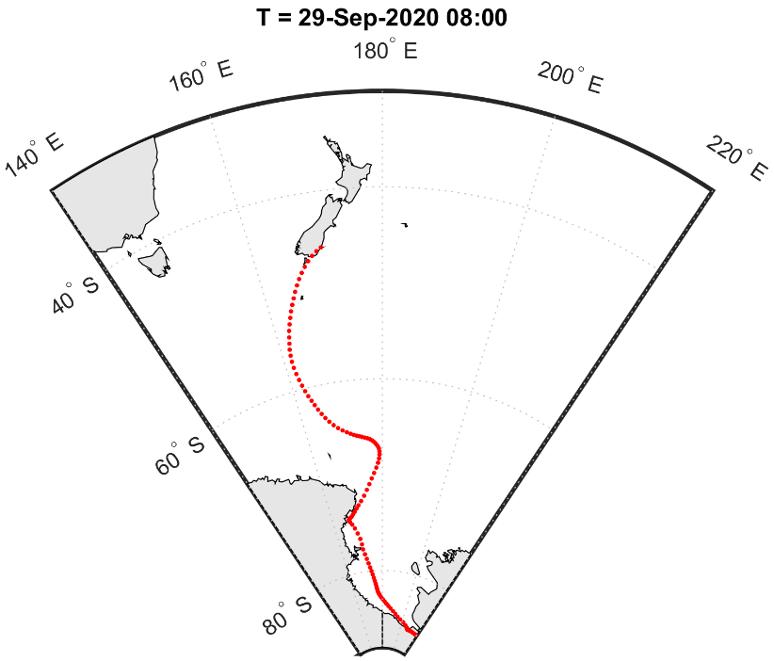
Figure 3. HYSPLIT trajectory output for 8 a.m. 29 September 2020 (NZDT) out to -120 hours. The red-dotted trace indicates the 5-day track of the airmass that started over Antarctica at 8 a.m. on 24 September 2020, and arrived over Dunedin at 8 a.m. on 29 September 2020. Data credit: NOAA Air Resources Laboratory. Image credit: Todd Redpath.
On a given day (24-hour period) at New Zealand locations, the daily minimum temperature observed typically occurs overnight under clear skies and light winds. Remarkably, this wasn’t the case for several low elevation locations where on 29 September, the lowest daily temperatures were observed near the middle of the day. Locations where this occurred included Dunedin (Musselburgh; -0.2°C between 10-11 a.m.), Balclutha (-0.7°C between 12-1 p.m.) and Tiwai Point (-1.5°C between 10-11 a.m.). Nugget Point recorded its lowest ever September temperature of -1.4°C between 11 a.m. and midday.
Table 7: Extremes of high daily maximum temperature in 2020 were recorded at:
Location | Extreme maximum (°C) | Date of extreme temperature | Year records began | Ranking
January
Paeroa | 32.2 | 26th | 1947 | Highest
Matamata | 32.8 | 26th | 1999 | Highest
Taupō | 33.2 | 26th | 1949 | Highest
Motu | 31.1 | 31st | 1990 | Highest
Hicks Bay | 30.6 | 31st | 1969 | Highest
Gisborne | 38.2 | 31st | 1905 | Highest
Mahia | 32.6 | 31st | 1990 | Highest
Takaka | 34.6 | 28th | 1978 | Highest
Puysegur Point | 24.9 | 24th | 1978 | Highest
February
Kaitaia | 30.7 | 2nd | 1948 | Highest
Kerikeri | 33.2 | 1st | 1945 | Highest
Whangārei | 34.1 | 4th | 1967 | Highest
Whitianga | 33.1 | 1st | 1962 | Highest
Tauranga | 33.6 | 1st | 1913 | Highest
Te Puke | 33.0 | 3rd | 1973 | Highest
Whakatāne | 36.4 | 3rd | 1975 | Highest
Motu | 32.5 | 3rd | 1990 | Highest
Takapau Plains | 33.8 | 4th | 1962 | Highest
Hicks Bay | 31.8 | 2nd | 1969 | Highest
Waipawa | 36.9 | 4th | 1945 | Highest
Whanganui | 31.6 | 4th | 1937 | Highest
Akaroa | 35.5 | 2nd | 1978 | Highest
Le Bons Bay | 32.2 | 2nd | 1984 | Highest
Wairoa | 37.3 | 2nd | 1964 | Equal highest
March
Whitianga | 30.3 | 4th | 1962 | Highest
Hanmer Forest | 32.6 | 2nd | 1906 | Highest
April
South West Cape | 21.3 | 5th | 1991 | Highest
May
Puysegur Point | 20.9 | 1st | 1978 | Highest
June
Whakatāne | 20.9 | 2nd | 1975 | Highest
Motu | 19.6 | 2nd | 1990 | Highest
Port Taharoa | 20.5 | 22nd | 1973 | Highest
Porirua | 19.4 | 27th | 1968 | Highest
Farewell Spit | 19.4 | 2nd | 1971 | Highest
Puysegur Point | 17.7 | 14th | 1978 | Highest
Akaroa | 23.0 | 16th | 1978 | Equal highest
July
Te Kuiti | 19.3 | 19th | 1959 | Highest
New Plymouth | 18.2 | 20th | 1944 | Highest
Porirua | 17.6 | 20th | 1968 | Highest
Stratford | 18.3 | 19th | 1960 | Highest
Arapito | 19.0 | 18th | 1978 | Equal highest
South West Cape | 16.0 | 29th | 1991 | Equal highest
August
Gisborne | 23.0 | 31st | 1905 | Highest
Hastings | 22.9 | 30th | 1965 | Highest
Takaka | 20.8 | 30th | 1978 | Highest
Farewell Spit | 19.4 | 29th | 1971 | Highest
Blenheim | 23.8 | 31st | 1932 | Highest
Lincoln | 22.3 | 30th | 1881 | Highest
Le Bons Bay | 20.4 | 30th | 1984 | Highest
Orari Estate | 23.8 | 30th | 1972 | Highest
Timaru | 25.1 | 30th | 1885 | Highest
Waimate | 23.4 | 30th | 1908 | Highest
Oamaru | 23.2 | 30th | 1967 | Highest
September
Tiri Tiri Lighthouse | 20.7 | 25th | 1982 | Highest
Cheviot | 25.2 | 23rd | 1982 | Highest
Le Bons Bay | 24.1 | 17th | 1984 | Highest
October
Cape Reinga | 22.3 | 27th | 1951 | Highest
Leigh | 24.8 | 24th | 1966 | Highest
Whitianga | 26.7 | 27th | 1962 | Highest
Rotorua | 24.2 | 5th | 1964 | Highest
Taupō | 27.6 | 5th | 1949 | Highest
Te Kuiti | 26.5 | 5th | 1959 | Highest
Tūrangi | 26.6 | 5th | 1968 | Highest
Waipawa | 27.8 | 5th | 1945 | Highest
Wairoa | 30.8 | 5th | 1964 | Highest
Hāwera | 22.9 | 25th | 1977 | Highest
Ohakune | 25.0 | 5th | 1962 | Highest
Balclutha | 27.5 | 4th | 1964 | Highest
Whangārei | 25.6 | 31st | 1967 | Equal highest
Whatawhata | 23.5 | 25th | 1952 | Equal highest
November
None observed
December
None observed

Table 8: Extremes of low daily maximum temperature in 2020 were recorded at:
Location | Extreme low maximum (°C) | Date of extreme temperature | Year records began | Ranking
January
Whitianga | 17.6 | 14th | 1971 | Lowest
February
None observed
March
Porirua | 13.6 | 28th | 1972 | Lowest
April
Secretary Island | 8.5 | 13th | 1989 | Lowest
May
None observed
June
None observed
July
Tiwai Point | 2.3 | 17th | 1972 | Lowest
August
None observed
September
Secretary Island | 6.0 | 28th | 1989 | Lowest
Puysegur Point | 6.2 | 28th | 1978 | Lowest
Dunedin (Airport) | 5.2 | 29th | 1972 | Lowest
Manapouri (West Arm Jetty) | 1.9 | 28th | 1972 | Lowest
Alexandra | 4.6 | 29th | 1930 | Lowest
Clyde | 5.7 | 29th | 1978 | Equal lowest
October
None observed
November
None observed
December
Secretary Island | 11.1 | 11th | 1989 | Lowest

Table 9: Extremes of low daily minimum temperature in 2020 were recorded at:
Location | Extreme minimum (°C) | Date of extreme temperature | Year records began | Ranking
January
None observed
February
None observed
March
Christchurch (Airport) | -1.3 | 18th | 1863 | Lowest
Le Bons Bay | 3.5 | 24th | 1984 | Lowest
Clyde | -1.6 | 29th | 1978 | Lowest
April
None observed
May
Tūrangi | -5.6 | 22nd | 1968 | Lowest
Ohakune | -6.7 | 22nd | 1962 | Lowest
June
Clyde | -9.9 | 14th | 1978 | Lowest
July
None observed
August
None observed
September
Le Bons Bay | -0.9 | 18th | 1984 | Lowest
Orari Estate | -4.0 | 4th | 1972 | Lowest
Nugget Point | -1.4 | 30th | 1970 | Lowest
Tautuku | -3.0 | 2nd | 1976 | Lowest
Puysegur Point | 1.1 | 29th | 1978 | Equal lowest
Christchurch | -4.8 | 30th | 1863 | Equal lowest
October
Timaru (Airport) | -4.5 | 16th | 1885 | Lowest
Balclutha | -4.5 | 10th | 1964 | Lowest
November
None observed
December
None observed

Table 10: Extremes of high daily minimum temperature in 2020 were recorded at:
Location | Extreme high minimum (°C) | Date of extreme temperature | Year records began | Ranking
January
Upper Hutt (Trentham) | 20.0 | 27th | 1972 | Highest
Arthur’s Pass | 16.3 | 27th | 1978 | HIghest
February
Masterton | 22.2 | 4th | 1943 | Highest
Upper Hutt (Trentham) | 21.4 | 4th | 1972 | Highest
Appleby | 20.5 | 2nd | 1941 | Highest
Blenheim | 22.0 | 4th | 1947 | Highest
Waiau | 24.4 | 3rd | 1974 | Highest
Cheviot | 24.5 | 3rd | 1982 | Highest
Rangiora | 22.1 | 3rd | 1972 | Highest
Akaroa | 23.8 | 3rd | 1978 | Highest
Le Bons Bay | 21.5 | 3rd | 1984 | Highest
Lake Tekapo | 21.5 | 3rd | 1928 | Highest
Milford Sound | 18.2 | 3rd | 1935 | Equal highest
Wānaka | 20.3 | 3rd | 1972 | Equal highest
March
Whangaparāoa | 20.1 | 4th | 1982 | Highest
April
Te Anau | 16.1 | 6th | 1973 | Highest
May
Puysegur Point | 16.7 | 2nd | 1978 | Highest
South West Cape | 14.7 | 2nd | 1991 | Highest
June
Puysegur Point | 13.3 | 16th | 1978 | Highest
South West Cape | 12.2 | 16th | 1991 | Highest
July
Roxburgh | 9.9 | 31st | 1950 | Equal highest
August
Milford Sound | 11.6 | 2nd | 1935 | Highest
Secretary Island | 13.6 | 1st | 1988 | Highest
Brothers Island | 12.8 | 30th | 1997 | Highest
Cheviot | 11.8 | 30th | 1982 | Highest
Mt Cook (Airport) | 10.0 | 31st | 1929 | Highest
Tara Hills | 9.7 | 30th | 1949 | Highest
Wānaka | 10.8 | 31st | 1972 | Highest
Te Anau | 10.7 | 31st | 1973 | Highest
Lumsden | 12.6 | 31st | 1982 | Highest
Porirua | 12.5 | 21st | 1972 | Equal highest
September
Hastings | 16.0 | 27th | 1972 | Highest
Waiouru | 10.7 | 24th | 1972 | Highest
Grassmere Salt Works | 15.9 | 24th | 1972 | Highest
Le Bons Bay | 15.4 | 23rd | 1984 | Highest
Cape Reinga | 14.8 | 27th | 1971 | Equal highest
October
Cape Reinga | 16.0 | 31st | 1971 | Highest
New Plymouth | 16.2 | 31st | 1944 | Highest
Martinborough | 17.0 | 25th | 1986 | Highest
Paraparaumu | 15.6 | 31st | 1972 | Highest
Porirua | 15.4 | 31st | 1972 | Highest
Wellington (Airport) | 16.5 | 31st | 1972 | Highest
Upper Hutt (Trentham) | 16.1 | 31st | 1972 | Highest
Arapito | 14.9 | 26th | 1978 | Highest
Reefton | 15.0 | 26th | 1972 | Highest
Greymouth | 14.4 | 31st | 1972 | Highest
Puysegur Point | 15.2 | 25th | 1978 | Highest
Motueka | 15.8 | 27th | 1972 | Highest
Blenheim | 17.3 | 26th | 1947 | Highest
Arthur’s Pass | 11.6 | 26th | 1973 | Highest
Manapouri (West Arm Jetty) | 12.2 | 31st | 1972 | Highest
Roxburgh | 17.8 | 4th | 1950 | Highest
Hāwera | 15.3 | 31st | 1977 | Equal highest
Franz Josef | 13.4 | 26th | 1953 | Equal highest
November
None observed
December
Takapau Plains | 18.7 | 8th | 1972 | Highest

Strong winds
On 15 April, a deep low centred east of the South Island generated strong southerly winds and large swells. Coastal parts of Wellington were inundated by large waves, measured to be at least 5.5 m high by a NIWA buoy near Baring Head. The large waves deposited debris over coastal roads and caused damage to private property, including garage doors and walls. The occupants of five properties were forced to evacuate. One person was swept out to sea, but was rescued shortly thereafter suffering moderate injuries.
During the night of 3-4 October, strong westerly winds fanned fires near Lake Ōhau Alpine Village in Canterbury. The 5360 hectare Lake Ōhau fire destroyed about 50 homes and at least 300 livestock were killed. Although the are no formal weather stations operating at Lake Ōhau Alpine Village, residents reported being kept awake by the roaring strength of the winds prior to the fire’s arrival.
On 21 November strong winds affected Otago and Southland and led to downed trees, roofs lifting and widespread power outages. A Fire and Emergency New Zealand spokesman said it was called to 33 wind-related callouts in Southland and Otago. The strong winds on Otago Peninsula contributed to a fire in Portobello. Twenty-eight residents from 14 houses were evacuated to Portobello’s Coronation Hall.
Table 11. Maximum wind gust extremes in 2020 were recorded at:
Location | Maximum wind gust (km/h) | Date of maximum wind gust | Year records began | Ranking
January
Secretary Island | 161 | 11th | 1994 | Highest
Oamaru | 106 | 30th | 1984 | Highest
Gore | 130 | 30th | 1987 | Highest
February
Secretary Island | 165 | 16th | 1994 | Highest
March
Oamaru | 100 | 23rd | 1984 | Highest
April
Clyde | 95 | 12th | 1983 | Equal highest
May
Hāwera | 111 | 3rd | 1986 | Highest
June
Secretary Island | 133 | 15th | 1994 | Highest
July
None observed
August
Gore | 107 | 31st | 1987 | Equal highest
South West Cape | 169 | 31st | 1991 | Equal highest
September
Upper Hutt (Trentham) | 98 | 28th | 1999 | Highest
Hāwera | 104 | 29th | 1986 | Highest
Westport | 120 | 15th | 1973 | Highest
Secretary Island | 156 | 26th | 1994 | Highest
Palmerston North | 96 | 15th | 1991 | Equal highest
October
None observed
November
None observed
December
Hāwera | 96 | 1st | 1986 | Highest
Secretary Island | 143 | 2nd | 1994 | Equal highest

Snow and ice
August 2020 was notable for a relative lack of snow in many of New Zealand’s mountain areas. Towards the end of August, snow depths were approximately half of usual for the time of year at several NIWA Snow and Ice Monitoring sites, including Mt Philistine (Arthur’s Pass National Park), Mueller Hut (Aoraki/ Mount Cook National Park) and Castle Mount (Fiordland National Park). Several ski areas were impacted by the lack of snow, including Temple Basin (Arthur’s Pass) which announced it wouldn’t open at all for the season.
From 28-29 September, snow settled to sea level in Otago, Southland and Stewart Island. It was the most widespread low-elevation snowfall of the year, with polar air drawn from Antarctica by a deep low pressure system in the Southern Ocean. There were widespread road closures in Southland and Otago, and snow also caused the closure of SH6 between Fox Glacier/Te Moeka o Tuawe and Franz Josef Glacier/Kā Roimata o Hine Hukatere. Approximately 50 cars and trucks were stranded on SH1 north of Balclutha due to blizzard conditions, with police and council contractors called in to move the vehicles safely. Flights at Invercargill, Dunedin and Queenstown Airports were disrupted by snow on their runways and poor visibility. The Remarkables ski area reported up to 60 cm of fresh snow. Snow also fell to low elevations in Nelson and Tasman, with several road closures including SH63 from Kawatiri to St Arnaud and Canaan Road (Takaka Hill).

Tornadoes and waterspouts
On 26 June, three separate small tornadoes were reported in Northland. In Whangārei, six boats were blown off their cradles in the Norsand Boatyard. In Mata (south of Whangārei), trees were toppled and iron from a farm shed strewn among a nearby stand of trees. Farther north in Ōakura, trees were also toppled by a tornado. A tornado also struck Dairy Flat (north of Auckland), with one house suffering considerable damage including having the roof torn off. Nearby areas saw mature trees torn down with reports of miscellaneous property damage.
On 27 June, tornadoes were reported in Auckland and Papamoa. Multiple buildings and roofs were damaged in East Tamaki (south Auckland) and trees were brought down. In Papamoa a local reported seeing roof tiles, gutters and television dishes ripped off houses.
On 20 August, a tornado was reported in Pukenui (Northland). A launch was blown off its blocks, and one house lost half of its roof. Additional damage was reported to include trees, a large shed and a trampoline was sent tumbling along the road.

Cloud and fog
Significant smoke and haze from Australian bushfires affected New Zealand for several days starting 1 January. This peaked in the North Island on 5 January before a southerly change pushed the particulates northward on 6 January. The smoke and dust associated with this event deposited a layer of particulate over parts of the Southern Alps, causing a discolouration of the snow.
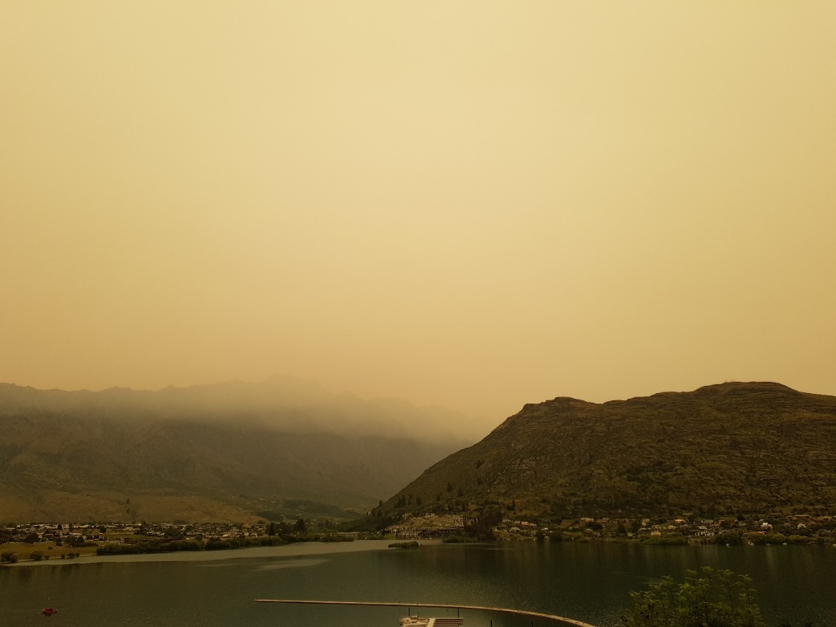
Australian bushfire smoke as viewed looking beyond Lake Wakatipu to the Remarkables mountain range in Queenstown on 1 January 2020. Picture taken around 9 a.m. Picture credit – Gregor Macara
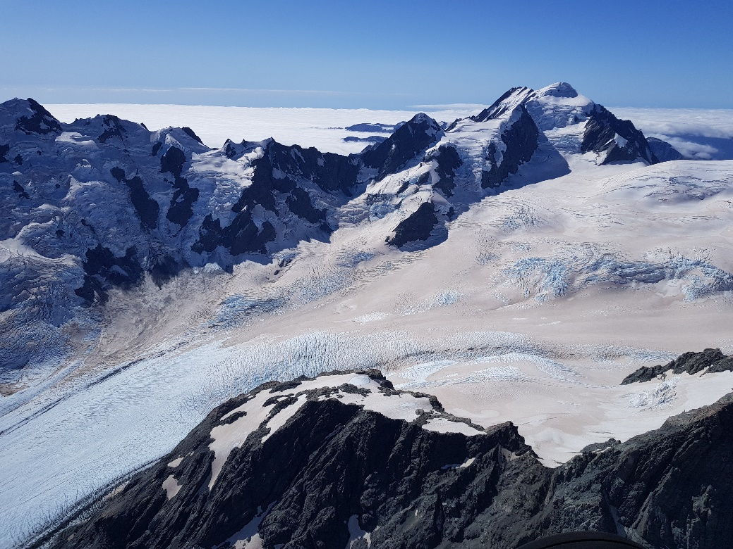
Upper reaches of the Tasman Glacier on 5 March 2020, with particulates deposited from the Australian Bushfires causing discolouration of the snow. Picture credit – Gregor Macara

Lightning and hail
On 6 September, a late-afternoon southerly change generated several thunderstorms over parts of Canterbury, especially towards the eastern foothills. Heavy hail was reported in the town of Oxford, which blanketed the ground white. Fire and Emergency responded to several calls in Oxford where household roofs were leaking. At least 900 lightning strikes were recorded over the area between Methven and Amberley.
On 26 December, thunderstorms and hail brought widespread damage to the Tasman region. The hail caused power outages, shredded vineyards, smashed greenhouses, dented and bruised apples, kiwifruit and hops and severely damaged buildings in Motueka. The cost of the damage was thought to be in the tens of millions of dollars.

For climate data or media comment, please contact:
Mr Gregor Macara
Climate Scientist, NIWA National Climate Centre
Tel. 04 386 0509

Note for editors:
Climate measurements have been made in New Zealand for about 150 years, with reasonable coverage of reliable data from at least the early 1900s. NIWA makes its raw climate data publicly available for free online. Journalists are advised, however, to take extreme care when interpreting trends from raw data to ensure they have not been compromised by changes in site location, urbanisation, exposure, or instrumentation over time. If in any doubt, please call us.

© Copyright NIWA 2021. All rights reserved

Acknowledgement of NIWA as the source of this information and all forms of media associated with it is required.

A dry spell is defined as a period of 15 days or more with less than 1mm of rain on any one day.
A climate phenomenon where sea surface temperatures are above average in the western Indian Ocean and correspondingly below average in the east near Sumatra (hence the term “dipole”).
Averaged over the area inclusive of 34-48˚S, 165-179˚E as calculated using the NCEP/NCAR Reanalysis.
The rankings (1st, 2nd, 3rd….etc) in Tables 1 to 11 are relative to climate data from a group of nearby stations, some of which may no longer be operating. The current climate value is compared against all values from any member of the group, without any regard for homogeneity between one station’s record and another. This approach is used because of the practical limitations of performing homogeneity checks in real-time.
Missing 2 days of data
Missing 1 day of data
Missing 5 days of data

