New Zealand Climate Summary: April 2020 Issued: 5 May 2020

Very dry for many parts of New Zealand
Rainfall | Rainfall was well below normal (<50% of normal) or below normal (50-79% of normal) for most of the North Island, Nelson, Tasman, Marlborough, Canterbury and eastern parts of Central Otago. Several locations in Wairarapa, coastal Marlborough and coastal North Canterbury received less than 5 mm of rain for the entire month. Rainfall was above normal (120-149% of normal) for some western parts of the South Island and Oamaru.
Soil Moisture | At the end of the month, soil moisture levels were considerably lower than normal for most of the North Island, as well as northern parts of the South Island. Soils were also drier than normal for many eastern parts of the South Island. Near normal soil moisture levels were typical in western and southern parts of the South Island.
Temperature | Temperatures were above average (0.51-1.20°C above average) for parts of Waikato, Bay of Plenty, Gisborne, Hawke’s Bay, Wairarapa, Manawatu, Canterbury, eastern Central Otago and Southland. Temperatures were typically near average (±0.50°C of average) for the remainder of the country.

Click on the link to jump to the information you require:
Overview
Rainfall
Temperature
April 2020 climate in the six main centres
Highlights and extreme events

Overview
April 2020 mean sea level air pressure was below normal to the southwest of the South Island. This was associated with more westerly air flows than usual over New Zealand. It was a very dry month for much of New Zealand, especially in eastern parts which were sheltered from the prevailing westerly airflow. Parts of Hawke’s Bay, Wairarapa and Canterbury received less than 20% of normal rainfall, while rainfall amounts for many locations in the North Island and upper South Island were close to record lows. Kaikoura received a mere 1.4 mm of rainfall during the month, with a 34-day dry spell observed there from 31 March – 4 May 2020. The ongoing lack of rain resulted in soils remaining considerably drier than normal in many parts of the North Island, especially about Hawke’s Bay, Coromandel, Auckland and Northland. Soils were also drier than normal for northern and eastern parts of the South Island.
Temperatures were generally mild throughout April, although a cold front delivered snow to low elevations of Southland and Otago around mid-month (see Highlights and extreme events for further details). Overall, the nationwide average temperature in April 2020 was 13.5°C. This was 0.2°C above the 1981-2010 April average from NIWA’s seven station temperature series which begins in 1909.
Further Highlights:
- The highest temperature was 27.9°C, observed at Waiau on 11 April.
- The lowest temperature was -3.9°C, observed at Middlemarch on 29 April.
- The highest 1-day rainfall was 119 mm, recorded at Arthur’s Pass Village on 12 April.
- The highest wind gust was 161 km/h, observed at South West Cape on 30 April.
- Of the six main centres in April 2020, Auckland was the warmest, Tauranga was the sunniest, Christchurch was the driest, Hamilton was the wettest, and Dunedin was the coldest and least sunny.
- Of the available, regularly reporting sunshine observation sites, the sunniest four locations in 2020 so far are Bay of Plenty (1096 hours), Taranaki (1080 hours), Greater Nelson (1029 hours) and Auckland (991 hours).
For further information, please contact:
Gregor Macara
Climate Scientist
Tel. 04 386 0509

Rainfall: Ongoing lack of rainfall for much of the North Island
April was yet another dry month for many parts of the North Island. Rainfall was well below normal (<50% of normal) for many northern, eastern and southern parts of the North Island. Total rainfall from January to April was less than 40% of usual for parts of Northland, Auckland, Waikato, Bay of Plenty and Hawke’s Bay. April was also a dry month in Nelson, Tasman, Marlborough, Canterbury and eastern parts of Central Otago, with well below normal or below normal (50-79% of normal) rainfall in these parts. Taupo, Masterton and Wairoa each observed their driest April on record, while Kaikoura recorded a mere 1 mm of rainfall during the month. In contrast, rainfall was above normal (120-149% of normal) for some western parts of the South Island and Oamaru.
Record or near-record April rainfall totals were recorded at:
Location | Rainfall total (mm) | Percentage of normal | Year records began | Comments
High records or near-records
None recorded
Low records or near-records
Taupo | 13 | 19 | 1949 | Lowest
Masterton | 4 | 7 | 1926 | Lowest
Wairoa | 20 | 15 | 1964 | Lowest
Whitianga | 37 | 25 | 1961 | 2nd-lowest
Martinborough | 3 | 7 | 1924 | 2nd-lowest
Mahia | 25 | 20 | 1990 | 2nd-lowest
Cape Campbell | 2 | 5 | 1873 | 2nd-lowest
Kaikoura | 1 | 3 | 1898 | 2nd-lowest
Waipara West | 9 | 16 | 1973 | 2nd-lowest
Auckland (Whenuapai) | 38 | 40 | 1943 | 3rd-lowest
Auckland (Western Springs) | 25 | 27 | 1948 | 3rd-lowest
Wellington (Kelburn) | 22 | 25 | 1928 | 3rd-lowest
Wellington (Airport) | 15 | 21 | 1958 | 3rd-lowest
Lincoln | 8 | 18 | 1881 | 3rd-lowest
Whitianga | 42 | 28 | 1961 | 4th-lowest
Tauranga | 16 | 14 | 1898 | 4th-lowest
Dunedin (Airport) | 18 | 38 | 1962 | 4th-lowest

Temperature: A relatively mild month for most
The nationwide average temperature in April 2020 was 13.5°C. This was 0.2°C above the 1981-2010 April average from NIWA’s seven station temperature series which begins in 1909. It has now been 39 consecutive months since New Zealand experienced a nationwide temperature that was below average. Fourteen locations observed record or near-record high mean maximum temperatures, while two locations observed near-record low mean minimum temperatures.
Record or near-record mean air temperatures for April were recorded at:
Location | Mean  air temp. (ºC) | Departure from normal (ºC) | Year records began | Comments
High records or near-records
Farewell Spit | 16.4 | 1.8 | 1971 | Highest
Low records or near-records
None observed

Record or near-record mean maximum air temperatures for April were recorded at:
Location | Mean maximum  air temp. (ºC) | Departure from normal (ºC) | Year records began | Comments
High records or near-records
Farewell Spit | 21.2 | 2.7 | 1971 | Highest
Medbury | 20.2 | 1.9 | 1927 | Highest
Taupo | 19.5 | 2.3 | 1949 | 2nd-highest
Te Kuiti | 21.4 | 1.7 | 1959 | 2nd-highest
Takaka | 20.3 | 1.6 | 1978 | 2nd-highest
Blenheim | 20.8 | 1.9 | 1932 | 3rd-highest
Hanmer Forest | 20.6 | 2.9 | 1906 | 3rd-highest
Waiau | 20.8 | 2.5 | 1974 | 3rd-highest
Whangarei | 22.3 | 1.7 | 1967 | 4th-highest
Leigh | 22.3 | 2.2 | 1966 | 4th-highest
Whitianga | 21.7 | 1.5 | 1962 | 4th-highest
Waipawa | 20.5 | 1.9 | 1945 | 4th-highest
Cheviot | 19.9 | 1.7 | 1982 | 4th-highest
Ranfurly | 17.5 | 1.7 | 1897 | 4th-highest
Low records or near-records
None observed
Record or near-record mean minimum air temperatures for April were recorded at:
Location | Mean minimum  air temp. (ºC) | Departure from normal (ºC) | Year records began | Comments
High records or near-records
None observed
Low records or near-records
Te Kuiti | 6.6 | -1.9 | 1959 | 4th-lowest
Taumarunui | 5.2 | -2.0 | 1947 | 4th-lowest

April climate in the six main centres
April was a very dry month in Auckland, Tauranga, Wellington and Christchurch, where rainfall was well below normal. Temperatures were above average in Tauranga and Christchurch, and near normal for remaining main centres. Of the six main centres in April 2020, Auckland was the warmest, Tauranga was the sunniest, Christchurch was the driest, Hamilton was the wettest, and Dunedin was the coldest and least sunny.
April 2020 main centre climate statistics:
Temperature
Location | Mean temp. (ºC) | Departure from normal (ºC) | Comments
Aucklandª | 16.3 | +0.1 | Near average
Tauranga^{b} | 16.2 | +0.6 | Above average
Hamilton^{c} | 14.4 | +0.2 | Near average
Wellington^{d} | 13.9 | +0.2 | Near average
Christchurch^{e} | 12.7 | +0.8 | Above average
Dunedin^{f} | 11.6 | -0.1 | Near average
Rainfall
Location | Rainfall (mm) | % of normal | Comments
Aucklandª | 25 | 29 | Well below normal
Tauranga^{b} | 16 | 14 | Well below normal
Hamilton^{c} | 76 | 87 | Near normal
Wellington^{d} | 22 | 26 | Well below normal
Christchurch^{e} | 13 | 30 | Well below normal
Dunedin^{f} | 46 | 90 | Near normal
Sunshine
Location | Sunshine (hours)
Aucklandª | 202
Tauranga^{b} | 203
Hamilton^{g} | 195
Wellington^{d} | 196
Christchurch^{e} | 199
Dunedin^{f} | 159
ª Mangere ^{b} Tauranga Airport ^{c} Hamilton Airport ^{d} Kelburn ^{e} Christchurch Airport ^{f} Musselburgh ^{g} Ruakura

Highlights and extreme events

Temperatures
On 6 April, warm northerly winds and cloud cover resulted in high overnight and early-morning temperatures in many parts of the lower South Island. Several locations observed record or near-record high daily minimum temperatures for April. The daily minimum temperature in Te Anau was 16.1°C, its highest daily minimum temperature in April on record.
The highest temperature was 27.9°C, observed at Waiau on 11 April.
The lowest temperature was -3.9°C, observed at Middlemarch on 29 April.
Record or near-record daily maximum air temperatures for April were recorded at:
Location | Extreme maximum (°C) | Date of extreme temperature |  | Year records began | Comments
High records or near-records
South West Cape | 21.3 | 5th | 1991 |  | Highest
Puysegur Point | 21.3 | 5th | 1978 |  | 3rd-highest
Farewell Spit | 23.2 | 1st | 1971 |  | 4th-highest
Le Bons Bay | 24.4 | 30th | 1984 |  | Equal 4th-highest
Low records or near-records
Secretary Island | 8.5 | 13th | 1989 |  | Lowest

Record or near-record daily minimum air temperatures for April were recorded at:
Location | Extreme minimum (°C) | Date of extreme temperature | Year records began | Comments
High records or near-records
Te Anau | 16.1 | 6th | 1973 | Highest
Campbell Island | 10.9 | 6th | 1991 | Highest
Wanaka | 15.6 | 6th | 1972 | Equal highest
Secretary Island | 15.8 | 5th | 1988 | 2nd-highest
Queenstown | 16.0 | 6th | 1871 | 2nd-highest
South West Cape | 14.3 | 6th | 1991 | 3rd-highest
Wairoa | 18.2 | 18th | 1972 | 4th-highest
Haast | 15.3 | 6th | 1949 | 4th-highest
Tiwai Point | 13.6 | 6th | 1972 | 4th-highest
Low records or near-records
None observed

Rain and slips
Heavy rain events were few and far between in April. More notable was the ongoing lack of significant rain and resulting dry conditions for many parts of the country. On 15 April, Watercare reported that Auckland’s nine water storage dams were only 50% full, saying such low levels in April had not been seen since 1994. On 17 April, drought conditions in Northland were reported as the worst experienced there in at least 20 years.
The highest 1-day rainfall was 119 mm, recorded at Arthur’s Pass Village on 12 April.
Record or near-record April extreme 1-day rainfall totals were recorded at:
Location | Extreme 1-day rainfall (mm) | Date of extreme rainfall | Year records began | Comments
None observed

Wind
On 15 April, a deep low centred east of the South Island generated strong southerly winds and large swells. Coastal parts of Wellington were inundated by large waves, measured to be at least 5.5 m high by a NIWA buoy near Baring Head. The large waves deposited debris over coastal roads and caused damage to private property, including garage doors and walls. The occupants of five properties were forced to evacuate. One person was swept out to sea, but was retrieved shortly thereafter suffering moderate injuries.
The highest wind gust was 161 km/h, observed at South West Cape on 30 April.
Record or near-record April extreme wind gusts were recorded at:
Location | Extreme wind gust (km/h) | Date of extreme gust | Year records began | Comments
Clyde | 95 | 12th | 1983 | Equal highest
Motu | 106 | 13th | 1991 | 2nd-highest
Secretary Island | 146 | 27th | 1994 | 2nd-highest
Palmerston North | 83 | 13th | 1991 | 3rd-highest
South West Cape | 161 | 30th | 1991 | Equal 3rd-highest
Te Puke | 50 | 13th | 1987 | Equal 4th-highest
Turangi | 93 | 13th | 1973 | Equal 4th-highest
Hawera | 85 | 14th | 1986 | Equal 4th-highest
Waiouru | 93 | 12th | 1970 | Equal 4th-highest
Cape Campbell | 102 | 13th | 1963 | Equal 4th-highest

Snow and ice
On 14 April, snow fell to low elevations in parts of Otago and Southland. Approximately 5cm of snow was reported in Kingston, with a dusting on the hilltops near Dunedin. The Milford Road (SH94) and Crown Range Road were temporarily closed due to snow, with a warning in place on SH6 between Athol and Garston due to snow.

Lightning and hail
On 13 April, a thunderstorm developed over South Canterbury, with lightning causing a mobile outage in the Glenavy and Morven areas.

For further information, please contact:
Gregor Macara
Climate Scientist, NIWA Wellington
Tel. 04 386 0509

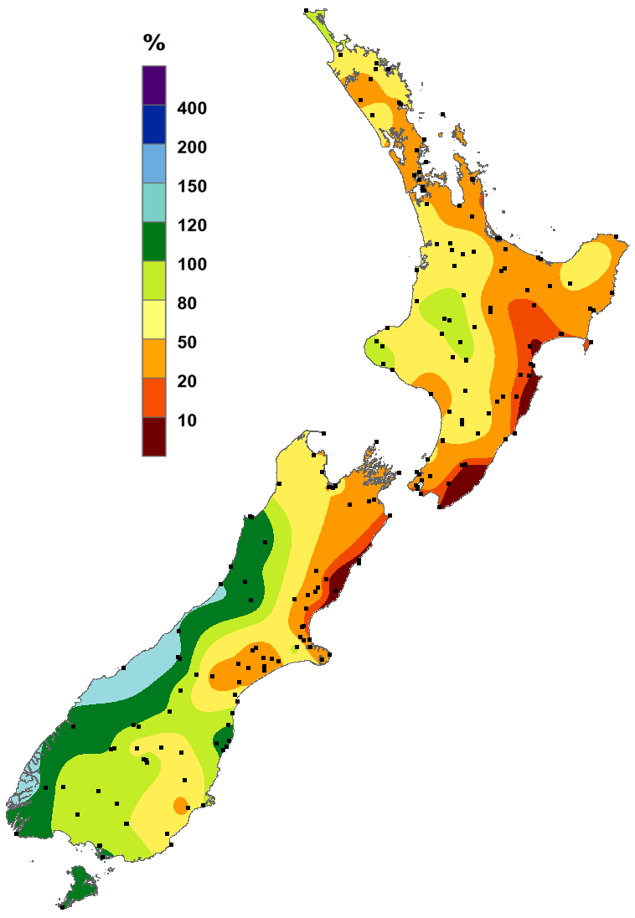
April 2020 rainfall expressed as a percentage of normal (1981-2010 normal).
It was a very dry month for many parts of the North Island, as well as northern and eastern parts of the South Island.
Parts of Hawke’s Bay, Wairarapa and Canterbury received less than 20% of normal rainfall, as indicated by the dark orange and red colours on the map.

https://www.niwa.co.nz/our-science/climate
© Copyright NIWA 2020.
All rights reserved. Information presented in this summary is based on data available at the time of publication, which is subject to ongoing quality assurance procedures.

Consecutive days with less than 1 mm on each day.
The rankings (1st, 2nd, 3rd.etc) in all Tables in this summary are relative to climate data from a group of nearby stations, some of which may no longer be operating. The current climate value is compared against all values from any member of the group, without any regard for homogeneity between one station’s record, and another. This approach is used due to the practical limitations of performing homogeneity checks in real-time.

