Wednesday, 8 April 2020
NIWA's Hotspot Watch
A weekly update describing soil moisture patterns across the country to show where dry to extremely dry conditions are occurring or imminent. Regions experiencing significant soil moisture deficits are deemed “hotspots”. Persistent hotspot regions have the potential to develop into drought.
Facts: Soil Moisture
In the North Island, minimal rainfall (<5 mm) was observed nearly everywhere during the past week. Only isolated parts of Gisborne, Hawke’s Bay, and Taranaki received slightly higher amounts. This meagre rainfall resulted in generally moderate soil moisture decreases across the entire North Island. The driest soils across the North Island, when compared to normal for this time of the year, are located across much of the upper North Island, East Cape, Ruapehu District, and a small portion of Central Hawke’s Bay. Meanwhile, the wettest soils for this time of the year are located in Wairarapa. The New Zealand Drought Index (NZDI) shows that severe meteorological drought remains across the Coromandel Peninsula and near Cape Reinga. Meteorological drought is found across parts of the Far North, Auckland, and far northern Waikato (see NZDI map at bottom).
Hotspot coverage increased slightly in the past week, with hotspots now found across parts of Northland, much of Auckland, far northern Waikato, the Coromandel Peninsula, southern Hastings, Central Hawke’s Bay, and much of Manawatu-Whanganui.
In the South Island, moderate to heavy rainfall occurred across Fiordland and much of Westland during the past week, but most other locations across the South Island received only light rain (generally less than 10 mm). This resulted in light to moderate soil moisture decreases everywhere in the South Island, with the exception of Fiordland where slight increases occurred. The driest soils in the South Island compared to normal for this time of the year are located in Nelson and nearby parts of Tasman, while the wettest soils for this time of the year are found in Kaikoura. The NZDI shows that meteorological drought is no longer found in the South Island, although widespread dry soils are still present in the top of the South Island and parts of Canterbury (see NZDI map at bottom).
Hotspot coverage generally expanded across the South Island in the past week, with hotspots now found in Nelson and nearby parts of Tasman, and in broken pockets from Selwyn District south to Waimate.
Outlook and Soil Moisture
In the North Island, scattered rainfall is occurring in many locations today (8 April), with some places likely to receive up to 10 mm. A few more isolated showers will be possible on Thursday before high pressure brings dry weather from Friday through to Sunday (10-12 April). However, moderate to even heavy rain will be possible on Monday as a strong front moves across the North Island. Widespread amounts of 20-35 mm will be possible, although totals may be a bit lower along the east coast and in the far north. Thereafter, only isolated showers are possible during the middle of next week.

With many locations across the North Island expected to see weekly rainfall totals of 25-40 mm (with isolated higher amounts), minor to moderate soil moisture increases will be likely in most areas. Current hotspots will likely not be eliminated, but most are expected to decrease in size and strength.

In the South Island, isolated showers will be possible through Thursday (9 April), with high pressure bringing dry weather on Friday and Saturday. By late Sunday and Monday (12-13 April), heavy rain will impact the West Coast while moderate rain will affect most locations east of the Alps. Total rainfall is likely to exceed 100-150 mm in the West Coast, with amounts perhaps reaching 40-60 mm in the lower South Island. From Canterbury to Marlborough, amounts of 20-40 mm will be possible.

The possibility for at least moderate rainfall across northern and eastern parts of the South Island during the next week should allow for at least minor to moderate soil moisture increases. Therefore, all existing South Island hotspots are likely to decrease in size and strength at least slightly.

Background:
Hotspot Watch: a weekly advisory service for New Zealand media. It provides soil moisture and precipitation measurements around the country to help assess whether extremely dry conditions are imminent.
Soil moisture deficit: the amount of water needed to bring the soil moisture content back to field capacity, which is the maximum amount of water the soil can hold.
Soil moisture anomaly: the difference between the historical normal soil moisture deficit (or surplus) for a given time of year and actual soil moisture deficits.
Definitions: “Extremely” and “severely” dry soils are based on a combination of the current soil moisture status and the difference from normal soil moisture (see soil moisture maps at https://www.niwa.co.nz/climate/nz-drought-monitor/droughtindicatormaps)
Hotspot: A hotspot is declared if soils are "severely drier than normal" which occurs when Soil Moisture Deficit (SMD) is less than -110 mm AND the Soil Moisture Anomaly is less than -20 mm.

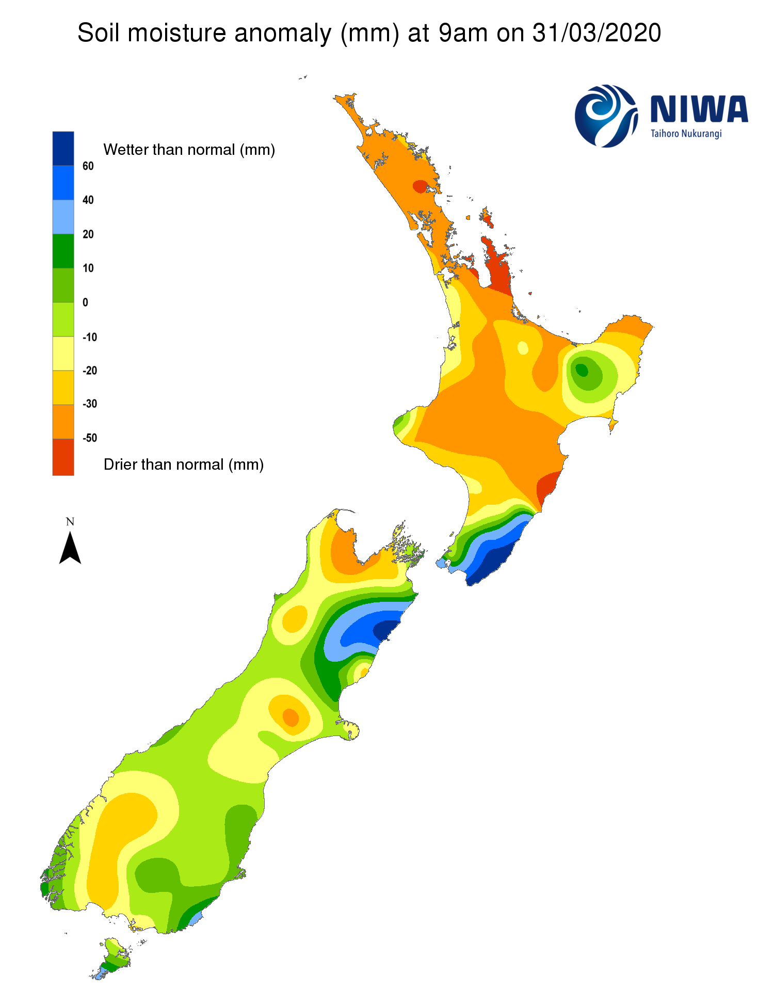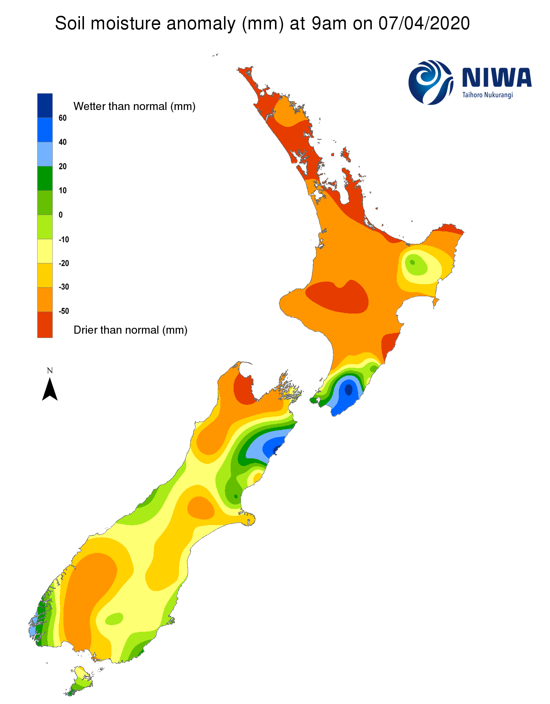
Pictured above: Soil Moisture Anomaly Maps, relative to this time of year. The maps show soil moisture anomaly for the past two weeks.

As of 6 April, the New Zealand Drought Index (NZDI) map below shows that severe meteorological drought and meteorological drought remain in place across parts of the upper North Island, particularly the Coromandel Peninsula. Meteorological drought and severe meteorological drought are no longer found in the South Island. Please note: some hotspots in the text above may not correspond with the NZDI map. This difference exists because the NZDI uses additional dryness indices, including one which integrates the rainfall deficit over the past 60 days. Changes are therefore slower to appear in the NZDI compared to soil moisture anomaly maps that are instantaneously updated.
