Media Release
Virus spreads to spending patterns
Tuesday 3 March 2020

Spending through the Paymark network reveals mixed spending patterns resulting from the coronavirus during January and February.

Spending with China-issued credit cards was down 39.3% in February from a year earlier but had been up 19.8% in January. Total foreign-issued credit card spending was up 4.1% in January and 12.7% in February, with the high February figure in part due to the leap year effect.

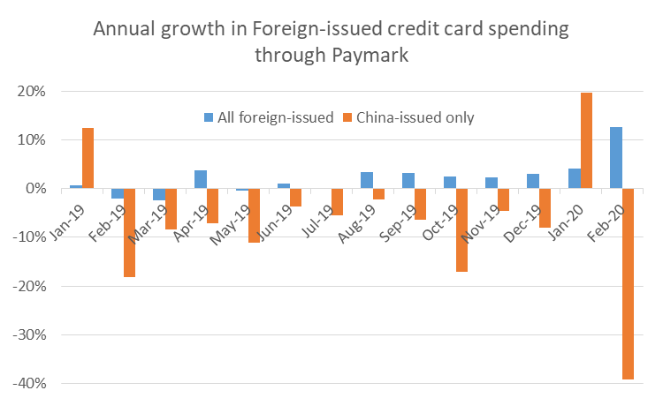

Figure 1: Annual growth in Paymark foreign-issued credit cards spending in recent months

Spending with China-issued cards had been generally down over 2019 but there was a sharp increase in January and an even sharper fall in February, both changes occurring across a wide range of merchant sectors. Spending at Chemists with China-issued cards jumped 94.1%in January from a year earlier and was still up 4.4% in February.

Spending with other foreign-issued credit cards had been generally rising through 2019 and accelerated in January and February. This pattern was particularly noticeable amongst cards issued in the US.

 | Monthly spending ($m) |  | Annual change monthly spending ($m) |  | Annual change monthly spending (%pa) |  | Previous 3 months (%pa)
Country of card origin | Jan-20 | Feb-20 | Jan-20 | Feb-20 | Jan-20 | Feb-20 | Oct-Dec
AUSTRALIA | 98 | 77 | -2 | 2 | -2.3% | 3.0% | -0.5%
UNITED STATES OF AMERICA | 64 | 97 | 12 | 44 | 23.9% | 83.3% | 16.2%
UNITED KINGDOM | 31 | 35 | -3 | -1 | -7.9% | -1.9% | -10.4%
CHINA | 20 | 17 | 3 | -11 | 19.8% | -39.3% | -11.3%
GERMANY | 19 | 20 | -2 | -1 | -9.3% | -4.3% | -10.7%
Other foreign-issued cards | 108 | 103 | 5 | 6 | 4.7% | 6.0% | 5.2%
All foreign cards | 340 | 348 | 13 | 39 | 4.1% | 12.7% | 2.6%

Figure 2: Foreign-issued credit cards spending through Paymark in recent months

In total $348 million was spent in February through Paymark with credit cards that could be identified as foreign-issued, up 12.7% on a year earlier.

Across all foreign-issued cards, spending was down in February within Otago (-2.6%), Southland (-2.8%) and West Coast (-10.2%). Foreign-issued card spending was down in these regions amongst Accommodation merchants, as was the case also in Canterbury and South Canterbury. Foreign-card spending had already been down declining in West Coast during recent months.

PAYMARK Foreign-issued Cards Data
(Feb 2020 versus same month 2019)
Paymark region | Spending ($) | Annual Change ($) | Annual Change (%)
Auckland/Northland | 124,546,886 | 21,380,630 | 20.7%
Waikato | 14,965,187 | 1,431,831 | 10.6%
BOP | 25,469,825 | 1,914,450 | 8.1%
Gisborne | 1,237,284 | 206,827 | 20.1%
Taranaki | 3,067,620 | 662,713 | 27.6%
Hawke’s Bay | 6,537,400 | 1,300,260 | 24.8%
Wanganui | 1,915,550 | 301,268 | 18.7%
Palmerston North | 3,695,966 | 1,753,753 | 90.3%
Wairarapa | 1,437,349 | 268,702 | 23.0%
Wellington | 26,384,265 | 6,760,680 | 34.5%
Nelson | 9,101,116 | 1,074,974 | 13.4%
Marlborough | 9,549,281 | 892,491 | 10.3%
West Coast | 7,658,351 | -869,261 | -10.2%
Canterbury | 36,642,490 | 3,908,836 | 11.9%
South Canterbury | 4,813,986 | 78,331 | 1.7%
Otago | 55,081,624 | -1,492,704 | -2.6%
Southland | 15,622,748 | -455,202 | -2.8%
New Zealand | 347,976,058 | 39,145,913 | 12.7%

Figure 3: Foreign-issued credit cards spending by region through Paymark (February 2020 versus February 2019)

Otherwise spending with all cards – credit and debit, local and foreign – through Paymark was $5,194 million in February, up 6.7% in underlying terms on February 2019, again a higher rate than of late due to the leap year effect, giving us an extra day of spending. The annual underlying growth rate of the previous three months had averaged 4.0%. Growth was slowest in Auckland/Northland (+4.1%).

PAYMARK All Cards Data (Feb 2020 versus same month 2019)
 | Volume | Underlying* | Value | Underlying*
Paymark Region | transactions millions | Annual % change | transactions $millions | Annual % change
Auckland/Northland | 42.17 | 4.0% | $2,037.8 | 4.1%
Waikato | 8.40 | 7.7% | $372.7 | 7.5%
BOP | 7.67 | 9.2% | $355.6 | 9.0%
Gisborne | 1.09 | 13.0% | $45.0 | 11.0%
Taranaki | 2.36 | 8.6% | $101.5 | 9.7%
Hawke's Bay | 3.51 | 12.1% | $155.1 | 11.9%
Wanganui | 1.30 | 7.8% | $52.1 | 9.7%
Palmerston North | 3.60 | 8.1% | $185.6 | 14.4%
Wairarapa | 1.16 | 10.6% | $49.8 | 11.6%
Wellington | 11.67 | 6.7% | $495.7 | 10.3%
Nelson | 2.09 | 5.3% | $100.8 | 5.0%
Marlborough | 1.44 | 10.8% | $70.9 | 10.4%
West Coast | 0.80 | 9.1% | $39.6 | 5.3%
Canterbury | 12.01 | 5.6% | $558.0 | 5.9%
South Canterbury | 1.58 | 6.8% | $77.0 | 7.7%
Otago | 6.77 | 10.5% | $320.7 | 6.9%
Southland | 2.54 | 5.7% | $125.8 | 4.9%
New Zealand | 110.94 | 6.3% | $5,194.3 | 6.7%
* Underlying spending excludes large clients moving to or from Paymark

Figure 4: Paymark All Cards transaction data by region (February 2020 versus February 2019)

There were some noticeable spikes in annual growth rates during some days in February. There was the usual holiday effects around Waitangi Day and the usual romance effects around Valentine’s Day.

However there was also a spike in total card spending at Supermarkets and Chemists on Saturday 29 February, relative to Saturday 2 March 2019. This spending spike was strongest in Auckland/Northland, with Supermarkets up +40.2% and Chemists sharply up by +75.5%.

ENDS
For more information please contact: Paul Brislen 021 988 896, paul.brislen@paymark.co.nz
We are New Zealand’s leading electronic payments company

Paymark completed its 20 billionth transaction in May 2019. We process around 60 transactions every second of the day.
For more than 30 years we have served hundreds of thousands of New Zealand merchants through our secure and reliable infrastructure.
Paymark connects to over 100,000 EFTPOS machines, accounting for in excess of 70% of the New Zealand payments landscape.

