CHAIR OF THE DIGITAL COUNCIL
MITCHELL PHAM
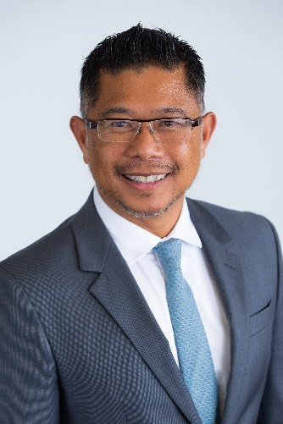
Mitchell is a Vietnamese-Kiwi business & social entrepreneur. He is the co-founder, Director and head of Sales & Marketing of the Augen Software Group in New Zealand, as well as Chairman & Director of their operation in Vietnam. Among other roles, Mitchell also serves as chair of the NZ Technology Industry Association (NZTech), the NZ Financial Innovation & Technology Association (FinTechNZ) and is Trustee of the Auckland Refugee Family Trust (ARFT).
MEMBERS OF THE DIGITAL COUNCIL
ROGER DENNIS
Roger is a consultant specialising in foresight, innovation and large-scale change. Roger provides advice to governments and companies worldwide on the implications of digital transformation on a range of industries including telecommunications, financial services, healthcare, energy and infrastructure.

MARIANNE ELLIOTT
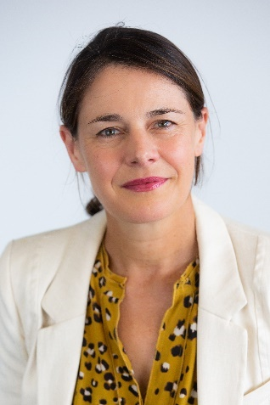
Marianne is a researcher, writer and consultant who advocates for evidence-based solutions to the big challenges facing human rights and democracy. She was co-founder of ActionStation and is currently Co-Director of The Workshop. Marianne is a trained human rights lawyer, with experience in building online communities, social entrepreneurship and storytelling.

KENDALL FLUTEY
An emerging leader in New Zealand, Kendall is the co-founder and CEO of Banqer, the EdTech start-up that teaches young Kiwis about money and personal finance. Prior to Banqer's launch in 2015, Kendall worked as both a big four accountant, and as a web developer. Kendall was named Young Māori Business Leader of the Year in 2018 and Young New Zealander of the Year in 2019.

COLIN GAVAGHAN
Colin is the inaugural New Zealand Law Foundation Chair in Law and Emerging Technologies at the Faculty of Law, University of Otago, where he also researches and lectures in medical and criminal law. Colin is the principal investigator in a multi-disciplinary research project examining the legal and social implications of artificial intelligence and algorithmic decision-making for New Zealand.
RACHEL KELLY
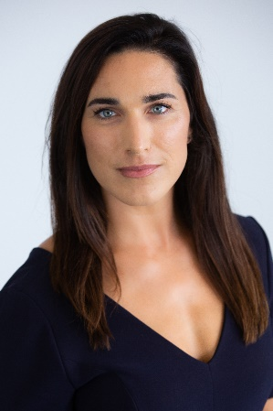
Rachel is an ex-scientist, strategist, business developer, and marketing professional who has spent the last 19 years in the science and technology sector. She is a co-founder of the Waikato Technology Cluster, former Deputy Chair of NZTech, and is on the AI Forum New Zealand Executive Council. Rachel has a keen interest in digital trust, ethics and artificial intelligence.

NIKORA NGAROPO
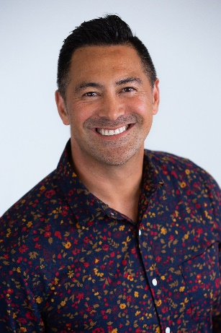
Nikora is the Director and Founder of NNMD Tech, a Māori-led design and animation technology company which aspires to enable Māori and all New Zealanders through building capability and capacity in education and technology. Mr Ngaropo has experience in developing high end digital content and visual effects and also works with tamariki to support the raising of digital literacy and digital readiness.

