**MEDIA INFORMATION**

**Tuia 250:** The Voyage Begins

**WHAT YOU NEED TO KNOW**

* *Tuia 250* recognises New Zealand’s rich voyaging heritage, starting with the spectacular feats of Pacific voyagers who navigated their way across the vast ocean to settle in Aotearoa many generations ago.

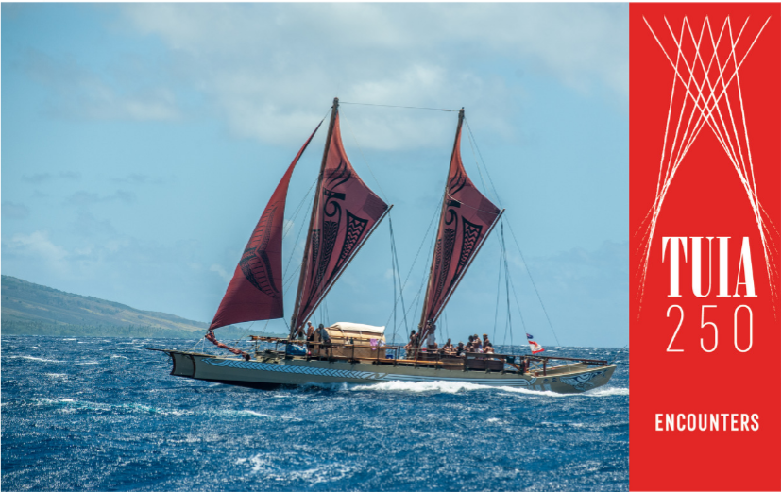

**Specs**: For vessel profile see website: [www.tuia250.nz/tuia-flotilla/](http://www.tuia250.nz/tuia-flotilla/)

**Distance:** The voyage will cross a distance of around **2,330 nautical miles** (more than 4,300 kms).

**Route:** From Pape’ete, Tahiti, to Rarotonga, to the Kermadec Islands, to Tauranga, Aotearoa – see maps below.

**Live-tracker –** track the voyage on www.tuia250.nz

* The departure of the vessel, *Fa’afaite*, from Tahiti to Aotearoa using celestial navigation (no instruments) reminds us of the skill and science used on those epic journeys across Te Moananui a Kiwa (the Pacific Ocean).
* *Fa’afaite* is planned to depart on 19 August (20 August NZ-time) and arrive in Tauranga in mid-September.
* The vessel will participate in the *Tuia 250 Voyage* in Aotearoa - marking 250 years since the first onshore encounters between Māori and Pākehā.
* *Fa’afaite* and the crew represent their ancestor, high priest (arioi) and navigator Tupaia. He helped navigate the *HMB Endeavour* before it made landfall in Aotearoa, and was pivotal in communicating with Māori.
* All New Zealanders, and everyone around the globe, can track the Voyage online and learn more about our Pacific voyaging heritage, on the *Tuia 250* website. (www.tuia250.nz)

**TUIA 250 THEMES**

* Dual Heritage – Shared Future: Presenting a balanced and honest historical narrative to better understand our relationships and build a strong foundation for a richer shared future.
* Voyaging: Increasing awareness about Pacific/Māori and European voyaging and navigation techniques.
* First meetings, migration and settlement: Considering their impact on contemporary society.
* The arts, science, technology and mātauranga of two great voyaging traditions (Pacific and European): The innovation and skill that existed in 1769 and before that time.
* Whakapapa and identity: Exploring our own stories and our common bond as voyagers to Aotearoa New Zealand.

**ABOUT TUIA 250**

* In 2019, Aotearoa New Zealand will acknowledge 250 years since the first onshore encounters between Māori and Pākehā, with a national commemoration called Tuia – Encounters 250 (Tuia 250).
* Tuia 250 will encourage kōrero (discussion) debate and reflection, and enable a more balanced telling of our stories, so that we speak openly and respectfully about our histories. It is an opportunity to hold some honest conversations about Māori and Pākehā settlement of New Zealand to guide our futures forward.
* Tuia 250 is about the people and place of Aotearoa New Zealand - what brought us together, the challenges we face and how we will weave our cultures and values into a future we will be proud to leave for the next generation.
* Tuia 250 will recognise the extraordinary voyaging traditions and cultures of Te Moana Nui a Kiwa (the Pacific), the exceptional feats of Pacific voyagers, their mātauranga (knowledge), innovation and non-instrument navigation prowess and their decision to settle in Aotearoa many generations ago.
* Tuia 250 will also acknowledge the feats of European explorers, the technology they developed and their first encounters with the people of this place when James Cook, Tupaia and others on the Endeavour arrived and sailed around Aotearoa in 1769.

**MAPS**

**Track the Voyage on** [**www.tuia250.nz**](http://www.tuia250.nz) **or** see charts below for more detail.

*Tahiti to Rarotonga*

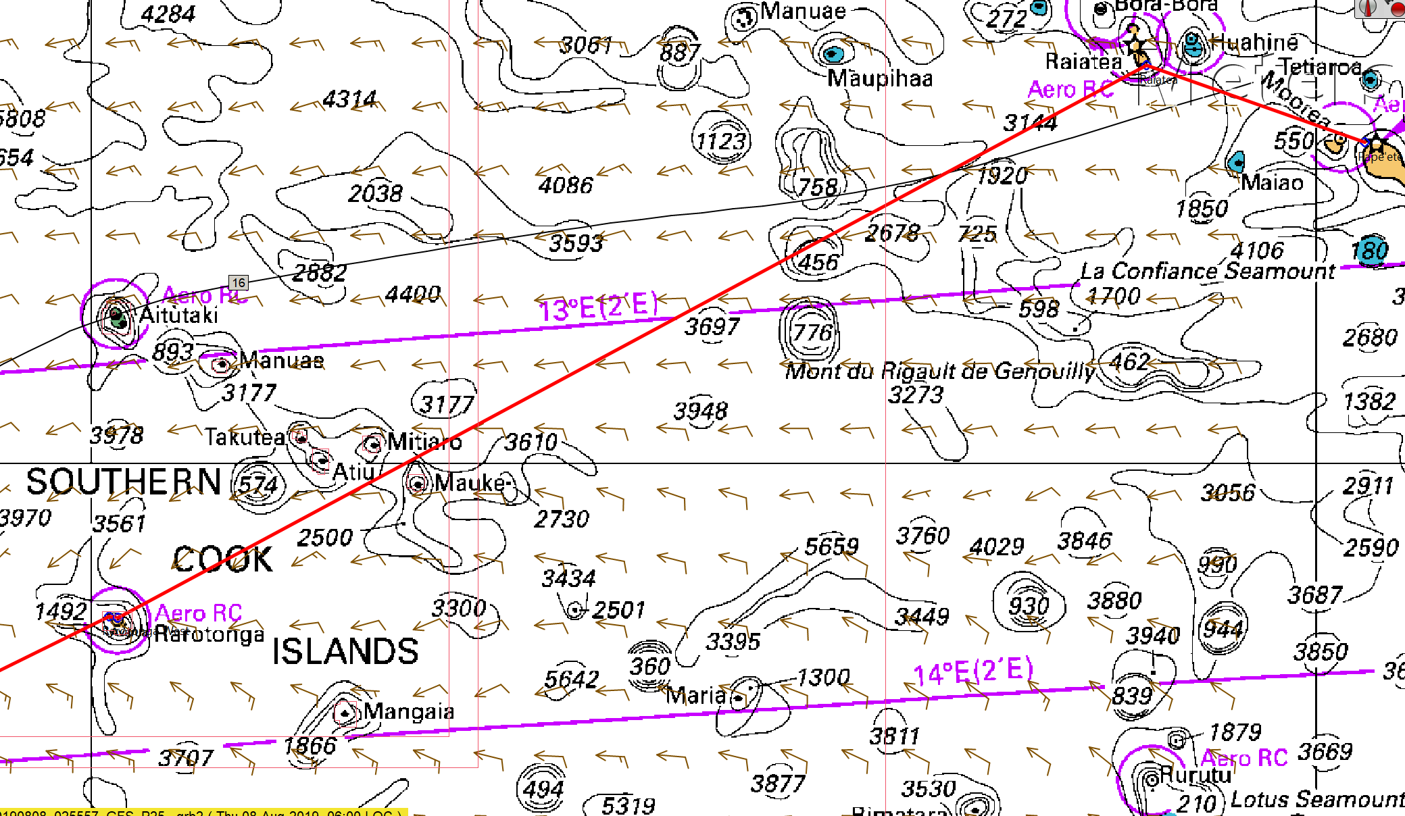

*Rarotonga to Kermedec Islands*

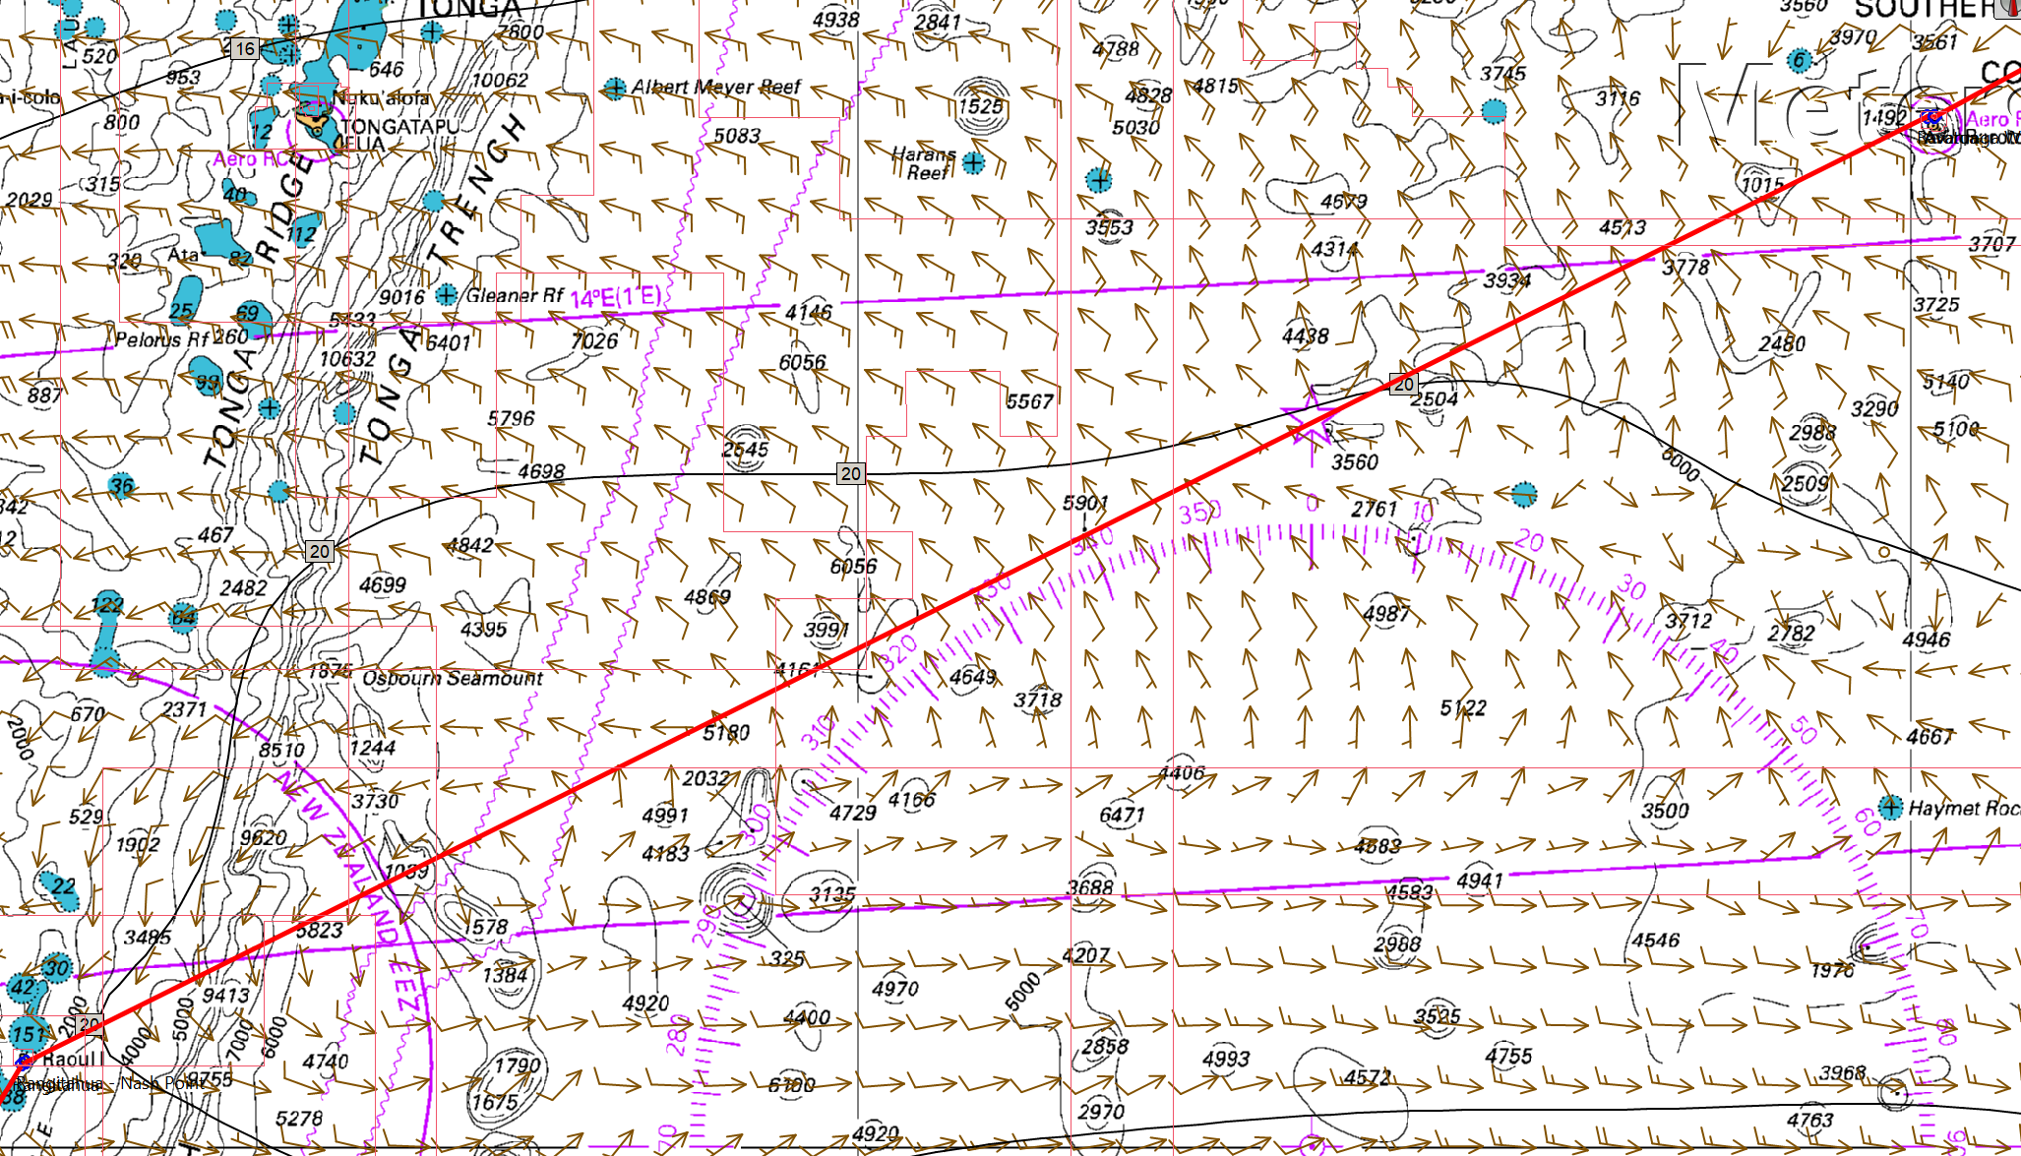

*Kermedec Islands to Tauranga*

