**KiwiBuild eligibility criteria**

**Background information**

The Kiwi dream of homeownership is slipping away. Home ownership is at its lowest level in over sixty years. Homeownership rates have been falling for 30 years, down from approximately 75 per cent in 1991,[1] to the latest estimate of 62.7 per cent.[2]

Too few homes are being built, which is helping to drive up prices beyond the reach of middle New Zealand; and, of the homes being built, few are priced in the lower quartile of existing stock where over a third of first home buyers purchase their homes.

Younger generations have been the most affected. A generation of young New Zealanders who have good jobs are priced out of home ownership. They made good choices, but still can’t afford the security of their own home. Families which would have traditionally been able to purchase a home are now locked out in ever increasing numbers.

KiwiBuild is about restoring the Kiwi dream of home ownership to those families who traditionally would have expected to own their own home and expanding that same dream to thousands of more families across New Zealand.

**One of the main causes are increasing house prices**

Three separate periods of high home price inflation are likely to have been the primary cause of declining home ownership, particularly in Auckland, where price rises have been highest.

Adjusted for inflation, the median priced Auckland home now costs $650,000 more than 25 years ago. In March 2018 the median house price was $851,250 up from $433,813 in March 2009. In addition to Queenstown and Auckland, other areas which have traditionally had steady house price growth, such as Whangarei, are also experiencing large growth. Since June 2015 the median home price has increased from $320,000 to over $450,000 in December 2017.

**Homes are not affordable**

Over the last decade the nationwide median home price to median household income ratio, (median multiple), has increased from 4.58 in March 2009 to 6.34 in March 2018. In March 2018, the median multiple was 9.5 in Auckland and 11.7 in Queenstown.

Only Whanganui and Invercargill achieved the international affordability benchmark of three times the median income.

**Younger generations have been the most affected.**

Overall, only a quarter of adults under 40 own their own home, compared to half in 1991Home ownership has declined for all age groups but most acutely by those under 40 years’ of age.

**A broad range of households have been locked out of home ownership**

It is a sign of the severity of the crisis that young, professional couples remain locked out of home ownership. Some of the biggest declines in home ownership have been for families earning between $97,600 and $188,899.

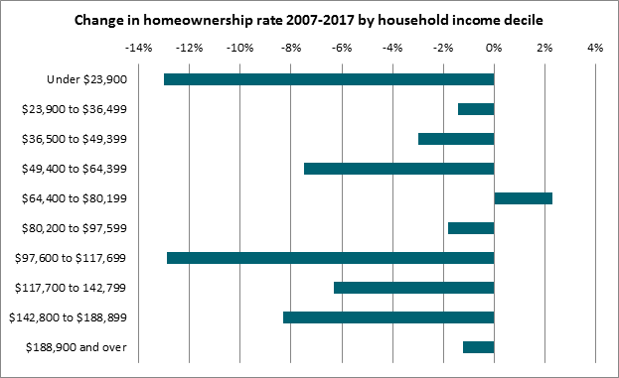

**Eligibility criteria**

The primary objective of KiwiBuild is to increase home ownership through increasing the supply of affordable starter homes for families. The eligibility criteria for KiwiBuild home buyers is that they must be:

* First-home buyers or ‘second chancers’,
* New Zealander citizens, permanent or ordinarily resident,
* Intend to own for three years and live in it,
* Have an income below $120,000 for sole purchasers and $180,000 for couples.

**First home buyers with a family income of below $180,000 will be able to purchase KiwiBuild homes.**

The choice of the income cap reflects the expectation that very high income families would not be able to get a KiwiBuild home, while keeping KiwiBuild open to young families who have traditionally been homeowners but are now locked out of the current home market.

Young families with working parents such teachers, tradies, or office workers, with individual incomes between $50,000 and $90,000, can have can have a household income well above $100,000 yet still struggle to buy a home, particularly in Auckland.

The evidence confirms this:

* The Household Economy Survey shows households in the $80,000 to $180,000 income range experienced the largest decline in homeownership in the past decade. The same survey shows nearly half of families with children fall within the $80,000-$180,000 income range.
* 2013 Census statistics show that homeownership among families with children was declining at twice the rate experienced by households without children.
* 2013 Census data also shows that the largest decline in homeownership was among adults under 40. Half of whom owned their own home in 1991, compared to a quarter in 2013.

The $180,000 cap excludes current first home buyers with the highest 8% of incomes, while retaining access to KiwiBuild for families who are struggling to access homeownership.

**Assisted home ownership schemes**

As we ramp up KiwiBuild, we are also working on a number of programmes to complement KiwiBuild and enable more families to take advantage of the KiwiBuild programme. In particular, we are investigating a progressive home ownership scheme – a joint NZ First, Labour and Greens commitment.

**Reducing costs and building below the price caps**

One of the goals of KiwiBuild is to use the scale of the KiwiBuild and public housing build programme to reduce the costs of building a home through our procurement practices. One example will be the increased use of off-site manufacturing. As KiwiBuild drives construction costs down over time, we will pass these savings onto first home buyers.

We are aiming to build as many homes as we can below the price caps. For example, the first KiwiBuild homes at McLennan, in Auckland, will be sold for $579,000 for a three bedroom home – $71,000 less than the maximum price cap.

**KiwiBuild sales process**



1. Note that the census did not identify cases where the home is owned by a family trust until 2006, meaning that earlier census data understated homeownership. The graph shows a range of estimates from the Reserve Bank for home ownership that included family trusts prior to 2006.
2. As at 31 March 2018, Statistics NZ, Dwelling and Household Estimates.