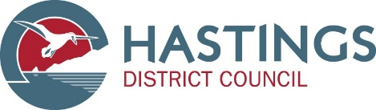

Boil water notice
Esk water supply

[3.20pm, 12 April 2017]

Boil your tap water before drinking

Routine water monitoring results on 12 April showed E coli in the Esk water supply. Because of that, the Hawke’s Bay District Health Board and Hastings District Council are instructing residents and businesses connected to the Hastings District Council Esk community supply in the affected area that they must boil their water until further notice.

Residents in the area supplied by the Council-run Esk water supply are advised that they need to use boiled tap water or store-bought bottled water for drinking, cleaning teeth, making ice, washing dishes and preparing food until further notice.
Boiling water will kill all disease-causing organisms. Place the water in a clean metal pan and bring to a rolling boil for one minute. Electric jugs with a cut-off switch can be used as long as they are full – allow the water to come to the boil and switch off. Do not hold the switch down to increase the boiling time. Boiling water should be covered and allowed to cool in the same container. The taste will improve if allowed to stand for a few hours before use.

The supply is also being chlorinated but it is important that the water used for drinking cleaning teeth, making ice, washing dishes and preparing food is brought to a rolling boil before using.
This boil water notice applies to all residents using the town water supplies in the Esk Valley area.

Updates to this notice will be provided via media, the HDC web page: http://www.hastingsdc.govt.nz/ and via Hastings District Council’s Facebook page.

Please share this information with all the other people who drink this water, especially those who may not have received this notice directly (for example, people in holiday homes and businesses). You can do this by talking to your neighbours, posting this notice in a public place, or distributing copies by hand.

If you have water supply questions, phone Hastings District Council on 06 871 5000.
If you have health related questions, phone the Healthline on: 0800 611 116

