April – June 2017 Issued: 31 March 2017
Hold mouse over links and press ctrl + left click to jump to the information you require:
Overview
Regional predictions for the next three months
Northland, Auckland, Waikato, Bay of Plenty
Central North Island, Taranaki, Whanganui, Manawatu, Wellington
Gisborne, Hawke’s Bay, Wairarapa
Tasman, Nelson, Marlborough, Buller
West Coast, Alps and foothills, inland Otago and Southland
Coastal Canterbury, east Otago
Background
Contacts
Notes to reporters and editors
NIWA Outlook: April – June 2017
Overview
The tropical Pacific is currently in an ENSO (El Niño – Southern Oscillation) neutral state overall, but with very mixed signals. In the western and central Pacific, there is a La Niña-like set-up, with stronger than normal easterly trade winds, wetter conditions over the Indonesian region and drier conditions near the Dateline, and sea surface temperatures (SSTs) near or slightly below average. In the eastern equatorial Pacific, SSTs are above average, and indeed are close to record warmth near the South American coast, associated with heavy rains and flooding in Peru during March 2017.
In the subsurface ocean, warmer than average temperatures (+2ºC anomalies) persist in the western equatorial Pacific, but have shown no sign of progressing further eastwards. The Southern Oscillation Index (SOI) was weakly positive during March 2017.
International guidance is about equally split between continuing ENSO-neutral conditions (53% chance) and developing El Niño conditions (47%) during the next three months (April - June 2017). However, from late winter onwards, a transition to El Niño conditions is favoured, with the chance of an El Niño event rising to over 60%.
Over the next three months, the atmospheric circulation around New Zealand is expected to favour higher pressure than normal to the west of the country, with more anticyclonic south-westerly wind flows than normal, a pattern suggestive of El Niño. However, in April 2017 as the season starts, it is expected that New Zealand will be influenced by active sub-tropical disturbances, potentially producing heavy rainfall, and frequent wind flows from the north.

Outlook Summary
April – June 2017 temperatures are most likely to be above average (50% chance) in the north of the North Island, and about equally likely to be above average (45% chance) or average (40% chance) for all other regions of New Zealand. There is little chance (only 10-15%) of temperatures being below average over the late autumn season as a whole, but nevertheless frosts will occur from time to time in cooler locations later in the season.
April – June 2017 rainfall totals are about equally likely to be above normal (40% chance) or near normal (35% chance) in the north of both Islands. Conversely, rainfall is about equally likely to be below normal (40% chance) or near normal (35% chance) in the west of the South Island. For other regions, near normal rainfall is the most likely outcome (45% chance).
April – June 2017 soil moisture levels and river flows are about equally likely to be above normal (40-45% chance) or near normal (35-40% chance) in the north and west of the North Island, but below normal (45% chance) in the west of the South Island. In the east of the North Island, soil moisture levels are likely to be near normal (40% chance), with river flows equally likely to be normal or below (35% chance). In the north of the South Island, soil moisture is likely to be normal (40% chance) or above (35% chance), with river flows near normal (40% chance). Finally, in the east of the South Island, both soil moisture levels and river flows are most likely to be near normal (45% chance).

Regional predictions for the April – June 2017 season
Northland, Auckland, Waikato, Bay of Plenty
The table below shows the probabilities (or percent chances) for each of three categories: above average, near average, and below average. In the absence of any forecast guidance there would be an equal likelihood (33% chance) of the outcome being in any one of the three categories. Forecast information from local and global guidance models is used to indicate the deviation from equal chance expected for the coming three month period, with the following outcomes the most likely (but not certain) for this region:
- Temperatures are most likely to be above average (50% chance).
- Rainfall totals are about equally likely to be in the near normal (40% chance) or above normal range (35% chance).
- Soil moisture levels are about equally likely to be above normal (40% chance) or near normal (35% chance).
- River flows are most likely to be above normal (45% chance).
The full probability breakdown is:
 | Temperature | Rainfall | Soil moisture | River flows
Above average | 50 | 35 | 40 | 45
Near average | 40 | 40 | 35 | 35
Below average | 10 | 25 | 25 | 20

Central North Island, Taranaki, Whanganui, Manawatu, Wellington
Probabilities are assigned in three categories: above average, near average, and below average.
- Temperatures are about equally likely to be above average (45% chance) or near average (40% chance).
- Rainfall totals are most likely to be near normal (45% chance).
- Soil moisture levels and river flows are equally likely to be normal (40% chance) or above normal (40% chance).
The full probability breakdown is:
 | Temperature | Rainfall | Soil moisture | River flows
Above average | 45 | 35 | 40 | 40
Near average | 40 | 45 | 40 | 40
Below average | 15 | 20 | 20 | 20

Gisborne, Hawke’s Bay, Wairarapa
Probabilities are assigned in three categories: above average, near average, and below average.
- Temperatures are about equally likely to be above average (45% chance) or near average (40% chance).
- Rainfall totals are most likely to be near normal (45% chance).
- Soil moisture levels are most likely to be near normal (40% chance).
- River flows are equally likely to be near normal (35% chance) or below normal (35% chance).
The full probability breakdown is:
 | Temperature | Rainfall | Soil moisture | River flows
Above average | 45 | 25 | 30 | 30
Near average | 40 | 45 | 40 | 35
Below average | 15 | 30 | 30 | 35

Tasman, Nelson, Marlborough, Buller
Probabilities are assigned in three categories: above average, near average, and below average.
- Temperatures are about equally likely to be above average (45% chance) or near average (40% chance).
- Rainfall totals and soil moisture levels are about equally likely to be in the near normal (40% chance) or above normal range (35% chance).
- River flows are most likely to be normal (40% chance).
The full probability breakdown is:
 | Temperature | Rainfall | Soil moisture | River flows
Above average | 45 | 35 | 35 | 30
Near average | 40 | 40 | 40 | 40
Below average | 15 | 25 | 25 | 30

West Coast, Alps and foothills, inland Otago, Southland
Probabilities are assigned in three categories: above average, near average, and below average.
- Temperatures are about equally likely to be above average (45% chance) or near average (40% chance).
- Rainfall totals are about equally likely to be in the below normal (40% chance) or near normal range (35% chance).
- Soil moisture levels and river flows are most likely to be below normal (45% chance).
The full probability breakdown is:
 | Temperature | Rainfall | Soil moisture | River flows
Above average | 45 | 25 | 20 | 20
Near average | 40 | 35 | 35 | 35
Below average | 15 | 40 | 45 | 45

Coastal Canterbury, east Otago
Probabilities are assigned in three categories: above average, near average, and below average.
- Temperatures are about equally likely to be above average (45% chance) or near average (40% chance).
- Rainfall totals, soil moisture levels and river flow are all most likely to be near normal (45% chance).
The full probability breakdown is:
 | Temperature | Rainfall | Soil moisture | River flows
Above average | 45 | 25 | 25 | 25
Near average | 40 | 45 | 45 | 45
Below average | 15 | 30 | 30 | 30

Graphical representation of the regional probabilities
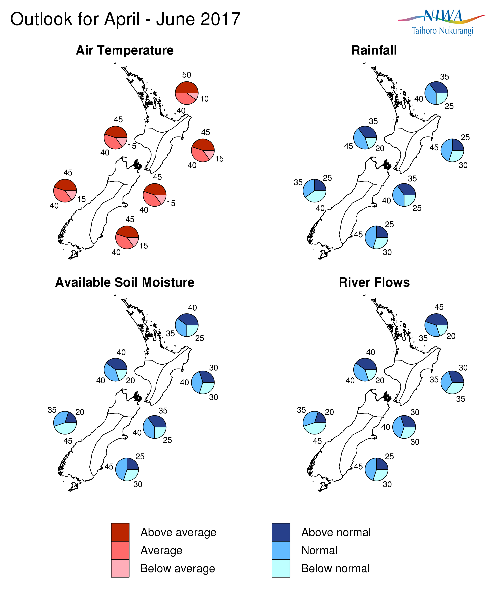

Background
The tropical Pacific is currently in an ENSO (El Niño – Southern Oscillation) neutral state, although some of the indices are indicative of La Niña conditions: sea surface temperatures (SSTs) in the western equatorial Pacific Ocean remained slightly below average (an anomaly of -0.1ºC in the NINO4 region) in March. The SOI was weakly positive, although still in the neutral range. The pattern of tropical convection was more indicative of La Niña conditions, with enhanced rainfall over the Maritime Continent (Indonesia region) but drier conditions near and east of the Dateline.
Conversely, near the Peruvian coast, SSTs are at record warm levels, and the event is being referred to as a ‘coastal El Niño’. These very warm SSTs in the east overlie cooler than normal subsurface water below 100m depth. In the western Pacific, warmer than normal subsurface waters persist, but have yet to show any sign of moving into the central Pacific, as would be necessary for the initiation of a Pacific-wide El Niño event.
International guidance is about equally split between continuing ENSO-neutral conditions (53% chance) and developing El Niño conditions (47%) during the next three months (April – June 2017). However, from late winter onwards, a transition to El Niño conditions is favoured: 68% chance in July –September 2017 and 62% chance in October–December 2017. Of the 10 dynamical models monitored by NIWA, only two clearly indicate SSTs warm enough to qualify as El Niño conditions in April – June, but 7 models reach this threshold by July-September.
Water temperatures surrounding New Zealand are close to average around much of the country, but warmer than average to the northeast. Models indicate New Zealand sitting in a region of near normal SSTs over the next three month period, within a larger domain of well above normal SSTs for the Tasman-western South Pacific as a whole.
Climatologically, January – March is the most active part of the tropical cyclone season. (Refer to NIWA’s updated Tropical Cyclone Outlook at https://www.niwa.co.nz/news/southwest-pacific-tropical-cyclone-outlook-update-0 for more information). The 2016-17 tropical cyclone season got off to a slow start, but cyclone activity increased during March. Tropical Cyclone Debbie, which struck north Queensland on 28 March, has left a lot of warm, moist air in the northern Tasman which could invigorate weather systems heading to New Zealand in the early part of April. Substantial rainfall from these sub-tropical systems could offset the drier conditions which would be anticipated for the season as a whole from anticyclonic south-westerly air flows, and this is reflected in NIWA’s rainfall tercile probabilities.
For comment, please contact
Chris Brandolino, Principal Scientist – Forecasting, NIWA National Climate Centre
Tel (09) 375 6335, Mobile (027) 886 0014

Dr Brett Mullan, Principal Scientist, NIWA National Climate Centre
Tel (04) 386 0508, Mobile (027) 294 1169
Notes to reporters and editors
- NIWA’s outlooks indicate the likelihood of climate conditions being at, above, or below average for the season as a whole. They are not ‘weather forecasts’. It is not possible to forecast precise weather conditions three months ahead of time.
- The outlooks are the result of the expert judgment of NIWA’s climate scientists. They take into account observations of atmospheric and ocean conditions and output from global and local climate models. The presence of El Niño or La Niña conditions and the sea surface temperatures around New Zealand can be a useful indicator of likely overall climate conditions for a season.
- The outlooks state the probability for above average conditions, near average conditions, and below average conditions for rainfall, temperature, soil moisture, and river flows. For example, for winter (June–July–August) 2007, for all the North Island, we assigned the following probabilities for temperature:
· Above average: 60 per cent
· Near average: 30 per cent
· Below average: 10 per cent
We therefore concluded that above average temperatures were very likely.
- This three-way probability means that a random choice would be correct only 33 per cent (or one-third) of the time. It would be like randomly throwing a dart at a board divided into three equal parts, or throwing a dice with three numbers on it. An analogy with coin tossing (a two-way probability) is not correct.
- A 50 per cent ‘hit rate’ is substantially better than guesswork, and comparable with the skill level of the best overseas climate outlooks. See, for example, analysis of global outlooks issued by the International Research Institute for Climate and Society based in the US published in the Bulletin of the American Meteorological Society (Goddard, L., A. G. Barnston, and S. J. Mason, 2003: Evaluation of the IRI’s “net assessment” seasonal climate forecasts 1997–2001. Bull. Amer. Meteor. Soc., 84, 1761–1781).
- Each month, NIWA publishes an analysis of how well its outlooks perform. This is available online and is sent to about 3500 recipients of NIWA’s newsletters, including many farmers. See www.niwa.co.nz/our-science/climate/publications/all/cu
- All outlooks are for the three months as a whole. There will inevitably be wet and dry days, and hot and cold days, within a season. The exact range in temperature and rainfall within each of the three categories varies with location and season. However, as a guide, the “near average” or middle category for the temperature predictions includes deviations up to ±0.5°C for the long-term mean, whereas for rainfall the “near normal” category lies between approximately 80 per cent and 115 per cent of the long-term mean.
- The seasonal climate outlooks are an output of a scientific research programme, supplemented by NIWA’s Capability Funding. NIWA does not have a government contract to produce these outlooks.
- Where probabilities are within 5% of one another, the term “about equally” is used.
Visit our media centre at: www.niwa.co.nz/news-publications/media-centre

