Hutt Valley Chamber of Commerce
Sponsored by Red Hot Business Coaching
Business Confidence Survey – March 2017

Hutt Valley Chamber of Commerce
Media Release
27 March 2017

Hutt Valley business confidence positive
Hutt Valley business confidence in New Zealand’s economy has improved according to the latest Hutt Valley Chamber of Commerce Business Confidence Survey, sponsored by Red Hot Business Coaching.

Expectations and confidence have increased this quarter compared to the last survey in December. Respondents are anticipating positive activity with a net 35% expecting the situation to improve over the next 6 months, compared to net 30% in December and net 50% in September.

Overall figures show that 41% of respondents expect the national business situation to improve, 52% expect it to remain the same, and 6% expect it to deteriorate.

Hutt Valley business confidence in their own business also remains stable. A net 56% of business respondents said they expected their own business situation to improve over the next 6 months, compared to net 51% in December and net 55% in September. Of all respondents, 61% expect an improvement, 33% expect things to stay the same and 6% expect a decline in their own situation.

The survey was conducted in March over a two-week period.

Expectations around business investment have improved. A net 21% of businesses expect to invest more in buildings over the next 12 months, compared to a net 11% in December. Investment in plant and machinery has improved again from last quarter, with a net 24% of businesses expect to invest in the next 12 months, compared to a net 22% in December.

Business hiring expectations have remained consistent with a net 19% expecting to hire full-time and a net 13% expecting to hire part-time staff over the next three months.

According to respondents, the last 3 months have seen positive sales and profitability results. Increased profits were recorded by 40% of respondents, with 41% seeing similar profits to December. Sales in New Zealand were positive over the past 3 months, with 39% of respondents noting an increase in New Zealand sales, although exports were not as positive with only 10% of respondents noting an increase in exports sales.

Lack of demand continues to be the prevalent factor limiting business expansion, remaining the top factor of the last year, and respondents highlighted the continuous difficulty in finding skilled employees. Of respondents, finding skilled staff is still a challenge, with 35% saying it was harder to find skilled staff compared to 3 months ago and only 2% are finding it easier than 3 months ago. This compares with 36% finding it harder, and only 1% finding it easier in December.

Chief Executive of the Hutt Valley Chamber of Commerce, Mark Futter, said “the results show a stable economic environment. Expectations for the next few months are confident, and likely reflect the strong results seen over the past 3 months.”

“Hutt Valley’s diverse business environment is overall performing well and feeling optimistic.”

“With strong performance comes a greater need for skilled talent. It is a concern that our businesses are still struggling to connect with the skilled staff.”

ENDS
For more information contact Mark Futter 04 939 9821
Note to eds – Net percentage is the balance of sentiment, positive minus negative responses.

Hutt Valley Chamber of Commerce
Sponsored by Red Hot Business Coaching
Business Confidence Survey – March 2017 Report

Business Sector and Size
The charts below give an indication of the participants’ business sector and size by employees.

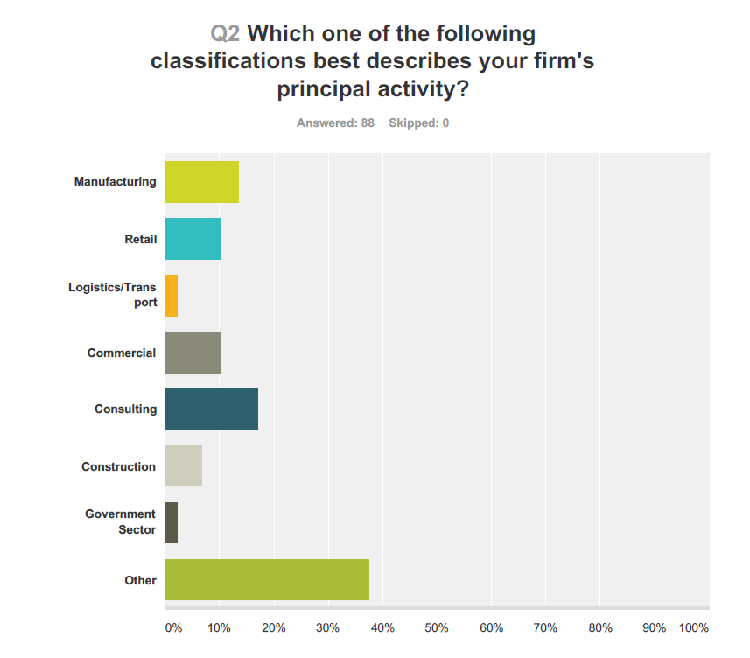
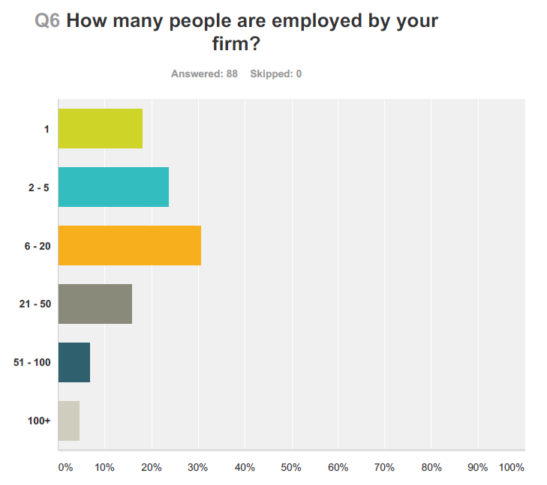
Do you believe that the general business situation in New Zealand will improve, remain the same or deteriorate in the next six months?
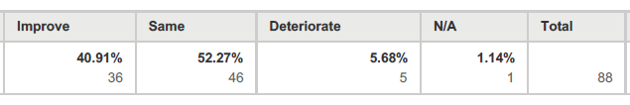
Expectation of improvement of the New Zealand business situation, up from last quarter.
March: net 35.23%
December: net 29.7%
September: net 49.5%
June: net 15%
March: net 21%
December 2015: Net 30.4%
September 2015: Net -2%

Do you believe that the general business situation in your own business will improve, remain the same or deteriorate in the next six months?
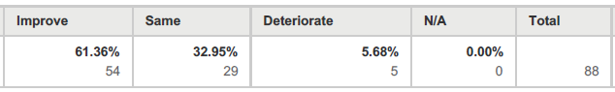
Positive outlook for own business situation – steady from last quarter.
March: net 55.7%
December: net 51.4%
September: Net 55%
June: Net 47%
March: Net 52%
December 2015: Net 60.8%
September 2015: Net 41.2%

Do you believe your personal workload will improve, remain the same or deteriorate in the next six months?
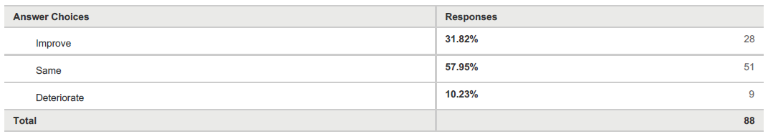
Outlook still positive in terms of improving workload. Generally people thinking it will remain about the same.

March: net 21.6%
December: net 17.5%
September: net 17.5%
June: net 21%
March: net 14%
December 2015: Net 17.7%
September 2015: net 16.9%
June 2015: Net 20.35%

In general, do you find that getting the staff you want today is easier, the same or harder than it was three months ago?
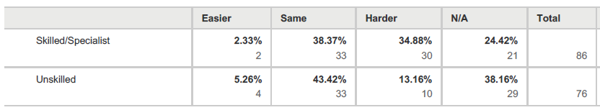
Continuous difficult outlook in terms of attracting skilled talent, and seen as about the same as last quarter. No change in difficulty when looking for unskilled employees.
Skilled
March: Net -33% difficulty
December: Net -34% difficulty
September: Net -27% difficulty
June: Net -25% difficulty
March: Net -39% difficulty
December 2015: Net -39.7 difficulty
September 2015: Net -21.7% difficulty

Unskilled
March: Net -8% difficulty
December: Net 0% difficulty – no change
September: Net -11% difficulty
June: Net -2% difficulty
March: Net 0% - no change
December 2015: Net 0%
September 2015: Net 0%

What single factor, if any, is most limiting your ability to expand your activities?
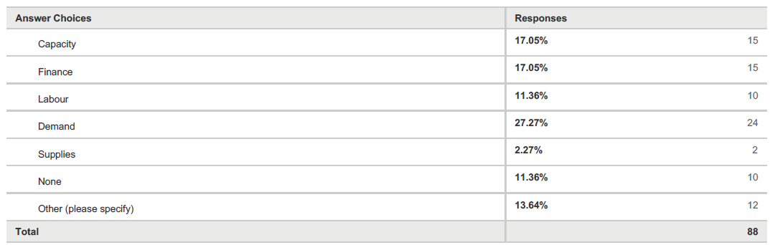
Demand still the predominant factor limiting ability to expand activities.
March: Demand, finance, capacity, labour, supplies. 11.36% found no factors limiting their ability to expand.
December: Demand, labour, finance, capacity, supplies. 8% found no factors limiting their ability to expand.
September: Demand, finance, capacity, labour, supplies. 15% found that there was no factors limiting their ability to expand.
June: Demand, finance, capacity, labour, supplies.
March: Demand, capacity, finance, labour, supplies.
December: Demand, capacity, finance, labour, supplies. Other: qualified staff, production planning and management, strategy.
September: Demand, finance, capacity, labour, supplies. “Other” included comments regarding market competition, government regulation and compliance, and poor internal systems or resource.
Do you expect the interest rates charged on loans during the next twelve months to be greater, the same, or less than those during the past twelve months?
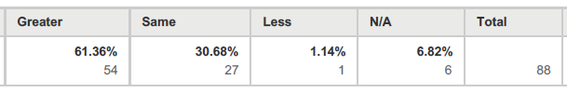
Most expect interest rates to increase.

March: net 60.22% more
December: net 45.95% more
September: net -10.68% less
June: net -5.83 less
March: net -30% less
December 2015: Net -33.3 (less)
September 2015: Net – 40.5% (less)
Do you expect the amount of new investment approved by your firm during the next twelve months to be greater, the same, or less than those during the past twelve months?
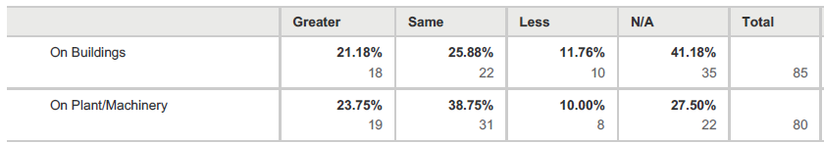
Investment outlooks remain positive. Building investment slightly less than December, and down when compared with this time last year. Plant/machinery investment less than last quarter. Similar investment as this time last year.

On buildings
March: net 9% greater investment
December: net 11% greater investment
September: net 9% greater investment
June: net 6%
March: net 23%
December 2015: Net 34%
September 2015: Net – 10.6%

On plant/machinery
March: net 14% greater investment
December: net 22% greater investment
September: net 11%
June: net 17%
March: net 18%
December 2015: Net 27.6%
September 2015: Net: 11%

Excluding normal seasonal changes, what has been your firm’s experience during the past three months in respect of:
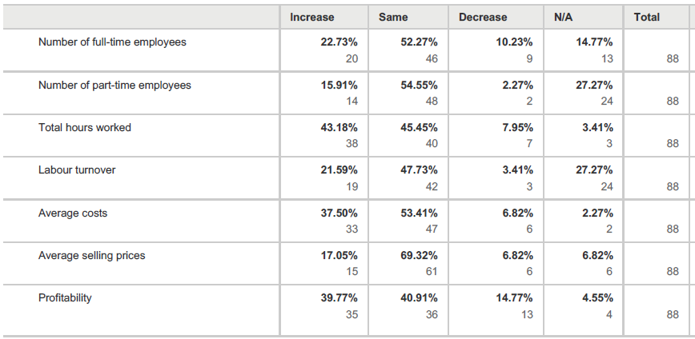
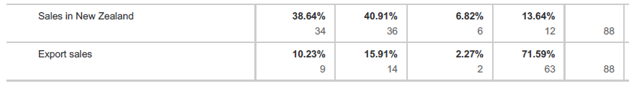
Number of full-time employees
Declined from last quarter.
March: net 12.5%
December: net 20%
September: net 12%
June: Net 8%
March: Net 15%
December 2015: Net 16%
September 2015: Net 3.1%

Number of part time employees
About the same as December.
March: net 14%
December: net 16%
September: net 12.6%
June: net 2.5%
March: Net 23%
December 2015: Net 20.7%
September 2015: Net 9.5%

Total hours worked
Decrease in amount of hours worked.
March: net 35%
December: net 40%
September: net 25%
June: net 31%
March: net 35%
December 2015: Net 37.3%
September 2015: net 20%

Labour turnover
Big increase, as expected at the beginning of the year, but double last March.
March: net 18%
December: net 0%
September: net 1%
June: net 8%
March: net 9%
December 2015: net 0% (no change)
September 2015: net 3.41%

Average costs
Increase in average costs.
March: net 31%
December: net 17%
September: net 21%
June: net 26%
March: net 26%
December 2015: net 13.3%
September 2015: net 30.8%

Average selling prices
Increase.
March: net 10%
December: net 6.7%
September: net 17%
June: net 14%
March: net 18%
December 2015: net – 5.6%
September 2015: net 5.9%

Profitability
Net improvement in profitability.
March: net 25%
December: net 13.5%
September: net 12%
June: net 7%
March: net 7%
December 2015: net -6.7%
September 2015: net -6.5%

Sales in New Zealand
Slight decline from last quarter.
March: net 31%
December: net 20%
September: net 27%
June: net 23%
March: net 26%
December 2015: net 20.9%
September 2015: net 7.7%

Export sales
Overall net increase, although the majority of exporters saw no change. About 70% of respondents stated question was N/A.
March: net 8%
December: net 12%
September: net 5%
June: net 9%
March: net 49%
December 2015: net 34.6%
September 2015: net 27.9%

Excluding normal seasonal changes, what do you believe will be your firm’s experience during the next three months in respect of:
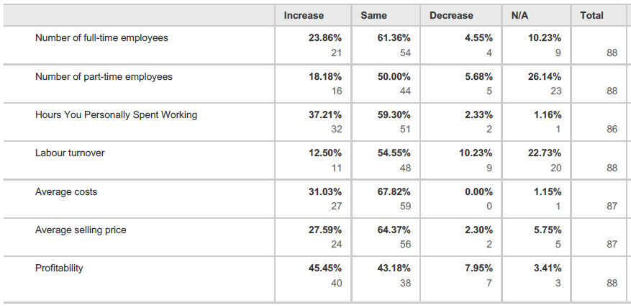
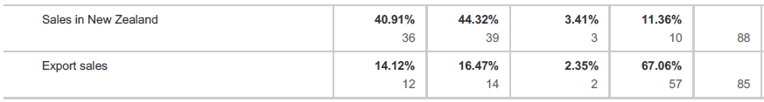
Number of full-time employees
Expecting positive employment levels, and improved last quarter.
March: net 19%
December: net 15%
September: net 15%
June: Net 8%
March: Net 18%
December 2015: net 18.8%
September 2015: Net 7.2%

Number of part time employees
Expecting positive employment level, and slight improvement on last quarter.
March: net 13%
December: net 12%
September: net 15%
June: net 3%
March: net 12%
December 2015: net 24.1%
September 2015: net 15%

Total hours worked
Expecting work hours to pick up at the beginning of the year.
March: net 35%
December: net 18%
September: net 30%
June: net 35%
March: Net 35%
December 2015: net 27.3%
September 2015: net 37.5%

Labour turnover
Slight improvement on last quarter.
March: net 2%
December: net 0%
September: net -2%
June: net -6%
March: Net -3%
December 2015: net 8.3%
September 2015: net -0.8%

Average costs
Expected to increase.
March: net 31%
December: net 18%
September: net 22.5%
June: net 21%
March: net 19%
December 2015: net 18.4%
September 2015: net 22.6%

Average selling prices
Expected to remain the same.
March: net 25%
December: net 26%
September: net 23%
June: net 18%
March: net 19%
December 2015: net 14.1%
September 2015: net 14.1%

Profitability
Positive – some increase on last quarter.
March: net 37.5%
December: net 22%
September: net 31%
June: net 19%
March: net 30%
December 2015: net 29.2%
September 2015: net 9.1%

Sales in New Zealand
Positive – the majority expected an increase. Increase from last quarter.
March: net 38%
December: net 20%
September: net 41%
June: net 25%
March: net 35%
December 2015: net 43.1%
September 2015: net 23.4%

Export sales
Positive. Again, about 70% stated N/A.
March: net 12%
December: net 11%
September: net 12%
June: net 6%
March: net 54%
December 2015: net 26.9%
September 2015: net 34%

