

Christchurch, 14 February 2017

Dear Mayor Dalziel

Thank you for the invitation on the TC3 Facebook page on 5 February 2016 to return to the issues faced by the eastern coastal areas of Christchurch. A vital part of any recovery, and one that is patently missing in the coastal areas, is ensuring the built environment provides for the long-term sustainability of the city and the wellbeing of residents.  
Unfortunately, few of the public promises made to address these problems have been honoured. For example, following our meeting almost a year ago with you and other Council officers in April 2016, we are still waiting for the legal opinion on EURs you promised *["Yes, I’m happy that we get Brent to update the legal opinion"*]. Your comment at the time that Council had no legal mandate to prevent the application of existing use rights, and your recent statement that you cannot change the RMA, are contradicted by the facts. The Council has consistently misapplied EURs, repeatedly ignored legal advice and recommendations, and breached statutory regulations. Some examples:

EURs  
1) A Council senior planner (Kent Wilson) detailed the 2 options for re-establishing a building in February 2012 ("*either by demonstrating that existing use rights apply, or obtaining a resource consent"*). We have documentation showing that existing use rights were unilaterally applied by Council to rebuild a property in a flood management area at 11.27 m above the CCC datum in 2016. No application for EURs was made for the site in question. At our meeting in April 2016, you stated that "*the fall in the land, all that does is create the difference in the measurement, but nobody should be building below the Building Act level*". Further: "*We don’t have a legal basis to act, except for the fifty-year level. I can’t understand how floor levels could be lower than the fifty-year level*".

2) Simpson Grierson gave local authorities legal advice as early as June 2010, advising that development in hazardous areas should be prevented or restricted. It also stated that "The RMA provides councils with a comprehensive mandate to prevent or restrict both new development and the extension of existing development in hazardous areas."

3) A Council newsletter in November 2010 advised that a resource consent (with the higher floor level - at that time 11.8 m, now 12.3 m above datum) would be required for houses that were not rebuilt on the same footprint in flood management areas (FMAs), and for filling in these areas.

4) Another Council newsletter acknowledged that the higher floor level was needed in more flood prone areas and that the one-in-50 year floor height under the Building Act was "not adequate".

5) MBIE Guidance stated that, if existing use rights were applied, levels had to be at or above the Building Act 2004 level (11.8 m).

In practice, the Christchurch City Council has repeatedly allowed existing use rights in conjunction with placing hazard notices on LIMs for many properties in the eastern suburbs. In April 2017, many homeowners in these districts will find they are in High Flood Hazard Management Areas (HFHMAs). In the absence of any flood or erosion mitigation measures, this will slash their equity values, put future insurability at risk, and largely transfer the flooding and erosion risks from Council to residents.   
Closer analysis of the land and floor level issues indicates that the root of the problem is that the Minister chose not to use the power under the CER legislation – under Section 48 (g) – to terminate the application of "Existing Use Rights" for the most damaged areas/uninsurable land. He further instructed the Christchurch City Council to delay recognition of high hazard areas in the Replacement District Plan until 2017 or later. The high hazard risk has been introduced in the coastal areas by the earthquakes, specifically by land subsidence and the erection of the temporary stop banks. "Intolerable risk" to life and property does not seem to have been either adequately defined or quantified. These and other issues were brought up in a letter from the Minister in August 2014: <http://cera.govt.nz/sites/default/files/common/ministerial-comments-on-draft-proposals-for-christchurch-replacement-district-plan-signed-letter-and-comments.pdf>

No one has been held responsible for the flood mapping error we brought to your attention back in April 2016. Property owners whose houses were built with floor levels as much as 53 cm below the Building Act minimum have not had any solutions proposed to them, nor have they been paid compensation for an error that is likely to cost hundreds of thousands of dollars in terms of house values. The only communications they have had from Council have been several letters on the subject of floor levels, claiming that the levels are adequate, without any explanation of the ramifications. Furthermore, Council flood maps that ignore some of the highest hazard areas continued to be issued as recently as June 2016 (see below). All of these practices make a mockery of the statements in the Graham Harrington affidavit (attached) for the EQC/ICNZ declaratory judgement (15.07.2014; paragraphs 12; 18; 19; 20; 22; 23; 25; 26; 29; 31; and in particular, paragraphs 49, 50 and 63):

Another concern we raised back in May 2016 was the toll the earthquake "recovery" has taken and continues to take on mental and physical health in Canterbury. We believe there is a direct correlation between this growing problem and the financial hardship, and psychological distress generated over recent years, along with anxieties about botched house repairs, flood risks, hazard notices and increased rates.

As mentioned on the Facebook thread, a Royal Commission of Inquiry into how and why this has happened might restrict the terms of the investigation required unless it were given the broadest possible scope – cf. "A Royal Commission can only inquire into such matters as are specified in its warrant of appointment or are reasonably incidental thereto, and it does not have a general roving jurisdiction." <http://www.teara.govt.nz/en/1966/royal-commission>This was discussed with the Royal Commission of Inquiry into the collapse of the CTV building. The members of the Commission made it absolutely clear that they could only investigate what they were instructed to investigate.

Most of the earthquake damage in Christchurch was to land. Many of the worst affected areas were red zoned, but many areas, for whatever reasons, were also zoned as TC3. An EQC presentation from the CERA seminar of 7 June 2014 identified 1,500 properties that needed horizontal soil beam remediation and 2,000 properties where there was no practical repair. To our knowledge, none of the properties in the first category have been remediated. Without the mitigation requirements specified by the EQC, a similar level of damage is likely to result in a future seismic event.

EQC has declined to identify the 2,000 properties in the second group with no solution. However, we are in possession of detailed documentation showing the properties in this category and the estimated cost of remediation.

Shortly after this seminar, Council introduced the coastal erosion and coastal inundation zones, resulting in 6,000 hazard notices being placed on property LIMs. Many of these properties are in high flood hazard management areas (although still to be notified) behind temporary flood protection.

Some of the damage inflicted, to both land and people, will be permanent and impossible to make good.

The Tonkin & Taylor Stage 1 report states the following:  
“*In zones with severely damaged land, those whose houses have been significantly damaged, due to severe lateral spreading and bearing capacity failure, may not accept the status quo. Similarly councils, insurers and financial institutions may also not agree to consent and provide ongoing cover within this zone because ground deformation expected under a similar earthquake is at the limit of or beyond currently accepted design practice, unless specific engineering design is undertaken for houses to be rebuilt in such areas.*  
  
*Councils may allow rebuilding on the worst affected land only with ground improvements to reduce the risk of future liquefaction effects. In areas which experienced severe lateral spreading, councils may require ground improvements and/or a more robust building/foundation design and construction to meet the ultimate limit state (ULS) performance standards set out in the building code.*

*In addition to councils, the commercial insurers also need to determine whether they will continue to provide cover for earthquake damage in the affected areas, and if so under what conditions. Financial institutions also need to confirm that they will continue to provide mortgage finance for such areas.”*

In essence, with an erosion hazard and/or high hazard notice on a property, neither Council nor financial institutions will have any motivation to ensure sustainability or future insurability. On the contrary, the insurance companies now have a financial motivation to reduce their costs and avoid the required risk mitigation.

The feasibility study carried out for the Avon tidal barrier in July 2015 stated that, if proper stop banks were to be erected with the required durability of 100 years pursuant to the RMA, they would need to be up to two metres high in the lowest tidally influenced areas. As matters stand, the temporary stop banks could last for 20 years at most. This represents a serious problem, since buildings need to have a service life of at least 50 years. In these circumstances, residents need to be informed and assured that they will have an insurable future to allow them to plan and move on with their lives.

We therefore ask that Council informs residents as a matter of urgency about:

• what flood/erosion protection measures will be implemented

• how Council proposes to protect residents' vehicles from saline tidal groundwater in the coastal areas

• what compensation will be paid to residents affected by the flood map error (both rebuilds and rebuilds that were delayed for years by the error)

• whether rebuilds will be consented along the riverbank and in areas prone to flooding and lateral spreading, and what the minimum floor levels will be

• the long-term plan for the coastal suburbs.

• how Council intends to ensure the long-term sustainability of the coastal suburbs and the wellbeing of residents

* the timeline Council envisages for homeowners - since the hazard notices have now removed Council's liability and threatened the future insurability of many coastal properties (due to the erosion hazard).

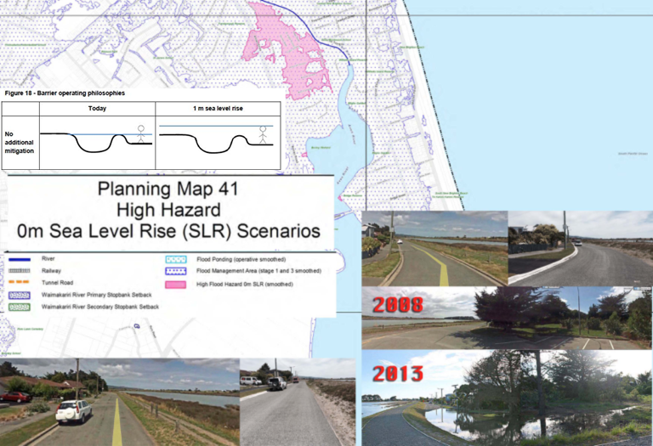

Above is a map produced by CCC at the request of CCRU indicating no high hazards along Kibblewhite St.

The stop banks there are up to 120 cm in height. Alongside the map are pre- and post- earthquake images. The ground elevation is as low as 10.10 m above the datum.

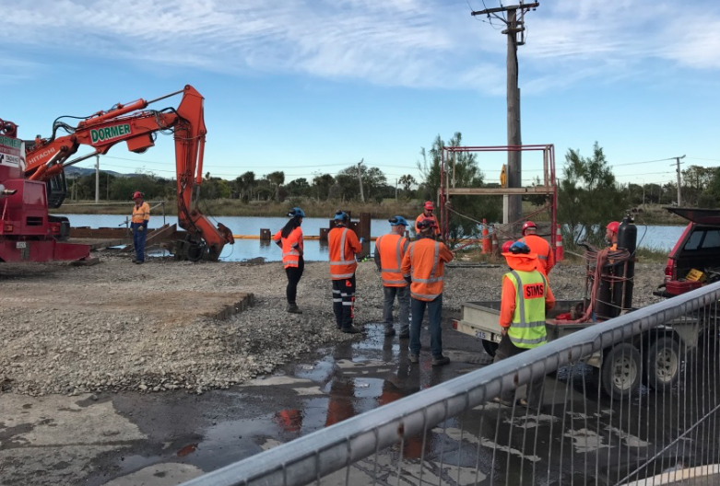

Stop bank maintenance: putting a temporary stop to leaking temporary stop banks by raising the road height.  
 (Taken on Owles Terrace at 7.32 a.m. on 15 December 2016.)  
 Leakage can be seen at every spring tide.  
  
Below is a map of tectonic movement from an affidavit given by Ian Simpson, then CEO of the EQC, a paragraph from the latest IFV documentation from EQC and a slide from Graham Harrington's presentation on elevation changes to the CCC benchmarks after the earthquakes.

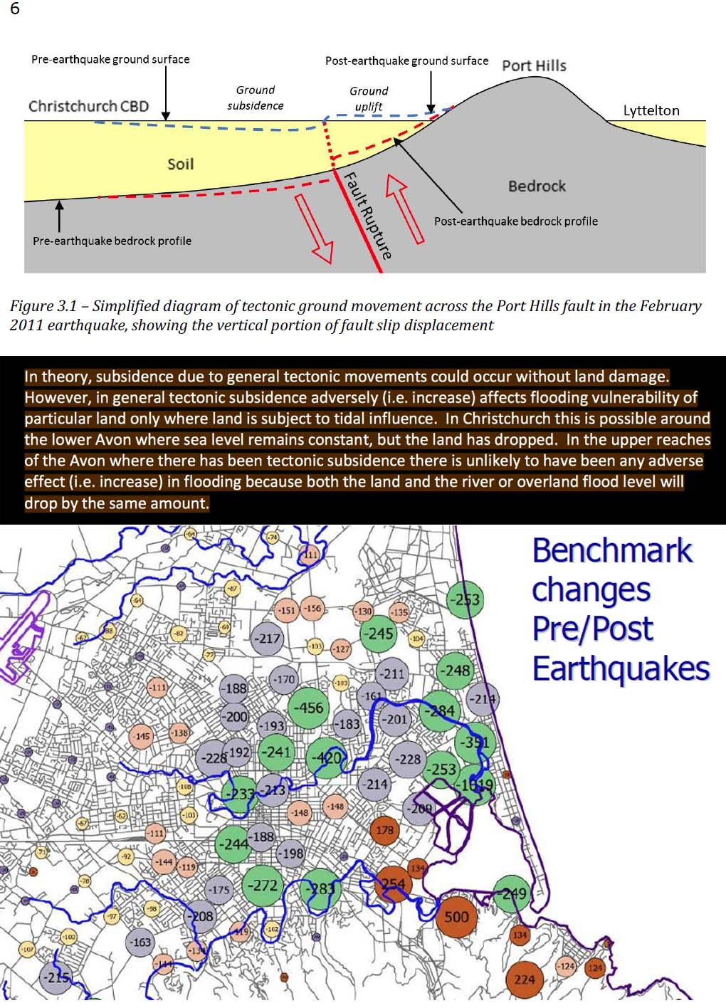

Kind regards

_________________ ___________________

Hugo Kristinsson Séamus O'Cromtha

Chair Secretary

**About Empowered Christchurch Incorporated:**

Empowered Christchurch is an apolitical community group set up to support Canterbury earthquake insurance claimants, engage on their behalf with the relevant authorities and entities, and help them achieve fair and just settlements.

[www.empoweredchristchurch.co.nz](http://www.empoweredchristchurch.co.nz/)