New book released February 2017

Petroleum Development and Environmental Conflict in
Aotearoa New Zealand
Dr Terrence Loomis
Published by Lexington Books, Lanham, MD

Shortly after the National government came to power in 2008, it set out a policy framework called the Business Growth Agenda in response to the global financial crisis to boost economic growth. The Agenda included major expansion of the oil and gas industry in the hope of a ‘game changing’ discovery. In hindsight National may not have fully appreciated the challenges it was buying into.

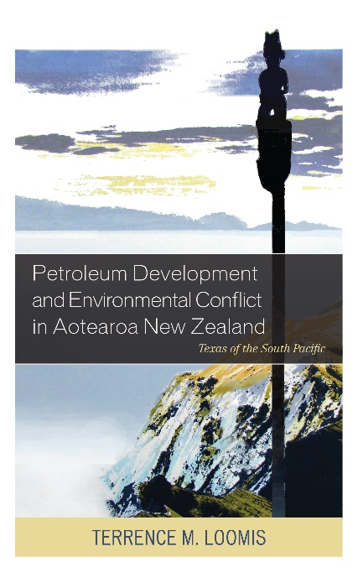
States seeking to grow their economies through expansion of resource extraction face more complex dilemmas than a few short decades ago. Besides the increasing influence of transnational corporations on domestic politics and democratic institutions and the need to prevent or mitigate the environmental damage from increased extraction activities, there is mounting evidence that unconventional oil and gas technologies and riskier ‘frontier’ exploration activities are harming communities, local environments, and human health. In addition international accords and growing citizen concerns over climate change are compelling states to review their energy policies and plan how to transition to a low-carbon economy.

In the case of New Zealand, the government chose to undertake a number of orchestrated steps in collaboration with the petroleum industry to remove perceived impediments to industry expansion, promote the petroleum industry to ‘middle New Zealand,’ and defuse, co-opt or subvert environmental opposition. The petroleum industry developed its own set of strategies, or borrowed them from overseas, to help achieve their mutual aims.

Economic anthropologist Dr Loomis has researched these developments over the past several years. In this book he examines the government’s maneuvers and oil industry strategies more closely. He reveals how criticism and resistance activities by environmental activists, concerned citizens’ groups and even some local authorities not only disrupted government/industry efforts and highlighted National’s contradictory energy and climate policies, but had far-reaching effects on institutional relations and values between the state and the community sector. NGOs and communities seemed to have less influence in policy-making, local planning, sustainable resource management and care for the environment than previously.

--Ends

About the author: Dr Terrence Loomis is an independent researcher and Visiting Research Scholar in the Institute for Governance and Policy Studies at Victoria University. He holds a BA from Hamline University in Minnesota, an MA (1st Hons) in Social Anthropology from Auckland University, a PhD in Economic Anthropology from the University of Adelaide, and certificate in Economic Development Finance Professional (EDFP) from the National Development Council of America. He has over 15 years research and development consulting experience in the US, Canada, Australia, the Pacific and New Zealand. He was also Director of Economic Development for the Mdewakanton Dakota tribe of Prairie Island, Minnesota for four years. Between 1997-2000 he was Foundation Professor of Development Studies in the School of Maori and Pacific Development at Waikato University, before becoming a senior policy advisor with the New Zealand government.

Contact: Dr Terrence Loomis phone 03 578 7330
mobile 027 499 0305
email loomistm@yahoo.com

