Celebrating in style

12 December, 2016

A total of $1290 million was spent through the Paymark network in the first 7 days of December. This represents an underlying 5.4% increase on last year, once large merchants additions and removals from the network in the interim period are excluded.

The results so far this month point to solid growth in the early stages of the busy pre-Christmas spending period.

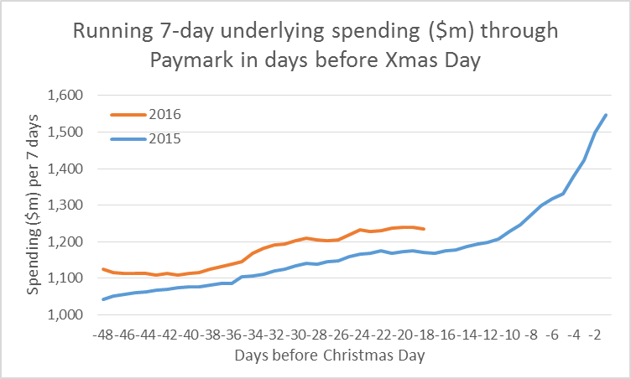

Figure 1: Underlying spending through Paymark for rolling 7 day periods

Annual growth rates were highest in Bay of Plenty, Hawke’s Bay and Palmerston North and were low in the Paymark-defined Marlborough region (that includes Kaikoura) and in Canterbury.

PAYMARK All Cards Data (1-7th Dec 2016 versus same dates 2015)
 | Value | Underlying*
Region | transactions $millions | Annual % change
Auckland/Northland | $533.8 | 5.8%
Waikato | $92.8 | 7.7%
BOP | $84.8 | 9.1%
Gisborne | $10.5 | 1.5%
Taranaki | $24.9 | 3.3%
Hawke's Bay | $35.9 | 8.2%
Wanganui | $11.6 | 6.4%
Palmerston North | $41.0 | 8.2%
Wairarapa | $10.9 | 6.2%
Wellington | $123.1 | 7.0%
Nelson | $24.5 | 2.7%
Marlborough | $14.0 | 0.4%
West Coast | $8.1 | 7.8%
Canterbury | $141.9 | 0.4%
South Canterbury | $20.2 | 1.4%
Otago | $69.8 | 6.7%
Southland | $28.3 | 4.0%
New Zealand | $1,289.7 | 5.4%
* Underlying spending excludes large clients moving to or from Paymark within last 12 months

Figure 2: Paymark All Cards data (1-7th December 2016 versus 1-7th December 2015)

It is also about this time of year that many end of year celebrations occur. As is usually the case, the level of spending through hospitality merchants was higher in the first 7 days compared to the previous 7 days, and is expected to increase again in the following 2 weeks. However the annual underlying growth rate did also accelerate to 12.4% in the first 7 days, implying a busier than usual start to the celebrations this month.

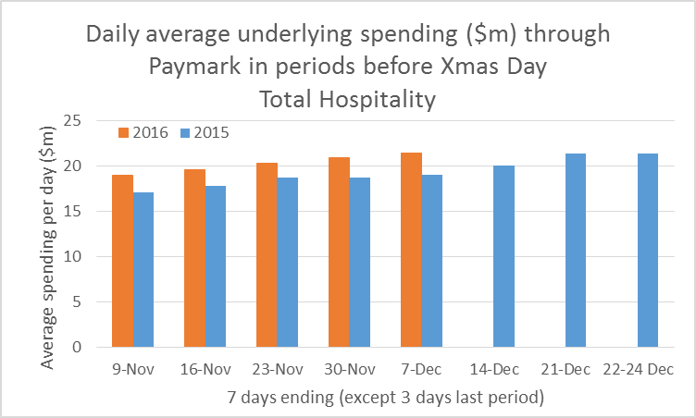

Figure 3: Paymark All Cards data for Hospitality industry (7 days ending in 2016 versus same dates in 2015)

The effect was stronger through the restaurants and cafes as opposed to the bars and clubs. Maybe champagne and canapes is more appropriate these days than a beer and sausage rolls?

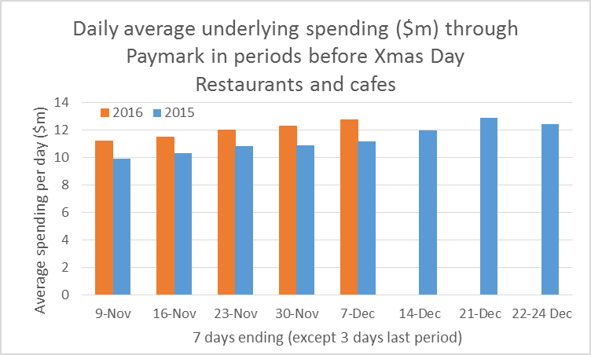

Figure 4: Paymark All Cards data for restaurants and cafes (7 days ending in 2016 versus same dates in 2015)

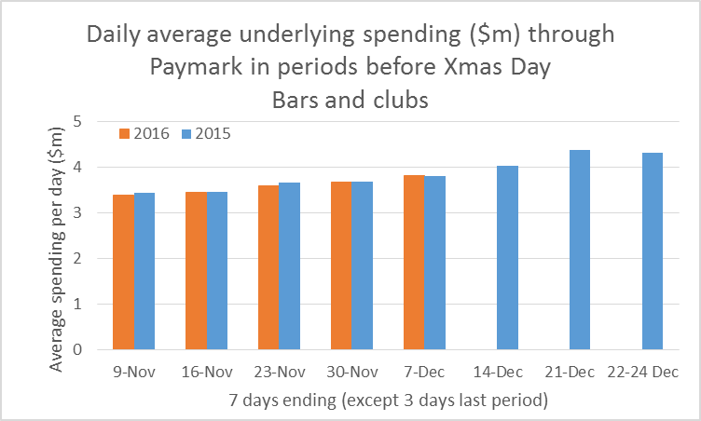

Figure 5: Paymark All Cards data for bars and clubs (7 days ending in 2016 versus same dates in 2015)

ENDS

For more information please contact: Paul Brislen 021 988 896, paul.brislen@paymark.co.nz

Paymark is New Zealand’s leading electronic payments company |  | For the past 26 years we have served hundreds of thousands of New Zealand merchants through our safe, secure and reliable infrastructure.
 | 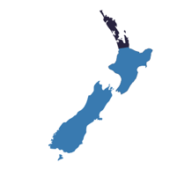 | Paymark covers more than 100,000 terminals, accounting for in excess of 75% of the New Zealand payments landscape. We process around 60 transactions every second of the day.
 |  | Paymark completed its 15 billionth transaction in October 2016.

