NZ OPERA SCHOOL STUDENTS 2017
Alicia Cadwgan
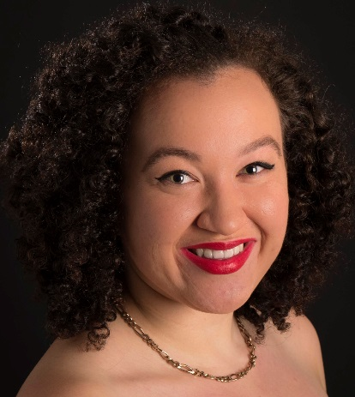
Hometown: Wellington
Voice Type: Soprano
Tertiary Institute: N/A
Course Name: N/A
Current Voice Teacher: Margaret Medlyn
NZOS History: Attended NZOS 2015 & 2016

Anna Mahon
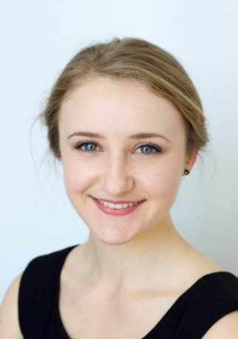
Hometown: Tauranga
Voice Type: Soprano
Tertiary Institute: University of Waikato
Course Name: BMus (Hons)
Current Voice Teacher: Glenese Blake
NZOS History: First Time Applicant

Clare Hood
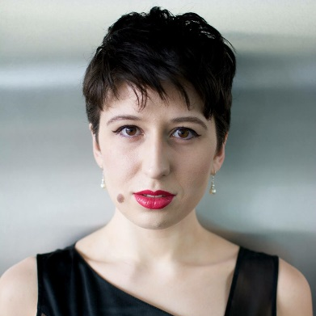
Hometown: Auckland
Voice Type: Soprano
Tertiary Institute: The University of Auckland
Course Name: BMus(Honours)
Current Voice Teacher: Dr Morag Atchison
& Dr Te Oti Rakena
NZOS History: First Time Applicant
Declan Cudd
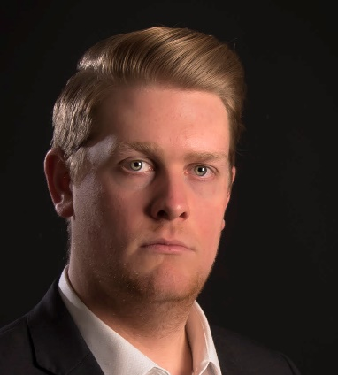
Hometown: Rotorua
Voice Type: Tenor
Tertiary Institute: N/A
Course Name: N/A
Current Voice Teacher: Richard Greager,
Lisa Harper-Brown
NZOS History: Attended NZOS 2016

Edward Laurenson
Postgraduate Alumni
Hometown: Auckland
Voice Type: Baritone
Tertiary Institute: Guildhall School of Music & Drama
Course Name: Master of Performance
Current Voice Teacher: Yvonne Kenny
NZOS History: First Time Applicant

Elisabeth Harris
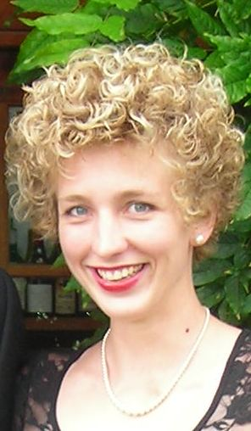
Hometown: Wellington
Voice Type: Mezzo Soprano
Tertiary Institute: N/A
Course Name: N/A
Current Voice Teacher: Margaret Medlyn
NZOS History: Attended NZOS 2013 & 2014
Eliza Boom
Dame Malvina Major NZ Scholars
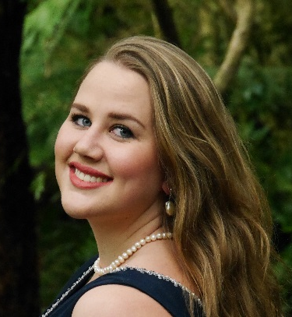
Hometown: Whangarei
Voice Type: Soprano
Tertiary Institute: N/A
Course Name: N/A
Current Voice Teacher: Dane Malvina Major
NZOS History: Attended NZOS 2013, 2015 & 2016

Elyse Hemara
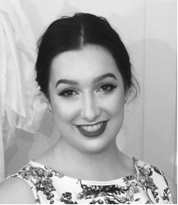
Hometown: Napier
Voice Type: Soprano
Tertiary Institute: Te Koki NZ School of Music
Course Name: N/A
Current Voice Teacher: Margaret Medlyn
Richard Greager
NZOS History: Attended NZOS 2016

Emily Mwila
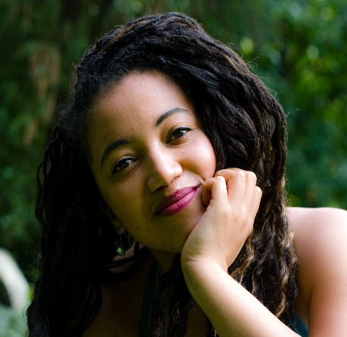
Hometown: Wellington
Voice Type: Soprano
Tertiary Institute: N/A
Course Name: N/A
Current Voice Teacher: Flora Edwards
NZOS History: First Time Applicant
Filipe Manu
Hometown: Auckland
Voice Type: Tenor
Tertiary Institute: University of Waikato
Course Name: Postgraduate Diploma
Current Voice Teacher: Dame Malvina Major
NZOS History: Attended NZOS 2015 & 2016

Frederick Jones
Hometown: Wellington
Voice Type: Tenor
Tertiary Institute: Wales Internat’lAcademy of Voice
Course Name: MA in Advanced Vocal Technique
(Completed 2016 w Distinction)
Current Voice Teacher: Dennis O'Neill
NZOS History: Attended NZOS 2013/2014

Harry Grigg
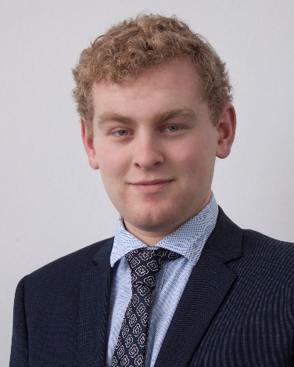
Hometown: Cheviot
Voice Type: Tenor
Tertiary Institute: University of Otago
Course Name: B.Music, Majoring Classical
Performance Voice
Current Voice Teacher: Judith Henley
NZOS History: Attended NZOS 2016
Imogen Thirlwall
Hometown: Tauranga
Voice Type: Soprano
Tertiary Institute: N/A
Course Name: N/A
Current Voice Teacher: Bruce Greenfield
NZOS History: Attended NZOS 2011, 2012, 2013

Isabella Moore
Postgraduate Alumni
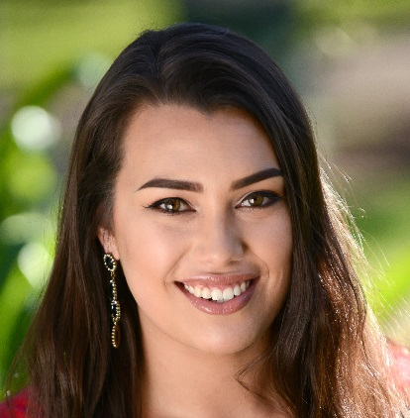
Hometown: Auckland
Voice Type: Soprano
Tertiary Institute: San Francisco Conservatory
of Music (Start: August 2016)
Course Name: Postgraduate Dip in Voice
Current Voice Teacher: Cesar Ulloa
NZOS History: First Time Applicant

James (Jamie) Henare
Dame Malvina Major NZ Scholars
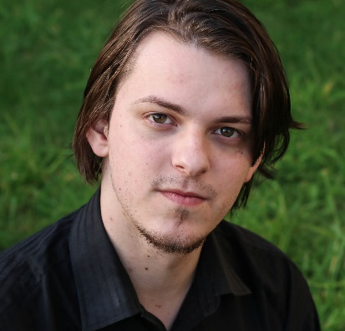
Hometown: Porirua
Voice Type: Bass
Tertiary Institute: N/A
Course Name: N/A
Current Voice Teacher: N/A
NZOS History: First Time Applicant
Jarvis Dams
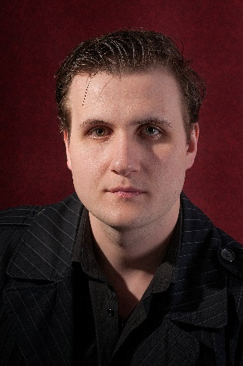
Hometown: Hamilton
Voice Type: Baritone
Tertiary Institute: N/A
Course Name: N/A
Current Voice Teacher: Catrin Johnsson
NZOS History: Attended NZOS 2015 & 2016

Katherine McIndoe
Hometown: Wellington
Voice Type: Soprano
Tertiary Institute: N/A
Course Name: N/A
Current Voice Teacher: Jenny Wollerman
Richard Greager
NZOS History: Attended NZOS 2014, 2015 & 2016

Madison Nonoa
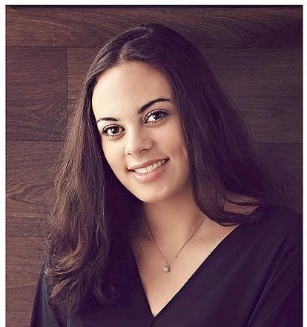
Hometown: Hamilton
Voice Type: Soprano
Tertiary Institute: University of Waikato
Course Name:
Current Voice Teacher: Dame Malvina Major/Frances Wilson
NZOS History: Attended NZOS 2016
Manase Latu
Hometown: Auckland
Voice Type: Tenor
Tertiary Institute: University of Auckland
Course Name: N/A
Current Voice Teacher: Te Oti Rakena, Claire Caldwell
NZOS History: First Time Applicant

Natasha Wilson
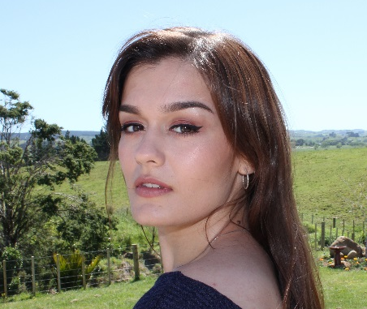
Hometown: Auckland
Voice Type: Soprano
Tertiary Institute: University of Auckland
Course Name: Bachelor of Music (Honours)
Classical Voice performance
Current Voice Teacher: Morag Atchison
NZOS History: First Time Applicant

Olivia Sheat
Dame Malvina Major NZ Scholars
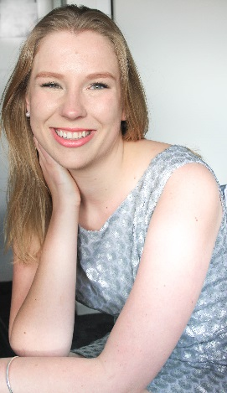
Hometown: Wellington
Voice Type: Soprano
Tertiary Institute: New Zealand School of Music
Course Name: Bachelor of Music (Performance Voice)
Current Voice Teacher: Jenny Wollerman, Margaret Medlyn
NZOS History: Attended NZOS 2016

Samson Setu
Hometown: South Auckland
Voice Type: Bass
Tertiary Institute: University of Auckland
Course Name: B.Mus
Current Voice Teacher: Dr. Te Oti Rakena
NZOS History: First Time Applicant

Shayna Tweed
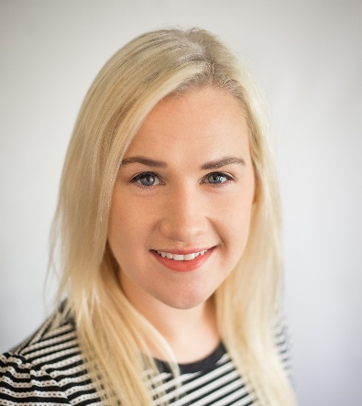
Hometown: Palmerston North
Voice Type: Soprano
Tertiary Institute: Te Kōkī New Zealand School
of Music at Victoria University
Course Name: Post-Graduate Diploma in
Classical Performance (Voice)
Current Voice Teacher: Lisa Harper-Brown
Jenny Wollerman

Sophie Sparrow
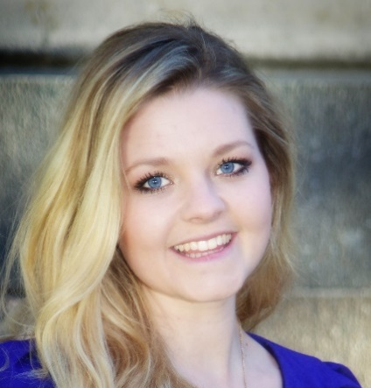
Hometown: Whangarei
Voice Type: Soprano
Tertiary Institute: N/A
Course Name: N/A
Current Voice Teacher: Frances Wilson
NZOS History: First Time Applicant

