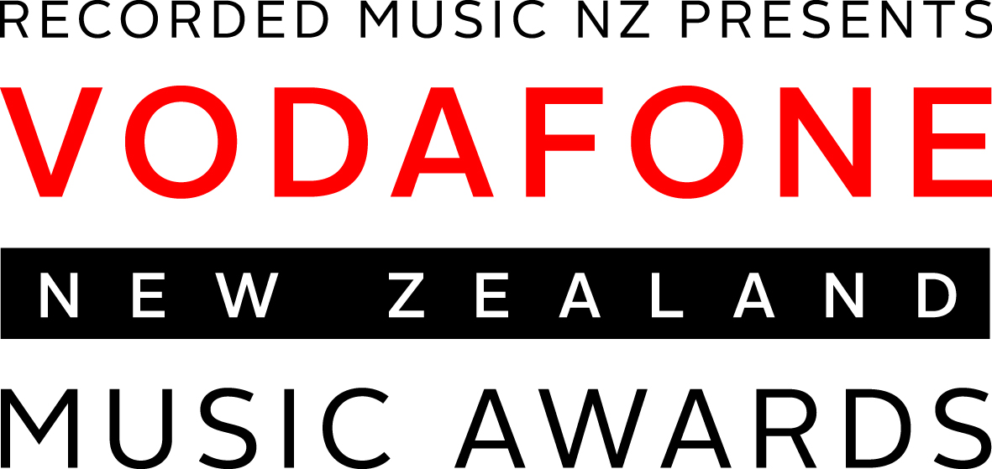

Media Release
13 October 2016
VODAFONE NZ MUSIC AWARDS FINALISTS 2016

VNZMA 2016 Finalists (by category)
1. Godfrey Hirst Album of the Year
Aaradhna – ‘Brown Girl’
Broods – ‘Conscious’
Fat Freddy’s Drop – ‘BAYS’
Hollie Smith – ‘Water Or Gold’
Tami Neilson – ‘Don’t Be Afraid’
The Phoenix Foundation – ‘Give Up Your Dreams’
2. Vodafone Single of the Year
Aaradhna – ‘Brown Girl’
Broods – ‘Free’
KINGS – 'Don't Worry Bout' It'
MAALA – ‘Kind of Love’
The Naked and Famous – ‘Higher’
Shapeshifter – ‘Stars’
3. Best Group
Broods – ‘Conscious’
Fat Freddy’s Drop – ‘BAYS’
The Phoenix Foundation – ‘Give Up Your Dreams’
Sol3Mio – ‘On Another Note’
4. Best Male Solo Artist
Avalanche City – ‘We Are For The Wild Places’
Dave Dobbyn – ‘Harmony House’
Lawrence Arabia – ‘Absolute Truth’
MAALA – ‘Composure’
5. Fiji Airways Best Female Solo Artist
Aaradhna – ‘Brown Girl’
Hollie Smith – ‘Water Or Gold’
Ladyhawke – ‘Wild Things’
Tami Neilson – ‘Don’t Be Afraid’
6. Breakthrough Artist of the Year
KINGS – 'Don't Worry Bout' It'
Leisure – All Over You’
nomad – ‘Oh My My’
SACHI – ‘Lunch with Bianca’
7. Best Rock Album
Beastwars – ‘The Death Of All Things’
Jordan Luck Band – ‘Not Only… But Also’
Villainy – ‘Dead Sight’
8. The Edge Best Pop Album
Avalanche City – ‘We Are For The Wild Places’
Broods – ‘Conscious’
MAALA – ‘Kind of Love’
9. Best Alternative Album
Lawrence Arabia – ‘Absolute Truth’
The Phoenix Foundation – ‘Give Up Your Dreams’
Silicon – ‘Personal Computer’
10. Best Urban/Hip Hop Album
Aaradhna – ‘Brown Girl’
PNC – The Luke Vailima EP
SWIDT – ‘SmokeyGotBeatz Presents SWIDT vs EVERYBODY’
11. Best Roots Album
Fat Freddy’s Drop – ‘BAYS’
Rob Ruha – ‘Pūmau’
Unity Pacific – ‘Blackbirder Dread’
12. Best Electronic Album
Electric Wire Hustle – ‘Aeons’
Opiuo – ‘Omniversal’
Pacific Heights – ‘The Stillness’
13. Te Mangai Paho Best Maori Album
Dennis Marsh – ‘Maori Songbook 2’
Kirsten Te Rito – ‘Āiotanga’
Rob Ruha – ‘Pūmau’
14. Best Worship Album
Edge Kingsland – ‘Edge Vol. 3: The Common Good’
Grace Vineyard Music – ‘Seek You’
LIFE Worship – ‘By My Spirit’
15. Best Classical Album
Anthony Ritchie and Ross Harris – ‘Fjarran’
Kenneth Young – ‘Shadows and Light’
Zephyr – ‘Zephyr’
Artisan Awards
16. NZ On Air Best Music Video
Chris Lane – ‘Inside Out’ (Avalanche City)
Sam Peacocke – ‘Buried By The Burden’ (Pacific Heights Ft. Louis Baker)
Simon Oliver – ‘Secret Lives of Furniture’ (Ha the Unclear)
17. Best Album Cover
Anns Taylor – ‘Absolute Truth’ (Lawrence Arabia)
Henrietta Harris – ‘I'll Forget 17’ (Lontalius)
Simon Faisandier – ‘Road To You’ (ARISE)
18. Massey University Best Producer
Devin Abrams – ‘The Stillness’ (Pacific Heights)
Joel Little – ‘Conscious’ (Broods)
Josh Fountain – ‘Composure’ (MAALA)
19. Best Engineer
Joel Little – ‘Conscious’ (Broods)
Miller & Phil Yule – ‘Shoot Me In The Heart’ (Miller Yule)
Samuel Flynn Scott & Lee Prebble –‘Harmony House’ (Dave Dobbyn)
Other awards
20. Vodafone People’s Choice Award
Broods
Fat Freddy’s Drop
KINGS
MAALA
Sol3Mio
21. NZ Herald Legacy Award
Bic Runga
22. NZ On Air Critics’ Choice Prize Shortlisted Artists
Kane Strang
Scuba Diva
Spycc & INF
23. Vodafone Highest Selling Single
24. Three Highest Selling Album
25. NZ On Air Radio Airplay Record of the Year
26. International Achievement
Additional Tuis presented in 2016
27. Best Pacific Album
Winner: Te Vaka – ‘Amataga’
Annie Grace – ‘The Journey’
Sol3Mio – ‘On Another Note’
28. Best Country Album
Winner: The Warratahs – ‘Runaway Days’
Eb & Sparrow – ‘Sun/Son’
Jody Direen – ‘Break Out’
29. Best Folk Album
Winner: Holly Arrowsmith – ‘For The Weary Traveller’
Amiria Grenell – ‘Autumn’
Nadia Reid – ‘Listen to Formations, Look for the Signs’
30. Best Jazz Album
Winner: Phil Broadhurst – ‘Panacea’
Kevin Field – ‘The A List’
Michael Houston & The Rodger Fox Big Band – ‘Concerti’
31. Best Children’s Album
Winner: Itty Bitty Beats – ‘Lay Your Head Down’
Anna Van Riel – ‘Cooking Up A Song’
Peter Weatherall – ‘Lollipop Man’

