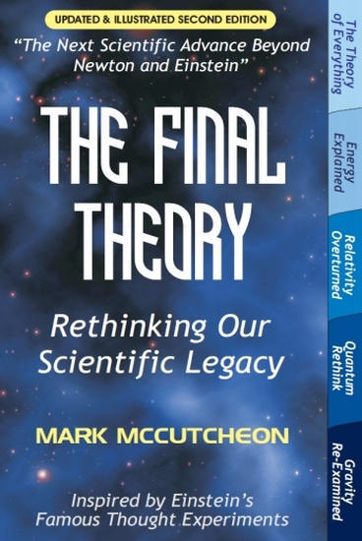
The Final Theory of Everything

An in-depth interview with the author

By Roland Michel Tremblay

In 2002 Mark McCutcheon published the first edition of his book The Final Theory at Universal Publishers. It was an instant success on the Amazon website, however it also created some controversy. It presented to the world a new Theory of Everything that worked out of the box, to replace Newton’s Law of Universal Gravitation, Einstein’s Theories of Relativity and Quantum Mechanics.

The theory is based on the one principle that matter simply expands constantly as an acceleration, reducing the distance between objects, explaining gravity. We stay on the ground because Earth is expanding underneath our feet. This expansion is unseen by us since everything expands proportionally at the same rate, including our measuring instruments and ourselves.

All particles, like protons and neutrons, are now composed solely of electrons expanding against each other within the atom, preventing them from flying apart, elucidating the strong nuclear force. A neutron is an unstable particle by nature that decays into a more stable proton, releasing an electron in the process, to justify the weak interaction.

There are no more charges or charged particles in electromagnetism, just like there is no more force acting at a distance in gravity, and yet the entire energy spectrum can be explained through the simple expansion and movement of the electrons. They move from where there is a surplus of electrons toward where there is a depletion, in a search for balance. The electrons are bouncing off between the expanding nuclei of atoms, justifying chemical bonds. Orbits are described by an ingenious new natural orbit effect through the simple geometry of expansion.

This is all four main forces of nature explained, while they are no longer forces per se, now that we understand their true nature. We could never have found a Unified Field Theory within Standard Theory, as there was nothing to unify in these four arbitrarily identified forces of nature.

I have written a few articles that describe in more detail this new Theory of Everything; they are included at the end of the first draft of my book New Age Physics that you can download below. The first section of the book includes the only summary of the theory ever written:

Summary of Atomic Expansion Theory and Articles
www.themarginal.com/NewAgePhysics.pdf

Mark McCutcheon is Canadian and has a combined Electrical Engineer / Physics degree. He has successfully re-written our entire physics, and yet it has gone largely ignored after the initial interest. This is the first in-depth interview with him, to catch up with what he thinks of his Theory of Everything now, and what he feels about the state of our physics today.

Q1. Roland Michel Tremblay: Could you describe to us, in your own words, Atomic Expansion Theory? How is it different than any other individual out there claiming to have found a Theory of Everything, and how does it differ from the other Theories of Everything being pursued by theoretical physicists today?

Mark McCutcheon: Expansion Theory, which encompasses both expanding subatomic and atomic matter, arose from my increasing awareness of many holes in accepted Standard Theory as I progressed through my scientific education, continuing even through university. Many of the problems were so fundamental that I saw no clear resolution, either personally or in the understanding of other scientists who went through this same system. In retrospect, it required an entirely new perspective on the fundamental physical sciences to truly address these key issues, and hence an entirely new Theory of Everything.

Of course any viable theory must be validated by real-world observations and experiments, which was my guide and entire purpose in pursuing this issue - to not only equally explain everything in current science, but further explain that which current science did not. I was not driven by nor interested in a personal ‘pet theory’, but truly comprehensive and objectively verifiable answers founded in solid logic and scientific principles.

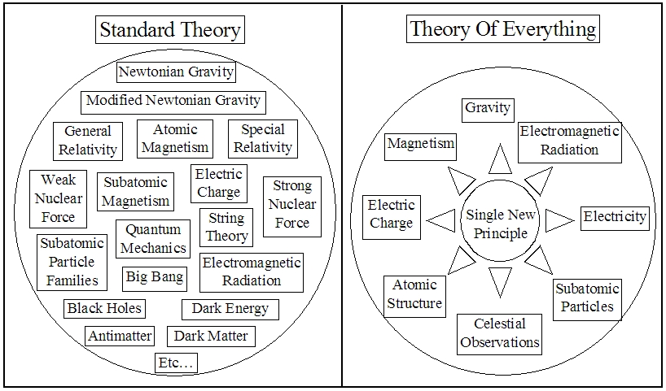
Q2. RMT: What was your eureka moment? When did you think for the first time that if matter was simply expanding, an entire new physics could emerge? How did you feel at the time, and what were your circumstances then?

MM: It was a few years after university, following one of the many TV documentaries I had seen about Einstein’s warped 4-dimensional space-time theory of gravity. It struck me just how fanciful and problematic this theory had grown from Einstein’s original intention to revise Newton’s theory of gravity, which he clearly felt was in need of a major rethink.

So rather than accepting being confined within the framework of one or the other, or both of these problematic theories of gravity, I pondered how I would explain my experience of gravity, simply and clearly, to beings who somehow had never experienced it.

First and foremost, I experienced an effective push from the planet below, which I had to continually combat to remain standing upright. The fact that Newton modelled this experience as an attracting force was secondary at this point, and, again, a problematic one at that (where was the power source? specifically why did it attract - why not repel? how could it never drain as it orchestrated the dynamics of our world and universe?).

From this push experience, it then followed that the only way everyone around the globe could be experiencing the same push from below is if the entire planet was pushing outward in all directions - i.e. expanding.

The next logical conclusion was that myself and every other object around me had to be similarly expanding, since everything remained the same relative size. And this would make sense from the fact that everything was made of the same atoms, which would then have to be equally expanding atoms.

The more I followed this line of thought, the more it moved from a simple abstract thought experiment to a viable explanation of actual real-world experience and observation, continuing through dropped objects, orbits, etc. And it also then occurred to me that this was quite similar to Einstein’s actual simple thought experiment that evolved over time into its ‘warped space-time’ form.

That early experiment was his suggestion that gravity was indistinguishable in every way to being in a box in space where there was no gravity, while being accelerated from below through space at a constant 1g acceleration. All experience and experiments would be indistinguishable from being in that box on Earth.

However, Einstein apparently never considered that Earth was literally that mechanical acceleration from below, as an expanding planet, proceeding instead down the path that led to warped 4-dimensional space-time instead.

Q3. RMT: After that great idea, you set yourself to write a very elaborate and ambitious book re-writing the entire physics. Could you tell us about how you went about it, how long it took, how much research you did, the entire process?

MM: It turns out I had accumulated quite a body of unanswered questions and problematic answers throughout my life, from grade school through university, which I eventually just came to accept and move on. So, once I had the expanding atomic-matter concept, issue after issue flooded back to mind, and as I applied my new perspective I began to find very sensible, satisfactory answers for the first time.

This process continued to the point where I had to start documenting it, and over a period of several months I had what might be considered a very rough start on an annotated first draft of what continued to grow into The Final Theory, published several years later.

Q4. RMT: The book was finally published, it was a success on Amazon, however it created some controversy. You were confronted by people who could not accept such a radically different way to describe our world, and who could not conceive that neither Newton nor Einstein could be incorrect, although Newton had already been superseded by Einstein. How did you welcome and deal with the success, and the backlash from firm believers in Standard Theory?

MM: I was very pleased with the enthusiastic response from many individual readers, both in the form of online reviews and personal email feedback. It was very rewarding to discover that there were a great many others having similar struggles to find sensible answers to many fundamental questions, and that this new perspective gave them viable answers for the first time, as it did for me.

I was also equally surprised by small groups of people who banded together via chat forums to mount coordinated efforts to attack and defame a book that they clearly had not even read, running on pure misconceptions and false assumptions. I found it particularly saddening that they were trying to mislead as many people as possible who could have greatly benefitted from the information in the book - material that I believed, and still do, to be their birth-right of understanding of the world around them and the universe in which they live. Today such efforts are well known as a fairly standard Internet Troll response to just about anything that appears on the radar, but at the time I was very surprised and saddened at this dynamic.

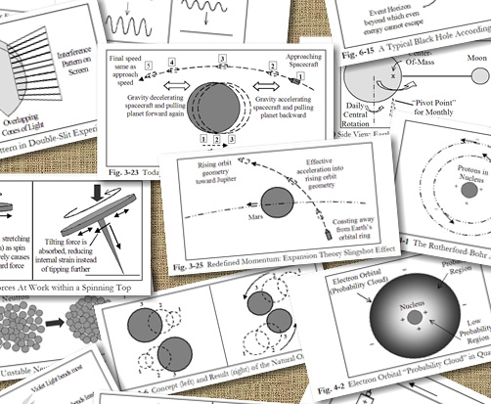
Q5. RMT: Now that time has passed, are you disillusioned about the state of our science? This hot pursuit for dark matter, dark energy, gravitational waves, graviton particles, the Big Bang, black holes, wormholes, singularities, parallel universes, etc., all of which cannot exist within Atomic Expansion Theory? Where have we gone wrong?

MM: I have come to see that our current scientific community is going to continue along as usual, deeply steeped in the various concepts you raise in your question. There is too much history, tradition and both personal and professional investment in that direction to expect anything to change.

Every so often there is also mounting pressure to announce success in one or another of these areas after much time, effort and expense, be it claims of finding a key fundamental particle, of experimental success further supporting an exotic theory, of apparent detection of a new supporting physical phenomena, etc. I’ll leave it up to each individual to decide whether they wish to seriously scrutinise and question these claims, but I believe the information in the book will greatly assist any such inquiry.

Q6. RMT: In most articles these days concerning dark matter and dark energy, I noticed that they fail to state why it is thought such concept-ideas should exist. When considering Atomic Expansion Theory, such concepts are superfluous. Could you tell us why exactly we are searching for dark matter and dark energy, and why you believe we won’t find them?

MM: Once Expansion Theory is considered, replacing both Newton’s and Einstein’s closely related mass/energy gravitational theories and mathematics, you can consider the expansion dynamics of matter, rather than a force or energy effect emanating from mass. Orbits can then be understood as geometry of expanding objects instead - whether it’s objects orbiting planets, planets orbiting stars, or solar systems swirling within galaxies. This frees us from the tenfold discrepancies in mass vs. observed orbital motion in today’s theories that have scientists filling in these huge gaps with claims of mysterious “dark matter” that does not reflect, absorb or emit any known form of energy or radiation. In other words, ‘dark matter’ is completely made up, with no evidence or physical explanation, rather than taking a second look at current unquestioned theories. This is the exact opposite of the proper Scientific Method - if experiment and observation clearly disagrees with a theory, the theory must be in error; we aren’t supposed to instead invent inexplicable justifications to retain the theory.

The same applies to the idea of ‘dark energy’, which violates one of the current fundamental laws of physics - the Law of Conservation of Energy. The interpretation of observations is claimed to show the universe flying apart with ever-greater acceleration but no explanation for the source of this supposed ever-increasing energy. Plus, every known attracting or repelling force weakens with distance, of course, but this mysterious ‘dark energy’ is claimed to strengthen even as matter presumably accelerates further and further apart. All of this arises from an interpretation of distant shifted light frequencies as indicating accelerating velocities, when far simpler explanations exist, such as the known fact that similar shifts should be expected simply due to light passing through space filled with gas and plasmas for billions of years. Such light shifting occurs even just passing light through gas or mere millimetres of plastic in lab environments. There is a concept of Occam’s razor, which says the simplest answer is probably the correct one. Why invent physically unexplainable, law-violating ‘dark energy’ when there are far simpler and more viable answers?

Q7. RMT: Would you say that science is closed to new theories and ideas, and that it is difficult to get any new idea, which lays outside Standard Theory, to be considered? What would you change in science today that could prevent this serious impediment to identifying a new Theory of Everything worth considering?

MM: I think the issue is largely one of human psychology. We would all like to think of science as an idealistic machine of pure objective logic and reason - basically the embodiment of the Scientific Method. But the reality, of course, is that this idealistic machine is operated by humans, who are susceptible to personal agendas, cognitive biases, vested interests, logical-fallacies, funding influences and pressures, competition, preconceived ideas, emotion-based decisions, etc.

Given this reality, although there is much well-intentioned rhetoric around searching for better understanding, and possibly even a true Theory of Everything that rewrites the textbooks, for the most part this seems true only to the extent that it doesn’t upset the human element too much.

When it comes down to it, most expert individuals and institutions aren’t truly willing to potentially risk their authority, reputation, status and funding - to consider that much of what they have studied and professed may be in question. And the assumption is that the sought-after understanding will be in line with all of these human concerns; but what if it is not? That appears to be the real roadblock.

Q8. RMT: What do you think of people like me, and others out there, who have picked up your theories and are developing them further? Are you encouraging everyone to do the same?

MM: Absolutely. This is not my pet theory. If correct, as it appears to be, it is humanity’s birth-right of understanding. It belongs to each and every one of us, allowing us to truly understand our world and universe, and make the most of it in whatever ways possible.

Q9. RMT: Any last thought you would like to share with us?

MM: Just to take note of the growing global realisation that the ‘Internet Trolls’ do not have the interests of others at heart. They have their own personal agendas, and are neither sincere nor knowledgeable in their efforts, doing a great disservice to others who allow them undue influence. A revolutionary new understanding awaits!

Standard Theory and Expansion Theory Maps

Larger versions available on the HTML page
www.themarginal.com/theory_of_everything.html

