FACT SHEET

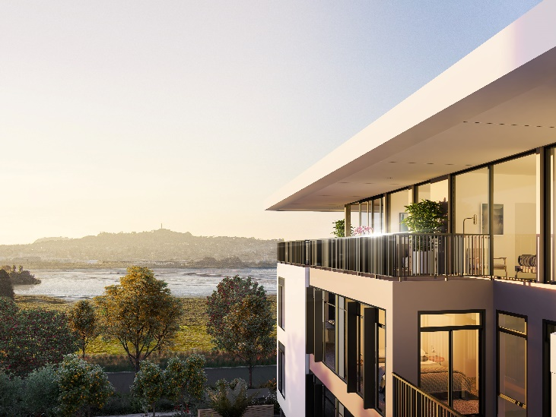
Overall neighbourhood:
- 14 hectare site
- SHA #59 in the Unitary Plan
- Location: Walmsley Road, Favona, on the Manukau Harbour close to Māngere Bridge, roughly halfway between Auckland Airport and Auckland City
- Total homes: 1,200 homes - a combination of architecturally-designed apartments with underground parking, and terrace homes.
- Green spaces: Private courtyards and resident-only vegetable gardens above underground parking spaces, complemented by a large, central 5,000 m2 park linking to a lengthy green coastal esplanade.
- Amenities: Village square with a community canopy, cafes, local convenience shops and playgrounds
- Social housing: Up to 20% provided for social housing as per criteria set in the SHA agreement for Market Cove. These homes to be managed by a community housing provider.
- Total residents: 4,000 approximately

Construction programme:
Stage 1:
- 38 two- storey terrace houses (2-5 bedrooms)
- 198 apartments (1, 2, and 3-bedroom options) in two apartment buildings (4, 5 and 6 storeys)
Stage 2: 15 Three-storey terrace houses (4-5 bedrooms)
Construction start: Terrace homes late-2016. First apartment buildings early 2017
Construction completion: Terrace homes late 2017. First apartment buildings mid 2018
Early indicative prices: 1-bedroom apartments likely to start around $425,000. 2-bedroom terrace homes start from $745,000

Organisations involved:
- Developer: Favona Limited Partnership
Led by: Guy Taylor, General Manager (Market Cove), John Sax, Executive Director
- Architects: Young and Richards – designers of the terraced houses and Graeme Scott, ASC Architects– designers of the apartments.
- Urban design: Reset Urban Design, Garth Falconer and Greenscene Mike Jack.
- Construction: Precision Construction – Terraced Homes

Sustainability
- All homes will have 6-Homestar ratings, ensuring energy and water resources are used efficiently and every home is well- insulated, dry and warm.
- Buildings have been designed to enable alternative energy sources to be used, such as solar technology.
- Stormwater is proposed to be treated in the streets through a series of planted rain gardens and swales, which will help to remove pollutants and slow down stormwater flows.

For more information, images and interviews, contact:
- Luke Henshall, The Clarity Business: 021 424 907, luke@theclaritybusiness.co.nz

