NEW ZEALAND SOMME PERSONAL STORIES
Hēnāre Kōhere
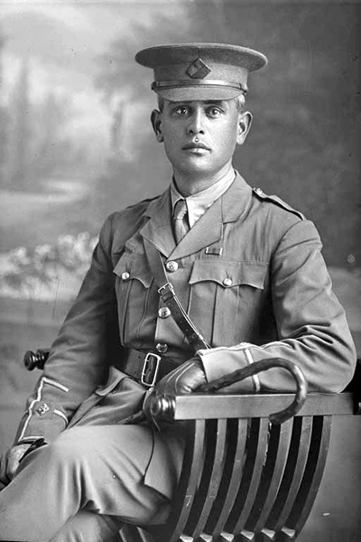
More than 2500 Māori and Pacific Islanders served overseas with the New Zealand Expeditionary Force during the First World War. More than 700 were wounded and 330 killed, or nearly 50 per cent of the total number of men sent overseas.
One of these casualties was Second Lieutenant Hēnare Mōkena Kōhere, a highly respected officer of the Ngāti Porou tribe, who died of wounds on 16 September 1916.
Born in 1880 in Te Araroa, near the North Island’s East Cape, Hēnare was the fourth child of Hōne Hiki Kōhere and Hēnarata Pereto (Bristow), and the grandson of a Ngāti Porou chief, Mōkena Kōhere. He was educated at Kawakawa Native School in Te Araroa, and, following family tradition, Te Aute College in Hawke’s Bay.
After leaving school, Henare worked as a farm cadet on a Nelson sheep station before returning to the family farm. In 1901, he received the Royal Humane Society’s bronze medal for saving the life of a sailor whose boat had overturned. The following year Hēnare and a cousin travelled to London as Māori members of the New Zealand contingent that attended the coronation of King Edward VII. He trained and led the contingent in the haka.
On his return to New Zealand Hēnare went back to farming. In 1905, he married Ngārangi Tūrei, the daughter of the Ngāti Porou leader Mohi Tūrei. They had three children, Huinga Raupani, Ngārangi Putiputi, and Hōne Hiki.
In 1915, Hēnare followed his younger brother and enlisted for service in the New Zealand army. Before heading overseas, he wrote a letter to his children:
Ka nui te pai o nga rangi e noho atu nei. Ina tonu a Peta e noho nei kei te korero pukapuka, kei roto i taku ruma. Kia pai te noho, e hika ma, kia pai kia koutou ki to koutou tipuna hoki. Kei te pai te whanau e noho atu nei; hei te Ratapu rawa pea au nei tae ai ki te taone ki te karakia i roto i nga whare whakamiharo o te Pakeha. Kaore he korero ke atu, heoi ano ko te mahi tonu i nga mahi a te hoia. Kua tino mohio rawa te ahua o te tangata ki te mahi nei.
Hei kona ra e Hui – kia aroha ki o taina, kia pai ki a Ngarangi, a kia pai ki a Hiki. Hei Kona ra, e Hiki, tae rawa atu au kua pakeke rawa koe. Hei kona i o koutou taina, tuakana hoki; ka tata koutou te kite i a Papa. Ma te Atua tatou e tiaki e awhina, i nga wa katoa, a ka kite ano.
Heoi ano, Na to koutou papa aroha.
Papa XXXXX Ma Ngarangi e tuari nga kihi
[The weather has been good here. Peta is sitting in my room reading a book. Look after yourselves, be good to each other and be good to your Nanny. All of us are doing fine. On Sunday I’ll most probably go into town to church to one of the beautiful buildings of the Pākehā [Europeans]. There is nothing else to write about – just the usual routine of soldiers’ duties. We are getting used to this way of life.
Goodbye for now. Huinga – look after your young sister, Ngārangi, and be good to Hiki. Goodbye Hiki. When I come back you will be a big boy. Say goodbye to all your cousins and relations. It won’t be long before you see Papa again. Huinga, you and Ngārangi keep praying for Papa. The Lord support and guide us always.
Goodbye for now, from your loving Papa.
Papa XXXXX Ngārangi, you can share all the kisses to everyone.]
Hēnare reached France with the New Zealand Pioneer Battalion in April 1916. This unit worked primarily in a combat support role – clearing trees, digging trenches, building roads and other logistical tasks – and soon gained a reputation for bravery and determination. This was especially evident during the Battle of the Somme (July-November 1916) when the pioneers dug two important communication trenches – Turk Lane and Fish Alley – towards the front line under heavy shellfire.
On 14 September, Hēnare was badly wounded during a heavy artillery bombardment. Carried to his dugout, Hēnare was visited by the battalion’s second in command, Major Peter Buck. When Buck asked, ‘Kei te pehea koe, Kōhere?’ (How is it, Kōhere?), Hēnare replied, ‘Ka nui te kino’ (Things are very bad). He died of wounds two days later and was buried in Heilly Station Cemetery near the village of Mericourt-l′Abbe. At his request, the leadership of his platoon passed to another Ngāti Porou officer, Lieutenant Pekama Kaa.
NB Credit 'Sir George Grey Special Collections, Auckland Libraries, 31-K2804' for the image and historical data.
THE FIRST NEW ZEALAND SOLDIER TO DIE ON THE WESTERN FRONT?
Michael Tobin
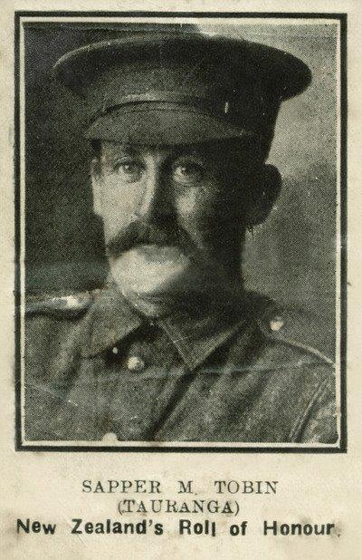
Sapper Michael Tobin is believed to be the first New Zealand soldier in the New Zealand Expeditionary Force to die on the Western Front.
Michael worked for the Public Works Department in Tauranga as a miner and in October 1915 responded to the call for men with mining experience to enlist in a specialist mining corps with the New Zealand Engineers.
Michael and his fellow tunnellers arrived in France in early 1916 and by April they were in Arras where it was reported that ‘a number of men off on account of bad colds and a few with measles'. Michael was one of these men. He was admitted to hospital on 14 April and died a day later of Bronchial Pneumonia.
The Unit Diary reports that on 20 April 1916 mining was in full swing North of Scarpe and in two galleries in hand near Agny. It also records; ‘Received word to-day of first death among members of Coy. No 4/1639 Sapper M. Tobin, who died in Hospital on 15th inst. of Broncho-Pneumonia and was buried at Lucheux Military Cemetery’.
After the Armistice, the graves at Lucheux were moved to Rows A and G of Beauval Communal Cemetery – where Michael’s is the only grave of a New Zealander.
Tragically, just days after receiving news of Michael’s death, his brother James took his own life.
With thanks to Sue Baker Wilson, Project Manager, New Zealand Engineers Tunnelling Company, Waihi Heritage Vision
LETTER TO MICHAEL FROM HIS GREAT NIECE – ANNE
Dear Michael
Today is 15 April 2016, the 100th anniversary of your death. The story of the N.Z Tunnellers is now being told and, as the first New Zealander to die on the Western Front, your name is becoming quite well known. What would you make of that?
This evening, the daily Beating of the Retreat Ceremony at the NZ National War Memorial, was in memory of you and Piana Pera, the second New Zealander and the first member of the NZ Maori Pioneer Battalion to die on the Western Front. To honour you both some top military brass attended the ceremony, including two serving Sappers. Did you ever receive so much honour when you were serving? I had the privilege of reciting the Ode to the Fallen at the Tomb of the Unknown Warrior, accompanied by Sylvia Pene, the G.G. niece of Piana. She recited the Ode in Maori.
In the preparation beforehand, we had been told that when we stepped forward to recite the Ode, we should consider that we owned the Tomb of the Unknown Warrior. As I stood listening to Sylvia, the meaning of that ownership hit me. That became you, Michael, lying in that tomb, you were real to me, not just a name on a family tree and I had so much to say to you! I was still processing all this as I stepped forward to recite the Ode in English. I was so pre-occupied with the things I wanted to say, that I started to recite the words from partway through. When I realised this I stopped, took a quick breath, looked at the words in my hand and began again from the beginning.
It was Poppy Day and I had bought a poppy that morning which I laid on the tomb, acknowledging out loud, that I laid it in memory of you. I was a little sad that I could not stand there and talk to you then, but the ceremony had to move on.
When the ceremony was over, Sylvia and I hugged each other, both a little shaken with emotion. We then had a T.V. interview for a programme on Anzac Day. I went first. My mind was still so much on what I wanted to say to you that I was not concentrating on my answers. Think I have mucked that up too, especially as I had also wanted to share how the news of your death had affected James. With his death as well, this left only William to carry on the family name. About 4 years ago, his grandson, Jeff, made contact with me after reading that I was researching the Tobin Family of Pukekohe. We have now met on two occasions at events honouring the New Zealand Tunnellers.
Perhaps the real legacy of your death will be that the later generations reunite and heal a family split by grief and the Victorian, moralistic attitudes of those days.
After the interview, the custodian of the Hall of Memories offered to show us the relevant entries in the Book of Memories. When I saw your name on the page of that special book, I was once again filled with emotion. Unfortunately by then it was getting cold and dark and Iain was ready to drive back home. Know that next time I am back in Wellington, I will be standing at that tomb, owning it, and having that conversation with you!
Your great niece.
Anne
“Harry” Palin
Henry William Bourne Palin (known to the family as Harry) is the Great Uncle of comedian, writer , actor and presenter Michael Palin.
Harry was a farmhand who at the outbreak of war in 1914 enlisted in the 1st battalion of the Canterbury Regiment of the New Zealand Expeditionary Force. He rose to the rank of Lance Corporal and died in the Battle of the Somme two years later. He has no known grave and is commemorated on New Zealand Memorial at Caterpillar Valley.
Michael takes up the story:
“When I first saw the name ‘Palin H.W.B’, with 1,200 others on that wall, I was deeply moved. That there was so little about him affected me all the more. It was as if his memory had been saved by the skin of its teeth. From that time on, I knew I had a duty to find out more, to drag great-uncle Harry back from the brink of obscurity.
“Soon after arriving in Europe from New Zealand, Harry was deployed to the Dardanelles where he fought in and survived the Gallipoli campaign in 1915.
“I know he was one of the New Zealand Division who fought for 23 consecutive days in the Battle of the Somme, and I have stood at the spot where he died on that late September afternoon, between the villages of Flers and Guedecourt. It was hardly a case of closure, as they call it these days, but then the New Zealand Archive tracked down something that made my throat dry: a hand-written account of great-uncle Harry’s death, entered in the official report by a Sgt Gridley.
“On 27th Sept L/cpl Palin and myself were in the same shell hole just before the taking of Gird Trench. Palin was just getting up to fire when he was hit through the head. I was next to him and am sure he was killed outright”.
Donald Brown VC
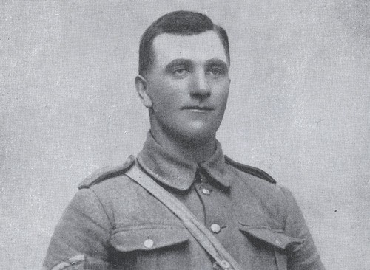
Credit: J.R. Byrne, New Zealand Artillery in the field, 1914–1918, Whitcombe & Tombs, 1922
Serjeant Donald Forrester Brown was the first member of the New Zealand Expeditionary Force to be awarded a Victoria Cross on the Western Front.
Born on 23 February 1890 in Dunedin, New Zealand – where he was a farmer – Donald volunteered for service with the New Zealand Expeditionary Force (NZEF) on 19 October 1915.
He joined the New Zealand Division in Egypt in January 1916 before he was sent to France with his unit – the 2nd Battalion, Otago Infantry Regiment.
Donald was awarded his Victoria Cross for his actions during the Battle of Flers-Courcelette – part of the Somme Offensive.
An extract from the London Gazette, dated 14th July, 1917, records the following:-
"For most conspicuous bravery and determination in attack (south-east of High Wood, France, on September 15, 1916), when the company to which he belonged had suffered very heavy casualties in officers and men from machine gun fire. At great personal risk this N.C.O. advanced with a comrade and succeeded in reaching a point within 30 yds of the enemy guns. Four of the gun crew were killed and the gun captured. The advance of the company was continued until it was again held up by machine gun fire. Again Serjt. Brown and his comrade, with great gallantry, rushed the gun and killed the crew. After this second position had been won, the company came under very heavy shell fire, and the utter contempt for danger and coolness under fire of this N.C.O. did much to keep up the spirit of his men. On a subsequent occasion in attack, Serjt. Brown showed most conspicuous gallantry. He attacked, single handed, a machine gun which was holding up the attack, killed the gun crew, and captured the gun. Later, whilst sniping the retreating enemy, this very gallant soldier was killed."
Donald is buried in the CWGC Warlencourt British Cemetery, France.

