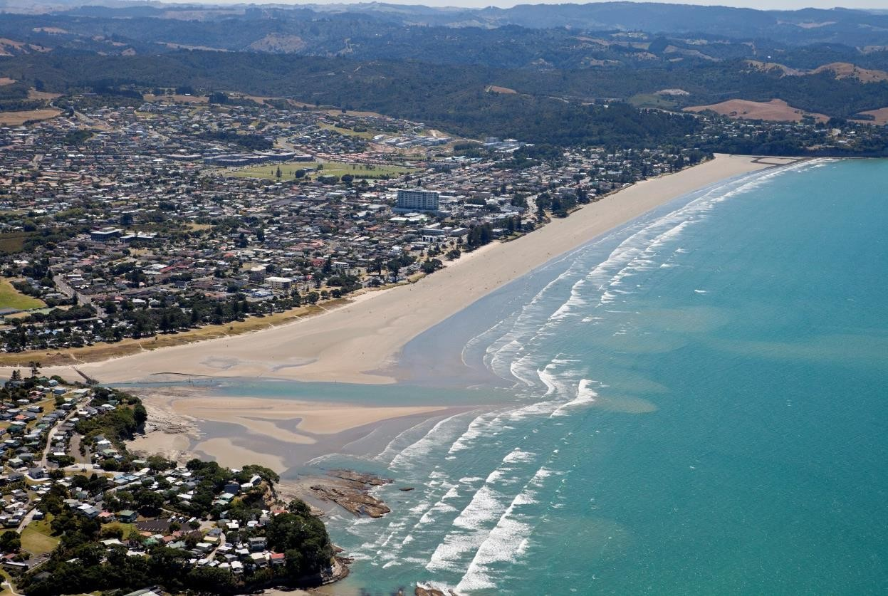
Orewa – Ahead of the wave

Auckland’s first
tsunami walk

Auckland Council invites you to attend Auckland’s first ever tsunami walk.

Join students and the community in Orewa who will be testing their evacuation route.

Where: Media are invited to join the walk with Orewa College students.
When: Please assemble on the Netball Court of Orewa College, 76 Riverside Road, for a briefing at 8:45am on Wednesday 25 May.

Interviews with participants will be available from 10:30am including:
- Auckland Council’s Head of Emergency Management and Operations - Aaron Davis
- President elect of Orewa Rotary – Billy Beggs

Please R.S.V.P to Katie MacKinnon
Katie.mackinnon@aucklandcouncil.govt.nz or 021 894 462

