January – March 2016 Issued: 8 January 2016
Hold mouse over links and press ctrl + left click to jump to the information you require:
Overview
Regional predictions for the next three months:
Northland, Auckland, Waikato, Bay of Plenty
Central North Island, Taranaki, Wanganui, Manawatu, Wellington
Gisborne, Hawke’s Bay, Wairarapa
Nelson, Marlborough, Buller
West Coast, Alps and foothills, inland Otago and Southland
Coastal Canterbury, east Otago
Background
Contacts
Notes to reporters and editors
NIWA Outlook: January - March 2016
Overview
Strong El Niño conditions continued to dominate the tropical Pacific during December 2015. Sea surface temperature anomalies in the central and eastern Pacific have weakened slightly, but still exceed +2ºC. The SOI is weakly negative at -0.6 for the month of December; however, strong westerly wind anomalies (weaker easterly trade-winds) continue to affect the western and central Pacific. Several ENSO indicators showed a weakening in the last two weeks, raising the possibility that El Niño could have reached its peak at the end of 2015. However, the current event is expected to remain in the strong category for the next three months, and the impacts of El Niño on New Zealand’s climate will likely persist into autumn.
International guidance indicates that El Niño conditions will continue (100% probability) over the next three months (January – March 2016) and will rapidly decay thereafter, with a return to normal conditions or a transition to La Niña conditions by July – September 2016.
For January - March 2016, above normal pressure is forecast to the north of New Zealand, while below normal pressure is expected to the south of the country. This circulation pattern is likely to be accompanied by anomalous westerly wind flows – a signature consistent with El Niño.

Outlook Summary
January - March 2016 temperatures are most likely (45% chance) to be above average for the east of the North Island. Temperatures are about equally likely to be near average (35% chance) or above average (40% chance) for all remaining regions of the country.
January - March 2016 rainfall is most likely (45% chance) to be below normal for the north of the North Island. Seasonal rainfall totals are about equally likely to be near normal (35-40% chance) or below normal (35-40% chance) for the remaining regions of the North Island and the north and east of the South Island. January - March 2016 rainfall is most likely (45% chance) to be above normal for the west of the South Island.
January - March 2016 soil moisture levels are most likely to be in the below normal range (45-55% chance) for the north and east of both Islands. Soil moisture levels are equally likely to be normal (40% chance) or below normal (40% chance) in the west of the North Island. In the west of the South Island, soil moisture levels are about equally likely to be in the above normal range (40% chance) or normal range (35% chance).
January - March 2016 river flows are most likely to be in the below normal range (45-50% chance) in the north of the North Island and the north and east of the South Island. River flows are equally likely to be in the normal range (40% chance) or below normal range (40% chance) for the west and east of the North Island. For the west of the South Island, river flows are about equally likely to be in the above normal range (40% chance) or normal range (35% chance).
Regional predictions for the January - March 2016 season
Northland, Auckland, Waikato, Bay of Plenty
The table below shows the probabilities (or percent chances) for each of three categories: above average, near average, and below average. In the absence of any forecast guidance there would be an equal likelihood (33% chance) of the outcome being in any one of the three categories. Forecast information from local and global guidance models is used to indicate the deviation from equal chance expected for the coming three month period, with the following outcomes the most likely (but not certain) for this region:
- Temperatures are about equally likely to be above average (40% chance) or average (35% chance).
- Rainfall totals are most likely to be below normal (45% chance).
- Soil moisture levels and river flows are most likely to be below normal (50-55% chance).
The full probability breakdown is:
 | Temperature | Rainfall | Soil moisture | River flows
Above average | 40 | 20 | 15 | 20
Near average | 35 | 35 | 30 | 30
Below average | 25 | 45 | 55 | 50

Central North Island, Taranaki, Wanganui, Manawatu, Wellington
Probabilities are assigned in three categories: above average, near average, and below average.
- Temperatures are about equally likely to be above average (40% chance) or average (35% chance).
- Rainfall totals are about equally likely to be near normal (40% chance) or below normal (35% chance).
- Soil moisture levels and river flows are equally likely to be in the below normal range (40% chance) or normal range (40% chance).
The full probability breakdown is:
 | Temperature | Rainfall | Soil moisture | River flows
Above average | 40 | 25 | 20 | 20
Near average | 35 | 40 | 40 | 40
Below average | 25 | 35 | 40 | 40

Gisborne, Hawke’s Bay, Wairarapa
Probabilities are assigned in three categories: above average, near average, and below average.
- Temperatures are most likely to be above average (45% chance).
- Rainfall totals are about equally likely to be below normal (40% chance) or near normal (35% chance).
- Soil moisture levels are most likely to be in the below normal range (45% chance).
- River flows are equally likely to be in the below normal range (40% chance) or normal range (40% chance).
The full probability breakdown is:
 | Temperature | Rainfall | Soil moisture | River flows
Above average | 45 | 25 | 20 | 20
Near average | 30 | 35 | 35 | 40
Below average | 25 | 40 | 45 | 40

Nelson, Marlborough, Buller
Probabilities are assigned in three categories: above average, near average, and below average.
- Temperatures are about equally likely to be above average (40% chance) or average (35% chance).
- Rainfall totals are about equally likely to be normal (40% chance) or below normal (35% chance).
- Soil moisture levels and river flows are most likely to be in the below normal range (45% chance).
The full probability breakdown is:
 | Temperature | Rainfall | Soil moisture | River flows
Above average | 40 | 25 | 20 | 20
Near average | 35 | 40 | 35 | 35
Below average | 25 | 35 | 45 | 45

West Coast, Alps and foothills, inland Otago, Southland
Probabilities are assigned in three categories: above average, near average, and below average.
- Temperatures are about equally likely to be above average (40% chance) or average (35% chance).
- Rainfall totals are most likely to be above normal (45% chance).
- Soil moisture levels and river flows are about equally likely to be above average (40% chance) or average (35% chance).
The full probability breakdown is:
 | Temperature | Rainfall | Soil moisture | River flows
Above average | 40 | 45 | 40 | 40
Near average | 35 | 35 | 35 | 35
Below average | 25 | 20 | 25 | 25

Coastal Canterbury, east Otago
Probabilities are assigned in three categories: above average, near average, and below average.
- Temperatures are about equally likely to be above average (40% chance) or average (35% chance).
- Rainfall totals are about equally likely to be near normal (40% chance) or below normal (35% chance).
- Soil moisture levels and river flows are most likely to be in the below normal range (45% chance).
The full probability breakdown is:
 | Temperature | Rainfall | Soil moisture | River flows
Above average | 40 | 25 | 20 | 20
Near average | 35 | 40 | 35 | 35
Below average | 25 | 35 | 45 | 45

Graphical representation of the regional probabilities

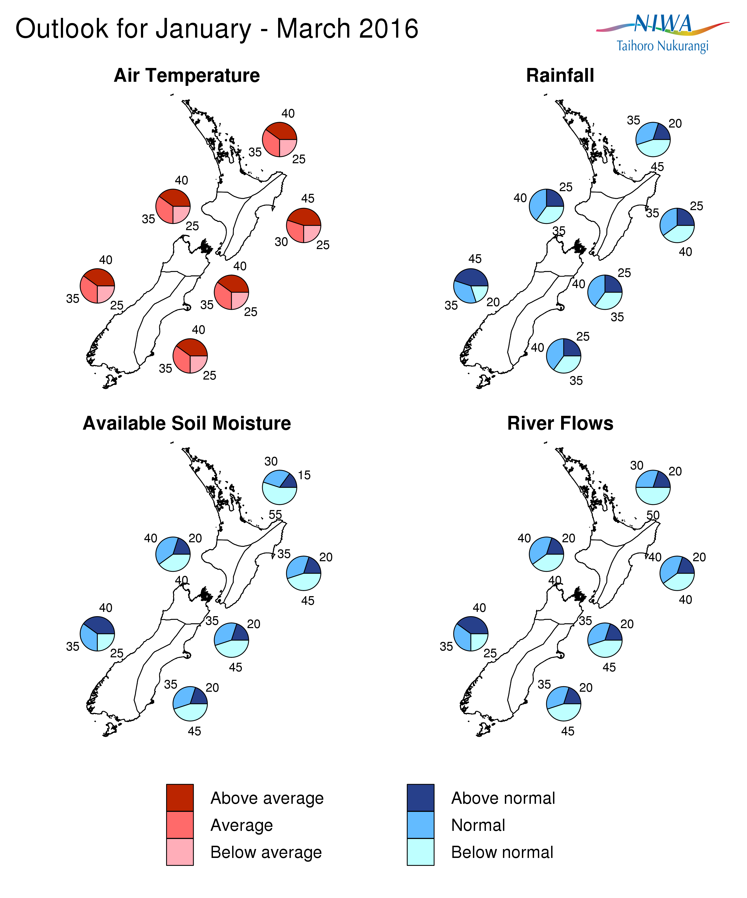

Background

Strong El Niño conditions continued to dominate the tropical Pacific during December 2015. The latest monthly sea surface temperature anomalies in the central and eastern Pacific have weakened slightly, but still exceed +2ºC. The sub-surface ocean temperature anomalies in the eastern Pacific have decreased significantly over the last month (December 2015) and now reach about +4ºC at 75-100m depth near 120ºW (compared to peak values of about 7ºC earlier last month). The Southern Oscillation Index (SOI) is weakly negative at -0.6 for the month of December; however, strong westerly wind anomalies (weaker easterly trade-winds) continue to affect the western and central Pacific. Convective activity and rainfall also remain higher than normal in the central and eastern Pacific, while parts of the Maritime Continent continue to experience drier than normal conditions.
International guidance indicates that El Niño conditions will continue (100% probability) over the next three months (January – March 2016) and will rapidly decay thereafter, with a return to normal conditions or a transition to La Niña conditions by July – September 2016.
While several ENSO indicators showed a weakening in the last two weeks, raising the possibility that El Niño could have reached its peak at the end of 2015, it is important to note that the current event is expected to remain in the strong category over the next three months. Moreover, the impacts of El Niño on New Zealand’s climate will likely persist into autumn.
El Niño events are typically (but not always) associated with stronger and/or more frequent westerly winds over summer in New Zealand, following more southwesterlies in spring. Such a circulation pattern can lead to wetter than normal conditions to the west of the Southern Alps and drier conditions in northern and eastern regions of both Islands. The next three months (January – March 2016) rainfall forecasts broadly reflect these typical impacts. Note that the three previous strongest El Niño events since 1950 (1972/73, 1982/83 and 1997/98) were all associated with very dry conditions (below 50% of the normal rainfall over summer) in northeast parts of the country: eastern Northland, Coromandel, coastal Bay of Plenty, southern Hawke’s Bay and coastal Wairarapa, and Marlborough.

On average, New Zealand experiences at least one ex-tropical cyclone passing within 550km of the country every year. For this tropical cyclone season (through to April 2016), the risk for New Zealand is slightly higher than normal. If an ex-tropical cyclone comes close to the country, the current background climate conditions suggest it has an equal probability of passing east or west of Auckland city. Typical impacts from such systems include heavy rain and strong winds, particularly for the northeast of the country. For example, earlier this month a low of tropical origin provided many locations on the east and north of the North Island with 50-100% of the total normal January rainfall.
Water temperatures surrounding New Zealand are currently slightly below normal, Ocean models suggest that waters will remain cooler than normal especially to the east of the country.
To find out more about normal conditions for this outlook period, refer to NIWA’s website, where daily updates on climate maps are available.

For comment, please contact
Chris Brandolino, Principal Scientist – Forecasting, NIWA National Climate Centre
Tel (09) 375 6335, Mobile (027) 886 0014

Dr Brett Mullan, Principal Scientist, NIWA National Climate Centre
Tel (04) 386 0508, Mobile (027) 294 1169.
Notes to reporters and editors
- NIWA’s outlooks indicate the likelihood of climate conditions being at, above, or below average for the season as a whole. They are not ‘weather forecasts’. It is not possible to forecast precise weather conditions three months ahead of time.
- The outlooks are the result of the expert judgment of NIWA’s climate scientists. They take into account observations of atmospheric and ocean conditions and output from global and local climate models. The presence of El Niño or La Niña conditions and the sea surface temperatures around New Zealand can be a useful indicator of likely overall climate conditions for a season.
- The outlooks state the probability for above average conditions, near average conditions, and below average conditions for rainfall, temperature, soil moisture, and river flows. For example, for winter (June–July–August) 2007, for all the North Island, we assigned the following probabilities for temperature:
· Above average: 60 per cent
· Near average: 30 per cent
· Below average: 10 per cent
We therefore concluded that above average temperatures were very likely.
- This three-way probability means that a random choice would be correct only 33 per cent (or one-third) of the time. It would be like randomly throwing a dart at a board divided into three equal parts, or throwing a dice with three numbers on it. An analogy with coin tossing (a two-way probability) is not correct.
- A 50 per cent ‘hit rate’ is substantially better than guesswork, and comparable with the skill level of the best overseas climate outlooks. See, for example, analysis of global outlooks issued by the International Research Institute for Climate and Society based in the US published in the Bulletin of the American Meteorological Society (Goddard, L., A. G. Barnston, and S. J. Mason, 2003: Evaluation of the IRI’s “net assessment” seasonal climate forecasts 1997–2001. Bull. Amer. Meteor. Soc., 84, 1761–1781).
- Each month, NIWA publishes an analysis of how well its outlooks perform. This is available online and is sent to about 3500 recipients of NIWA’s newsletters, including many farmers. See www.niwa.co.nz/our-science/climate/publications/all/cu
- All outlooks are for the three months as a whole. There will inevitably be wet and dry days, and hot and cold days, within a season. The exact range in temperature and rainfall within each of the three categories varies with location and season. However, as a guide, the “near average” or middle category for the temperature predictions includes deviations up to ±0.5°C for the long-term mean, whereas for rainfall the “near normal” category lies between approximately 80 per cent and 115 per cent of the long-term mean.
- The seasonal climate outlooks are an output of a scientific research programme, supplemented by NIWA’s Capability Funding. NIWA does not have a government contract to produce these outlooks.
- Where probabilities are within 5% of one another, the term “about equally” is used.
Visit our media centre at: www.niwa.co.nz/news-publications/media-centre

