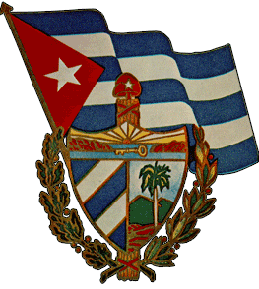
Embassy of Cuba in New Zealand

Newsletter
No.14 14th April 2015

ABSTRACT
All of the Americas outside of the United States support the lifting of the blockade and removal of Cuba from the list of countries supporting terrorism. Media are reporting the US president considering this move in view of the Cuban position that diplomatic ties cannot be re-established until this is achieved. So our first stories cover these current historic events at the 7th Americas Summit and diplomatic visits. Cuba’s medical efforts overseas are welcomed by Chile and praised by WHO and Liberia as Cuba graduates 24 500 doctors for 83 countries at its ELAM institution.
In science we cover biogas in Panama, biotechnology opportunities in China; UNESCO highlights Cuba’s spend of 13 percent of its gdp on education, the highest in Latin America, which also draws praise from the Economic Commission for Latin America and the Caribbean’s Alicia Barcenas who says that despite the blockade Cuba had invested important resources for all levels of teaching and technology innovation.
Finally, an interesting window on the developing interface with international trade from minister of foreign trade and investment Rodrigo Malmierca who points to the need to harmonise the efficient use of non-traditional funding and making better use of the funding available.

Embassy of Cuba in New Zealand

Newsletter
No.14 14th April 2015
Upcoming events
April
M | T | W | T | F | S | S
 |  | 1 | 2 | 3 | 4 | 5
6 | 7 | 8 | 9 | 10 | 11 | 12
13 | 14 | 15 | 16 | 17 | 18 | 19
20 | 21 | 22 | 23 | 24 | 25 | 26
27 | 28 | 29 | 30

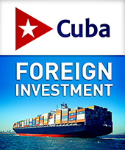
In this issue
- 7th Summit of the Americas an historic event
- An intense bilateral agenda
- Presidents meet at the 7th Summit of the Americas
- Raul meets president of US Chamber of Commerce
- Raul meets Ban Ki-moon in Panama
- South Africa welcomes Cuba at Summit of the Americas
- Cuban medical brigade travels to Chile
- Cuba graduates over 24500 doctors for 83 countries in ten ceremonies
- Cuban health model ‘an example for the world’
- Cuba’s experience: biogas technology in Panama
- Liberian foreign minister praises Cuban doctors
- Biotechnology opportunities in China for Cuba
- UNESCO applauds Cuba’s priority on education
- CEPAL executive secretary praises Cuban education
- New challenges for ‘the socialist company’

BLOCKADE

7th Summit of the Americas an historic event
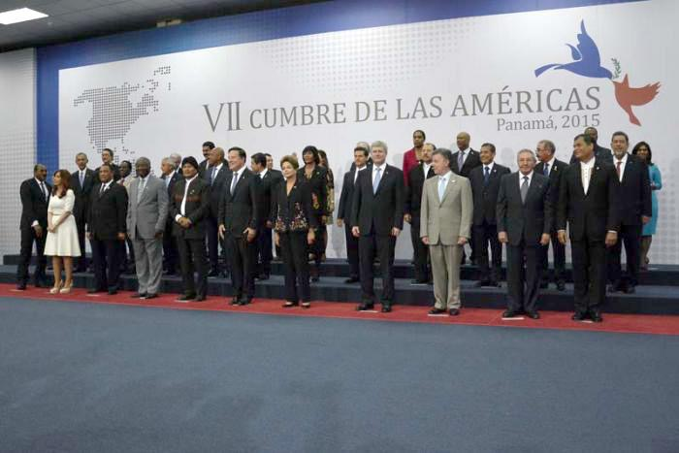
The 7th Summit of the Americas has confirmed the historic significance of an event noteworthy, above all, for Cuba’s participation for the first time.
The speakers all welcomed the presence of President Raúl Castro at the summit, as well as the willingness of the governments of Cuba and the United States to reestablish diplomatic relations. Rejection of the executive order issued by President Obama classifying Venezuela as a threat was also expressed.
Raúl was the sixth leader to speak, following the US president, and received a unanimous ovation from the plenary in recognition of the historic significance of the occasion. He stated that it was a joy to be present at the meeting and joked about the fact that Cuba was owed six summits, which is why he requested that Juan Carlos Varela, president of the host country, allow him a few more minutes to speak.
Raúl was precise and emphatic in his speech. He praised Martí, Fidel and his heroic people. He recalled difficult and unforgettable moments of the island’s history which have left an indelible mark on the Cuban Revolution, the immense work which fills him with passion.
To Obama, he reiterated Cuba’s willingness to engage in dialogue, based on respect and peaceful coexistence; and expressed gratitude for his intention to remove Cuba from the list of state sponsors of terrorism.
Raúl called on the leaders of the region to continue supporting the struggle to end the blockade which remains intact and constitutes the principle obstacle to the development of the Cuban economy.
As was expected, he reaffirmed Cuba’s full solidarity with Venezuela, a country struggling to carve out its own path, and which is suffering unjust unilateral sanctions and “is experiencing the same aggressions we suffered.”
He concluded, stating that thanks to Fidel and the Cuban people, we had come to this Summit, to fulfil the mandate of Martí “with the freedom won by our own hands, proud of our America, to serve and honour her...with the determination and capacity to help ensure that she is valued for her merits, and respected for her sacrifices.”
Read the speech in full

Back to top
DIPLOMACY
An intense bilateral agenda
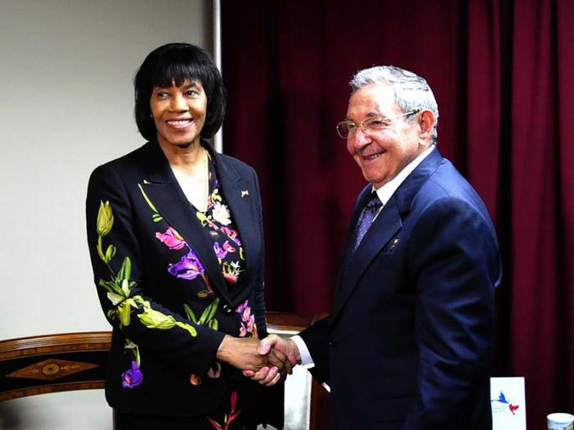
In addition to the official sessions of the summit, Raúl had an intense bilateral schedule, which began in the afternoon with a meeting with Barack Obama and concluded in the evening with prime minister of Jamaica Portia Simpson.
During a plenary session recess, Raúl and Obama met in a room prepared for the occasion in the ATLAPA Convention Centre, one of the highlights of the summit and long-awaited by the delegations and accredited press in the country.
The island’s ministry described the exchange as respectful and constructive, during which both leaders expressed their points of view regarding the process of re-establishing diplomatic relations between the two neighbouring nations.
Raúl reiterated Cuba’s willingness to discuss any issue, on the basis of mutual respect. Meanwhile, Obama commented on the historic significance of the encounter and described as important the exchanges which currently exist between the governments and peoples of Cuba and the United States.
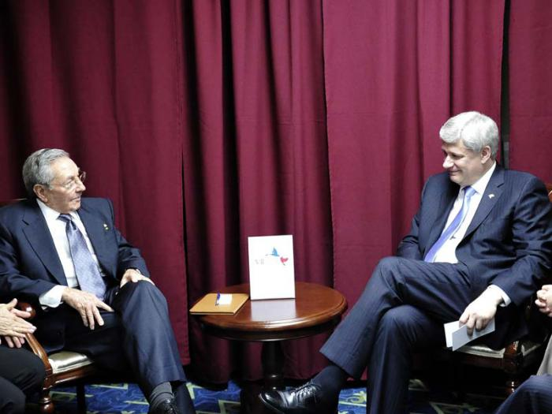
As part of his agenda Raúl also held a meeting with the prime minister of Canada, Stephen Harper, during which the good state of relations with the northern country were expressed and described as an example of mutually beneficial ties.
Specifically, in March, 2015, the 70th anniversary of uninterrupted diplomatic relations between the two nations had been celebrated, and Canada was currently one of Cuba’s top five trading partners.
Also present during the bilateral meeting, which was also held in one of the ATLAPA Convention Centre’s rooms, were deputy chief of staff Howard Anglin, minister of foreign affairs Bob Nicholson; and deputy minister of foreign relations of Cuba, Rogelio Sierra Díaz.

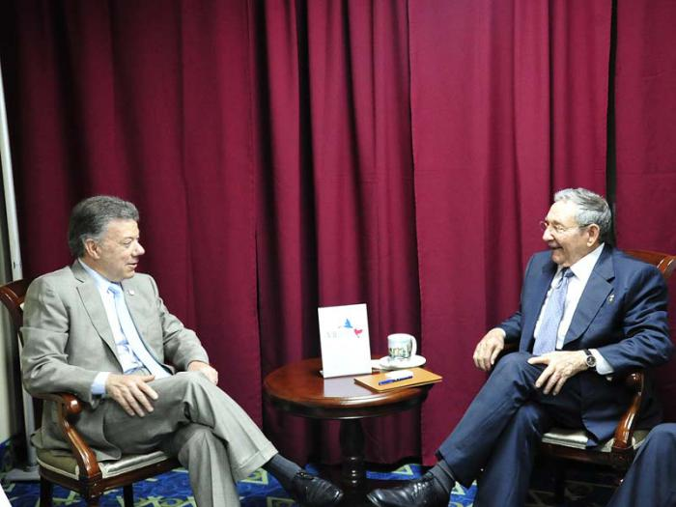
Afterwards, Raúl met with Colombian president Juan Manuel Santos to discuss, among other topics, the country’s peace talks taking place in Havana. The Cuban president reiterated his country’s willingness to continue supporting, as it has done to date, this effort to achieve peace. Also participating in the conversation, during which issues on regional agenda were addressed, were Colombian minister and deputy ministers of foreign affairs — María Ángela Holguín and Sierra Díaz, respectively.
Later, it was the turn of the Netherlands, represented by prime minister Mark Rutte. Also in attendance at the meeting with Raúl were the prime minister of Aruba, Mik Eman; minister of finance of Curazao, José Jardim; director of the Americas department of the Ministry of Foreign Relations, Maryam Van Heuyel; as well as Jack Twiss, foreign affairs advisor.
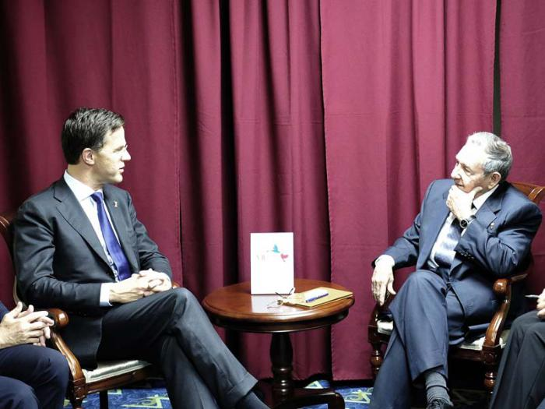
There, the positive state of relations between the two countries and interest in promoting the presence of Dutch businesses on the island were expressed. Prime Minister Mark Rutte showed particular interest in Cuba’s history and the origins of the conflict between the US and Cuba.
Raúl’s meeting with Portia Simpson and the delegation accompanying her to the summit, became another opportunity in which the close relations between the two islands were confirmed and a fitting moment to recall the historic decision of a group of Caribbean countries to reestablish relations with Cuba in 1972.
In all the meetings Raúl’s counterparts expressed interest in the progress of the process of negotiations for the re-establishment of diplomatic relations with the United States and supported Cuba’s petition to be removed from the list of state sponsors of terrorism, as well as the lifting of the blockade.

Back to top

DIPLOMACY

Presidents meet at the 7th Summit of the Americas
Presidents Raúl Castro and Barack Obama finally met on Saturday, April 11, during a break in the sessions of the last day of the 7th Summit of the Americas, an encounter highly anticipated by everyone.
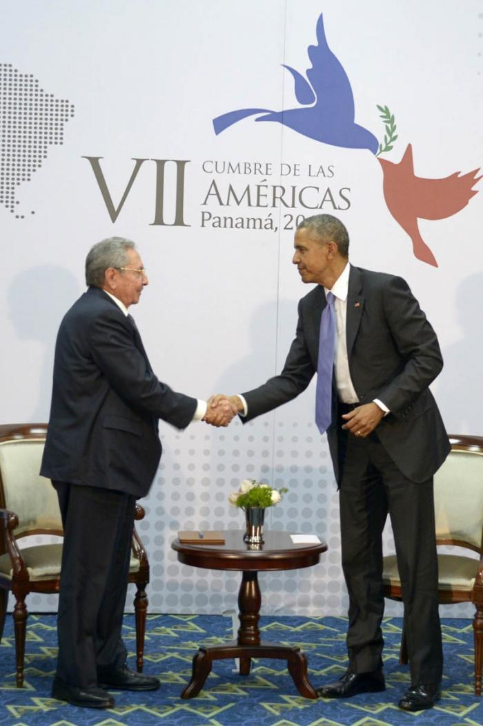
Raúl said the key aspect was that the two sides were willing to discuss everything, including human rights and press freedom — these and other issues relating to Cuba and also the United States.
“I think everything can be discussed, if done so with mutual respect,” said the Cuban president. “It may be that we convince each other of certain things, but not others.
“We should be under no illusions, we have many differences and a complex history, but we are ready to move forwards in these meetings to establish diplomatic relations.”
Raúl referred to the opening of embassies, increased visits between the two countries and to engage in all the issues pertinent to such close neighbours.
“We can talk about everything with patience, even in these times when life moves so fast,” he said. “We hope that our closest collaborators know how to comply with the instructions of both presidents.”
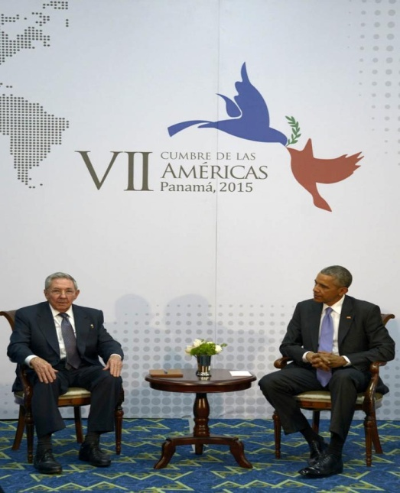
Obama, for his part, said that the history between the U.S. and Cuba was complicated, as there had been a climate of mistrust for a long time. After 50 years it was time to try something new.
“It is important to maintain contact between the two governments and peoples. We are now in a position to move on a path toward the future: we will leave behind the things that complicated the past.”
Obama said the two peoples had positively supported the changes: “As exchanges increase I believe there will be more direct contact and greater connection between our countries.
“There will continue to be deep and significant differences, we will continue to attempt to raise concerns about democracy and human rights.
“As Raúl said in his impassioned speech they are also attempting to raise those concerns,” commented Obama. “Over time, it is possible for us to turn the page and develop a new relationship between our two countries.
“We want our diplomats to have more daily contact,” he said, “to the point of opening the two embassies.
“Thanks to Castro, for the spirit of openness that he has demonstrated towards us, we can continue to construct our relationship based on mutual respect.
“Castro spoken of the hardships that the Cubans have had to endure, my policy is to help them to be more prosperous. The Cubans are an enlightened, intelligent and brilliant people,” he concluded.
Also attending the meeting were Susan Rice, national security adviser; Roberta Jacobson, assistant secretary of state for Western Hemisphere affairs; Ben Rhodes, deputy national security adviser; and Ricardo Zúñiga, senior director for Western Hemisphere affairs at the National Security Council.
Representing Cuba were foreign minister Bruno Rodríguez Parrilla, Alejandro Castro Espín and Juan Francisco Arias Fernández, both of the Commission for National Security and Defence; and MINREX director general for the United States, Josefina Vidal Ferreiro.

Back to top

DIPLOMACY

Raul meets president of US Chamber of Commerce
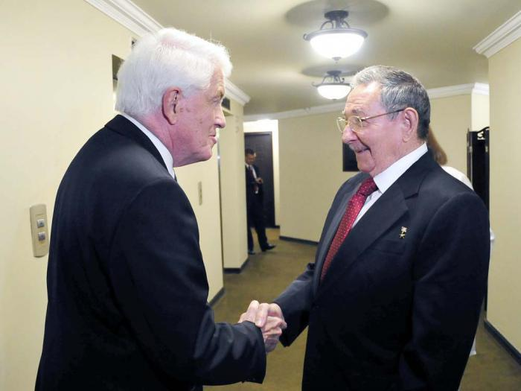
Cuban president Raul Castro has met in Panama the president and CEO of the Chamber of Commerce of the United States, Tom J Donohue.
The meeting was part of the agenda of the head of state prior to the beginning of the 7th Summit of the Americas.
According to media reports, this was the second meeting between the Cuban head of state and the US official, who visited Havana in May, 2014.
Present at the meeting, in which topics of interest for the two countries were tackled, was the vice-president for the Americas of the International Division of the US Chamber of Commerce Jodi Hanson, and the Cuban minister of foreign trade and investment, Rodrigo Malmierca.
Also taking part in the meeting were Cuban deputy foreign minister Rogelio Sierra and the director of the United States office of the island’s Ministry of Foreign Affairs, Josefina Vidal.
Back to top

DIPLOMACY

Raul meets Ban Ki-moon in Panama
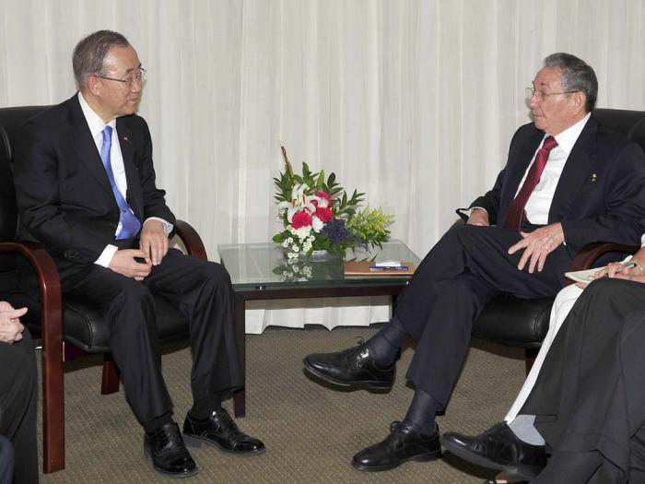
Cuban president Raul Castro met this week in the Panamanian capital with United Nations secretary general Ban Ki-moon.
In a meeting prior to the inauguration on Friday night of the 7th Summit of the Americas, the men focused on topics of the global agenda, such as the strengthening of the international organization, disarmament, peace and social development.Ban Ki-moon was accompanied at the meeting by Susana Malcorra, head of the secretary general’s cabinet, Jeffrey Feltman, undersecretary of the Department of Political Affairs; and Alicia Barcelona, executive director of the Economic Commission for Latin America and the Caribbean (ECLAC).

Back to top

DIPLOMACY
South Africa welcomes Cuba at Summit of the Americas
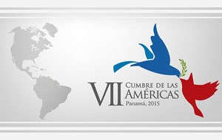
Cuba's presence at the next Summit of the Americas in Panama is confirmation of the example of its independence for the world, said a leader of the South African Communist Party (SACP).
The situation shows that the US is losing support in Latin America and the Americans have realized that, said Chris Matlhako, secretary of SACP’s international affairs.
Mathlako highlighted the integration process taking place in the region and said that the US has noticed that it is impossible stop the trend.
Matihako — also secretary general of the Friends of Cuba Association in South Africa — said that the Cuban presence at that meeting would be a historical fact, chiefly because, he added, this would also happen after big pressure on Washington to change its policy towards Cuba.

Back to top

MEDICINE
Cuban medical brigade travels to Chile
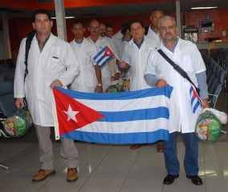
A Cuban medical brigade has gone to Chile to assist people in areas affected by severe flooding and heavy rains.

The group, made up of 15 professionals — nine physicians, four nurses, and two professionals in hygiene and epidemiology — was farewelled by health minister Roberto Morales, who recalled that Chile was the first country where Cuba began the medical collaboration in 1961, after an earthquake.

The island's professionals went a second time in 2010, also after an earthquake, with a much bigger brigade working in two field hospitals.

This time, a small group is working with the Chilean health system, and will help mitigate the damages the country is currently facing, said Morales.

“Again, an army in white coats will give the solidarity and human response to people that need it, and we are sure that they will return ‘mission accomplished’ as we have already received the two first brigades that returned from fighting the ebola virus in West Africa” he told media.

Back to top

MEDICINE
Cuba graduates over 24500 doctors for 83 countries in ten ceremonies
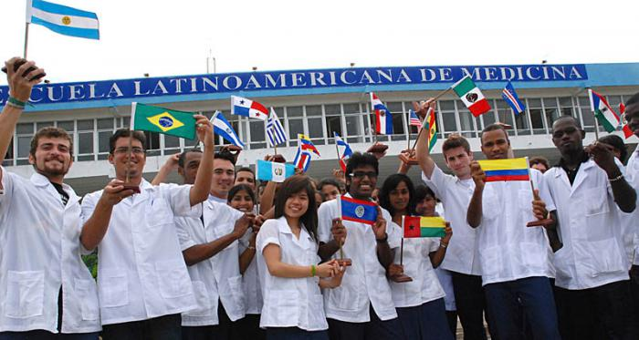
More than 24,500 general practitioners from 83 countries graduated from the classrooms of the Latin American School of Medicine (ELAM) in its 10 graduations.
Dr. Rafael Gonzalez Ponce de León, rector of the institution, told the National Information Agency, that more than 1,200 of the total of graduates had second specialties.
Currently 6,075 students from 117 countries, including 104 from the United States are studying to be doctors in the school, founded on November 15, 1999 by the leader of the Cuban Revolution, Fidel Castro, Gonzalez said.
He explained that there were already 112 physicians from the northern nation, graduated by the model of integration for peoples. He emphasised that over 60 percent of those enrolled were from Africa, and there were also graduates from America, Asia, Middle East and Oceania.
Dr. González will take this experience to the Forum of Rectors, which will be held parallel to the Seventh Summit of the Americas in Panama City.

Back to top

MEDICINE

Cuban health model ‘an example for the world’
The Cuban health model is an example for the world, Dr. José Luis Di Fabio, representative of Pan American and World Health Organization (PAHO / WHO) told the National Information Agency saying that Cuba had access and universal health coverage, and, just like education, it was a right of all the people.
Di Fabio highlighted the programme of the family doctor and nurse, which from the community, through the primary health care system, worked in health promotion and prevention, diagnosis and treatment of diseases, a way to ensure the welfare of the population.
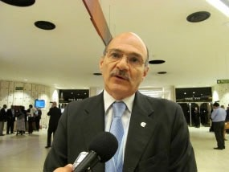
He referred to infant mortality, down to 4.2 per a thousand born alive last year, the lowest rate in the Americas, including the US and Canada, and the increased life expectancy to almost 80 years old.
"Cuba has much to show in the field of health in the civil society forum, which will be held this week in the frame of the Seventh Summit of the Americas in Panama," said Di Fabio.
He stressed that one of the topics covered in the event was related to equity and universal coverage of health services, and in this regard , he reiterated that Cuba is a model.
Di Fabio spoke about the importance of taking into account the epidemiological characteristics of the population of the region, and recalled the increase of chronic diseases such as cancer, cardiovascular and cerebrovascular diseases.
“That should also be a priority to be discussed at the event, directly related to access and universal coverage if you consider those were the conditions responsible for more sickness and death,” he said.
Another issue that would be addressed in parallel to the debate of heads of state and government forums, was related to the ebola virus in West Africa, compliance IHR and to see how prepared the hemisphere was to face the introduction of this disease in the region.
Di Fabio also praised the international collaboration of Cuba, which since the early 60s of last century has fulfilled missions in more than one hundred nations.
He talked about the programme "More Doctors", which Brazil supports, where Cuban health professionals were taking care of more than 50 million people and had contributed to the increase of public health indicators.
In the same way the Cuban involvement with medical services in many states was precisely to provide that access to health care for vulnerable people with no access, he said.

Back to top

SCIENCE
Cuba’s experience: biogas technology in Panama
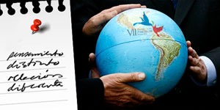
The use of biogas as a renewable energy source with community involvement is one of the experiences that Cuba will present at the civil society forum preceding the 7th Summit of the Americas in Panama.

Doctor of Science José Antonio Guardado Chacón, a CUBASOLAR specialist, told media that for 30 years the country has been developing this technology, which seeks a sustainable environment and the welfare of the community.
This was a new modality, the Cuban nation the only one in the continent which can boast of societal participation as its main ally, said Guardado who specializes in wastewater treatment systems, biogas plants and environmental management.
He further explained that the experience emerged in 1983 in central Cuba, as an initiative developed by the Biogas-Users Network (or MUB): a voluntary group, whose main stage was the Cuban countryside and rural areas, own-consumption farms, pig farms, small producers, and users as part of local development strategies.
Biogas is an energy carrier, a renewable energy source, mainly used in food production, but it can also be used in power generation, welding, and some even use it as an insecticide and bactericide, biofertilizer and compost for soil fertilization, he said.
More than a hundred representatives of the Cuban civil society — young people, intellectuals, farmers, cooperatives, entrepreneurs and scholars — were participating in forums and parallel activities.
Issues related to democratic governance and citizen participation, migration, security, energy, environment, health and education were addressed.

Back to top

SCIENCE

Liberian foreign minister praises Cuban doctors
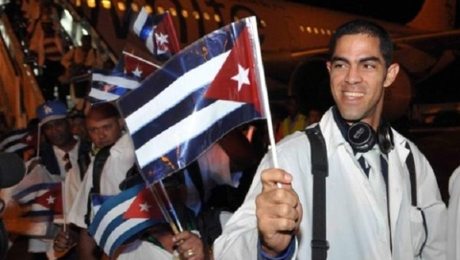
Liberian foreign minister Augustine Kpehe told media that an important chapter will be devoted to the role of Cuban doctors when the history of how Africa defeated ebola is told.
Kpehe told Cuban reporters in Liberia that Cuba should be present also during the recovery stage after ebola because Cuban medical standards area highly competent.
During the high-level meeting summoned by the United Nations on ebola, Cuba was among the first countries volunteering to help and its support was decisive to halt and control the virus.
He said that the arrival of Cuban doctors brought much hope to his country and also that when a human being was willing to offer his or her life to save another, that is the highest expression of love, and that was what Cuban doctors did.
The political relations between Cuba and Liberia have been traditionally strong, since the establishment of diplomatic relations in the 1970s, mainly at UN forums and the non-aligned countries organisation.
On the rapprochement between Cuba and the United States, Kpehe voiced the support of his government for Cuba’s sovereignty and for any initiative passed at regional blocs, like the African Union.

Back to top

SCIENCE
Biotechnology opportunities in China for Cuba
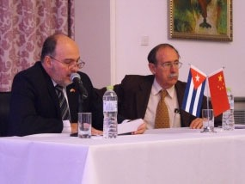
The director of the Molecular Immunology Centre (CIM), Doctor Agustin Lage, has presented the opportunities Cuba offers to a group of Chinese business people for investment in biotechnology and pharmaceutics, particularly in the Mariel Special Development Zone.
The scientist reported to dozens of managers from Chinese companies, presenting the current panorama of biotechnology worldwide, the progress of that specialty in Cuba, and the peculiarities of the centre he has led for more than 20 years.
Doctor Lage was introduced to executives and representatives from bodies and institutions from Cuba and China by Ambassador Alberto Blanco, who referred to the progress of cooperation between Cuba and China in biotechnology.
“I come here to explain to you why investomg in Cuba is important,” said Lage, who detailed the main projects open to foreign participation in the Mariel Special Development Zone (ZDEM).
The CIM director first stressed the quality of Cuba’s human resources, and talked of the development of biotechnology projects in his country, new productions to support industrial investments, and incentives for investment in the ZDEM.
There were some possibilities to invest in the pharmaceutical industry in cytostatic products, antiretroviral treatments, blood derivatives, oral drugs (tablets and capsules), aerosols and injections such as cephalosporin and carbapenem, among others, he said.
The CIM director stated that there were some proposals in the spheres of natural products such as cosmetics, homeopathic remedies, powders and liquid extracts, as well as materials and services needed for bio-pharmaceutical industry, biotechnology and packaging for both industries.
Cuba began in biotechnology in 1981 and founded the centre for genetic engineering in 1986, opening the Scientific Resort in 1992 with more than 20 institutions, 10,000 employees and exports to 50 countries. The pharma industry and the Biocubafarma Holding organization merged three years ago.
The latter has 32 companies, eight of them trade companies, 78 production facilities, and 21,785 workers, 262 of them with scientific degrees.

Back to top

EDUCATION
UNESCO applauds Cuba’s priority on education
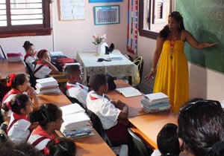
Cuba devoted 13 percent of its gdp to education last year, the highest rate in Latin America, educaton specialist Nihan Blanchy Koseleci said this week.
That sector has been prioritised in the nation's financial commitments, said Koseleci, researcher of the Education for All (EFA) Global Monitoring Report 2015, prepared by UNESCO (United Nations Educational, Scientific and Cultural Organization).
The island attained the most progress in the region in the main EFA areas. It has invested in training teachers and has reached many achievements in preschool, primary and junior high level, said Koseleci.
The report, presented this week by UNESCO, showed that one of three countries in the world has reached the global goals of education for all in the 2000-2015 period, a goal only Cuba achieved in Latin America.
The main goal, universal education of all children in age of attending primary schools, was achieved by half of the nations worldwide, the document stated.
Other items were: extending and improving care in early childhood education, ensuring youth and adults have equal access to learning and acquisition of skills for daily life, and achieving a 50-percent reduction of illiteracy levels in adult population.
Removing disparity among sexes, achieving equality among them in education, improving quality of education for everyone, and getting measurable learning outcomes are also on the list.
UNESCO estimates that about $22 billion dollars a year will be needed to supplement the contributions provided by governments, either ambitious for themselves, if we want the new goals in education that are now being set for the 2015-2030 period to be achieved.

Back to top

EDUCATION
CEPAL executive secretary praises Cuban education
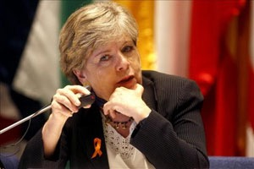
Executive secretary of the Economic Commission for Latin American and the Caribbean (ECLAC), Alicia Barcenas, stated today that Cuba is an exception in the continent, because access to education is a right for everyone.
She noted to media that despite the difficulties imposed by the blockade, the Caribbean nation had invested important resources for all teaching levels and technology innovation, in terms of education.
Barcenas praised the quality of human resources, saying they were the best prepared professionals at this time to work in crucial issues such as biotechnology and stressed that the region had generated its own patents, as Cuba did with the meningococcal vaccine.
The ECLAC executive secretary stated that we should train more qualified people to work on the issue of equality, and abolish the culture of privileges.
Barcenas also referred to the challenges the region is currently facing, among them the link of education with the productive structures, and the need to achieve in the educational field illustrates the core values of society.
During her speech at the Rectors' Forum the ECLAC top representative proposed an alternative for a free education and achieving full employment in all countries.
Back to top

INSIDE CUBA
New challenges for ‘the socialist company’
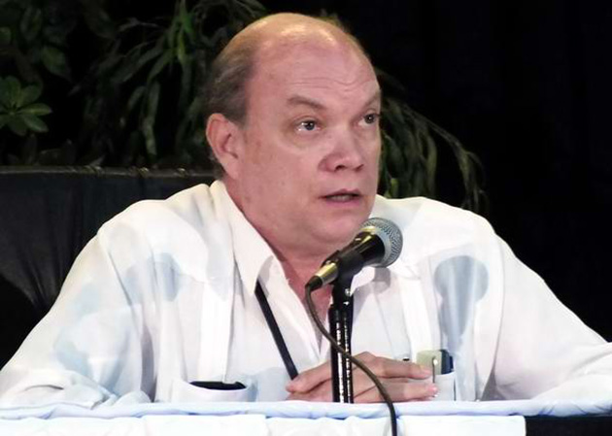
Minister of foreign trade and investment Rodrigo Malmierca has pointed out that in the current context the socialist enterprise faced new challenges to achieve objectives such as attracting foreign capital to the country.
IN his address to the general assembly of members of the Chamber of Commerce of Cuba (CCC) he also referred to the need for efficient use of non-traditional funding sources and better use of those available.
“We also pay attention to issues sometimes tackled with little frequency such as quality of both the production of goods and services, among many others no less important,” he said
The minister also referred to the problems in the investment process, which required special attention.
The new regulations made clear the responsibilities of all factors involved in this complex activity, but required effort to harmonize the forces and achieve the completion of the work.
The new value of use created with investment is the one that would allow recovering of the resources used, he said.
He also noted the need to adequately train the managers so as to be in better condition to assume the responsibility for the greater autonomy and independence that the economic guidelines assigned to socialists enterprises would bring.
Back to top

Embassy of the Republic of Cuba in New Zealand
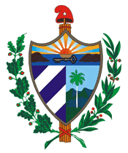
76 Messines Rd, Karori, Wellington 6012
www.cubadiplomatica.cu/nuevazelanda/EN/Home.aspx
Visit the Embassy of Cuba in New Zealand Facebook page
Text edited by David Reade of International Public Relations (ipr.bz) on behalf of the Cuban Embassy, Wellington, from Cuban news agency sources

