**Media Release**

**2 December 2014**

**Asking prices bust through the $500,000 barrier**

The average asking price of a property for sale in New Zealand broke through the $500,000 barrier for the first time in November, as the Trade Me Property Price Index rose 2.3 per cent.

The Property Price Index measures trends in asking prices for residential property listings added to Trade Me Property by real estate agents and private sellers over the previous three months. It provides buyers, sellers and realtors with insights into ‘for sale’ price trends by property type and property size.

Head of Trade Me Property Nigel Jeffries said the new record high in asking price signalled ongoing confidence in the property market from sellers. “The November data echoes the lift we saw in October, meaning sellers have continued to raise their price expectations to land at a new high water mark of $509,750. There has been a resounding resurgence in the property market after a pretty subdued winter and that all adds up to good news for sellers and a bitter pill for buyers to swallow. ”

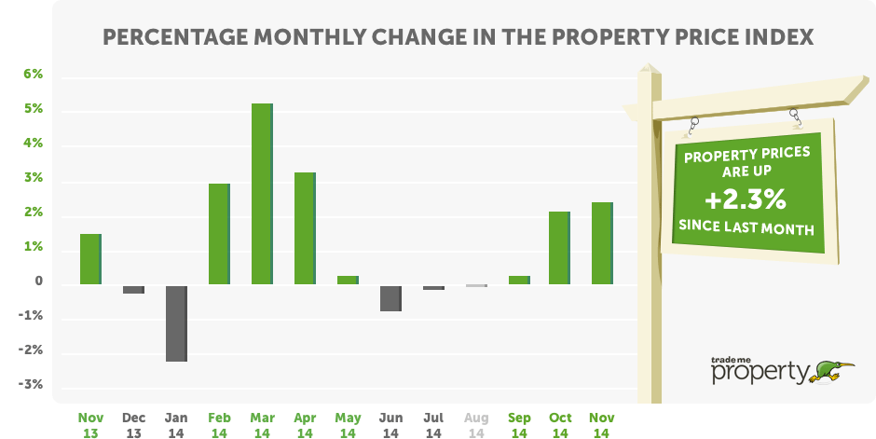

Mr Jeffries said the average asking price across all property types for the three months to November was up 13.7 per cent year-on-year, and the new record asking price represented an overall increase of 27.6 per cent since November 2009.

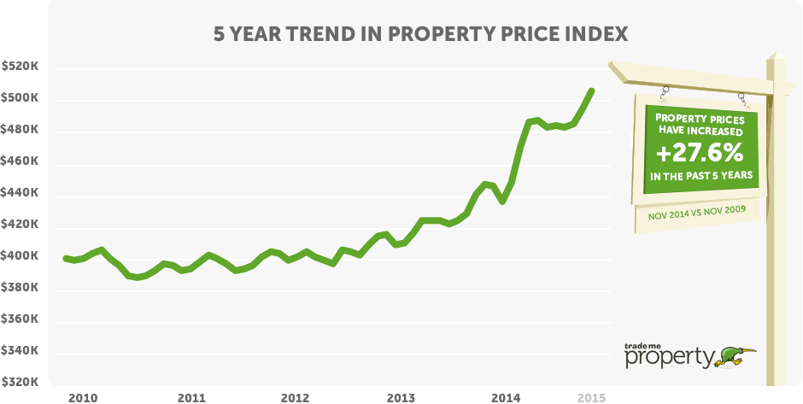

**Ups and downs in the regions**

Mr Jeffries said there were clear signs across the country that the pace of price increase was steady, and only the West Coast reported a fall in price expectation in November. All other regions saw a year-on-year rise in average asking price, ranging from Waikato’s small lift of 1.8 per cent, through to the strong 24.1 per cent increase in the Hawke’s Bay. Mr Jeffries said it was good to see the Waikato return to growth after a quiet period.

Five other regions showed double-digit growth: Taranaki (+18.2 per cent), Canterbury (+12.5 per cent), Otago (+11.6 per cent), Auckland (+11.3 per cent) and Southland (+10.8 per cent).

Mr Jeffries said the data from the country’s major urban centres reflected a strengthening market heading into the pre-Christmas period, with solid increases in asking price expectations from sellers across Auckland, Wellington and Christchurch.

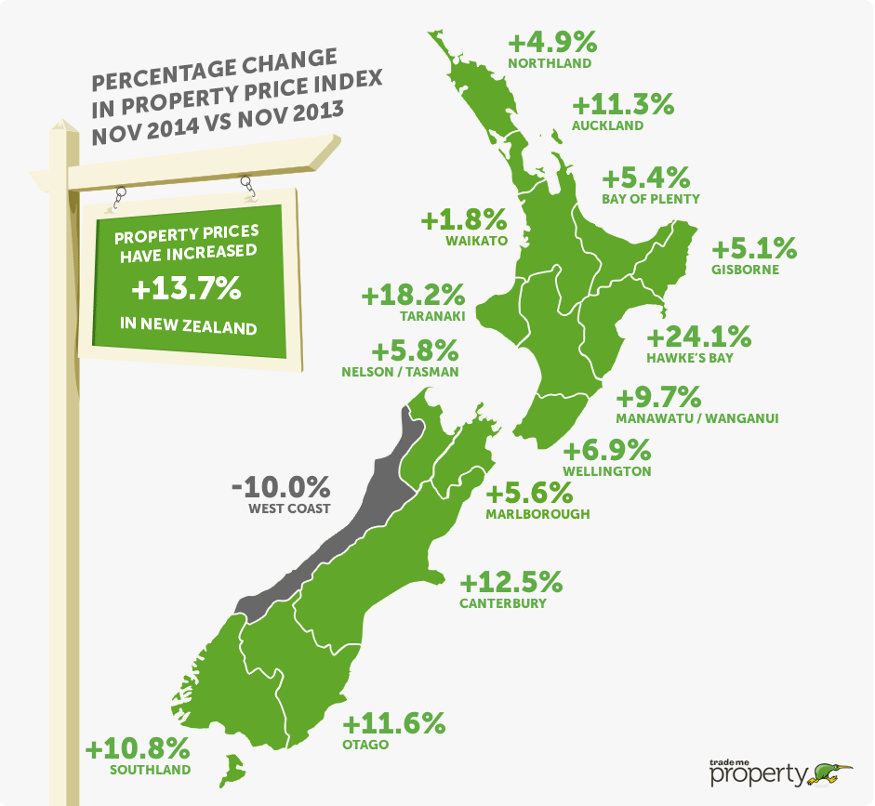

**Smaller properties also breaking records**

Mr Jeffries said there was a significant rise in price expectations for small and medium-sized properties in November, up more than 15 per cent and 13 per cent respectively to new record asking prices. “The lift in seller expectations remains strong in the major metro areas, but we’ve seen this spread wider too. For example we’ve seen asking prices for three and four bedroom properties in Taranaki, Hawke’s Bay and Bay of Plenty all reach record levels.”

There are early signs that the pressure in the Christchurch residential for sale market is easing, with the November increase of 12.5 per cent down on October’s 13.6 per cent increase.

***Table 1: Asking prices for houses by size & YoY changes (Nov 2014 vs Nov 2013)***

|  |  |  |  |  |
| --- | --- | --- | --- | --- |
|  | New Zealand | Auckland | Wellington | Christchurch |
| All property types | $509,750 + 13.7% | $690,100 + 11.3% | $445,000 + 6.9% | $451,700 + 10.9% |
| Large houses 5+ bedrooms | $867,700 + 8.5% | $1,020,800 + 5.3% | $714,950 + 2.5% | $690,650 - 4.3% |
| Medium houses  3-4 bedrooms | $514,050 + 13.2% | $702,900 + 8.7% | $458,800 + 5.8% | $478,700 + 9.7% |
| Small houses  1-2 bedrooms | $334,700 + 15.4% | $521,750 + 14.4% | $329,300 + 9.5% | $239,100 + 7.8% |

**Apartment market surges ahead**

Mr Jeffries said expectations in the apartment sector were clearly on the rise with a new average asking price record of $426,950 in November, following on from a new record last month. “It’s no surprise that the driving force here is Auckland – up 22 per cent to an average asking price of $435,500, and up more than $30,000 since October. Compact living in the city remains alluring.”

***Table 2: Asking prices for apartments/townhouses/units & YoY changes (Nov 2014 vs Nov 2013)***

|  |  |  |  |  |
| --- | --- | --- | --- | --- |
|  | New Zealand | Auckland | Wellington | Christchurch |
| All property types | $509,750 + 13.7% | $690,100 + 11.3% | $445,000 + 6.9% | $451,700 + 10.9% |
| Apartments | $426,950 + 14.9% | $435,500 + 22.8% | $409,450 + 7.7% | $425,400 + 14.7% |
| Townhouses | $477,150 + 7.6% | $641,450 + 5.2% | $390,800 + 4.6% | $414,250 + 9.5% |
| Units | $355,500 + 15.2% | $460,000 + 11.9% | $264,700 + 5.0% | $294,150 + 14.8% |

-**ends-**

**MORE INFORMATION**

* **About the Trade Me Property Price Index:** 
  + The Index is a piece of analysis focused on expected sale price. Listings are from private advertisers and real estate agents.
  + The Index is produced from data on properties listed on Trade Me Property in the three months leading up to the last day of each period. Each period’s value is a truncated mean of the complete three months’ worth of listings. This is to better reflect trends in property prices rather than month-to-month fluctuations in housing stock.
  + The Index uses an “80% truncated mean” of the expected sale price. This excludes the upper and lower 10% of listings by price, and averages the expected sale prices of the remaining properties.
  + It is the first report to provide an insight into ‘for sale’ price trends by type and size of property. Other reports tend to aggregate the property price data across these various properties.
* **Regional data:** If you are after information for a particular region, please email Jeff Hunkin via [mediaenquiries@trademe.co.nz](mailto:mediaenquiries@trademe.co.nz) and we will see what we can unearth for you. We can also provide the graphs and tables.
* **Contact:** Nigel Jeffries is available for interviews. To tee up a time that suits, please email Jeff Hunkin via [mediaenquiries@trademe.co.nz](mailto:mediaenquiries@trademe.co.nz) or phone (04) 803 2702.