December 2014 – February 2015 Issued: 2 December 2014
Hold mouse over links and press ctrl + left click to jump to the information you require:
Overview
Regional predictions for the next three months:
Northland, Auckland, Waikato, Bay of Plenty
Central North Island, Taranaki, Wanganui, Manawatu, Wellington
Gisborne, Hawke’s Bay, Wairarapa
Nelson, Marlborough, Buller
West Coast, Alps and foothills, inland Otago and Southland
Coastal Canterbury, east Otago
Background
Contacts
Notes to reporters and editors
NIWA Outlook: December 2014-February 2015
Overview
In November 2014, the equatorial Pacific Ocean warmed significantly, reaching El Niño levels towards the end of the month. Some – but importantly not all – atmospheric indicators also show patterns consistent with the development of a weak El Niño.
International guidance indicates that the chance for El Niño developing over the December 2014 – February 2015 period is about 75%. This figure has increased compared to forecasts issued last month.
During December 2014 – February 2015, lower pressures than normal are forecast over the New-Zealand region. This pressure pattern is expected to produce a weak southwesterly flow anomaly with perturbed conditions from time to time.
Sea surface temperatures for the coming three months are expected to be near average around the coasts of New Zealand.
New Zealand has a slightly elevated chance of having an ex-tropical system coming within 550km of the country during the 2014 - 2015 Tropical Cyclone season. The tropical cyclone outlook indicates this risk will be highest between February and April.

Outlook Summary
December 2014 – February 2015 temperatures are most likely (45-50% chance) to be average in all regions but for the east of the North Island, where seasonal temperatures are about equally likely (40-35% chance) to be near average or above average.
December 2014 – February 2015 rainfall totals are most likely (40-50% chance) to be in the near normal range for all regions.
Soil moisture and river flow are about equally likely (40-45% chance) to be in the near normal or below normal range in the north and east of the North Island and the north of the South Island. Soil moisture levels and river flows are most likely (45-50% chance) to be in the near normal range in all remaining regions of the country.

Regional predictions for the December to February season
Northland, Auckland, Waikato, Bay of Plenty
The table below shows the probabilities (or percent chances) for each of three categories: above average, near average, and below average. In the absence of any forecast guidance there would be an equal likelihood (33% chance) of the outcome being in any one of the three categories. Forecast information from local and global guidance models is used to indicate the deviation from equal chance expected for the coming three month period, with the following outcomes the most likely (but not certain) for this region:
- Temperatures are most likely (45% chance) to be near average.
- Rainfall totals are most likely (45% chance) to be in the normal range.
- Soil moisture levels and river flows are about equally likely (40-45% chance) to be in the near normal or below normal range.
Other outcomes cannot be excluded. The full probability breakdown is:
 | Temperature | Rainfall | Soil moisture | River flows
Above average | 35 | 25 | 20 | 15
Near average | 45 | 45 | 40 | 40
Below average | 20 | 30 | 40 | 45

Central North Island, Taranaki, Wanganui, Manawatu, Wellington
Probabilities are assigned in three categories: above average, near average, and below average.
- Temperatures are most likely (45% chance) to be near average.
- Rainfall totals, soil moisture levels and river flows are all most likely (50% chance) to be in the near normal range.
The full probability breakdown is:
 | Temperature | Rainfall | Soil moisture | River flows
Above average | 35 | 30 | 30 | 25
Near average | 45 | 50 | 50 | 50
Below average | 20 | 20 | 20 | 25

Gisborne, Hawke’s Bay, Wairarapa
Probabilities are assigned in three categories: above average, near average, and below average.
- Temperatures are about equally likely (40-35% chance) to be average or above average.
- Rainfall totals are most likely (45% chance) to be in the normal range.
- Soil moisture levels and river flows are about equally likely (40-45% chance) to be in the near normal or below normal range.
The full probability breakdown is:
 | Temperature | Rainfall | Soil moisture | River flows
Above average | 35 | 20 | 15 | 15
Near average | 40 | 45 | 45 | 45
Below average | 25 | 35 | 40 | 40

Nelson, Marlborough, Buller
Probabilities are assigned in three categories: above average, near average, and below average.
- Temperatures are most likely (45% chance) to be near average.
- Rainfall totals are most likely (40% chance) to be in the near normal range.
- Soil moisture levels and river flows are about equally likely (40-45% chance) to be in the near normal or below normal range.
The full probability breakdown is:
 | Temperature | Rainfall | Soil moisture | River flows
Above average | 30 | 30 | 20 | 15
Near average | 45 | 40 | 40 | 45
Below average | 25 | 30 | 40 | 40

West Coast, Alps and foothills, inland Otago, Southland
Probabilities are assigned in three categories: above average, near average, and below average.
- Temperatures are most likely (50% chance) to be in the near average range.
- Rainfall totals, soil moisture levels and river flows are all most likely (45-50% chance) to be in the near normal range.
The full probability breakdown is:
 | Temperature | Rainfall | Soil moisture | River flows
Above average | 30 | 30 | 25 | 25
Near average | 50 | 45 | 50 | 50
Below average | 20 | 25 | 25 | 25

Coastal Canterbury, east Otago
Probabilities are assigned in three categories: above average, near average, and below average.
- Temperatures are most likely (50% chance) to be in the near average range.
- Rainfall totals are most likely (50% chance) to be in the near normal range.
- Soil moisture levels and river flows are most likely (45% chance) to be in the near normal range.
The full probability breakdown is:
 | Temperature | Rainfall | Soil moisture | River flows
Above average | 30 | 25 | 20 | 20
Near average | 50 | 50 | 45 | 45
Below average | 20 | 25 | 35 | 35

Graphical representation of the regional probabilities
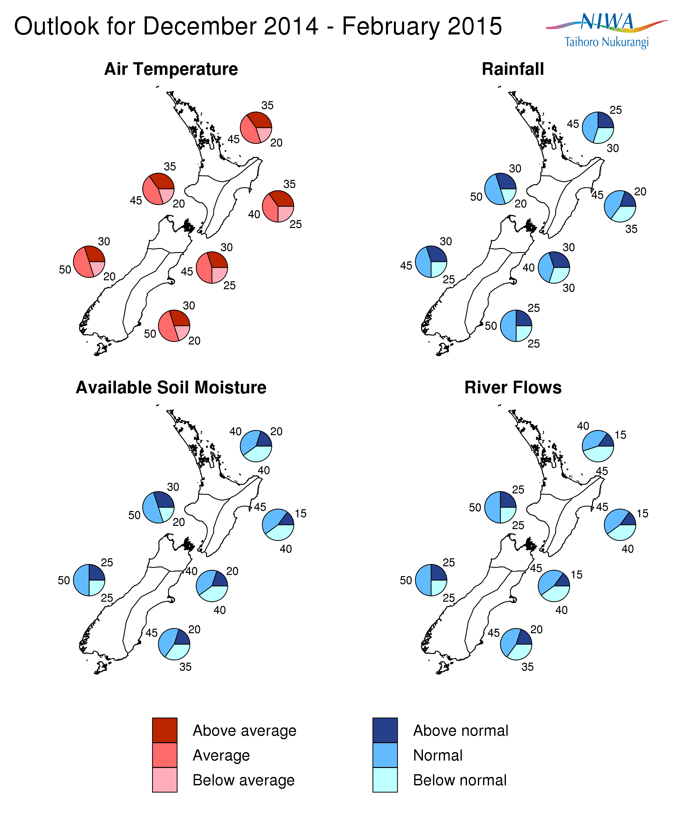

Background
Sea-Surface-Temperatures in the equatorial Pacific Ocean steadily increased through November 2014, and have now crossed the conventional El Niño threshold of 0.7 ºC above normal. It remains to be seen whether SST’s will persist at these levels. The subsurface ocean is also currently warmer than normal (+ 4 ºC) at about 100 to 150 m depth in the eastern Pacific around 120ºW.

The preliminary NIWA Southern Oscillation Index (SOI) for November 2014 is –0.7. This brings the 3-months September-October-November value to -0.8. Strongly negative SOI values (less than -1) are typically associated with El Niño.

Despite oceanic anomalies showing signs of a weak El Niño, the atmosphere has not yet fully shifted to El Niño conditions. In particular, patterns of convection and rainfall are lower than expected in the central Pacific.

The international guidance places the chances of El Niño developing over the December 2014 to February 2015 period at about 75%, a sharp increase from outlooks issued last month.

Note that for New Zealand, El Niño events are typically (but not always) associated with stronger and/or more frequent westerly winds. Such a climate pattern typically leads to drier conditions in eastern areas and more rain in western areas of the country. The rainfall outlook - as synthesized from various dynamical and statistical models - indicates that near normal rainfall is the most likely outlook for all regions of New Zealand, although a significant chance for below normal rainfall (35%) is present for the east of the North Island.

Meanwhile, waters surrounding New Zealand remain slightly warmer than average around the South Island, and close to normal or slightly cooler than normal around the North Island. Ocean models forecasts indicate that SSTs are likely to be close to normal around the country over the next three months.

To find out more about normal conditions for this outlook period, refer to NIWA’s website, where daily updates on climate maps are available.

For comment, please contact
Chris Brandolino, NIWA forecaster, NIWA National Climate Centre
Tel (09) 375 6335, Mobile (027) 886 0014

Dr Brett Mullan, Principal Scientist, NIWA National Climate Centre
Tel (04) 386 0508, Mobile (027) 294 1169.
Notes to reporters and editors
- NIWA’s outlooks indicate the likelihood of climate conditions being at, above, or below average for the season as a whole. They are not ‘weather forecasts’. It is not possible to forecast precise weather conditions three months ahead of time.
- The outlooks are the result of the expert judgment of NIWA’s climate scientists. They take into account observations of atmospheric and ocean conditions and output from global and local climate models. The presence of El Niño or La Niña conditions and the sea surface temperatures around New Zealand can be a useful indicator of likely overall climate conditions for a season.
- The outlooks state the probability for above average conditions, near average conditions, and below average conditions for rainfall, temperature, soil moisture, and river flows. For example, for winter (June–July–August) 2007, for all the North Island, we assigned the following probabilities for temperature:
· Above average: 60 per cent
· Near average: 30 per cent
· Below average: 10 per cent
We therefore concluded that above average temperatures were very likely.
- This three-way probability means that a random choice would be correct only 33 per cent (or one-third) of the time. It would be like randomly throwing a dart at a board divided into three equal parts, or throwing a dice with three numbers on it. An analogy with coin tossing (a two-way probability) is not correct.
- A 50 per cent ‘hit rate’ is substantially better than guesswork, and comparable with the skill level of the best overseas climate outlooks. See, for example, analysis of global outlooks issued by the International Research Institute for Climate and Society based in the US published in the Bulletin of the American Meteorological Society (Goddard, L., A. G. Barnston, and S. J. Mason, 2003: Evaluation of the IRI’s “net assessment” seasonal climate forecasts 1997–2001. Bull. Amer. Meteor. Soc., 84, 1761–1781).
- Each month, NIWA publishes an analysis of how well its outlooks perform. This is available online and is sent to about 3500 recipients of NIWA’s newsletters, including many farmers. See www.niwa.co.nz/our-science/climate/publications/all/cu
- All outlooks are for the three months as a whole. There will inevitably be wet and dry days, and hot and cold days, within a season. The exact range in temperature and rainfall within each of the three categories varies with location and season. However, as a guide, the “near average” or middle category for the temperature predictions includes deviations up to ±0.5°C for the long-term mean, whereas for rainfall the “near normal” category lies between approximately 80 per cent and 115 per cent of the long-term mean.
- The seasonal climate outlooks are an output of a scientific research programme, supplemented by NIWA’s Capability Funding. NIWA does not have a government contract to produce these outlooks.
Visit our media centre at: www.niwa.co.nz/news-publications/media-centre

