Friday, 14 November 2014

National enjoy delayed honeymoon with big lead over leaderless Labour before new leader is selected next week
Today’s New Zealand Roy Morgan Poll shows National (49.5%, up 6% since early October). Support for Key’s Coalition partners is down slightly with the Maori Party 1% (down 1%), Act NZ 0.5% (unchanged) and United Future 0% (down 0.5%).
Support for the main opposition Labour Party is up slightly to 24% (up 1.5%) and down for the other two opposition parties: Greens 14.5% (down 3%) and NZ First 6.5% (down 0.5%). For the parties outside Parliament the Conservative Party of NZ is 2% (down 3%) while the Internet-Mana Party alliance is at 0.5% (down 0.5%) and support for Independent/ Others is 1.5% (up 1%).
If a National Election were held now the latest New Zealand Roy Morgan Poll shows that National would be easily re-elected.
Despite the boost for the Government the latest NZ Roy Morgan Government Confidence Rating has fallen significantly to 126pts (down 11pts) with 56% (down 5.5%) saying NZ is ‘heading in the right direction’ compared to 30% (up 5.5%) that say NZ is ‘heading in the wrong direction’. However, even after this fall the NZ Government Confidence Rating remains substantially higher than in Australia – Australian Government Confidence last week was at 99.5pts.
Michele Levine, Chief Executive Officer, Roy Morgan Research, says:
“Prime Minister John Key is this week striding the world stage – visiting the APEC Summit in Beijing, the East Asia Summit in Myanmar and finishing off on the weekend at the G20 Summit in Brisbane. Key has had the chance to meet many world leaders including US President Barack Obama and Chinese President Xi Jinping.
“These meetings are mainly concerned with increasing trade and investment and promoting growth in the world economy, but they also provide a clear opportunity for the newly re-elected Prime Minister to demonstrate his leadership credentials. This week’s Morgan Poll shows National (49.5%) now more than double the Opposition Labour Party (24%).
“The contrast between the two parties is even more striking given Labour is still leaderless following former leader David Cunliffe’s resignation following the election defeat in September. Labour finally selects its new leader next Tuesday (November 18). The Labour leadership contest is a four-way fight between Wellington Central MP Grant Robertson, interim leader David Parker, Hauraki-Waikato MP Nanaia Mahuta and List MP Andrew Little. Given the complicating voting procedures in place it is almost impossible to predict which candidate will emerge as the new leader next week.”

Electors were asked: “If a New Zealand Election were held today which party would receive your party vote?” This latest New Zealand Roy Morgan Poll on voting intention was conducted by telephone – both landline and mobile telephone, with a NZ wide cross-section of 866 electors from October 27 – November 9, 2014. Of all electors surveyed 2.5% (up 0.5%) didn’t name a party.

For further information:
Contact | Office | Mobile
Gary Morgan: | +61 3 9224 5213 | +61 411 129 094
Michele Levine: | +61 3 9224 5215 | +61 411 129 093

Margin of Error
The margin of error to be allowed for in any estimate depends mainly on the number of interviews on which it is based. The following table gives indications of the likely range within which estimates would be 95% likely to fall, expressed as the number of percentage points above or below the actual estimate. The figures are approximate and for general guidance only, and assume a simple random sample. Allowance for design effects (such as stratification and weighting) should be made as appropriate.
Sample Size | Percentage Estimate
 | 40%-60% | 25% or 75% | 10% or 90% | 5% or 95%
1,000 | ±3.2 | ±2.7 | ±1.9 | ±1.4
1,500 | ±2.6 | ±2.2 | ±1.5 | ±1.1
Roy Morgan New Zealand 2014 Interactive Voting Charts
These interactive charts allow a deeper look at voting patterns in New Zealand over varying timeframes and provide election observers with the ability to pinpoint key turning points for the political parties.
View interactive New Zealand Election charts here.
Purchase the latest Roy Morgan New Zealand Electorate Profiles.

Voting Intention Summary
The following table compares the latest New Zealand Roy Morgan Polls on Voting Intention with the result from the September 20, 2014 General Election:

PRIMARY VOTE | National | Labour | Green  Party | NZ  First |  | Maori  Party* | ACT  NZ | United  Future | Conservatives* | Mana  Party* | Internet* | Other
ELECTIONS | % | % | % | % |  | % | % | % | % | % | % | %
July 27, 2002 | 20.93 | 41.26 | 7.00 | 10.38 |  | n/a | 7.14 | 6.69 | n/a | n/a | n/a | 6.60
September 17, 2005 | 39.10 | 41.10 | 5.30 | 5.72 |  | 2.12 | 1.51 | 2.67 | n/a | n/a | n/a | 2.48
November 8, 2008 | 44.93 | 33.99 | 6.72 | 4.07 |  | 2.39 | 3.65 | 0.87 | n/a | n/a | n/a | 3.38
November 26, 2011 | 47.31 | 27.48 | 11.06 | 6.59 |  | 1.43 | 1.07 | 0.60 | 2.65 | 1.08 | n/a | 0.73
September 20, 2014 | 47.04 | 25.13 | 10.70 | 8.66 |  | 1.32 | 0.69 | 0.22 | 3.97 | 1.42 | n/a | 0.85
ROY MORGAN POLL
Sep 29-Oct 12, 2014 | 43.5 | 22.5 | 17.5 |  | 7 | 2 | 0.5 | 0.5 | 5 | 1 | ^ | 0.5
Oct 27-Nov 9, 2014 | 49.5 | 24 | 14.5 |  | 6.5 | 1 | 0.5 | ^ | 2 | 0.5 | ^ | 1.5
^ Result less than 0.5%. *The Maori Party was launched in July 2004; The Mana Party was launched in July 2011. The Conservative Party was launched in August 2011. The Internet Party was launched in January 2014. The Internet Party & Mana Party announced an alliance in May 2014 that jointly contested the 2014 NZ Election. The combined result for the Internet-Mana Party Alliance is included in the Mana Party result (1.42%).

Two-Party Preferred: National Party-led Government vs. Parliamentary Opposition Parties
The following table compares the latest New Zealand Roy Morgan Polls on Voting Intention with the result from the September 20, 2014 General Election:
 | National Party-led Government* | Parliamentary  Opposition Parties#
Election, November 8, 2008 | 51.84 | 48.16
Election, November 26, 2011 | 50.41 | 46.21
Election, September 20, 2014 | 49.27 | 44.49
ROY MORGAN POLL
September 29 – October 12, 2014 | 46.5 | 47
October 27 – November 9, 2014 | 51 | 45

*National-led Government: National Party, Maori Party, ACT NZ, United Future; #Opposition Parties: Labour Party, Green Party, NZ First. Parties not represented: Conservative Party, Internet Party, Mana Party & Other not included as they are not represented in Parliament.

Finding No. 5929 taken from Computer Report No. 2413
The Roy Morgan Poll is conducted by the ONLY Australian and NZ member of the Gallup International Association.
No other public opinion poll taken in Australia or New Zealand has this qualification.
NEW ZEALAND: HEADING IN “RIGHT” OR “WRONG” DIRECTION?

Electors were asked: “Generally speaking, do you feel that things in New Zealand are heading in the right direction or would you say things are seriously heading in the wrong direction?”

 | NZ Roy Morgan Government Confidence Rating: Interviewing Dates (National Party Govt.)
 | June 3-16,  2013 | June 17-30,  2013 | July 1-14,  2013 | July 15-28,  2013 | July 29-Aug 11,  2013 | Aug 12-25,  2013 | Aug 26-Sep 8,  2013 | Sep 16-29,  2013
 | % | % | % | % | % | % | % | %
Right direction | 54 | 57 | 58 | 58.5 | 58 | 58 | 52.5 | 59
Wrong direction | 33.5 | 32 | 29.5 | 30 | 30 | 30.5 | 35.5 | 29.5
Roy Morgan GCR# | 120.5 | 125 | 128.5 | 128.5 | 128 | 127.5 | 117 | 129.5
Can’t say | 12.5 | 11 | 12.5 | 11.5 | 12 | 11.5 | 12 | 11.5
TOTAL | 100 | 100 | 100 | 100 | 100 | 100 | 100 | 100

 | NZ Roy Morgan Government Confidence Rating: Interviewing Dates (National Party Govt.)
 | Sep 30-Oct 13,  2013 | Oct 14-27,  2013 | Oct 28-Nov 10,  2013 | Nov 11-24,  2013 | Nov 25-Dec 8,  2013 | Jan 6-19,  2014 | Jan 20-Feb 2,  2014
 | % | % | % | % | % | % | %
Right direction | 55 | 57.5 | 61 | 59 | 58.5 | 63 | 63.5
Wrong direction | 31 | 28.5 | 27.5 | 29 | 28.5 | 23.5 | 24.5
Roy Morgan GCR# | 124 | 129 | 133.5 | 130 | 130 | 139.5 | 139
Can’t say | 14 | 14 | 11.5 | 12 | 13 | 13.5 | 12
TOTAL | 100 | 100 | 100 | 100 | 100 | 100 | 100

 | NZ Roy Morgan Government Confidence Rating: Interviewing Dates (National Party Govt.)
 | Feb 3-16,  2014 | Feb 17-Mar 2,  2014 | Mar 3-16,  2014 | Mar 17-30  2014 | Mar 31-Apr 13,  2014 | Apr 21-May 4,  2014 | May 5-18,  2014
 | % | % | % | % | % | % | %
Right direction | 63.5 | 65 | 61 | 61 | 65 | 62 | 60
Wrong direction | 23.5 | 23.5 | 25.5 | 28 | 22 | 26.5 | 28
Roy Morgan GCR# | 140 | 141.5 | 135.5 | 133 | 143 | 135.5 | 132
Can’t say | 13 | 11.5 | 13.5 | 11 | 13 | 11.5 | 12
TOTAL | 100 | 100 | 100 | 100 | 100 | 100 | 100

 | NZ Roy Morgan Government Confidence Rating: Interviewing Dates (National Party Govt.)
 | May 19-June 1,  2014 | June 2-15,  2014 | June 16-29,  2014 | June 30-July 13,  2014 | July 14-27,  2014 | Aug 4-17,  2014 | Aug 18-31,  2014 | Sep 1-14,  2014
 | % | % | % | % | % | % | % | %
Right direction | 64.5 | 63.5 | 65 | 65.5 | 60 | 63.5 | 61 | 62
Wrong direction | 24 | 24 | 23.5 | 23 | 25 | 24.5 | 25 | 24
Roy Morgan GCR# | 140.5 | 139.5 | 141.5 | 142.5 | 135 | 139 | 136 | 138
Can’t say | 11.5 | 12.5 | 11.5 | 11.5 | 15 | 12 | 14 | 14
TOTAL | 100 | 100 | 100 | 100 | 100 | 100 | 100 | 100

 | NZ Roy Morgan Government Confidence Rating: Interviewing Dates (National Party Govt.)
 | Sep 29-Oct 12,  2014 | Oct 27-Nov 9,  2014
 | % | %
Right direction | 61.5 | 56
Wrong direction | 24.5 | 30
Roy Morgan GCR# | 137 | 126
Can’t say | 14 | 14
TOTAL | 100 | 100

New Zealand Primary Vote
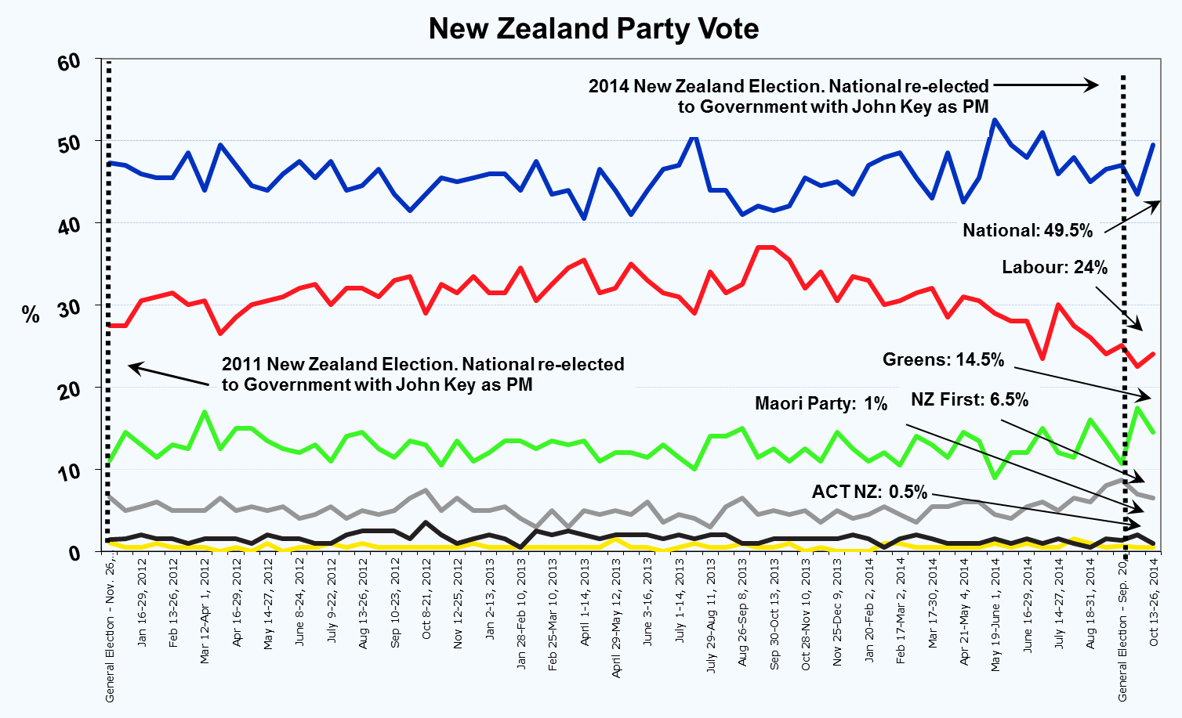
New Zealand Roy Morgan GCR
