Media Release 15 October 2014
Southwest Pacific Tropical Cyclone Outlook: Near average tropical cyclone numbers for the region is likely, with increased activity from February onward
Meteorological forecasting centres across the Southwest Pacific are predicting near average numbers of tropical cyclones (TC) for the 2014–15 season (November 2014 to April 2015). The 30-year average number of all (named) of TCs from 1981-2010 is 12.4 (10.4) in the Southwest Pacific each season from November to April. The outlook indicates that 8 to 12 named TCs are expected for the coming season. TC activity for Vanuatu and New Caledonia is anticipated to be below normal for this season, while elevated activity is expected for Samoa, Tuvalu, Tokelau, Niue, and the Southern Cook Islands. There is also an outlook of normal or above normal activity for countries situated close to the International Date Line (such as Wallis et Futuna and Tonga).
It should be recognised that the season-long forecast reflects an expectation of overall reduced activity during the early season (November to January) and net increased activity in general during the late season (February to April). Note that the TC activity outlook for islands like New Caledonia, Vanuatu, Fiji, and Tonga indicates two or more cyclones could interact with each of those countries during the season despite small differences from normal. At least one or more severe TCs (Category 3 or higher) could occur anywhere across the Southwest Pacific during the season. All communities should remain vigilant and follow forecast information provided by their national meteorological service.
On average, New Zealand experiences at least one ex-tropical cyclone passing within 550km of the country every year. For the coming TC season, the risk for New Zealand is slightly higher than normal. If an ex-tropical cyclone comes close to the country, the current background climate conditions suggest it has a higher probability of passing east rather than west of Auckland city.
Outlook analysis
Conditions within the ENSO-neutral range are indicated by sea surface temperature anomalies across the central and eastern Equatorial Pacific Ocean, and the atmospheric circulation patterns that exist over French Polynesia and northern Australia. There is an expectation amongst a number of international forecast centres of a weak El Niño developing in the coming months and this is supported by a few of the climate models. Taking this climate scenario into account, near normal TC activity can be expected for many islands in the Southwest Pacific during the 2014–2015 season, with 8 to 12 named TCs forming across the region during the November 2014–April 2015 period.
Southwest Pacific TCs are grouped into classes ranging from 1 to 5, with 5 being the most dangerous. For the coming TC season, at least four storms are predicted to reach at least Category 3, with mean wind speeds of at least 64 knots or 118 km/h (so-called ‘hurricane force’ winds). Of those systems, three storms may reach at least Category 4 strength, with mean wind speeds of at least 86 knots or 159 km/h. While Category 5 strength TCs (winds greater than 106 knots or 196 km/h) have not been prominent for ENSO neutral seasons like the current one, this type of event is still possible. Therefore, all communities should remain alert and prepared for severe events.
Tropical cyclones have a significant impact across the Southwest Pacific from year to year. Vanuatu and New Caledonia typically experience the greatest activity, with an average of 2 or 3 TCs passing close to land each year and there are indications that activity may be below average this season for those countries. The outlook for this season indicates near normal TC activity for the 2014–15 season for many islands, with reduced risk for Vanuatu and New Caledonia. Elevated risk is forecast for countries situated close to the International Date Line including Tokelau, Samoa, Niue, Tuvalu and further east in the Southern Cook Islands, although it should be recognized that during ‘normal’ seasons, significant TCs have affected those countries in the past.
On average, New Zealand usually experiences at least one interaction per season with an ex-tropical cyclone during ENSO neutral conditions. Most of the analog seasons identified for this forecast (1978/79; 1979/80; 1980/81; 1986/87; 1990/91; 2001/02; 2009/10 and 2012/13) show an ex-tropical cyclone coming close (within 550 km) to the country. Significant wind, waves and rainfall are possible from these systems. Their effects can be spread over a larger area when the ex-tropical cyclone meets a higher latitude high pressure system.
Even though TC activity is expected to be near normal or below normal for some countries, historical cyclone tracks (see supporting information for this forecast, Figure 2) indicate that TCs can affect parts of French Polynesia (including the Society Islands and the Austral Islands), especially late in the TC season. As with the majority of other years, the late TC season (February–April) is expected to be the most active time in the Southwest Pacific.
All Pacific Islands should remain vigilant in case conditions in the equatorial Pacific change during the TC season. Past ENSO neutral seasons have seen TC tracks with increased sinuosity (irregular or looping motions rather than a curvilinear trajectory), which means they have potential to impact a large area.
New Zealand’s National Institute of Water & Atmospheric Research (NIWA) and Meteorological Service of New Zealand (MetService) along with meteorological forecasting organizations from the Southwest Pacific, including the Australian Bureau of Meteorology, and the Pacific Island National Meteorological Services have prepared this tropical cyclone outlook.
Contacts for comment

In New Zealand:

Dr Andrew Lorrey
Climate Scientist, NIWA
Tel: +64 9 375 2055

Mr. Steve Ready
Manager, Wellington RSMC (Regional Specialized Meteorological Centre)
MetService New Zealand
Tel: +64 4 470 0737

Mr. Chris Brandolino
Meteorologist, NIWA
Tel: +64 9 375 6335

Dr Nicolas Fauchereau
Climate Scientist, NIWA
Tel: +64 9 375 4553

In the Pacific Islands, please contact your local national meteorological service for information about how this guidance should be interpreted.
For Australia and associated offshore islands, please contact the Australian Bureau of Meteorology for information about how this guidance should be interpreted.
For French Polynesia and New Caledonia, please contact MeteoFrance for information about how this guidance should be interpreted.
Additional background information
TCs in the Southwest Pacific usually develop between November and April, but occasionally they can occur in October and May, very rarely in June, July and August and relatively unknown in September.
Peak TC season is usually from January to March. In seasons with similar background climate conditions to present, several TCs occurred over the Gulf of Carpentaria and countries near the International Date Line. In addition, TCs also occurred near Fiji, Tonga, and Niue while a few affected other areas. On average, nearly half of the TCs that developed since the 1969-70 season have reached hurricane force with mean wind speeds of at least 64 knots (118 km/h).
To find past analogs that describe the climate state leading into the upcoming TC season, the past May-September conditions were examined for the tropical Pacific from 1969 to the present. For the majority of winter and early spring 2014, the ENSO system has been in a neutral state (with a bias towards El Niño characteristics).
The global climate forecast models discussed by the international climate research community involved in the Island Climate Update suggests neutral ENSO conditions or a weak El Nino are most likely for 2014-15 TC season. Close to neutral conditions exist at present for both equatorial sea surface temperatures and the atmospheric circulation in the Southwest Pacific, although indications of El Niño have been building lately. This has meant that the analog selection for the TC forecast was narrowed to include only past ENSO neutral cyclone seasons and seasons typified by weak El Niño conditions.
We used a joint ENSO index that combines the Southern Oscillation Index (SOI) with the most widely-used oceanic index of sea surface temperature anomalies in the equatorial central-western Pacific (NINO3.4). This joint ENSO index is described in Gergis and Fowler (2005) as the “Coupled ENSO Index” (CEI). Using the CEI, we selected analog TC seasons for the 2014-15 forecast. We highlighted seasons when the equatorial SSTs and the SOI were in the neutral range (i.e. neither El Niño nor La Niña as defined by the CEI with a 5-month mean SSTa threshold less than +/- 0.5°C and an 3-month SOI threshold less than +/- 1.0) during the May-October pre-TC season period. In addition, the analogues were further restricted to seasons when SSTs leading into the season were on the slightly positive side of neutral, and when either ENSO ‘NEUTRAL’ or weak El Niño conditions in general applied to the majority of the austral warm season (November-April).
Six analog TC seasons (1978/79; 1979/80; 1980/81; 1990/91; 2001/02; 2012/13) typified by ENSO neutral conditions and two analog seasons (1986/87 and 2009/10) that were weak El Niños were identified using the approach above. Note that the small number of analog seasons relates to the high-quality period of the TC data set in the satellite era beginning in 1969/70 (only 44 seasons), the availability of TC track data (current only to the end of the 2012/13 season), and the limited number of similar analogs to this season. The historic analogs suggest the most likely outcome for this season is ENSO neutral. As such, the guidance for November 2014 to April 2015 is built on the eight analog seasons identified above.
The Island Climate Update TC forecast spans four areas of responsibility controlled by international monitoring and forecast agencies (RMSC Nadi, TCWC Brisbane, TCWC Port Moresby and TCWC Wellington). We used a high quality set of past TC tracks from the South Pacific Enhanced Archive of Tropical Cyclones (SPEArTC) (Diamond et al., 2012) which covers 135°E to 120°W longitude to draw on past TC tracks for this seasonal forecast. This region encompases a basin that is defined by climatology rather than geopolitical or meteorological boundaries (Diamond et al., 2012). The analog tracks and anomalies for this region suggests TC activity is likely to be above normal close to and just east of the International Date Line, including Niue, Samoa, the Southern Cook Islands, Tuvalu and Tokelau (Table 1; Figure 1 & 2). The main TC genesis region is expected to lie within a band between 12 – 14°S (north of Vanuatu). While there is a low likelihood of a Category 5 system occurring, recent analogs suggest this type of event is still possible, and therefore this situation cannot be ruled out. A total of 10 named storms on average are expected; the range of variation between analog seasons suggests 8 to 12 for the total TC count (all named storms) within the forcast area could occur.
Based on previous research (Diamond et al., 2013), there are a wide range of TC track orientations during extra-tropical transition (ETT) during ENSO neutral conditions. Recent research has also indicated TC track sinuosity increases during neutral ENSO events (Philip Malsale, Vanuatu Meteorological Service, personal communication). This means that weaker TCs, such as a Category 1 system, might ‘wander’ or stall, causing prolonged or widespread effects. ENSO neutral and weak El Niño TC tracks between the point of genesis and ETT usually cover a broad region south of Fiji eastward to due south of Niue (mean longitude of ~175°W and a heading of ~165° at 25°S). About 50% of all historical TC tracks for the selected analog seasons made ETT within ±10° of the International Date Line.
A split of the analog TC seasons into early (November – January) and late (February – April) periods suggests TC activity will increase during the latter half of the TC season (Figure 3). A change in the foci of TC activity is also apparent as the season progresses (particularly for islands identified near and to the east of the Date Line). Activity northeast of Fiji is expected to pick up as the season progresses. Fiji, Vanuatu, New Caledonia, Tonga, Niue and New Zealand are also expected to experience increased risk as the TC season progresses.
TC intensity is related to how long developing cyclonic systems reside in the deep tropics and feed on warm waters for their growth. In addition, the subtropical jet and South Pacific Convergence Zone (SPCZ) mutually interact and contribute to shear during extra-tropical transition. It should also be noted that the interplay of a hemispheric-scale atmospheric circulation with the timing of the short-term Madden-Julian Oscillation (MJO) passage (typically on a 30-50 day cycle) can also have significant bearing on TC activity in the region; greater and more intense TC activity can be expected during the MJO 6-7 paired phase (Diamond and Renwick, 2014). Real-time monitoring of the MJO is available from the Australian Bureau of Meteorology at http://www.bom.gov.au/climate/mjo/.
Previous work (Lorrey et al., 2013) indicates New Zealand interacts with at least one ex-tropical cyclone passing within 550km of the country every year. For the coming TC season, the risk for New Zealand is slightly elevated. If an ex-tropical cycloneTC comes close to the country, it has a higher probability of passing east rather than west of Auckland city.
References
Gergis, J., and A. M. Fowler, 2005: Classification of synchronous oceanic and atmospheric El Niño–Southern Oscillation (ENSO) events for palaeoclimate reconstruction. International Journal of Climatology, 25, 1541–1565.
Diamond, H.J., and J.A. Renwick, 2014: The Climatological Relationship between Tropical Cyclones and the Madden-Julian Oscillation in the Southwest Pacific. International Journal of Climatology, doi: 10.1002/joc.4012.

Diamond, H.J., A.M. Lorrey, K.R. Knapp, and D.H. Levinson. 2012. Development of an enhanced tropical cyclone tracks database for the southwest Pacific from 1840-2011. International Journal of Climatology, 32: 2240–2250. doi:10.1002/joc.2412.

Diamond, H.J., A.M. Lorrey, and J.A. Renwick. 2013. A Southwest Pacific Tropical Cyclone
Climatology and Linkages to the El Niño–Southern Oscillation. Journal of Climate, 26(1), 3-25. doi:10.1175/JCLI-D-12-00077.1.

Lorrey, A.M., G. Griffiths, N. Fauchereau, H.J. Diamond, P.R. Chappell, and J. Renwick, 2013. An ex-tropical cyclone climatology for Auckland, New Zealand. International Journal of Climatology, doi: 10.1002/joc.3753.

Figure 1: Number of TCs occurring for the full season (November – April) in the Southwest Pacific (135°E to 120°W): (top panel) average number over 44 seasons, 1969/70 to 2012/13; (centre panel) average number over selected 8 analog seasons (Table 1); (bottom panel) departure from normal for the analog seasons (difference between count in centre and top panels).
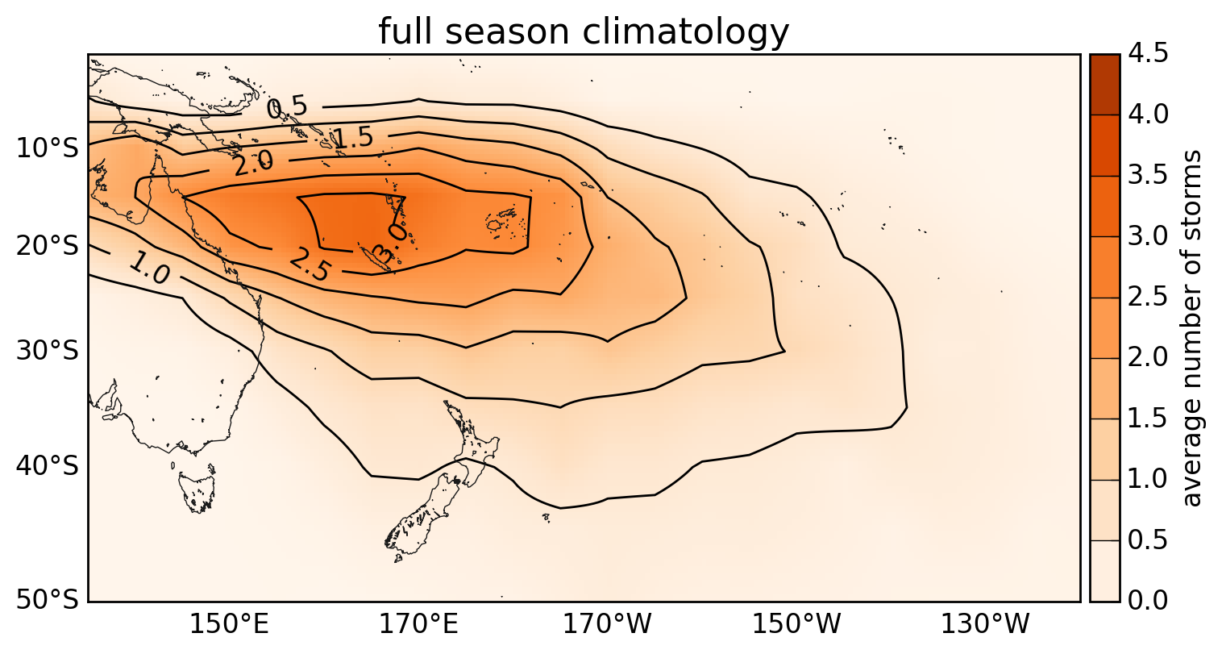
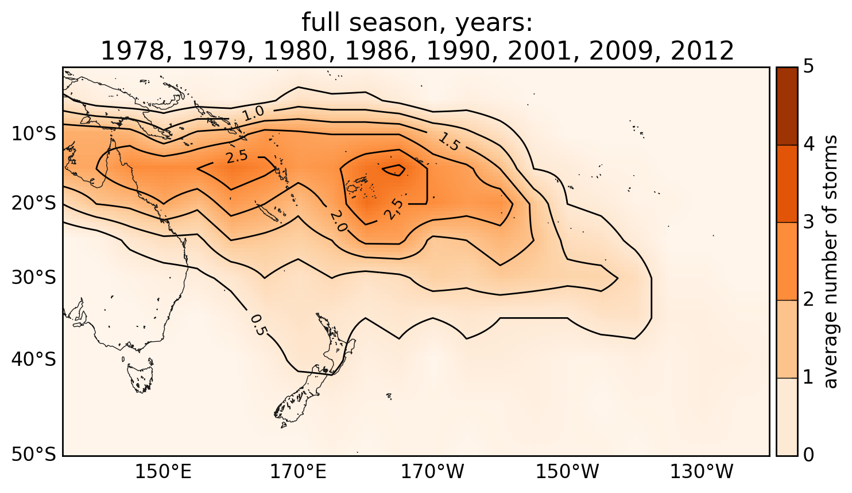
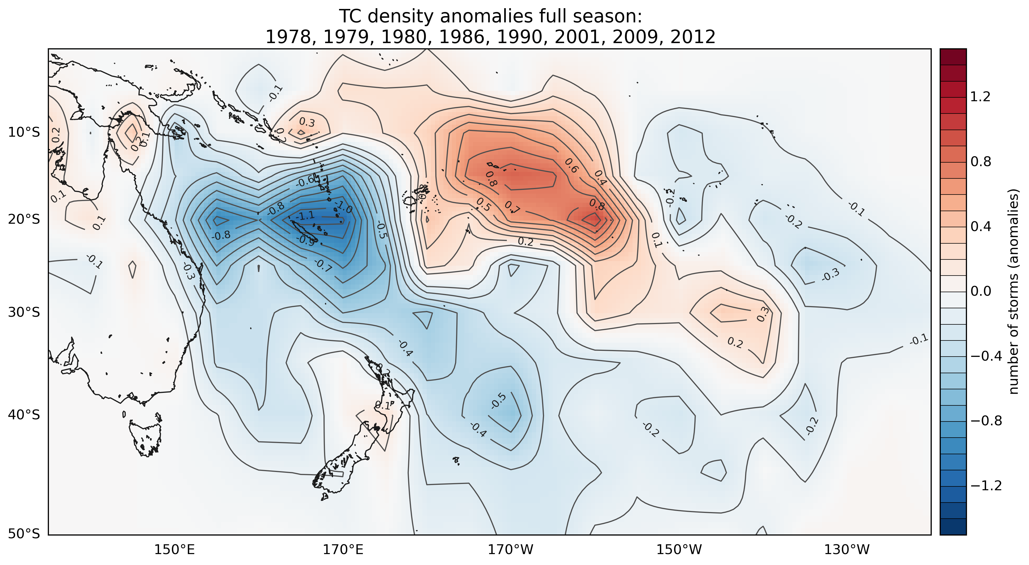
Table 1: The average number of TCs passing close to the main South Pacific Island groups between November and April. The activity associated with some island groups for the coming season is a subjective assessment, and has been stated to be consistent with the wishes of the national meteorological services involved in generating this regional forecast. In addition, subjective qualification of activity (and associated risk) also recognises the small differences between the actual TC counts for the analog composites and climatological values. The table is therefore only generally indicative of how many storms might be expected for any given island group for the coming season.
Country/  Territory | Climatology | Analog seasons | Anomaly | % Difference | Risk
Fiji | 2.5 | 2.6 | 0.1 | 4 | Normal
Wallis & Futuna | 2.2 | 2.6 | 0.4 | 18 | Normal
Tonga | 2.2 | 2.5 | 0.3 | 14 | Normal
Niue | 1.8 | 2.4 | 0.6 | 33 | Elevated
Samoa | 1.7 | 2.4 | 0.8 | 41 | Elevated
Tokelau | 1.6 | 2.3 | 0.7 | 44 | Elevated
Vanuatu | 2.9 | 2.15 | -0.75 | -26 | Reduced
Tuvalu | 1.4 | 2 | 0.6 | 43 | Elevated
S. Cooks | 1.3 | 1.9 | 0.6 | 46 | Elevated
New Caledonia | 2.75 | 1.75 | -1 | -36 | Reduced
Solomon Is. | 1.2 | 1.2 | 0 | 0 | Normal
Papua New Guinea | 0.9 | 0.9 | 0 | 0 | Normal
N. New Zealand | 0.75 | 0.75 | 0 | 0 | Normal
Austral Is. | 0.75 | 0.75 | 0 | 0 | Normal
Society Is. | 0.7 | 0.4 | -0.3 | -43 | Normal
Tuamotu | 0.2 | 0.4 | -0.1 | - | Unlikely
N. Cooks | 0.5 | 0.2 | -0.3 | - | Normal
W. Kiribati | 0.1 | 0.2 | 0.1 | - | Unlikely
E. Kiribati | 0 | 0 | 0 | - | Unlikely
Marquesas | 0.1 | 0 | -0.1 | - | Unlikely
Pitcairn | 0 | 0 | -0.2 | - | Unlikely
Table 2: Analog seasons and intensity of TCs and storms that occurred in the Southwest Pacific.
Season | Number of named storms | Right: TC category (BoM scale) | Cat 1 | Cat 2 | Cat 3 | Cat 4 | Cat 5
78/79 | 11 |  | 3 | 4 | 2 | 2 | 0
79/80 | 11 |  | 4 | 5 | 1 | 1 | 0
80/81 | 14 |  | 5 | 6 | 3 | 0 | 0
86/87 | 14 |  | 4 | 5 | 3 | 2 | 0
90/91 | 3 |  | 0 | 1 | 1 | 1 | 0
2001/02 | 10 |  | 8 | 0 | 1 | 1 | 0
2009/10 | 10 |  | 3 | 2 | 1 | 1 | 3
2012/13 | 8 |  | 2 | 3 | 1 | 2 | 0
Mean total | 10.1 |  | 3.6 | 3.25 | 1.5 | 1.25 | 0.4
Rounded mean total | 10 |  | 4 | 3 | 2 | 1 | 0

Analog guidance summary:
8-12 named TCs are expected for the 2014-15 season for the Southwest Pacific basin (135° E – 120° W), with a mean of 10 implied by the selected analogs. The historic average is just over 10 named cyclones per season for the basin.
Potentially, three cyclones may reach category 3 or 4 status. The long term TC climatology (last 44 seasons) suggests the occurrence of a Category 5 system is very low; however the occurrence of those types of storm systems have occurred in the past and cannot be ruled out.
In most of the analog seasons, at least one (if not more than one) ex-tropical cyclone came within 550 km of New Zealand during ENSO-neutral seasons. Some of these storms even made landfall. There is a normal likelihood of an interaction for New Zealand (at least one storm coming within 550km of the country) for the 2014-15 season. The probability of a cyclone tracking to the east of Auckland during ENSO-neutral conditions is twice as likely as those tracking to the west of Auckland city.
Figure 2: Plots of TC tracks and major storms that were monitored for analog seasons used in the 2014-15 seasonal forecast for the full season (November - April). Track data are courtesy of the South Pacific Enhanced Archive for TC research (SPEArTC).
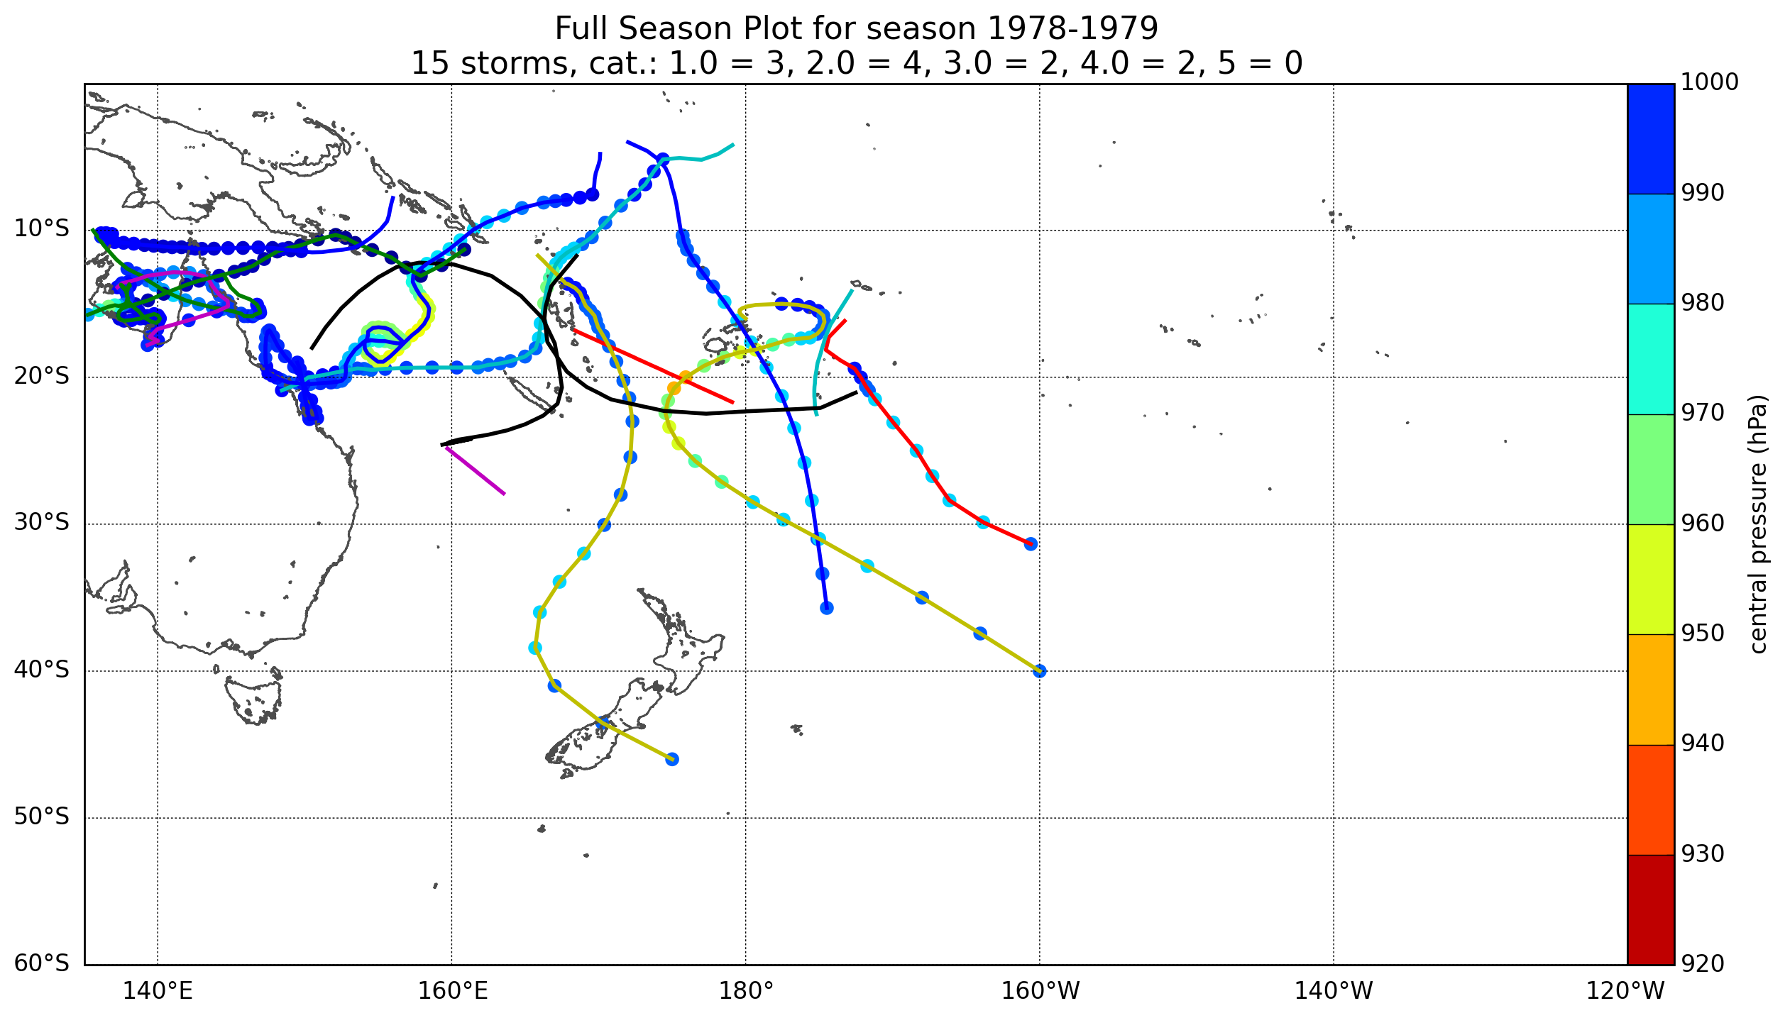
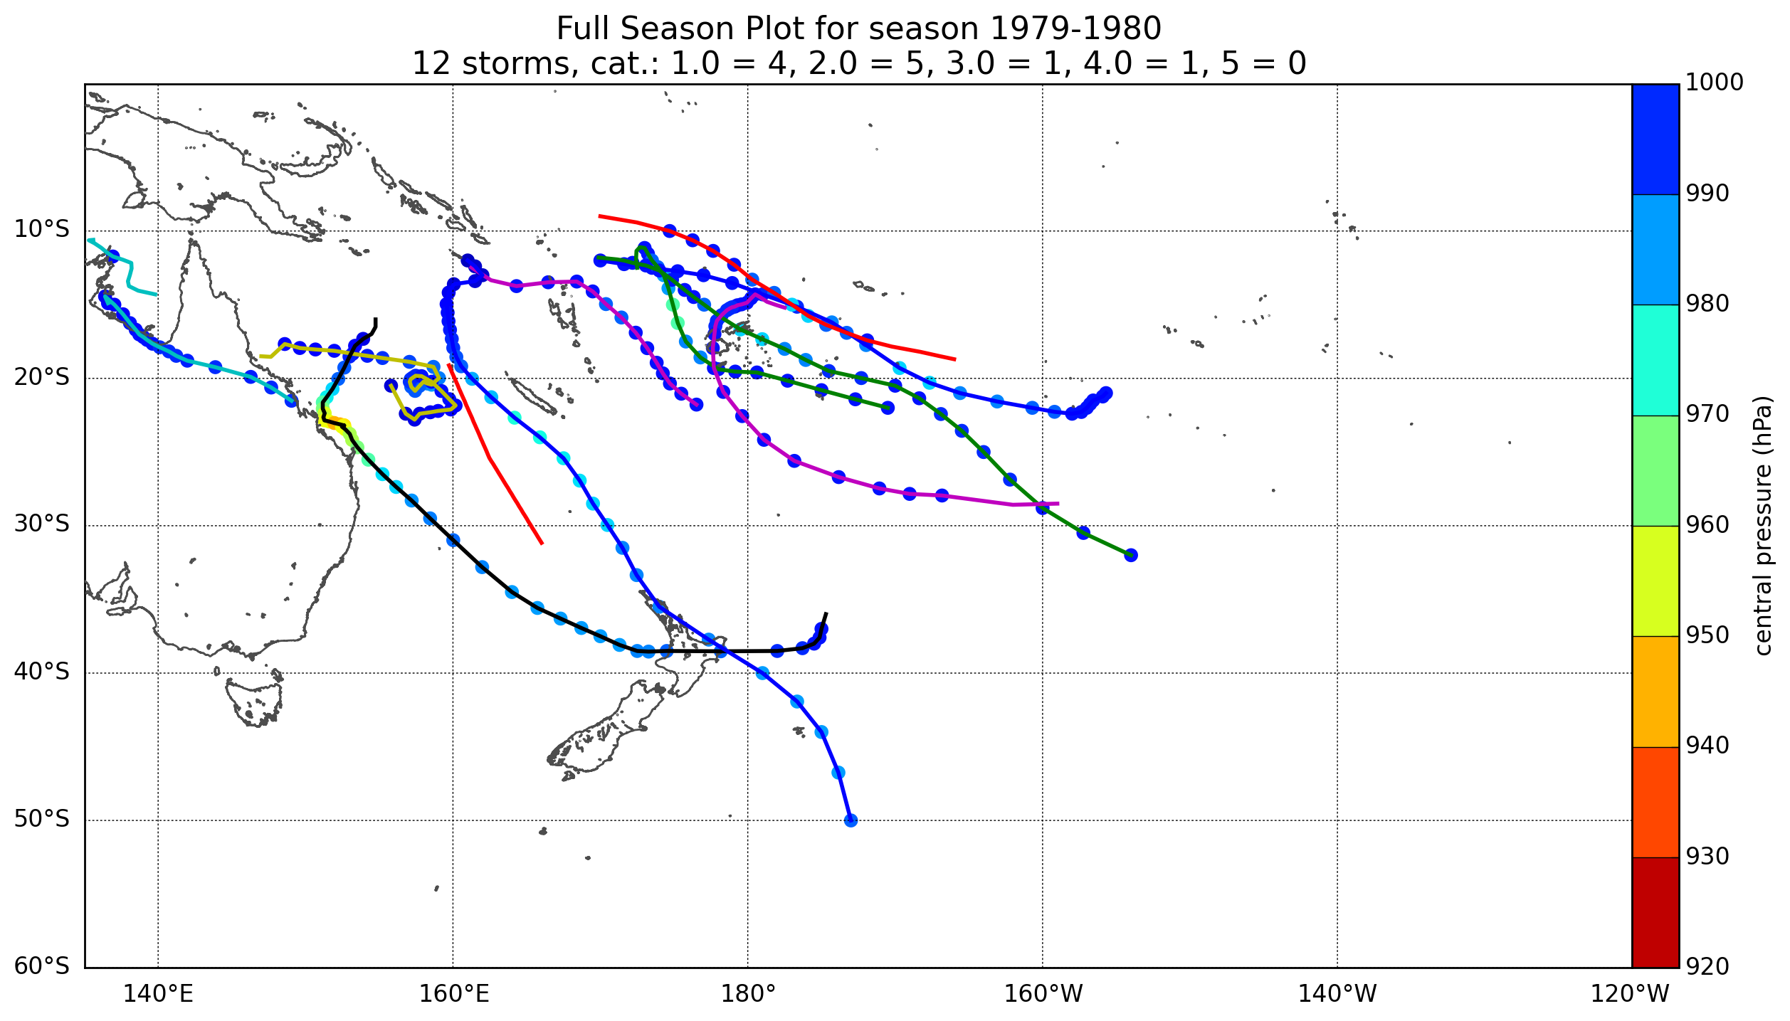
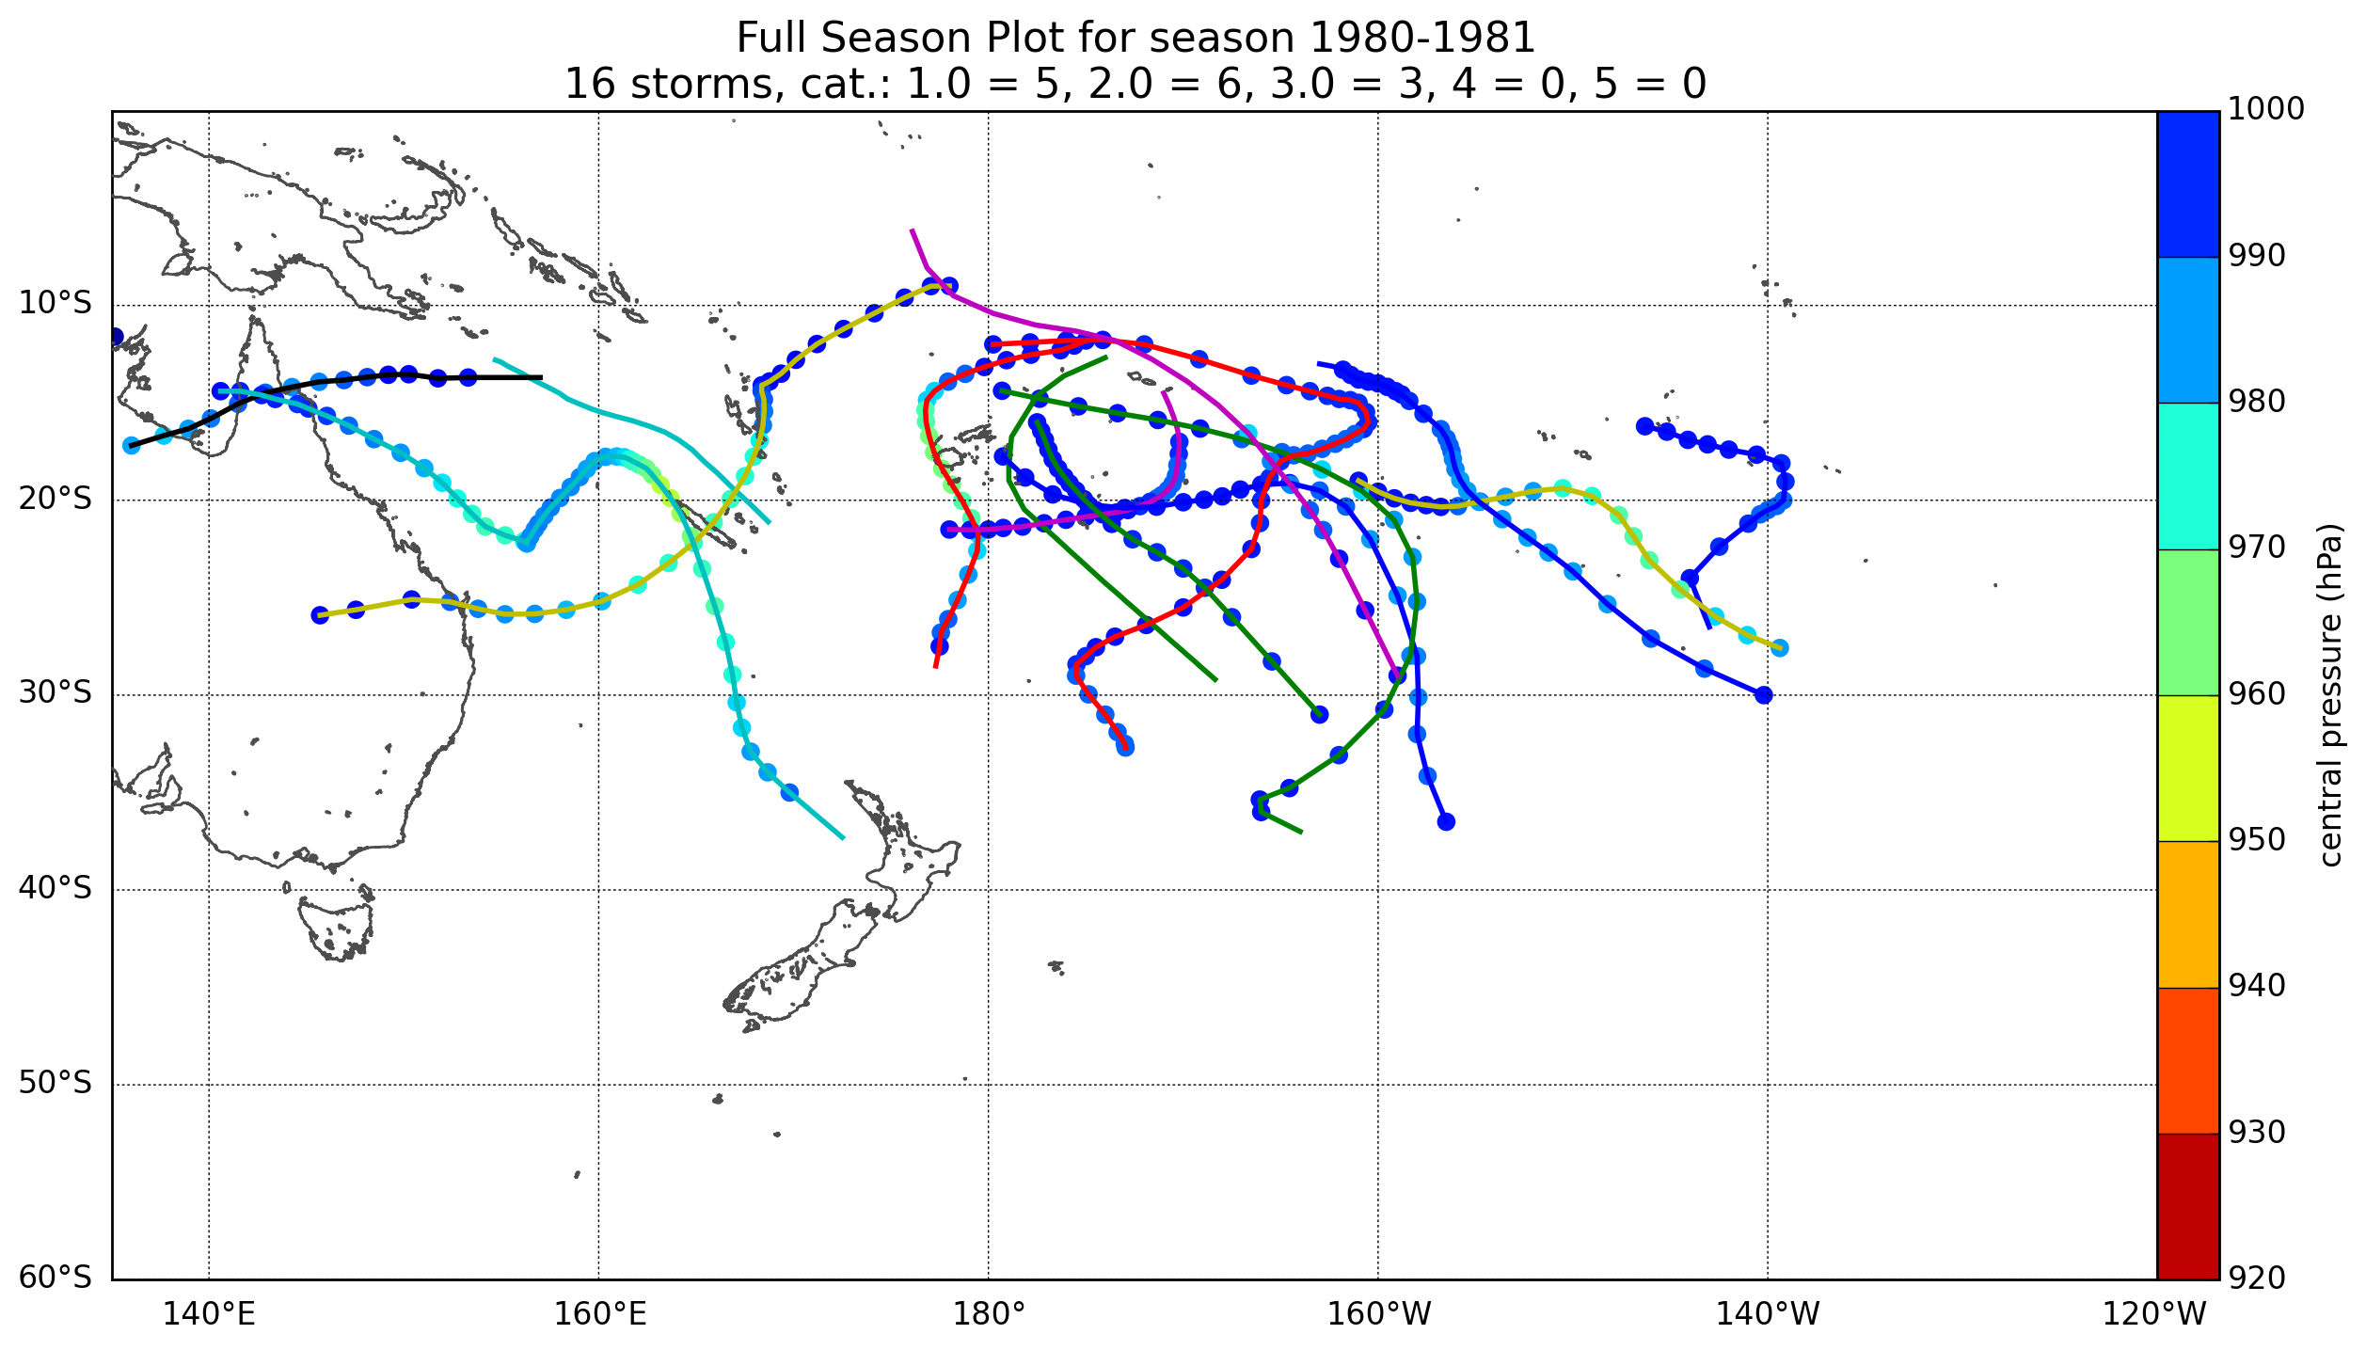
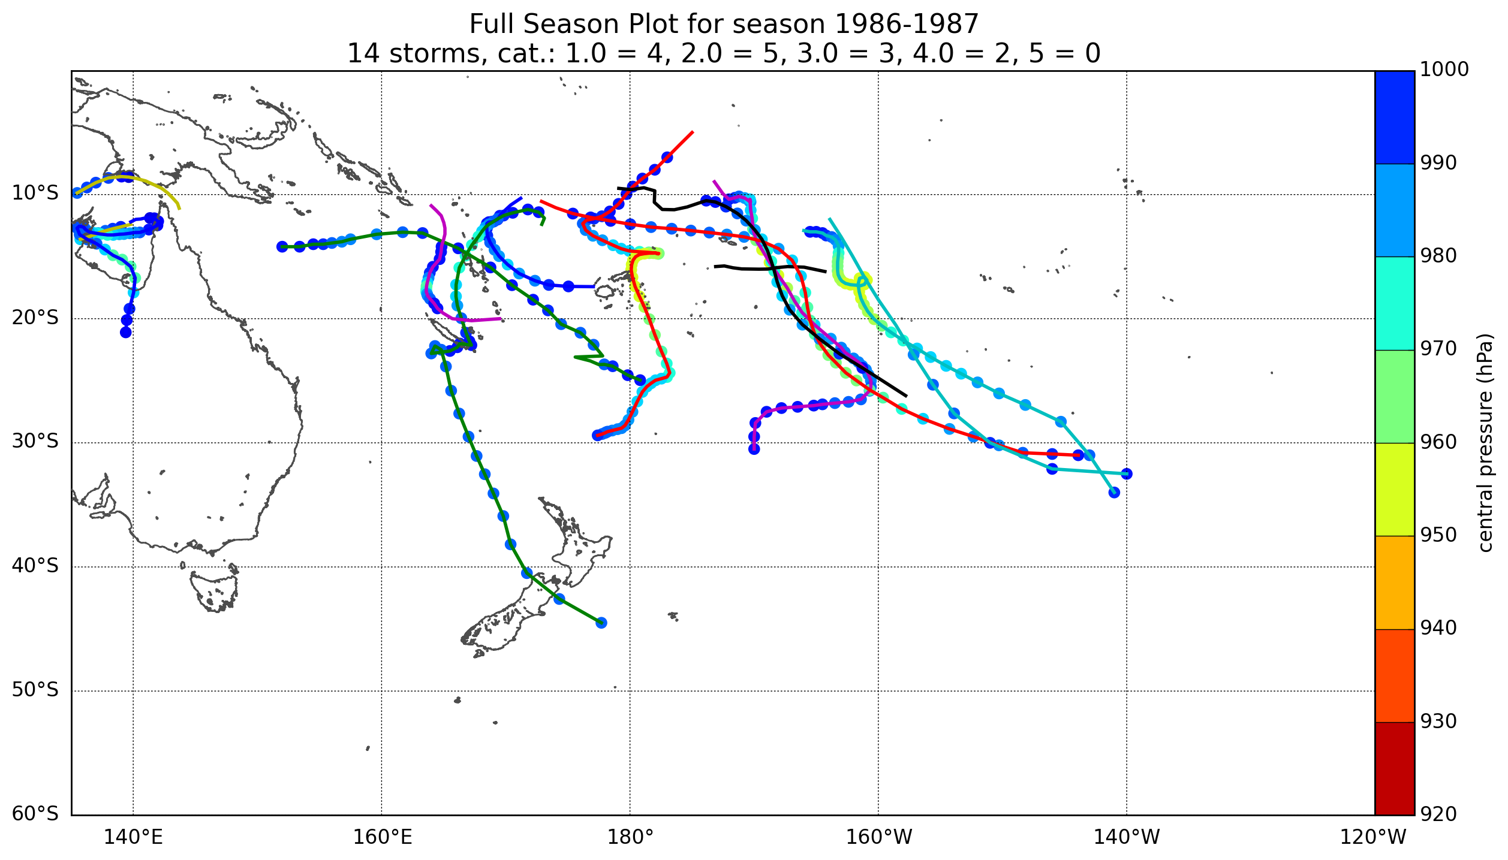
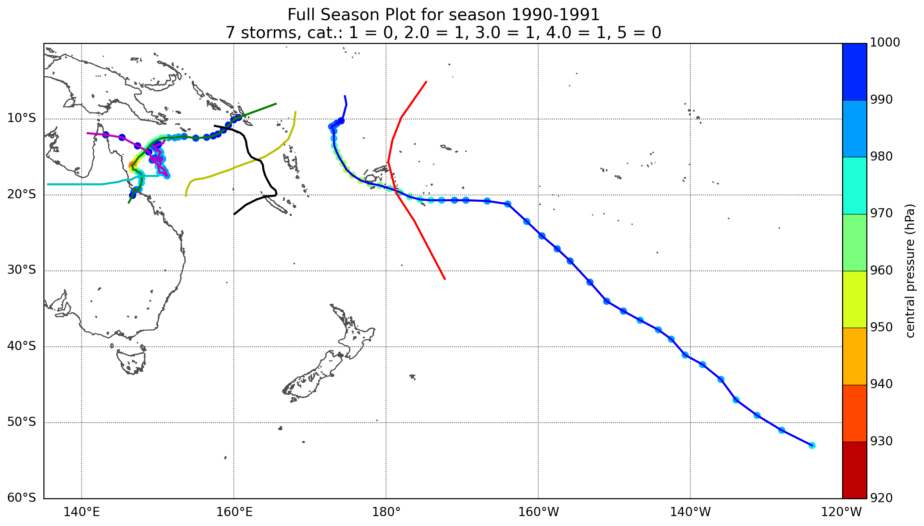
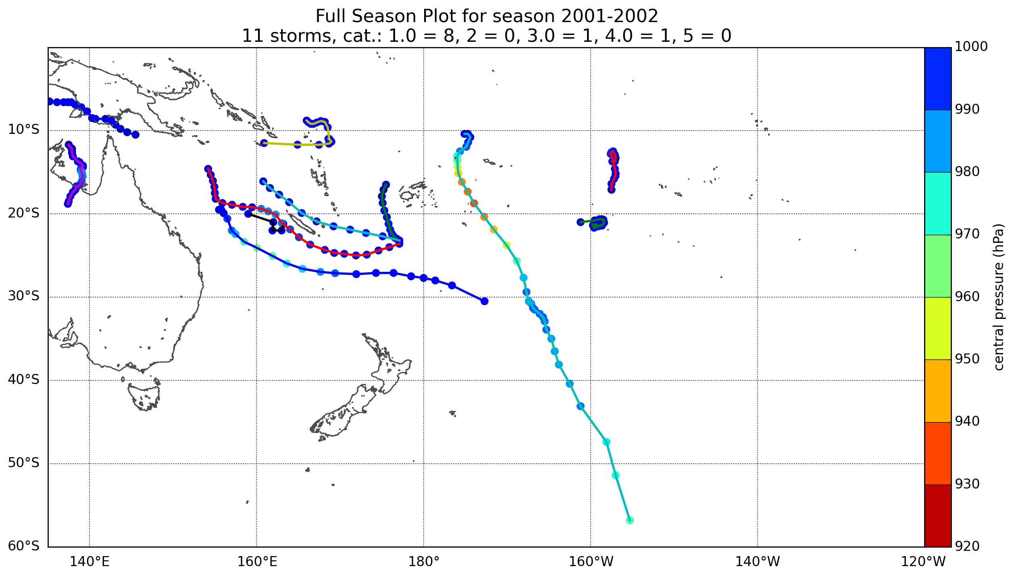
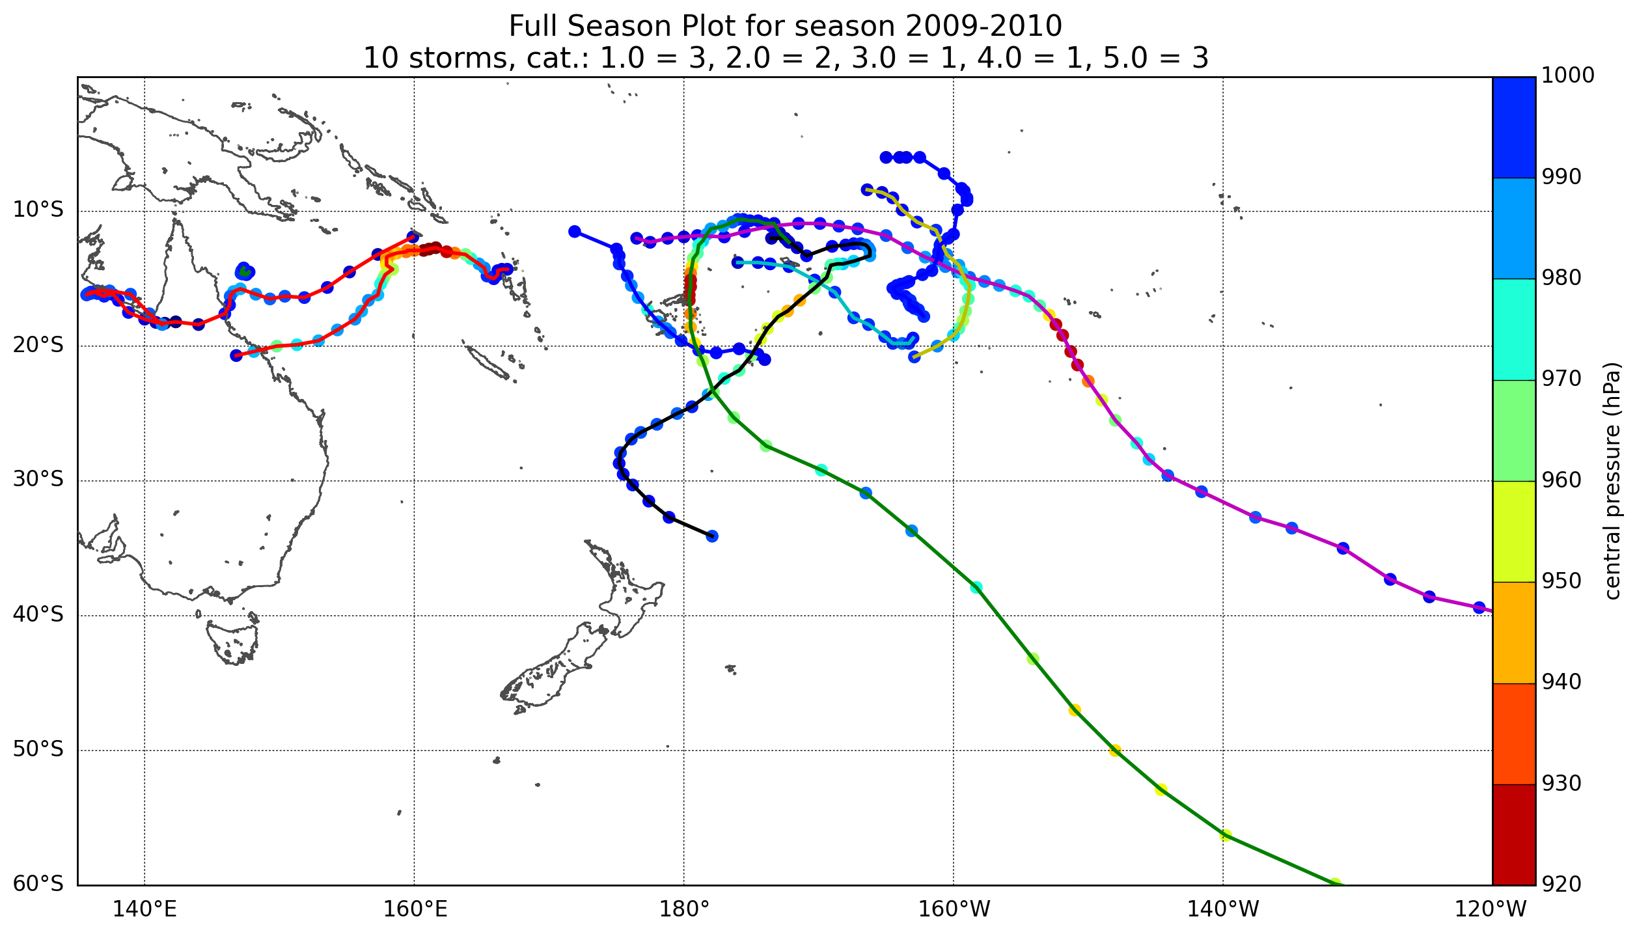

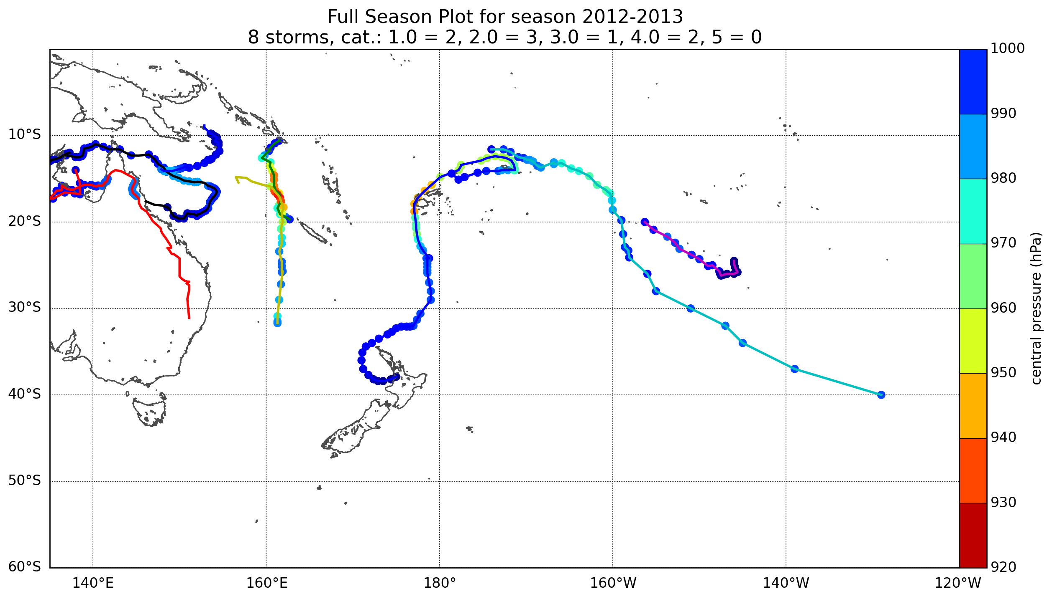

Figure 3: Early season (November to January) and late season (February to April) anomaly plots for selected TC analog seasons (data courtesy of South Pacific Enhanced Archive for Tropical Cyclone research (SPEArTC)).
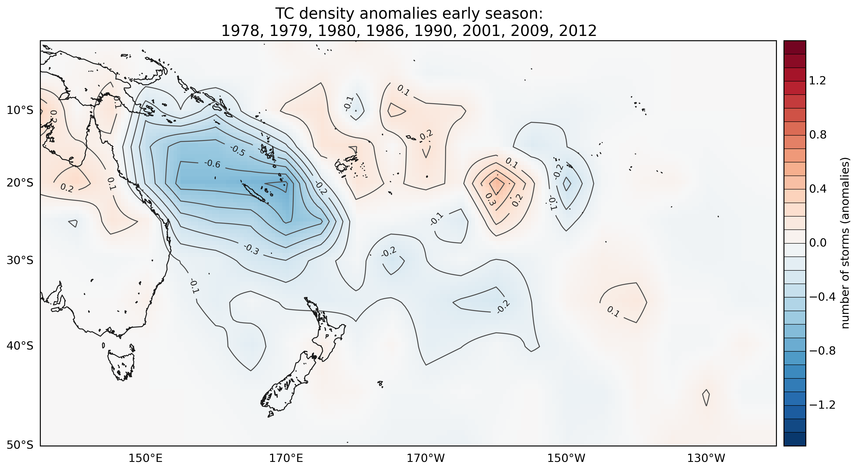
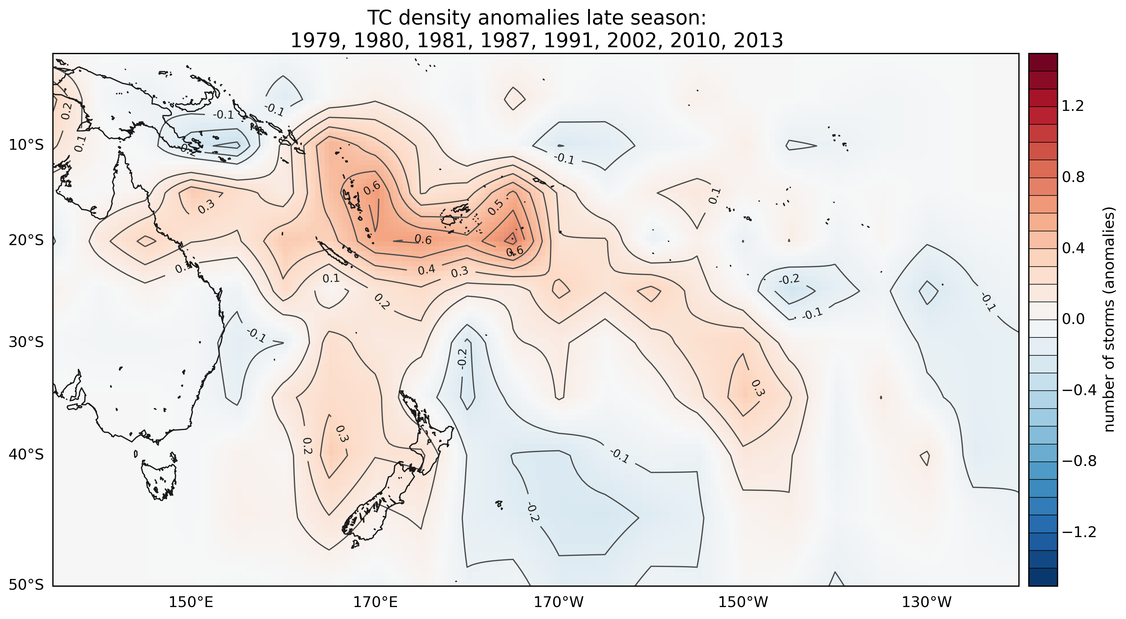

between 135°E (mid-Gulf of Carpentaria) and 120°W (French Polynesia)
See http://www.bom.gov.au/cyclone/about/intensity.shtml

