October – December 2014 Issued: 2 October 2014
Hold mouse over links and press ctrl + left click to jump to the information you require:
Overview
Regional predictions for the next three months:
Northland, Auckland, Waikato, Bay of Plenty
Central North Island, Taranaki, Wanganui, Manawatu, Wellington
Gisborne, Hawke’s Bay, Wairarapa
Nelson, Marlborough, Buller
West Coast, Alps and foothills, inland Otago and Southland
Coastal Canterbury, east Otago
Background
Contacts
Notes to reporters and editors
NIWA Outlook: October-December 2014
Overview
During September 2014, borderline El Niño conditions returned in the Pacific: sea surface temperatures rose in the western-central Pacific, sub-surface heat content increased, and the Southern Oscillation Index persisted at about -0.7. Both atmospheric and oceanic indicators are consequently close to conventional El Niño thresholds. International guidance indicates the development of a weak El Niño over the next three months is likely (67% chance).
During October–December 2014, mean sea level pressures are expected to be lower than normal to the north as well as over most of the country. This pressure pattern is expected to be accompanied by generally perturbed conditions.
Sea surface temperatures around New Zealand for the coming three months are expected to be near average.

Outlook Summary
October–December temperatures are likely (35-40% chance) to be average or above average for the east of the North Island, but are likely (40% chance) to be average or below average for the southwest and east of the South Island. Temperatures are likely (45-50% chance) to be near average for remaining regions of New Zealand.
October–December rainfall is likely (45-50% chance) to be in the near normal range for the north and west of the North Island, and likely (35-40% chance) to be normal or below normal in the east of the North Island. Normal or above normal rainfall is likely (40% chance) in all South Island regions.
Soil moisture levels and river flows are most likely (40-45% chance) to be in their near normal ranges for all regions of New Zealand.

Regional predictions for the September to November season
Northland, Auckland, Waikato, Bay of Plenty
The table below shows the probabilities (or percent chances) for each of three categories: above average, near average, and below average. In the absence of any forecast guidance there would be an equal likelihood (33% chance) of the outcome being in any one of the three categories. Forecast information from local and global guidance models is used to indicate the deviation from equal chance expected for the coming three month period, with the following outcomes the most likely (but not certain) for this region:
- Temperatures are most likely (50% chance) to be in the near average range.
- Rainfall totals are most likely (45% chance) to be in the near normal range.
- Soil moisture levels and river flows are most likely (45% chance) to be in the near normal range.
Other outcomes cannot be excluded. The full probability breakdown is:
 | Temperature | Rainfall | Soil moisture | River flows
Above average | 20 | 30 | 30 | 30
Near average | 50 | 45 | 45 | 45
Below average | 30 | 25 | 25 | 25

Central North Island, Taranaki, Wanganui, Manawatu, Wellington
Probabilities are assigned in three categories: above average, near average, and below average.
- Temperatures are most likely (50% chance) to be near average.
- Rainfall totals, soil moisture levels and river flows are all most likely (45-50% chance) to be in the near normal range.
The full probability breakdown is:
 | Temperature | Rainfall | Soil moisture | River flows
Above average | 25 | 30 | 25 | 30
Near average | 50 | 50 | 50 | 45
Below average | 25 | 20 | 25 | 25

Gisborne, Hawke’s Bay, Wairarapa
Probabilities are assigned in three categories: above average, near average, and below average.
- Temperatures are about equally likely (35-40% chance) to be above average or near average.
- Rainfall totals are about equally likely (35-40% chance) to be in the below normal or normal range.
- Soil moisture levels and river flows are most likely (40% chance) to be in the near normal range.
The full probability breakdown is:
 | Temperature | Rainfall | Soil moisture | River flows
Above average | 35 | 25 | 30 | 30
Near average | 40 | 40 | 40 | 40
Below average | 25 | 35 | 30 | 30

Nelson, Marlborough, Buller
Probabilities are assigned in three categories: above average, near average, and below average.
- Temperatures are most likely (45% chance) to be in the near average range.
- Rainfall totals are equally likely (40% chance) to be in the near normal or above normal range.
- Soil moisture levels and river flow are most likely (40% chance) to be in the normal range.
The full probability breakdown is:
 | Temperature | Rainfall | Soil moisture | River flows
Above average | 30 | 40 | 30 | 30
Near average | 45 | 40 | 40 | 40
Below average | 25 | 20 | 30 | 30

West Coast, Alps and foothills, inland Otago, Southland
Probabilities are assigned in three categories: above average, near average, and below average.
- Temperatures are equally likely (40% chance) to be in the near average or below average range.
- Rainfall totals are equally likely (40% chance) to be in the near normal or above normal range.
- Soil moisture levels and river flows are most likely (45% chance) to be in the near normal range.
The full probability breakdown is:
 | Temperature | Rainfall | Soil moisture | River flows
Above average | 20 | 40 | 30 | 30
Near average | 40 | 40 | 45 | 45
Below average | 40 | 20 | 25 | 25

Coastal Canterbury, east Otago
Probabilities are assigned in three categories: above average, near average, and below average.
- Temperatures are equally likely (40% chance) to be in the near average or below average range.
- Rainfall totals are equally likely (40% chance) to be in the near normal or above normal range.
- Soil moisture levels and river flows are most likely (40% chance) to be in the near normal range.
The full probability breakdown is:
 | Temperature | Rainfall | Soil moisture | River flows
Above average | 20 | 40 | 30 | 30
Near average | 40 | 40 | 40 | 40
Below average | 40 | 20 | 30 | 30

Graphical representation of the regional probabilities
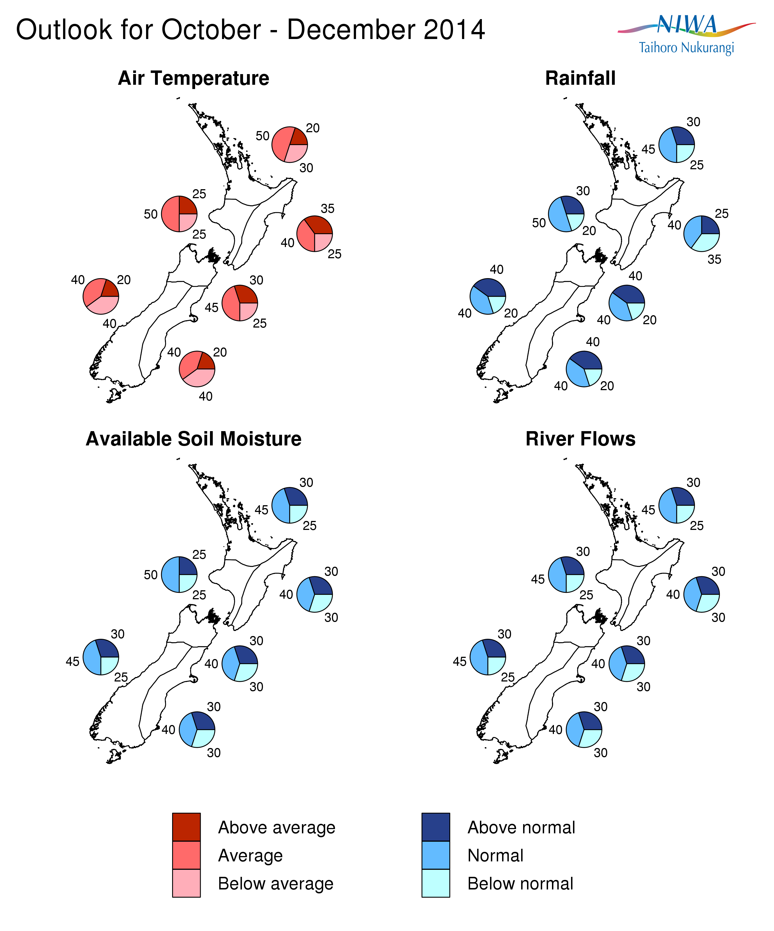

Background
During September 2014, borderline El Niño conditions returned in the Pacific. The sea surface temperature anomaly in the NINO3.4 region (170°W-120°W, 5°N-5°S) in September was about +0.5°C, near borderline El Niño levels. The sub-surface heat content also increased slightly. Sub-surface sea temperatures anomalies rose in the eastern Pacific to over +2°C at 50-100m depth near 120°W. Moreover, the latest observations show a resurgence of surface westerly wind anomalies in the far western Pacific (near 140°E), which should favour a continuation or enhancement of sub-surface warm anomalies in the equatorial Pacific over the next couple of months. In other words, the coupling between atmosphere and ocean in the tropical Pacific, which has been absent in the past few months, now looks to be lining up as one might expect for a developing El Niño. However, the coupling still needs to strengthen further before an event can be called.

International guidance indicates the development of a weak El Niño over the next three months is likely (67% chance). Six out of the ten dynamical models that NIWA monitors (and one of the four statistical models) indicate El Niño conditions developing over the next three months (October- December 2014). For the following 3 months (January-March 2015), eight of the 10 dynamical models suggest El Niño conditions prevail.

The NIWA Southern Oscillation Index (SOI) for September is –0.8. This brings the 3-month July-August-September value to –0.7. Strongly negative SOI values (less than -1) are typically associated with El Niño. In contrast, the NASA ENSO Precipitation Index (ESPI) for the 30 days to the 28th of September was +0.07 (neutral).

Note that for New Zealand, El Niño events typically reach their peak during summer, when they are related to stronger and/or more frequent westerly winds over the New Zealand region. Such a climate pattern typically leads to drier conditions in eastern areas and more rain in western areas of the country.

Meanwhile, waters surrounding New Zealand remain slightly warmer than average around the South Island, but are now cooler than normal to the east of the North Island. The monthly sea surface temperature anomaly around New Zealand was +0.2°C overall in September. Ocean model forecasts indicate that sea surface temperatures are likely to be close to normal around the country over the next three months.

For comment, please contact
Chris Brandolino, NIWA forecaster, NIWA National Climate Centre
Tel (09) 375 6335, Mobile (027) 886 0014

Dr Brett Mullan, Principal Scientist, NIWA National Climate Centre
Tel (04) 386 0508, Mobile (027) 294 1169.
Notes to reporters and editors
- NIWA’s outlooks indicate the likelihood of climate conditions being at, above, or below average for the season as a whole. They are not ‘weather forecasts’. It is not possible to forecast precise weather conditions three months ahead of time.
- The outlooks are the result of the expert judgment of NIWA’s climate scientists. They take into account observations of atmospheric and ocean conditions and output from global and local climate models. The presence of El Niño or La Niña conditions and the sea surface temperatures around New Zealand can be a useful indicator of likely overall climate conditions for a season.
- The outlooks state the probability for above average conditions, near average conditions, and below average conditions for rainfall, temperature, soil moisture, and river flows. For example, for winter (June–July–August) 2007, for all the North Island, we assigned the following probabilities for temperature:
· Above average: 60 per cent
· Near average: 30 per cent
· Below average: 10 per cent
We therefore concluded that above average temperatures were very likely.
- This three-way probability means that a random choice would be correct only 33 per cent (or one-third) of the time. It would be like randomly throwing a dart at a board divided into three equal parts, or throwing a dice with three numbers on it. An analogy with coin tossing (a two-way probability) is not correct.
- A 50 per cent ‘hit rate’ is substantially better than guesswork, and comparable with the skill level of the best overseas climate outlooks. See, for example, analysis of global outlooks issued by the International Research Institute for Climate and Society based in the US published in the Bulletin of the American Meteorological Society (Goddard, L., A. G. Barnston, and S. J. Mason, 2003: Evaluation of the IRI’s “net assessment” seasonal climate forecasts 1997–2001. Bull. Amer. Meteor. Soc., 84, 1761–1781).
- Each month, NIWA publishes an analysis of how well its outlooks perform. This is available online and is sent to about 3500 recipients of NIWA’s newsletters, including many farmers. See www.niwa.co.nz/our-science/climate/publications/all/cu
- All outlooks are for the three months as a whole. There will inevitably be wet and dry days, and hot and cold days, within a season. The exact range in temperature and rainfall within each of the three categories varies with location and season. However, as a guide, the “near average” or middle category for the temperature predictions includes deviations up to ±0.5°C for the long-term mean, whereas for rainfall the “near normal” category lies between approximately 80 per cent and 115 per cent of the long-term mean.
- The seasonal climate outlooks are an output of a scientific research programme, supplemented by NIWA’s Capability Funding. NIWA does not have a government contract to produce these outlooks.
Visit our media centre at: www.niwa.co.nz/news-publications/media-centre

