Thursday, 16 October 2014

National fail to get post-election bounce but leaderless Labour Party crash to lowest ever support
The first New Zealand Roy Morgan Poll since the NZ Election shows National (43.5%, down 3.54% since the September 20 Election). This isn’t unusual, National support has dropped after each of John Key’s Election victories. Support for Key’s Coalition partners has changed little overall with the Maori Party 2% (up 0.68%), Act NZ 0.5% (down 0.19%) and United Future 0.5% (up 0.28%).
However, support for the main opposition Labour Party has crashed to 22.5% (down 2.63% and the lowest support for Labour since the 1914 NZ Election as United Labour). Fellow opposition parties the Greens (17.5%, up 6.8% are at a new record high) while NZ First support is 7% (down 1.66%). The Greens need to work out why their support on Election Day was lower than all the major polls indicated.
For the parties outside Parliament the Conservative Party of NZ is 5% (up 1.03% a new record high level of support) while the Internet-Mana Party alliance is at 1% (down 0.42%) and support for Independent/ Others is 0.5% (down 0.35%).
If a National Election were held now the latest New Zealand Roy Morgan Poll shows that the result would be too close to call.
The latest NZ Roy Morgan Government Confidence Rating is virtually unchanged at 137pts (down 1pt) with 61.5% (down 0.5%) saying NZ is ‘heading in the right direction’ compared to 24.5% (up 0.5%) that say NZ is ‘heading in the wrong direction’. The NZ Government Confidence Rating remains substantially higher than in Australia – Australian Government Confidence last week was at 99pts.
Gary Morgan, Executive Chairman, Roy Morgan Research, says:
“Prime Minister John Key led National to a convincing election victory a month ago with National increasing its seats in Parliament despite a slight drop in support compared to the record high 2011 New Zealand Election result under the MMP system.
“National (43.5%, down 3.54% since the NZ Election) has failed to gain any post-election boost in support although this is not unusual – National support has now fallen immediately after all three election victories. Coalition partners Act NZ and United Future both retained their seats while the Maori Party lost a seat meaning the Government once again controls 64 seats in the 121 seat Parliament.
“After crashing to its worst election result in 92 years – since the 1922 NZ Election, a now leaderless Labour Party has dropped to only 22.5% support (down 2.63% since the NZ Election) – the lowest level of support for Labour since it contested the 1914 NZ Election as ‘United Labour’. The next month promises more pain for Labour before the selection of a new Labour Leader on November 18. After David Cunliffe’s withdrawal from the race this week the leadership contest is now a four-way fight between Wellington Central MP Grant Robertson, interim leader David Parker, Hauraki-Waikato MP Nanaia Mahuta and List MP Andrew Little.”

Electors were asked: “If a New Zealand Election were held today which party would receive your party vote?” This latest New Zealand Roy Morgan Poll on voting intention was conducted by telephone – both landline and mobile telephone, with a NZ wide cross-section of 927 electors from September 29 – October 12, 2014. Of all electors surveyed 2% (down 3%) didn’t name a party.

For further information:
Contact | Office | Mobile
Gary Morgan: | +61 3 9224 5213 | +61 411 129 094
Michele Levine: | +61 3 9224 5215 | +61 411 129 093

Margin of Error
The margin of error to be allowed for in any estimate depends mainly on the number of interviews on which it is based. The following table gives indications of the likely range within which estimates would be 95% likely to fall, expressed as the number of percentage points above or below the actual estimate. The figures are approximate and for general guidance only, and assume a simple random sample. Allowance for design effects (such as stratification and weighting) should be made as appropriate.
Sample Size | Percentage Estimate
 | 40%-60% | 25% or 75% | 10% or 90% | 5% or 95%
1,000 | ±3.2 | ±2.7 | ±1.9 | ±1.4
1,500 | ±2.6 | ±2.2 | ±1.5 | ±1.1
Roy Morgan New Zealand Election 2014 Interactive Charts
These interactive charts allow a deeper look at voting patterns in New Zealand over varying timeframes and provide election observers with the ability to pinpoint key turning points for the political parties.
View interactive New Zealand Election charts here.
Purchase the latest Roy Morgan New Zealand Electorate Profiles.
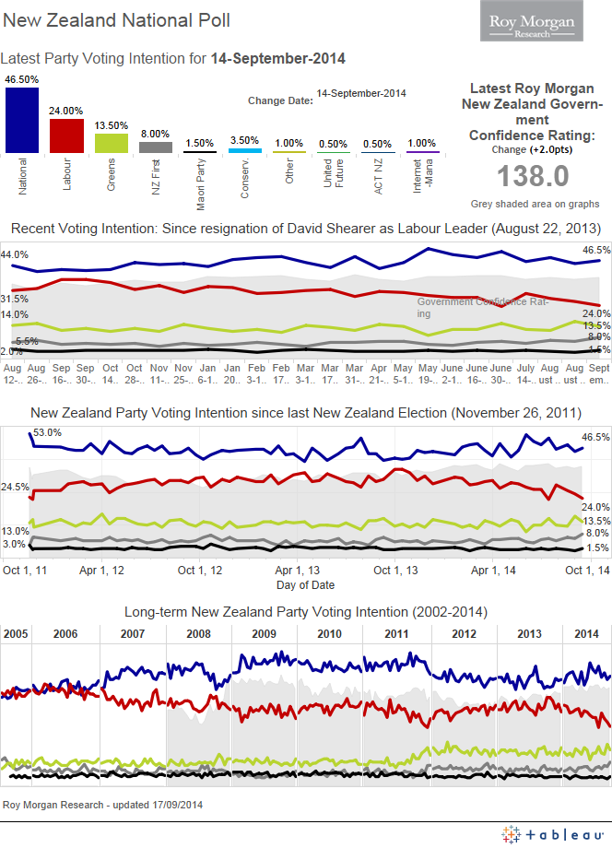
Voting Intention Summary
The following table compares the latest New Zealand Roy Morgan Polls on Voting Intention with the result from the November 26, 2011 General Election:

PRIMARY VOTE | National | Labour | Green  Party | NZ  First |  | Maori  Party* | ACT  NZ | United  Future | Conservatives* | Mana  Party* | Internet* | Other
ELECTIONS | % | % | % | % |  | % | % | % | % | % | % | %
July 27, 2002 | 20.93 | 41.26 | 7.00 | 10.38 |  | n/a | 7.14 | 6.69 | n/a | n/a | n/a | 6.60
September 17, 2005 | 39.10 | 41.10 | 5.30 | 5.72 |  | 2.12 | 1.51 | 2.67 | n/a | n/a | n/a | 2.48
November 8, 2008 | 44.93 | 33.99 | 6.72 | 4.07 |  | 2.39 | 3.65 | 0.87 | n/a | n/a | n/a | 3.38
November 26, 2011 | 47.31 | 27.48 | 11.06 | 6.59 |  | 1.43 | 1.07 | 0.60 | 2.65 | 1.08 | n/a | 0.73
September 20, 2014 | 47.04 | 25.13 | 10.70 | 8.66 |  | 1.32 | 0.69 | 0.22 | 3.97 | 1.42 | n/a | 0.85
ROY MORGAN POLL
Sep 29-Oct 12, 2014 | 43.5 | 22.5 | 17.5 |  | 7 | 2 | 0.5 | 0.5 | 5 | 1 | ^ | 0.5
^ Result less than 0.5%. *The Maori Party was launched in July 2004; The Mana Party was launched in July 2011. The Conservative Party was launched in August 2011. The Internet Party was launched in January 2014. The Internet Party & Mana Party announced an alliance in May 2014 that jointly contested the 2014 NZ Election. The combined result for the Internet-Mana Party Alliance is included in the Mana Party result (1.42%).

Two-Party Preferred: National Party-led Government vs. Parliamentary Opposition Parties
The following table compares the latest New Zealand Roy Morgan Polls on Voting Intention with the result from the November 26, 2011 General Election:
 | National Party-led Government* | Parliamentary  Opposition Parties#
Election, November 8, 2008 | 51.84 | 48.16
Election, November 26, 2011 | 50.41 | 46.21
Election, September 20, 2014 | 49.27 | 44.49
ROY MORGAN POLL
September 29 – October 12, 2014 | 46.5 | 47

*National-led Government: National Party, Maori Party, ACT NZ, United Future; #Opposition Parties: Labour Party, Green Party, NZ First. Parties not represented: Conservative Party, Internet Party, Mana Party & Other not included as they are not represented in Parliament.

Finding No. 5868 taken from Computer Report No. 2411
The Roy Morgan Poll is conducted by the ONLY Australian and NZ member of the Gallup International Association.
No other public opinion poll taken in Australia or New Zealand has this qualification.
NEW ZEALAND: HEADING IN “RIGHT” OR “WRONG” DIRECTION?

Electors were asked: “Generally speaking, do you feel that things in New Zealand are heading in the right direction or would you say things are seriously heading in the wrong direction?”

 | NZ Roy Morgan Government Confidence Rating: Interviewing Dates (National Party Govt.)
 | June 3-16,  2013 | June 17-30,  2013 | July 1-14,  2013 | July 15-28,  2013 | July 29-Aug 11,  2013 | Aug 12-25,  2013 | Aug 26-Sep 8,  2013 | Sep 16-29,  2013
 | % | % | % | % | % | % | % | %
Right direction | 54 | 57 | 58 | 58.5 | 58 | 58 | 52.5 | 59
Wrong direction | 33.5 | 32 | 29.5 | 30 | 30 | 30.5 | 35.5 | 29.5
Roy Morgan GCR# | 120.5 | 125 | 128.5 | 128.5 | 128 | 127.5 | 117 | 129.5
Can’t say | 12.5 | 11 | 12.5 | 11.5 | 12 | 11.5 | 12 | 11.5
TOTAL | 100 | 100 | 100 | 100 | 100 | 100 | 100 | 100

 | NZ Roy Morgan Government Confidence Rating: Interviewing Dates (National Party Govt.)
 | Sep 30-Oct 13,  2013 | Oct 14-27,  2013 | Oct 28-Nov 10,  2013 | Nov 11-24,  2013 | Nov 25-Dec 8,  2013 | Jan 6-19,  2014 | Jan 20-Feb 2,  2014
 | % | % | % | % | % | % | %
Right direction | 55 | 57.5 | 61 | 59 | 58.5 | 63 | 63.5
Wrong direction | 31 | 28.5 | 27.5 | 29 | 28.5 | 23.5 | 24.5
Roy Morgan GCR# | 124 | 129 | 133.5 | 130 | 130 | 139.5 | 139
Can’t say | 14 | 14 | 11.5 | 12 | 13 | 13.5 | 12
TOTAL | 100 | 100 | 100 | 100 | 100 | 100 | 100

 | NZ Roy Morgan Government Confidence Rating: Interviewing Dates (National Party Govt.)
 | Feb 3-16,  2014 | Feb 17-Mar 2,  2014 | Mar 3-16,  2014 | Mar 17-30  2014 | Mar 31-Apr 13,  2014 | Apr 21-May 4,  2014 | May 5-18,  2014
 | % | % | % | % | % | % | %
Right direction | 63.5 | 65 | 61 | 61 | 65 | 62 | 60
Wrong direction | 23.5 | 23.5 | 25.5 | 28 | 22 | 26.5 | 28
Roy Morgan GCR# | 140 | 141.5 | 135.5 | 133 | 143 | 135.5 | 132
Can’t say | 13 | 11.5 | 13.5 | 11 | 13 | 11.5 | 12
TOTAL | 100 | 100 | 100 | 100 | 100 | 100 | 100

 | NZ Roy Morgan Government Confidence Rating: Interviewing Dates (National Party Govt.)
 | May 19-June 1,  2014 | June 2-15,  2014 | June 16-29,  2014 | June 30-July 13,  2014 | July 14-27,  2014 | Aug 4-17,  2014 | Aug 18-31,  2014 | Sep 1-14,  2014
 | % | % | % | % | % | % | % | %
Right direction | 64.5 | 63.5 | 65 | 65.5 | 60 | 63.5 | 61 | 62
Wrong direction | 24 | 24 | 23.5 | 23 | 25 | 24.5 | 25 | 24
Roy Morgan GCR# | 140.5 | 139.5 | 141.5 | 142.5 | 135 | 139 | 136 | 138
Can’t say | 11.5 | 12.5 | 11.5 | 11.5 | 15 | 12 | 14 | 14
TOTAL | 100 | 100 | 100 | 100 | 100 | 100 | 100 | 100

 | NZ Roy Morgan Government Confidence Rating: Interviewing Dates (National Party Govt.)
Sep 29-Oct 12,
2014
 | %
Right direction | 61.5
Wrong direction | 24.5
Roy Morgan GCR# | 137
Can’t say | 14
TOTAL | 100

New Zealand Primary Vote
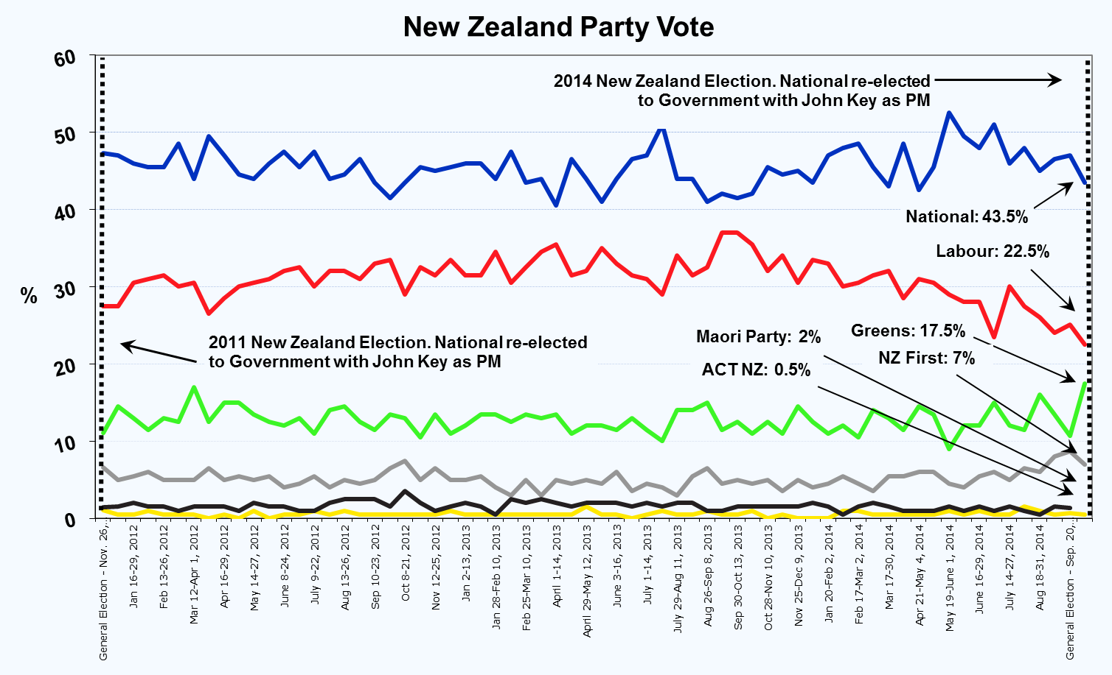
New Zealand Roy Morgan GCR
