August – October 2014 Issued: 31 July 2014
Hold mouse over links and press ctrl + left click to jump to the information you require:
Overview
Regional predictions for the next three months:
Northland, Auckland, Waikato, Bay of Plenty
Central North Island, Taranaki, Wanganui, Manawatu, Wellington
Gisborne, Hawke’s Bay, Wairarapa
Nelson, Marlborough, Buller
West Coast, Alps and foothills, inland Otago and Southland
Coastal Canterbury, east Otago
Background
Contacts
Notes to reporters and editors
NIWA Outlook: August-October 2014
Overview
The equatorial Pacific Ocean continues to remain ENSO-neutral at the end of July 2014, with atmospheric and oceanic conditions failing to sufficiently couple to initiate an El Niño event. Other El Niño indicators have also weakened in the last month. Thus, the chances of an El Niño event developing over spring appear to be lessening.
International guidance still indicates that El Niño is the most likely outcome (about 70% chance) over the coming three seasons through to the end of summer 2015. However, it should be recognised that this guidance is based on model simulations from end-of-June conditions so does not take account of the rapid changes observed in July. The behaviour of the atmosphere over the next month or two will be critical to whether an El Niño event initiates or not.
During August–October 2014, mean sea level pressures are expected to be lower than normal to the northeast of New Zealand, with higher pressures than normal to the southeast of the country. This pressure pattern is expected to be accompanied by generally anomalous flow from the easterly quarter.
Sea surface temperatures for the coming three months are expected to be near average off the west coast of New Zealand and above average to the east.

Outlook Summary
August-October temperatures are most likely (50% chance) to be above average for the east of the North Island, and likely (40-45%) to be average or above average for all remaining regions of New Zealand. Cold snaps and frosts can still be expected in some parts of the country as winter advances into spring.
August-October rainfall is equally likely (40% chance) to be normal or above normal in the north and east of the North Island, and normal or below normal in the west of the North Island and in the north of the South Island. In remaining South Island regions, seasonal rainfall is most likely (45%) to be in the near-normal range.
August– October river flows and soil moisture levels are about equally likely (35-40 % chance) to be normal or above normal in the north and east of the North Island, and most likely (45%) to be below normal in the west of the North Island. In the South Island, river flows and soil moisture levels are likely (40% chance) to be near normal in the west, but about equally likely (35-40 % chance) to be normal or below normal in the north and east.

Regional predictions for the August to October season
Northland, Auckland, Waikato, Bay of Plenty
The table below shows the probabilities (or percent chances) for each of three categories: above average, near average, and below average. In the absence of any forecast guidance there would be an equal likelihood (33% chance) of the outcome being in any one of the three categories. Forecast information from local and global guidance models is used to indicate the deviation from equal chance expected for the coming three month period, with the following outcomes the most likely (but not certain) for this region:
- Temperatures are likely (40-45% chance) to be average or above average.
- Rainfall totals are equally likely (40% chance) to be in the normal or above normal range.
- Soil moisture levels and river flows are about equally likely (40-35% chance) to be in the near normal or above normal range.
Other outcomes cannot be excluded. The full probability breakdown is:
 | Temperature | Rainfall | Soil moisture | River flows
Above average | 45 | 40 | 35 | 35
Near average | 40 | 40 | 40 | 40
Below average | 15 | 20 | 25 | 25

Central North Island, Taranaki, Wanganui, Manawatu, Wellington
Probabilities are assigned in three categories: above average, near average, and below average.
- Temperatures are likely (40-45% chance) to be average or above average.
- Rainfall totals are equally likely (40% chance) to be in the normal or below normal range.
- Soil moisture levels and river flows are most likely (45% chance) to be in the below normal range.
The full probability breakdown is:
 | Temperature | Rainfall | Soil moisture | River flows
Above average | 45 | 20 | 20 | 20
Near average | 40 | 40 | 35 | 35
Below average | 15 | 40 | 45 | 45

Gisborne, Hawke’s Bay, Wairarapa
Probabilities are assigned in three categories: above average, near average, and below average.
- Temperatures are most likely (50% chance) to be in the above average range.
- Rainfall totals are equally likely (40% chance) to be in the normal or above normal range.
- Soil moisture levels and river flows are about equally likely (40-35% chance) to be in the near normal or above normal range.
The full probability breakdown is:
 | Temperature | Rainfall | Soil moisture | River flows
Above average | 50 | 40 | 35 | 35
Near average | 40 | 40 | 40 | 40
Below average | 10 | 20 | 25 | 25

Nelson, Marlborough, Buller
Probabilities are assigned in three categories: above average, near average, and below average.
- Temperatures are likely (40-45% chance) to be in the average or above average range.
- Rainfall totals, soil moisture levels and river flows are all equally likely (40% chance) to be in the normal or below normal range.
The full probability breakdown is:
 | Temperature | Rainfall | Soil moisture | River flows
Above average | 45 | 20 | 20 | 20
Near average | 40 | 40 | 40 | 40
Below average | 15 | 40 | 40 | 40

West Coast, Alps and foothills, inland Otago, Southland
Probabilities are assigned in three categories: above average, near average, and below average.
- Temperatures are equally likely (40% chance) to be in the near average or above average range.
- Rainfall totals are most likely (45% chance) to be in the near normal range.
- Soil moisture levels and river flows are likely (40% chance) to be in the near normal range.
The full probability breakdown is:
 | Temperature | Rainfall | Soil moisture | River flows
Above average | 40 | 20 | 30 | 30
Near average | 40 | 45 | 40 | 40
Below average | 20 | 35 | 30 | 30

Coastal Canterbury, east Otago
Probabilities are assigned in three categories: above average, near average, and below average.
- Temperatures are equally likely (40% chance) to be in the near average or above average range.
- Rainfall totals are most likely (45% chance) to be in the near normal range.
- Soil moisture levels and river flows are about equally likely (35-40% chance) to be in the near normal or below normal range.
The full probability breakdown is:
 | Temperature | Rainfall | Soil moisture | River flows
Above average | 40 | 35 | 25 | 25
Near average | 40 | 45 | 35 | 35
Below average | 20 | 20 | 40 | 40

Graphical representation of the regional probabilities
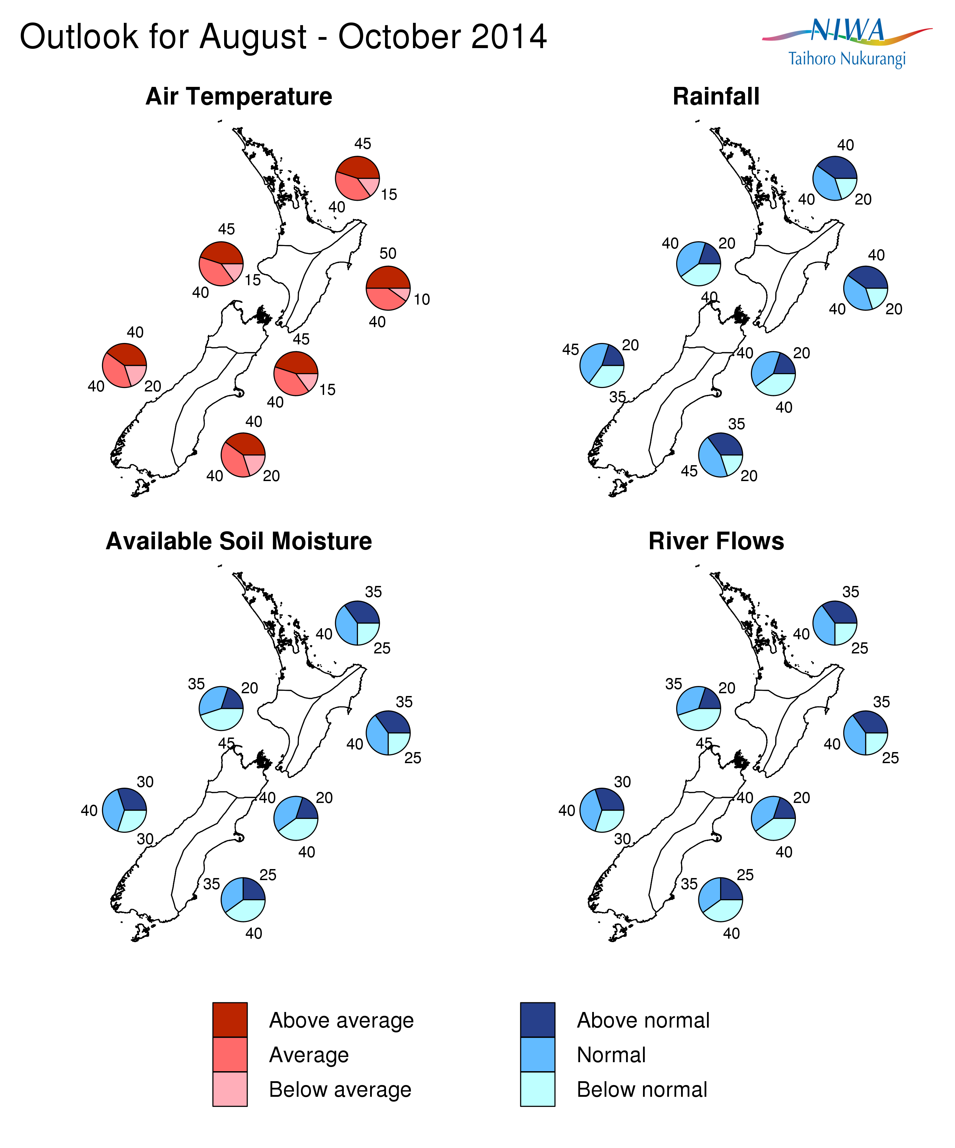

Background
The equatorial Pacific Ocean continues to remain ENSO-neutral at the end of July 2014, with atmospheric and oceanic conditions failing to sufficiently couple to initiate an El Niño event. Equatorial sea-surface temperature (SST) anomalies have eased back to below the +0.5°C El Niño threshold in the central Pacific, although SST anomalies remain elevated in the eastern Pacific. Moreover, the very large sub-surface temperature anomalies present in the eastern Pacific in June have now all but disappeared. Thus, the chances of an El Niño event developing over spring appear to be lessening, but are still significant.
International guidance still indicates that El Niño is the most likely outcome (about 70% chance) over the coming three seasons through to the end of summer 2015. However, it should be recognised that the model guidance was from simulations based on end-of-June conditions before the full extent of the July cooling occurred. The response of the atmosphere over the next month or two will be critical to whether an El Niño event initiates or not.
The NIWA Southern Oscillation Index (SOI) for July was –0.6 (estimated at 29-July). This brings the 3-month May-June-July value to -0.2. Further, the NASA ENSO Precipitation Index (ESPI) for the 30 days to 27-July was +0.2. These values are typically associated with ENSO neutral conditions.
Note that for New Zealand, El Niño events typically reach their peak during summer, when they are related to stronger and/or more frequent westerly winds over the New Zealand region. Such a climate pattern typically leads to drier conditions in eastern areas and more rain in western areas of the country. It is not uncommon for El Niño events to start late in the year (after June), but those that do tend to be weaker.
Meanwhile, waters surrounding New Zealand remain generally warmer than average, particularly to the east of the country. The estimated monthly sea surface temperature (SST) anomaly for New Zealand was +1.0°C in July (a slight change from the June value of +0.9ºC). SSTs have now been warmer than normal around New Zealand since January 2013.

For comment, please contact
Chris Brandolino, NIWA forecaster, NIWA National Climate Centre
Tel (09) 375 6335, Mobile (027) 886 0014

Dr Brett Mullan, Principal Scientist, NIWA National Climate Centre
Tel (04) 386 0508, Mobile (027) 294 1169.
Notes to reporters and editors
- NIWA’s outlooks indicate the likelihood of climate conditions being at, above, or below average for the season as a whole. They are not ‘weather forecasts’. It is not possible to forecast precise weather conditions three months ahead of time.
- The outlooks are the result of the expert judgment of NIWA’s climate scientists. They take into account observations of atmospheric and ocean conditions and output from global and local climate models. The presence of El Niño or La Niña conditions and the sea surface temperatures around New Zealand can be a useful indicator of likely overall climate conditions for a season.
- The outlooks state the probability for above average conditions, near average conditions, and below average conditions for rainfall, temperature, soil moisture, and river flows. For example, for winter (June–July–August) 2007, for all the North Island, we assigned the following probabilities for temperature:
· Above average: 60 per cent
· Near average: 30 per cent
· Below average: 10 per cent
We therefore concluded that above average temperatures were very likely.
- This three-way probability means that a random choice would be correct only 33 per cent (or one-third) of the time. It would be like randomly throwing a dart at a board divided into three equal parts, or throwing a dice with three numbers on it. An analogy with coin tossing (a two-way probability) is not correct.
- A 50 per cent ‘hit rate’ is substantially better than guesswork, and comparable with the skill level of the best overseas climate outlooks. See, for example, analysis of global outlooks issued by the International Research Institute for Climate and Society based in the US published in the Bulletin of the American Meteorological Society (Goddard, L., A. G. Barnston, and S. J. Mason, 2003: Evaluation of the IRI’s “net assessment” seasonal climate forecasts 1997–2001. Bull. Amer. Meteor. Soc., 84, 1761–1781).
- Each month, NIWA publishes an analysis of how well its outlooks perform. This is available online and is sent to about 3500 recipients of NIWA’s newsletters, including many farmers. See www.niwa.co.nz/our-science/climate/publications/all/cu
- All outlooks are for the three months as a whole. There will inevitably be wet and dry days, and hot and cold days, within a season. The exact range in temperature and rainfall within each of the three categories varies with location and season. However, as a guide, the “near average” or middle category for the temperature predictions includes deviations up to ±0.5°C for the long-term mean, whereas for rainfall the “near normal” category lies between approximately 80 per cent and 115 per cent of the long-term mean.
- The seasonal climate outlooks are an output of a scientific research programme, supplemented by NIWA’s Capability Funding. NIWA does not have a government contract to produce these outlooks.
Visit our media centre at: www.niwa.co.nz/news-publications/media-centre

