Media release
7 August, 2014
STRICLY EMBARGOED UNTIL 12 NOON AUGUST 7, 2014
Residential property value increases slowdown
The latest monthly QV Residential Price Movement Index shows that nationwide residential property values for July have increased 7.6% over the past year and 2.3% over the past three months. This means they are now 15.6% above the previous market peak of late 2007. When adjusted for inflation the nationwide annual increase drops slightly to 5.9% and values remain below the 2007 peak by 0.9%.
The Auckland market has increased 11.7% year on year and values are up 31.8% since 2007. When adjusted for inflation values are up 9.9% over the past year and are 12.9% above the 2007 peak.

QV National Spokesperson Andrea Rush said, “We are starting to see a slowdown in the rate of value increases in many of the main centres following on from the slowdown in sales volumes over the past few months.”
“The Auckland region as a whole has seen values rise over the past three months but some areas of the super city are now showing a slight decline in values.”
“Residential property values in Christchurch are still rising across the city and values in Tauranga and Dunedin have also increased slightly while Hamilton values are down slightly and Wellington values are now showing a downward trend.”
“Sales volumes are between 15 and 25% lower than they were this time in 2012 and 2013 in most places around the country.”
“This slowdown is most likely due to the LVR speed limits and interest rate rises as well as the annual winter seasonal downturn. However, and the reserve bank has now said it will take a break in rate rises for the moment and banks are advertising that they will negotiate on lending to those with deposits of less than 20%.”
Auckland

The Auckland region as a whole saw residential property values increase by 2.1 % over the past three months and 11.7% year on year.

North Shore Coastal saw values increased the most, up 3.5% over the past three months, followed by Rodney – North where values have risen 3.2% since April. For the first time in the past couple of years values in Auckland City – Central have seen a decrease in value, down by 1.2% over the past three months.
QV Valuer Bruce Wiggins said, “Auckland is starting to show a slowdown in the rate of home value increases and a few areas are showing a slight drift downwards in value over the past month including Auckland City East down by 1.3%, Auckland City down by 0.4% and North Shore-North Harbour down by 0.9%.”
“This is the first ‘normal’ winter the Auckland property market has seen in a few years, where we are seeing reduced house sales and fewer attendees at open homes.”
“Some properties are sitting around for several weeks with no offers, or below expectation offers which could be due to a ‘disconnect’ between buyer and seller expectations especially where the property requires some form of maintenance or upgrading.”
“This market is also underpinned by an environment where buyers need a 20% deposit and we have seen four successive interest rate increases.”
“QV valuers have been busy with refinancing work as people fix their interest rates. A rate increase of 1% per annum may not seem a lot but with large mortgages it can make quite a big difference to repayments.”
Hamilton and Tauranga
Residential property values in Hamilton City have decreased slightly by 0.2% over the past three months, however they are up by 3.9% since July last year.

Values in South West Hamilton have increased by 0.5% over the past three months. While, values in both the North East and North West of the city have decreased slightly, down 0.7% since April and South East Hamilton values are also down by 0.3% over the same period.
Values in the Waipa District are up 1.8% in the past three months and 6.5% year on year.
QV Valuer Nicky Harris said, “House sale volumes in Hamilton have been decreasing for some time now and this is now starting to effect sale prices with values in the city showing a slight decrease over all.”
“Despite some national media hype saying it could be easier to get a loan now if you have less than a 20% deposit, there still continues to be decreased activity in the lower end of the market since the LVR restrictions came into affect late last year.”
“However, the market is still relatively steady and there is a shortage of stock in well established areas close to city so these properties are selling well and holding value.”
“There are more properties in the $600,000 plus range coming on to the market and supply has finally caught up with demand resulting in a slowdown in volumes and sale prices due to this greater choice for purchasers.”
Residential Property values in Tauranga City have increased by 1.2% over the past three months and 5.6% year on year. Values in the Western Bay of Plenty have decreased by 0.6% since April and but are up 3.2% year on year.

QV Registered Valuer Mairi Macdonald said, “Sales volumes in Tauranga are decreasing however values in the city are still increasing slightly.”
“Fewer lower value homes are selling due to the LVR lending restrictions and properties are also taking longer to sell especially those under $350,000.”
“However, we are seeing more demand for higher value properties (typically over $500,000) due to out of town buyers and there is some evidence of investors looking for higher value properties.”
Wellington

Residential property values in the Wellington Region as a whole are down 0.9% over the past three months, but they have increased 1.2% year on year.

Wellington City have seen a slight decrease of 0.8% over the past three months, Lower Hutt is down 2.3% in the past three months and values there are now the same as they were this time last year. Upper Hutt is also down 0.3% over the past three months and 0.3% year on year. However, values on the Kapiti Coast District have increased 0.6% over the past three months and 3.2% year on year.
QV Wellington Registered Valuer Kerry Buckeridge said, “Year on year values in Wellington have increased, but the rate of increase is dropping month on month which is reflective of there being lower sales volumes than this time last year.”
“Even those real estate agents who have been optimistic up until now are saying there has been very little activity over the last six weeks and few factors to drive market growth. The Hutt Valley is very quiet, perhaps more so than Wellington.”
“Demand for apartments is low, particularly as for many the operating costs have increased due, partly, to the increased insurance costs following the Christchurch Earthquakes and also the need for earthquake strengthening in some buildings.”
“With insurance premiums now beginning to be struck at slightly lower levels than at the peak those buildings still needing to maintain high Body Corporate Levies due to the need to fund deferred maintenance or earthquake strengthening are suffering in the marketplace.”
Christchurch and Dunedin

Residential property values in Christchurch City have increased 2.1% over the past three months, 6.5% year on year.

Christchurch – Hills has seen an increase in home values of 4.4% over the past three months while Southwest Christchurch has increased 3.0%, Christchurch East is up 1.6% and Christchurch Central and North is up 1.3%.
QV Valuer Daryl Taggart said, “Over the past few months it has only been in the new build housing market where things appear to be at full steam ahead.”
“The rest of the residential property market is showing a normal level of activity and movement but we are far from where we were 12 to 18 months ago in so far as demand from buyers.”
“There is no longer such a large shortage of supply as more homes have been repaired and more new homes have been completed and are coming to market.”
“The Christchurch Hills area is showing a marked increase over the past three months however this is not indicative of the market there which is actually more in line with other city areas.”
Property values in Dunedin City have increased by 0.3% over the past three months and by 2.2% year on year and values there are now 1.6% above the previous peak of 2007.

Dunedin Central and North values are up 0.5% over the past three months and 2.2% year on year. Dunedin South has also increased 1.0% in the past three months and 2.3% year on year. Values in the Dunedin Peninsula and Coastal areas are also up 0.6 % over the past three months and 2.3% year on year.

QV Registered Valuer Duncan Jack said, “The market conditions of recent months prevail in Dunedin with slowly increasing values and overall listing numbers at low to moderate levels across the city.”

“There is reasonable to good demand for those properties listed and many properties are selling fairly quickly particularly those that are well presented and priced realistically. There has also been some multi offer scenarios reported of late.”

“The highest demand appears to be for low to mid value properties in the $250,000 to $350,000 range.”
“Listings may increase as we come into spring as winter is traditionally the least popular time of year to sell. Many buyers are still cautious and appear happy to wait for the ‘right’ property.”
Provincial centres

Values in the provincial centres are variable while many are decreasing or flat there are a number of areas where residential property values are rising.

In the North Island, residential property values in the Kaipara District have increased by 2.4% over the past three months and are up 7.6% year on year. The Matamata Piako District is also up 3.7% over the past three months and values there are up 5.5% since July last year. Values in New Plymouth are down slightly by 0.2% over the past three months but are up by 4.6% year on year.

In the South Island, residential property values in the Kaikoura District have increased by 4.0% over the past three months and are up 4.6% year on year. Values in the Clutha District are also up by 5.2% over the past three months and 7.1% year on year as are values in the Central Otago District which are up 3.4% over the past three months and 7.0% year on year.

For media enquiries and interviews, and for further information contact:
Andrea Rush
QV National Spokesperson
Mobile: 021 866 152
Tel: 09 361 7214
Email: andrea.rush@qv.co.nz

For further specific comment on local areas:
Hamilton. Nicky Harris - 0274 696506
Tauranga. Mairi MacDonald 027 230 7281
Wellington. Kerry Buckeridge 021 476-287
Christchurch. Daryl Taggart 027 304 9815
Dunedin. Duncan Jack 027 213 7618

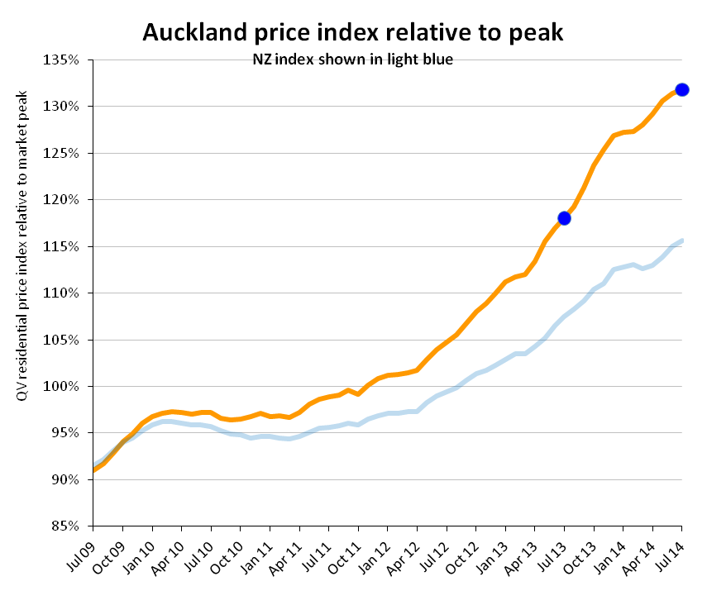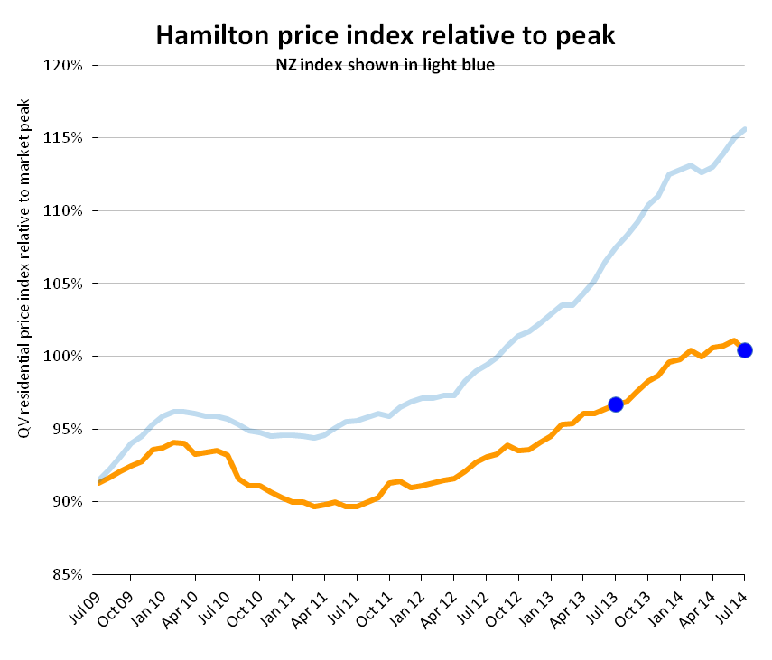
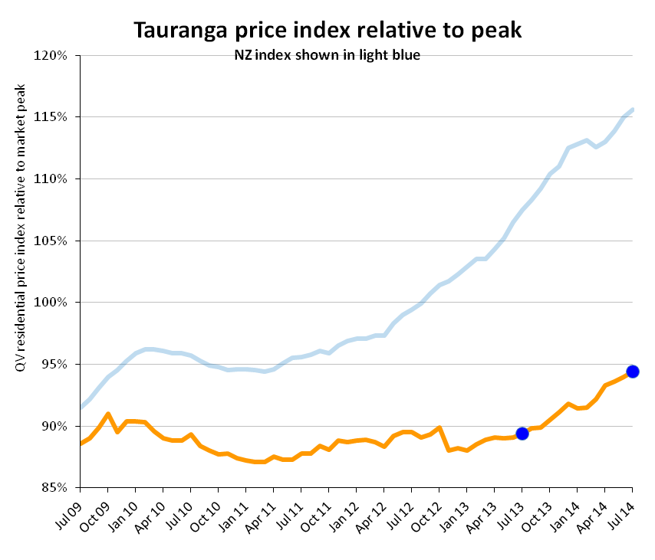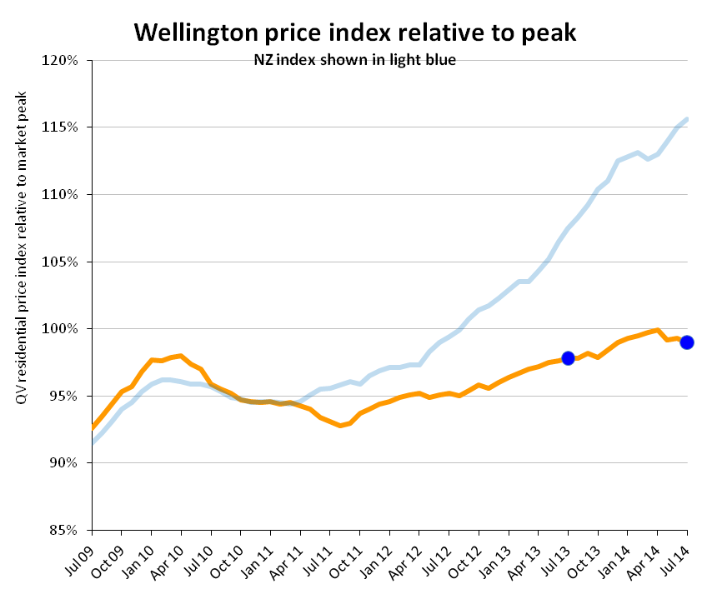

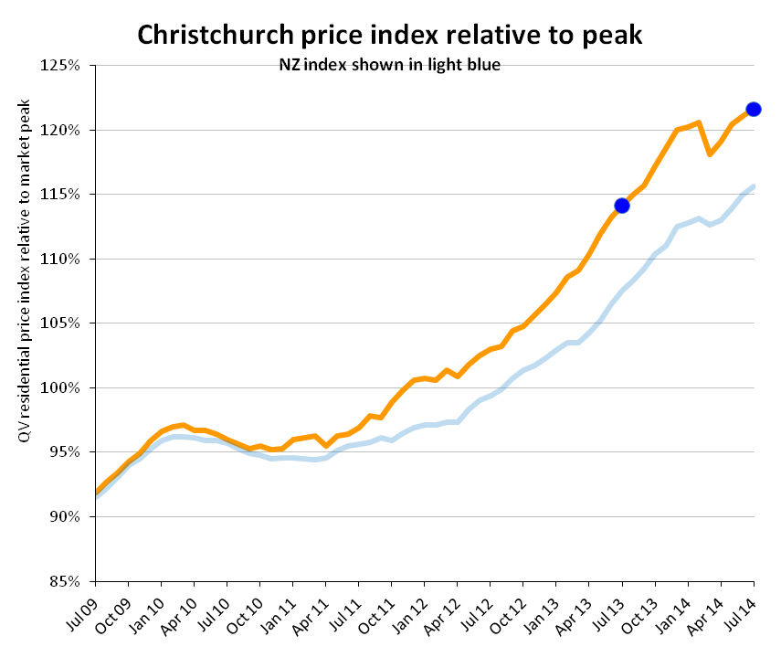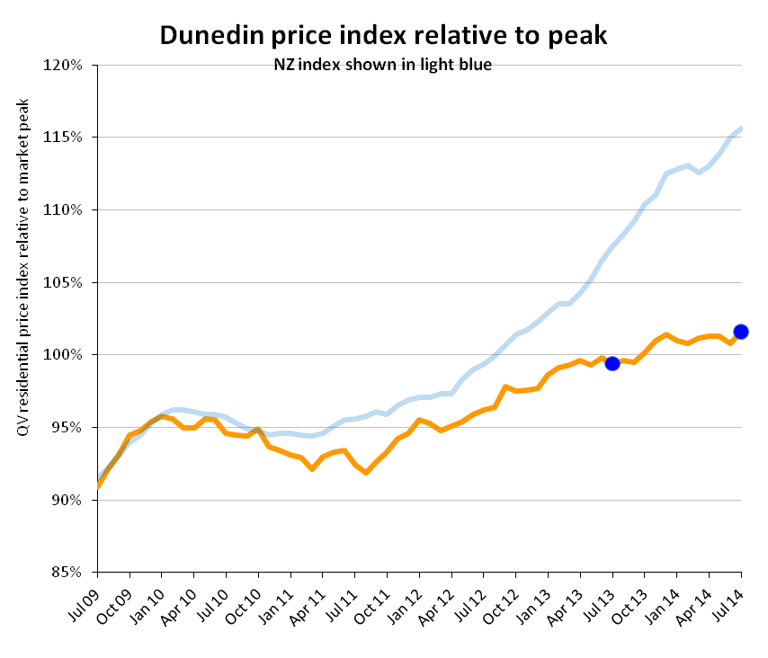

QV Residential Price Movement Index
Time period: 31 July 2014
 | Territorial authority | Average current value | 12 month change% | 3 month change % | Since 2007 market peak change %
 | Far North | 296,816 | -4.4% | -2.5% | -25.5%
 | Whangarei | 335,044 | 1.3% | -1.1% | -15.5%
 | Kaipara | 338,319 | 7.6% | 2.4% | -14.7%
 | Auckland - Rodney | 678,208 | 10.6% | 2.5% | 15.6%
 | Rodney - Hibiscus Coast | 670,890 | 10.6% | 2.0% | 14.2%
 | Rodney - North | 687,905 | 10.9% | 3.2% | 14.5%
#A | Auckland - North Shore | 857,239 | 12.7% | 2.7% | 32.8%
 | North Shore - Coastal | 990,893 | 13.1% | 3.5% | 31.5%
 | North Shore - Onewa | 680,340 | 12.8% | 2.5% | 37.2%
 | North Shore - North Harbour | 823,106 | 12.1% | 1.5% | 35.5%
#A | Auckland - Waitakere | 564,875 | 14.5% | 2.6% | 33.2%
#A | Auckland - City | 844,957 | 9.9% | 1.0% | 35.7%
 | Auckland City - Central | 747,278 | 8.3% | -1.2% | 31.2%
 | Auckland_City - East | 1,054,285 | 10.7% | 1.1% | 32.3%
 | Auckland City - South | 757,207 | 10.5% | 2.2% | 40.7%
 | Auckland City - Islands | 742,297 | 8.4% | -1.0% | 16.1%
#A | Auckland - Manukau | 598,838 | 13.3% | 2.2% | 30.8%
 | Manukau - East | 801,616 | 13.2% | 2.8% | 34.5%
 | Manukau - Central | 455,532 | 13.4% | 1.5% | 21.2%
 | Manukau - North West | 489,377 | 13.9% | 2.2% | 32.5%
#A | Auckland - Papakura | 431,444 | 13.0% | 0.2% | 19.9%
 | Auckland - Franklin | 465,090 | 10.5% | 1.2% | 17.6%
 | Thames Coromandel | 509,039 | 2.2% | 2.1% | -12.4%
 | Hauraki | 234,828 | -4.4% | -2.8% | -15.8%
 | Waikato | 286,237 | 5.5% | 3.8% | -5.4%
 | Matamata Piako | 278,852 | 5.5% | 3.7% | -4.4%
# | Hamilton | 363,118 | 3.9% | -0.2% | 0.4%
 | Hamilton - North East | 456,414 | 4.1% | -0.7% | 1.5%
 | Hamilton - Central & North West | 338,375 | 2.4% | -0.7% | -5.5%
 | Hamilton - South East | 334,087 | 4.0% | -0.3% | -4.4%
 | Hamilton - South West | 321,253 | 3.9% | 0.5% | -6.1%
 | Waipa | 341,194 | 6.5% | 1.8% | 3.6%
 | Otorohanga | N/A | N/A | N/A | N/A
 | South Waikato | 126,632 | -0.3% | -1.3% | -22.4%
 | Waitomo | N/A | N/A | N/A | N/A
 | Taupo | 342,312 | -1.8% | 1.2% | -14.5%
 | Western BOP | 410,366 | 3.2% | -0.6% | -8.9%
# | Tauranga | 454,570 | 5.6% | 1.2% | -5.6%
 | Rotorua | 270,592 | -1.0% | -1.6% | -7.8%
 | Whakatane | 294,705 | -0.6% | 0.5% | -15.3%
 | Kawerau | N/A | N/A | N/A | N/A
 | Opotiki | 209,890 | 0.0% | 2.0% | -26.2%
 | Gisborne | 229,699 | 0.4% | -0.6% | -22.7%
 | Wairoa | N/A | N/A | N/A | N/A
 | Hastings | 297,796 | -0.9% | -1.0% | -4.5%
# | Napier | 323,775 | 0.0% | -0.4% | -4.8%
 | Central Hawkes Bay | 210,605 | 8.6% | 1.1% | -20.5%
 | New Plymouth | 349,480 | 4.6% | -0.2% | 5.7%
 | Stratford | 202,899 | 4.4% | 3.6% | -7.2%
 | South Taranaki | 183,057 | 0.0% | 2.1% | -7.4%
 | Ruapehu | 136,091 | -4.0% | -2.3% | -24.5%
 | Wanganui | 177,919 | -6.0% | -3.5% | -20.6%
 | Rangitikei | 147,563 | -2.7% | 5.1% | -18.5%
 | Manawatu | 240,994 | 1.5% | -0.1% | -5.2%
# | Palmerston North | 284,963 | -0.1% | -0.9% | -4.5%
 | Tararua | 147,710 | -5.3% | -4.3% | -16.2%
 | Horowhenua | 205,958 | 2.9% | -0.2% | -13.4%
 | Kapiti Coast | 374,454 | 3.2% | 0.6% | -2.3%
#W | Porirua | 376,399 | -0.3% | -0.1% | -1.5%
#W | Upper Hutt | 333,513 | -0.3% | -0.3% | -5.1%
#W | Hutt | 370,566 | 0.0% | -2.3% | -5.6%
#W | Wellington | 535,559 | 1.9% | -0.8% | 0.6%
 | Wellington - Central & South | 546,894 | 2.3% | 0.1% | -2.4%
 | Wellington - East | 569,977 | 1.1% | -2.1% | -1.1%
 | Wellington - North | 472,151 | 2.7% | -0.1% | 1.3%
 | Wellington - West | 610,959 | 0.3% | -1.9% | 0.6%
 | Masterton | 235,962 | 0.0% | 0.2% | -17.4%
 | Carterton | 264,826 | 4.9% | 4.3% | -5.0%
 | South Wairarapa | 301,984 | 4.5% | 0.2% | -10.7%
 | Tasman | 413,611 | 3.7% | -0.8% | 3.0%
# | Nelson | 401,579 | 1.5% | -0.4% | 4.9%
 | Marlborough | 345,061 | -0.4% | -0.4% | -11.5%
 | Kaikoura | 367,671 | 4.6% | 4.0% | -14.9%
 | Buller | 207,288 | -5.9% | -2.4% | 0.9%
 | Grey | 212,805 | -2.3% | -2.5% | -12.9%
 | Westland | 227,723 | -2.4% | -1.0% | -5.2%
 | Hurunui | 335,478 | 0.6% | 0.7% | 7.3%
 | Waimakariri | 406,184 | 6.4% | 1.3% | 26.8%
# | Christchurch | 461,176 | 6.5% | 2.1% | 21.6%
 | Christchurch - East | 345,208 | 3.7% | 1.6% | 11.5%
 | Christchurch - Hills | 631,241 | 3.7% | 4.4% | 14.1%
 | Christchurch - Central & North | 538,728 | 7.7% | 1.3% | 21.7%
 | Christchurch - Southwest | 442,054 | 10.3% | 3.0% | 30.2%
 | Christchurch - Banks Peninsula | 470,485 | -7.2% | 0.4% | -2.1%
 | Selwyn | 505,602 | 7.6% | 2.5% | 35.6%
 | Ashburton | 321,402 | 6.6% | 2.1% | 14.8%
 | Timaru | 281,282 | 4.6% | 1.7% | 12.1%
 | MacKenzie | 280,627 | 5.2% | -4.2% | -2.0%
 | Waimate | 195,046 | 4.3% | -1.9% | 3.4%
 | Waitaki | 223,138 | 3.5% | 1.7% | -2.3%
 | Central Otago | 321,721 | 7.0% | 3.4% | 1.5%
 | Queenstown Lakes | 676,230 | 6.0% | 1.2% | -1.7%
# | Dunedin | 290,658 | 2.2% | 0.3% | 1.6%
 | Dunedin - Central & North | 299,535 | 2.2% | 0.5% | -0.7%
 | Dunedin - Peninsular & Coastal | 267,892 | 2.3% | 0.6% | -1.0%
 | Dunedin - South | 280,458 | 2.3% | 1.0% | -1.8%
 | Dunedin - Taieri | 299,838 | 1.9% | -0.5% | 2.0%
 | Clutha | 168,319 | 7.1% | 5.2% | -7.1%
 | Southland | 202,973 | -1.8% | -2.1% | -11.8%
 | Gore | 180,236 | 1.9% | -0.6% | 2.5%
# | Invercargill | 207,492 | 1.7% | 0.5% | -5.9%
 | Auckland Area | 720,426 | 11.7% | 2.1% | 31.8%
 | Wellington Area | 451,154 | 1.2% | -0.9% | -1.0%
# | Main Urban Areas | 558,131 | 9.1% | 2.1% | 21.5%
 | Total NZ | 479,193 | 7.6% | 2.3% | 15.6%
Notes on the above data:
1. The information included in the above table is based on the monthly property value index powered by CoreLogic NZ. This index is calculated based on the sales data entered into CoreLogic's system in the previous 3 month period. For example, information for the period ending June will be calculated based on sales entered between April 1 and June 30.
2. The average current value is the average (mean) value of all developed residential properties in the area based on the latest index. It is not an average or median sales price, as both of those only measure what happens to have sold in the period.
3. The percentage change over three months, twelve months and since the 2007 market peak are based on the change in the property value index between that time and the current.
4. Any of the statistical data shown in italics are calculated based on a sample set of data that is less than the recommended minimum. These results should be used with caution. Those showing N/A had too few sales to generate an index

