Media release
6 June
STRICLY EMBARGOED UNTIL 12 NOON JUNE 6, 2014
Nationwide property values continue to rise
The latest monthly QV Residential Price Movement Index shows that nationwide residential property values for May have increased 8.2% over the past year, and 0.7% over the past three months. This means they are now 13.9% above the previous market peak of late 2007. When adjusted for inflation the nationwide annual increase drops slightly to 6.6% and values remain below the 2007 peak by 2.2%.
The Auckland market has increased 13.1% year on year and values are up 30.6% since 2007. When adjusted for inflation values are up 11.4% over the past year and are 12.1% above the 2007 peak.

Andrea Rush QV National Spokesperson said, “Nationwide values are increasing for the second month in a row after showing a slight decline in March however the picture is quite mixed.”

“Whilst values in all the main centres have increased to varying levels, some areas within the cities are showing decreases and values in many of the smaller regions are flat or decreasing.”

“Sales volumes around the country are 10 to 15% lower than they were this time last year which could be a normal winter seasonal effect but it could also be a precursor to values dropping.”

“The LVR lending restrictions continue to have an effect in many of the regions with activity significantly slower at the entry level end of the market.”

Auckland

The Auckland region as a whole has increased 2.6% over the past three months. Auckland City – Central is the leader in terms of value rises over the past three months up 4.7%, followed by Rodney–Hibiscus Coast where values increased by 3.8% and then North Shore–coastal which is up 3.6%.

QV Valuer Bruce Wiggins said, “In Auckland the picture is mixed. We’re seeing some strong prices achieved at auctions, of note are some recent sales in the Southern Auckland suburbs of Mangere Bridge and Greenlane.”
“However properties in the inner city suburbs such as Grey Lynn and Ponsonby are often not achieving vendors’ price expectations. For example the Ponsonby property in Lincoln Street that was media hyped as looking for $2 million sold for just over $1.6 million and a Grey Lynn do-up that was poorly presented passed in, so the feeling is there are less buyers especially considering the prices required.”
“Other properties in these areas however are achieving record prices for example a four bedroom beautifully restored and extended villa in Crummer Road, Grey Lynn sold for $2 million, which is a street record.”
“The North Shore is steady but auctions are achieving only a small percentage of sales compared to the number of properties passing in or getting no bids.”
“Lending appears on the rise especially with the Heartland Bank promoting Reverse Mortgage and interest rate rises do not appear to have dampened demand.”
Hamilton and Tauranga

Hamilton City has risen 0.3% over the past three months, and 4.8% over the past year and values there are now 0.7% above the 2007 peak.

The North East of the city is up 0.7% in the past three months, 6.2% year on year and is 2.0% above 2007 levels. Hamilton Central and North West is up 0.2% in the past three months and 4.4% year on year but remains 4.7% below the peak of 2007. South East Hamilton is down 0.6% over the past three months and up 3.4% year on year. South West Hamilton is up 0.4% on three months ago and up 3.6% year on year.

QV Valuer Richard Allen said, “The low-end of the market is still seeing very little activity with the LVR speed limits impacting potential first home buyers, who may have previously been active in this market.”

“Rent levels are creeping up. This could be due to more first-home-buyers needing to continue renting because of lack of finance available to get them into the housing market.”

“People who have some equity behind them are driving most of the activity and there have been some price increases in the medium-high range. For this reason North-East Hamilton is the area seeing the bulk of activity, predominantly at the upper-end of the market.”

The Tauranga city market has increased 2.3% in the past three months and 5.1% year on year. The market however remains 6.4% below the peak of 2007. The Western Bay of Plenty is going ahead up 8.2% year on year and 3.9% in the past three months but remains 7.3% below the 2007 peak.

QV Registered Valuer Mairi MacDonald said, “The Tauranga market is steady and increasing slightly. There does seem to be a positive feeling in the market at the moment.”

“Well located higher end properties are selling well, such as Otumoetai and Mount Maunganui. Papamoa also has good new housing developments that are selling well, as are properties at The Lakes development near Pyes Pa,” she said.

“In the entry level market end of the market for properties in the mid $200,000s activity appears to have slowed and sales volumes are slightly down due to less first home buyers active in the market.”

“There is still good demand for this level of property however and the rise in interest rates don’t seem to have had an impact yet.”

Wellington

Values in the Wellington Region have increased 0.7% over the past three months and are up 1.8% since May last year. Values in the Kapiti Coast District have increased 1.7% over the past three months and 3.6% year on year.

Wellington Central and South values are up 0.6% in the past three months but Wellington City values have decreased 0.2%, Wellington East is down 0.6%, Wellington North is down 0.2% and the West of the city is also down 0.9%. Values in Upper Hutt are also down 1.3% over the past three months while values in Lower Hutt remain the same as three months earlier.

QV Registered Valuer Pieter Geill said, “Buyers are very cautious and particular about what they will buy.”
“There seems to be little urgency to make a decision from buyers as most properties are not getting snapped up quickly and there has been low attendance at open homes. Well presented and located property is still selling well”
“Investors are still active and when a rare bargain such as a mortgagee sale is around, these are jumped on quickly.”
“Some vendors appear to be setting their asking price unrealistically high for this market.”
“As is usual for this time of year, fewer properties are coming to market. One would expect it is a good time to sell due to the limited stock currently for sale.”
“Some people, who may have been first-home-buyers were it not for the LVR limits, continue to rent and save for their first home and this has led to an increase in demand for good quality rental properties, and rental prices are increasing slightly as a result.”
Christchurch and Dunedin

Property values in Christchurch City have decreased 0.2% over the past three months and are 7.6% higher than May last year and 20.9% higher than the peak of 2007.

Christchurch East is up 0.3% since February, as is Christchurch Hills which is up 0.5%, Christchurch Central and North is also up 0.8%. Christchurch Southwest is also up 1.8% over the past three months, as is the Selwyn District is also up 0.6% and the Waimakariri District is also up 1.3% for the same period.

Banks Peninsula has seen a large decrease in property values of 9.1% year on year and 8.3% over the past three months.

QV Valuer Daryl Taggart said, “Things in the Christchurch market are ticking along as they have for the last couple of months. The market is a bit quiet but there is still a bit of activity, just not as much as this time last year.”
“Things have been quiet for a long time on the Banks Peninsular area and it hasn't seen the same growth as Christchurch City. Earthquake damage, distance from the city and a lower demand are all factors in this.”
Property values in Dunedin City have increased 0.5% over the past three months, 2.0% year on year and values there are 1.3% higher than the previous peak of 2007.

The Dunedin Peninsula and Coastal areas are the market leaders with values there up 3.0% in the past three months and 4.3% since May last year. The area is now just 0.7% below the peak of 2007 so seems to have recovered better than some other coastal areas around the country.

Dunedin Central and North is down 0.1% over the past three months and up 1.7% year on year. Dunedin South is up 0.6% since February and 1.2% year on year and the Dunedin Taieri is up 0.2% over the past three months and up 2.0% year on year.

QV Valuer Duncan Jack said “Value levels in the city have been fairly static during recent months and sales listings are at reasonably low levels which could be seasonal as we are heading into winter which is traditionally not such a popular time to sell.”
“Although buyers are still active they are very cautious with their purchasing decisions.”
“Activity in the entry level end of the market under $250,000 remains subdued due to the LVR restrictions as many first home buyers don’t have the deposit to purchase now.”
“The strongest demand is for well-presented properties in the mid-higher ranges which for Dunedin are properties over $300,000.”

Provincial centres

Values in the provincial centres are variable with some showing slight increases, others flat and some decreasing.

In the North Island, the Kaipara District increased 2.9% over the past three months and is up 5.3% since May last year. The Far North District decreased 1.5% over the past three months and 4.8% year on year. The Ruapehu District is down 11.8% over the past three months and property values there are 28.5% below what they were in 2007. Palmerston North City remains flat with a 0.2% decrease over the past three months and a 0.7% increase year on year.

In the South Island regions that are satellite areas to Christchurch are seeing a flow on effect of the value increases in the city since the earthquakes compared to areas that are further afield. For example Ashburton where property values have increased is up 7.5% year on year and 14.7% since the peak of 2007. Also, Timaru, where values are up 5.9% year on year and 12.2% since 2007, the MacKenzie District where values have increased 4.9% year on year and are 1.8% above 2007 levels and the Waimate District which is up 4.3% year on year and 4.1% since 2007. The Hurinui District has increased 7.8% year on year and values are 9.1% higher than they were in 2007.

This compares to regions further South which where values are lower than the peak of 2007 such as the Clutha District where property values are down 0.8% year on year and 10.3% below what they were in 2007, also the Southland District which is up 0.8% year on year but still 10.1% below 2007 values and the Grey District which is up 3.6% year on year but 7.5% below 2007 levels.

For media enquiries and interviews, and for further information contact:
Andrea Rush
QV National Spokesperson
Tel: 09 361 7214
Mobile: 021 866 152
Email: andrea.rush@qv.co.nz

For further specific comment on local areas:
Auckland. Bruce Wiggins 027 291 4514
Hamilton. Richard Allen 027 230 7290
Tauranga. Mairi MacDonald 027 230 7281
Wellington. Pieter Geill 027 230 7291
Christchurch. Daryl Taggart 027 304 9815
Dunedin. Duncan Jack 027 213 7618

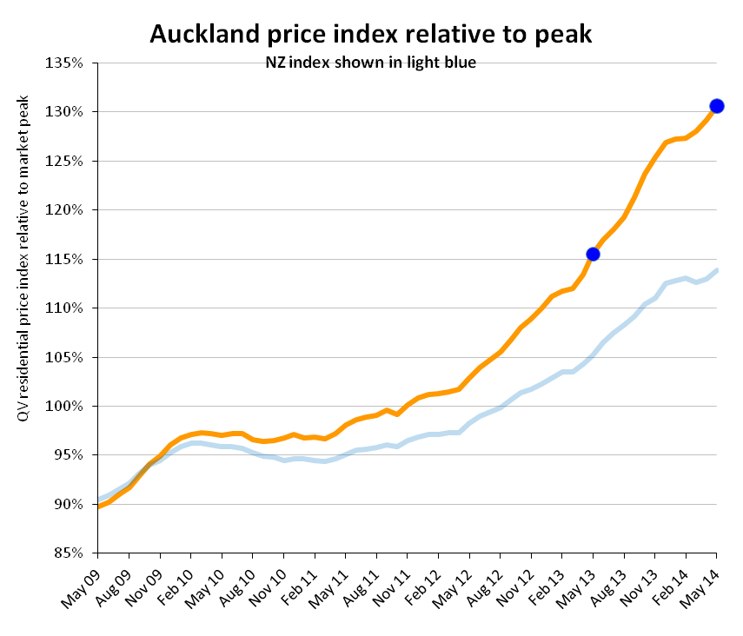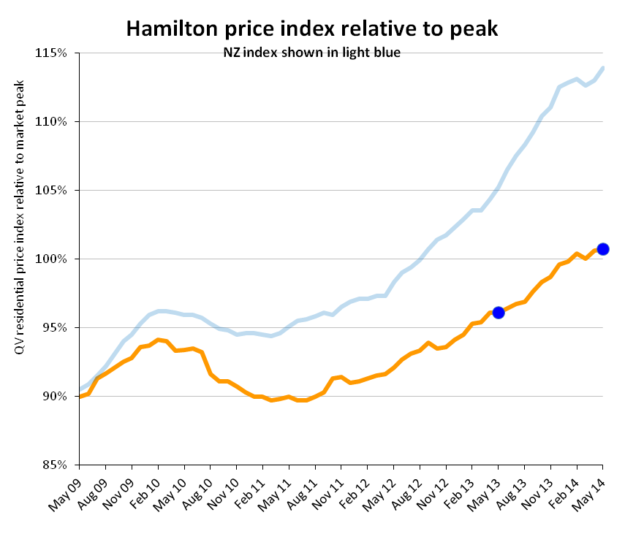

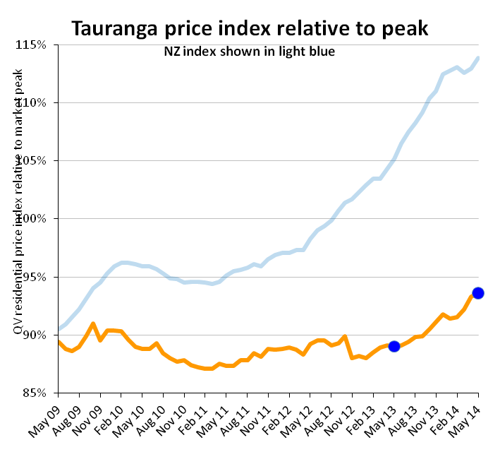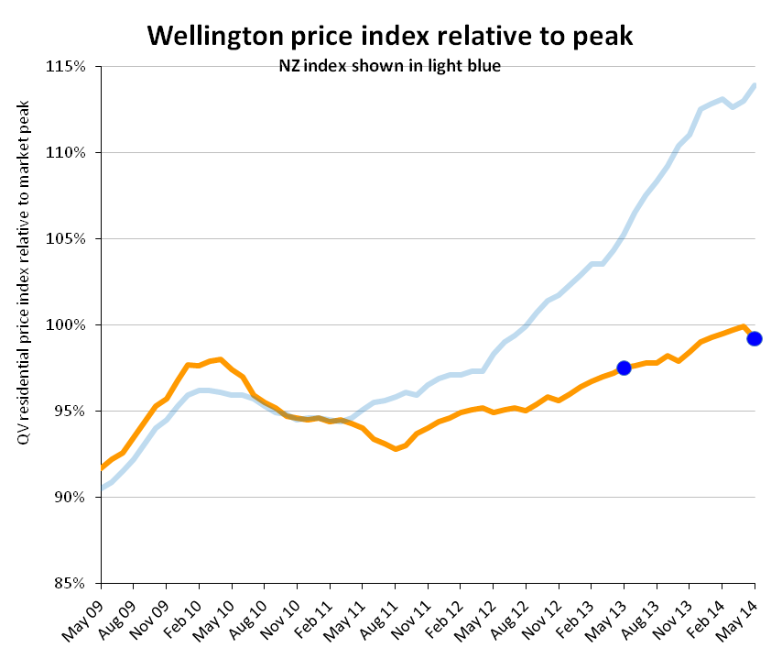
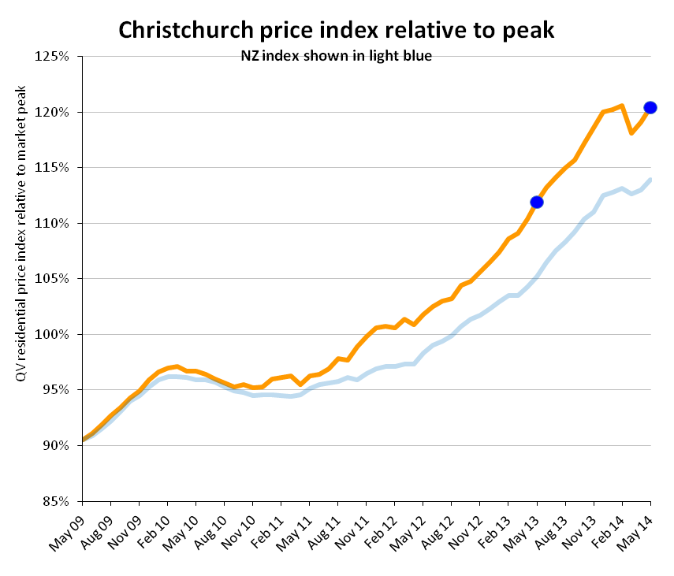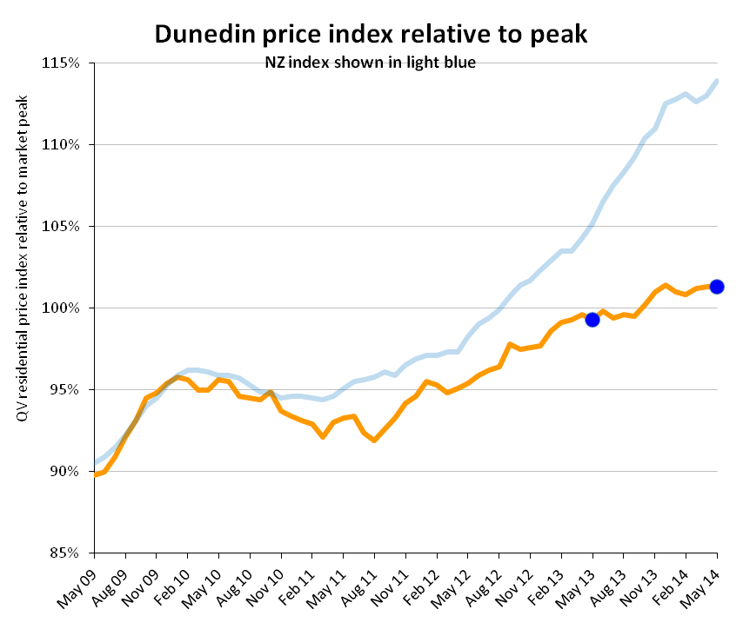

QV Residential Price Movement Index
Time period: 31 May 2014
 | Territorial authority |  | Average current value |  |  | 12 month change% | 3 month change % |  | Since 2007 market peak change %
 | Far North |  | 298,087 |  |  | -4.8% | -1.5% |  | -25.1%
 | Whangarei |  | 336,978 |  |  | 2.3% | 0.4% |  | -15.0%
 | Kaipara |  | 332,003 |  |  | 5.3% | 2.9% |  | -16.3%
 | Auckland - Rodney |  | 667,621 |  |  | 10.1% | 3.1% |  | 13.8%
 | Rodney - Hibiscus Coast |  | 662,200 |  |  | 9.3% | 3.8% |  | 12.7%
 | Rodney - North |  | 674,127 |  |  | 11.4% | 2.3% |  | 12.2%
#A | Auckland - North Shore |  | 849,285 |  |  | 14.2% | 3.2% |  | 31.6%
 | North Shore - Coastal |  | 979,249 |  |  | 13.7% | 3.6% |  | 30.0%
 | North Shore - Onewa |  | 671,717 |  |  | 14.7% | 1.8% |  | 35.4%
 | North Shore - North Harbour |  | 819,008 |  |  | 14.4% | 3.3% |  | 34.8%
#A | Auckland - Waitakere |  | 557,723 |  |  | 15.6% | 2.7% |  | 31.5%
#A | Auckland - City |  | 842,769 |  |  | 12.2% | 2.9% |  | 35.4%
 | Auckland City - Central |  | 758,115 |  |  | 10.7% | 4.7% |  | 33.1%
 | Auckland City - East |  | 1,050,074 |  |  | 14.1% | 2.4% |  | 31.8%
 | Auckland City - South |  | 749,414 |  |  | 11.8% | 2.6% |  | 39.2%
 | Auckland City - Islands |  | 742,673 |  |  | 8.7% | 1.5% |  | 16.2%
#A | Auckland - Manukau |  | 592,397 |  |  | 14.2% | 1.9% |  | 29.4%
 | Manukau - East |  | 791,855 |  |  | 14.0% | 2.3% |  | 32.9%
 | Manukau - Central |  | 452,297 |  |  | 14.3% | 1.7% |  | 20.3%
 | Manukau - North West |  | 483,724 |  |  | 15.0% | 1.6% |  | 30.9%
#A | Auckland - Papakura |  | 431,004 |  |  | 13.9% | 0.7% |  | 19.8%
 | Auckland - Franklin |  | 467,349 |  |  | 12.4% | 3.3% |  | 18.2%
 | Thames Coromandel |  | 505,370 |  |  | 3.2% | 0.7% |  | -13.1%
 | Hauraki |  | 241,583 |  |  | -1.6% | -4.0% |  | -13.4%
 | Waikato |  | 285,595 |  |  | 4.0% | 2.1% |  | -5.7%
 | Matamata Piako |  | 269,490 |  |  | 3.5% | 0.1% |  | -7.6%
# | Hamilton |  | 364,004 |  |  | 4.8% | 0.3% |  | 0.7%
 | Hamilton - North East |  | 458,577 |  |  | 6.2% | 0.7% |  | 2.0%
 | Hamilton - Central & North West |  | 341,192 |  |  | 4.4% | 0.2% |  | -4.7%
 | Hamilton - South East |  | 334,266 |  |  | 3.4% | -0.6% |  | -4.4%
 | Hamilton - South West |  | 320,624 |  |  | 3.6% | 0.4% |  | -6.3%
 | Waipa |  | 338,039 |  |  | 4.6% | 1.1% |  | 2.7%
 | Otorohanga |  | N/A |  |  | N/A | N/A |  | N/A
 | South Waikato |  | 128,371 |  |  | -1.8% | -1.6% |  | -21.3%
 | Waitomo |  | N/A |  |  | N/A | N/A |  | N/A
 | Taupo |  | 345,649 |  |  | -0.7% | 3.4% |  | -13.7%
 | Western BOP |  | 417,637 |  |  | 8.2% | 3.9% |  | -7.3%
# | Tauranga |  | 450,614 |  |  | 5.1% | 2.3% |  | -6.4%
 | Rotorua |  | 273,458 |  |  | 1.4% | -0.8% |  | -6.9%
 | Whakatane |  | 293,996 |  |  | 0.1% | 1.6% |  | -15.5%
 | Kawerau |  | N/A |  |  | N/A | N/A |  | N/A
 | Opotiki |  | 205,487 |  |  | -2.0% | -3.1% |  | -27.7%
 | Gisborne |  | 229,543 |  |  | 0.4% | -3.1% |  | -22.8%
 | Wairoa |  | N/A |  |  | N/A | N/A |  | N/A
 | Hastings |  | 301,547 |  |  | 0.5% | 0.0% |  | -3.3%
# | Napier |  | 324,721 |  |  | 0.6% | 0.4% |  | -4.6%
 | Central Hawkes Bay |  | 210,538 |  |  | 2.3% | 5.0% |  | -20.6%
 | New Plymouth |  | 350,673 |  |  | 5.0% | 1.2% |  | 6.0%
 | Stratford |  | 198,041 |  |  | -0.3% | -1.8% |  | -9.4%
 | South Taranaki |  | 179,889 |  |  | 0.2% | -0.4% |  | -9.0%
 | Ruapehu |  | 128,967 |  |  | -3.6% | -11.8% |  | -28.5%
 | Wanganui |  | 181,293 |  |  | -5.3% | -1.5% |  | -19.1%
 | Rangitikei |  | 146,127 |  |  | -1.6% | 0.6% |  | -19.3%
 | Manawatu |  | 239,779 |  |  | 2.2% | 0.2% |  | -5.7%
# | Palmerston North |  | 286,701 |  |  | 0.7% | -0.2% |  | -3.9%
 | Tararua |  | 154,659 |  |  | 1.0% | 1.8% |  | -12.3%
 | Horowhenua |  | 205,604 |  |  | 2.9% | 2.7% |  | -13.6%
 | Kapiti Coast |  | 375,344 |  |  | 3.6% | 1.7% |  | -2.0%
#W | Porirua |  | 373,947 |  |  | -1.0% | -1.4% |  | -2.1%
#W | Upper Hutt |  | 332,342 |  |  | -0.1% | -1.3% |  | -5.4%
#W | Hutt |  | 376,163 |  |  | 2.4% | 0.0% |  | -4.2%
#W | Wellington |  | 535,606 |  |  | 2.1% | -0.2% |  | 0.6%
 | Wellington - Central & South |  | 545,640 |  |  | 2.7% | 0.6% |  | -2.6%
 | Wellington - East |  | 574,954 |  |  | 0.7% | -0.6% |  | -0.2%
 | Wellington - North |  | 471,122 |  |  | 2.8% | -0.2% |  | 1.1%
 | Wellington - West |  | 612,648 |  |  | 1.3% | -0.9% |  | 0.9%
 | Masterton |  | 234,630 |  |  | -2.0% | -1.8% |  | -17.9%
 | Carterton |  | 260,273 |  |  | 3.7% | -0.3% |  | -6.6%
 | South Wairarapa |  | 298,036 |  |  | 2.9% | -1.6% |  | -11.9%
 | Tasman |  | 416,459 |  |  | 3.0% | 1.2% |  | 3.7%
# | Nelson |  | 401,566 |  |  | 2.1% | -0.2% |  | 4.9%
 | Marlborough |  | 346,230 |  |  | 1.3% | 1.0% |  | -11.2%
 | Kaikoura |  | N/A |  |  | N/A | N/A |  | N/A
 | Buller |  | 210,490 |  |  | -5.8% | 0.9% |  | 2.4%
 | Grey |  | 226,180 |  |  | 3.6% | 5.2% |  | -7.5%
 | Westland |  | 230,960 |  |  | 2.8% | 0.6% |  | -3.8%
 | Hurunui |  | 341,134 |  |  | 7.8% | -0.2% |  | 9.1%
 | Waimakariri |  | 404,972 |  |  | 7.0% | 1.3% |  | 26.5%
# | Christchurch |  | 456,962 |  |  | 7.6% | -0.2% |  | 20.4%
 | Christchurch - East |  | 343,584 |  |  | 5.8% | 0.3% |  | 11.0%
 | Christchurch - Hills |  | 626,090 |  |  | 4.8% | 0.5% |  | 13.2%
 | Christchurch - Central & North |  | 535,278 |  |  | 8.9% | 0.8% |  | 20.9%
 | Christchurch - Southwest |  | 436,395 |  |  | 11.2% | 1.8% |  | 28.6%
 | Christchurch - Banks Peninsula |  | 456,386 |  |  | -9.1% | -8.3% |  | -5.0%
 | Selwyn |  | 495,137 |  |  | 7.5% | 0.6% |  | 32.8%
 | Ashburton |  | 320,961 |  |  | 7.5% | 2.3% |  | 14.7%
 | Timaru |  | 281,665 |  |  | 5.9% | 2.3% |  | 12.2%
 | MacKenzie |  | 291,563 |  |  | 4.3% | -2.1% |  | 1.8%
 | Waimate |  | 196,335 |  |  | 4.3% | -1.3% |  | 4.1%
 | Waitaki |  | 219,960 |  |  | -0.2% | 0.9% |  | -3.7%
 | Central Otago |  | 314,022 |  |  | 5.3% | -0.1% |  | -0.9%
 | Queenstown Lakes |  | 668,791 |  |  | 5.6% | 1.1% |  | -2.7%
# | Dunedin |  | 289,964 |  |  | 2.0% | 0.5% |  | 1.3%
 | Dunedin - Central & North |  | 296,950 |  |  | 1.7% | -0.1% |  | -1.6%
 | Dunedin - Peninsular & Coastal |  | 268,931 |  |  | 4.3% | 3.0% |  | -0.7%
 | Dunedin - South |  | 280,762 |  |  | 1.2% | 0.6% |  | -1.7%
 | Dunedin - Taieri |  | 299,845 |  |  | 2.0% | 0.2% |  | 2.0%
 | Clutha |  | 162,487 |  |  | -0.8% | 2.1% |  | -10.3%
 | Southland |  | 206,870 |  |  | -0.8% | 3.1% |  | -10.1%
 | Gore |  | 175,751 |  |  | -4.1% | -5.2% |  | 0.0%
# | Invercargill |  | 209,719 |  |  | 0.7% | 1.9% |  | -4.9%
 | Auckland Area |  | 713,709 |  |  | 13.1% | 2.6% |  | 30.6%
 | Wellington Area |  | 452,099 |  |  | 1.8% | -0.3% |  | -0.8%
# | Main Urban Areas |  | 550,167 |  |  | 9.7% | 1.1% |  | 19.8%
 | Total NZ |  | 471,791 |  |  | 8.2% | 0.7% |  | 13.9%
Notes on the above data:
1. The information included in the above table is based on the monthly property value index powered by CoreLogic. This index is calculated based on the sales data entered into CoreLogic's system in the previous 3 month period. For example, information for the period ending June will be calculated based on sales entered between April 1 and June 30.
2. The average current value is the average (mean) value of all developed residential properties in the area based on the latest index. It is not an average or median sales price, as both of those only measure what happens to have sold in the period.
3. The percentage change over three months, twelve months and since the 2007 market peak are based on the change in the property value index between that time and the current.
4. Any of the statistical data shown in italics are calculated based on a sample set of data that is less than the recommended minimum. These results should be used with caution. Those showing N/A had too few sales to generate an index.

