Local Government and Environment Committee

Submission of the Christchurch City Council on the Building (Earthquake-prone
Buildings) Amendment Bill

Introduction
Thank you for coming to Christchurch.

Councillor Ali Jones and I want to speak to the city council’s written submission with only one thought in mind and that is that we learn the lessons of what happened here.

When people die there is nothing we can do to bring them back. The only comfort that we can offer those left behind is that their deaths were not in vain. That by our commitment to lessons learned, we ensure that no one else in the future suffers or dies in the way people did here and that other families are not left to grieve for the senseless waste of a life not fully lived.

Councillor Jones and I only want to speak to this aspect of our submission. We have technical staff from the council to answer questions on other aspects of the submission if you wish.

The Council’s submission acknowledges that the Bill is designed to improve the system of managing earthquake-prone buildings in New Zealand, but it simply doesn’t go far enough if we are to learn the lessons of our tragedy.

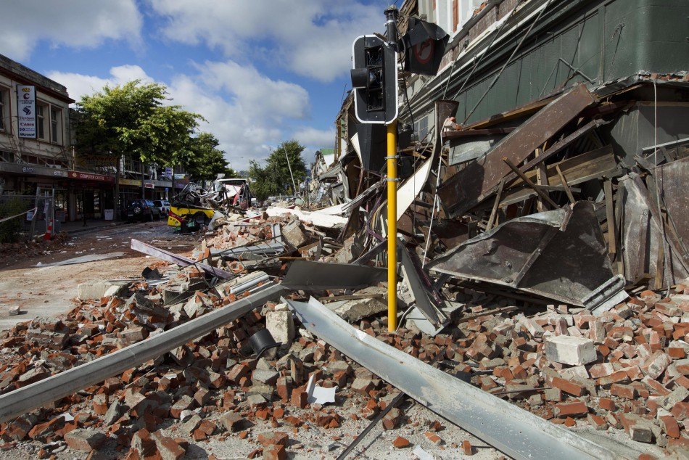
As our written submission says, the Council strongly urges the Select Committee to give further consideration to the Royal Commission recommendation on unreinforced masonry buildings and their hazardous features. Addressing hazardous features of buildings needs to happen in a short timeframe and will achieve maximum benefit, in terms of protection, against the dollars spent. The Council also believe there are local variations and risks which justify a risk based approach being taken.

This was some of the aftermath of the February 2011 earthquake. To be honest we thought the worst was over. We were the lucky city. We had experienced a 7.1 magnitude earthquake in September and no-one had died. That changed at 1.51pm on February 22. A 6.3 magnitude earthquake right under the city produced the highest peak ground accelerations in modern records.

Why were we not better prepared? Why were these facades not pinned back or the footpaths and streets not protected from the falling rubble? The Council did fence off some footpaths and require building owners to address the dangerous aspects of their buildings. Some acted, but it looks as if some of them thought they had all the time in the world.

People died under the rubble as people ran into the street. People died in the bus. Anne Brower who has also submitted on this Bill was on that bus – she was the only survivor. Please listen to what she says.

Let me ask the committee if you can answer why this was able to happen. Surely we knew these buildings were a risk? Even if we hadn’t had the September quake, we knew about the Alpine fault. But actually we had the September quake – why on earth were these risks not obvious?

I am not seeking to blame anyone. I am making the point we must learn the lessons. It is not as if it hadn’t happened before.

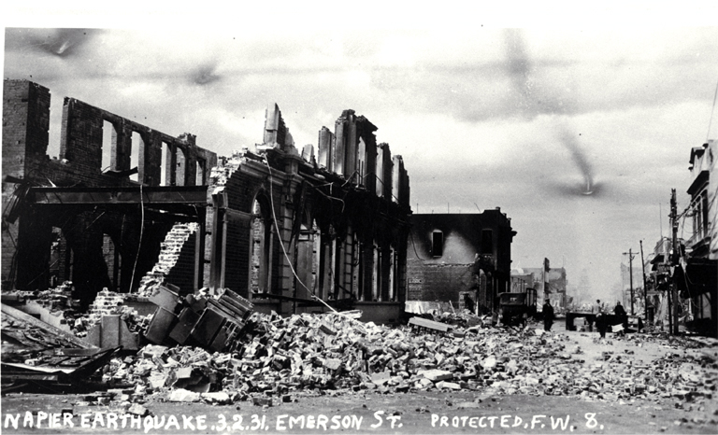
This is 80 years before – in the Hawkes Bay in the North Island – February 3 1931. Many of the first people who died were those who ran out of the buildings and were crushed in the rubble.

We gained a lot as a country from this disaster. Our building code and our Standards Council – and ultimately our national disaster insurance - EQC.

But somehow the risks associated with unreinforced masonry, parapets and decorative features were not identified as a matter that could be addressed separately from the building as a whole.

I remember meeting a man who had moved to Christchurch from Napier about 30 years ago. He said he thought there was something different about Christchurch houses when he arrived – he realised it was chimneys.

Why did we not act? Maybe like me everyone thought the big one would be Wellington. But as I said we had September – why weren’t we thinking about what we could do to de-risk our city? Maybe we knew to expect a one magnitude below and it hadn’t come – this was nearly 6 months later – maybe we thought a smaller magnitude earthquake couldn’t do more damage than the first one in the sequence.

Whatever we were thinking, we were wrong. And there were people who paid for that with their lives.

The Canterbury Earthquakes Royal Commission considered the remediation or strengthening of URM buildings and hazardous features of such buildings to be a priority. We ask you to adopt their recommendation in our submission, but looking at these two photos, ask yourself, for the most seismically vulnerable areas in New Zealand, does that even go far enough?

It was the Council's experience in the Canterbury earthquakes that buildings with critical structural weaknesses - URM's and buildings with hazardous features (verandas, parapets, ornamental features etc), failed and this led to many deaths.

That is why we say that URM's and buildings with hazardous features must be included as Priority Buildings in the primary legislation, (rather than waiting for regulations) and the legislation must require strengthening of hazardous features; it gives greater clarity, assigns greater importance to these buildings/features and enables shorter timeframes for strengthening to be applied by the Council immediately.

Anne Brower summed up the position very well when she said that the Bill should put non-structural unreinforced masonry - parapets, gables, and chimneys at the front of the queue for retrofitting because:
1) they are the cheapest to fix;
2) they are the first to fall; and
3) they are the deadliest when they do fall.

We agree.

Finally, Anne Brower made a very telling statement in her submission. She said that the MBIE research on quake prone buildings pays great attention to the cost of retrofitting, borne by building owners. It pays less close attention to the cost of failing to retrofit, borne by the public.

And not just any public – someone walking down the street – someone sitting on the bus.

Let’s learn the lessons so the families of those who died needlessly that day can at least say they did not die in vain.
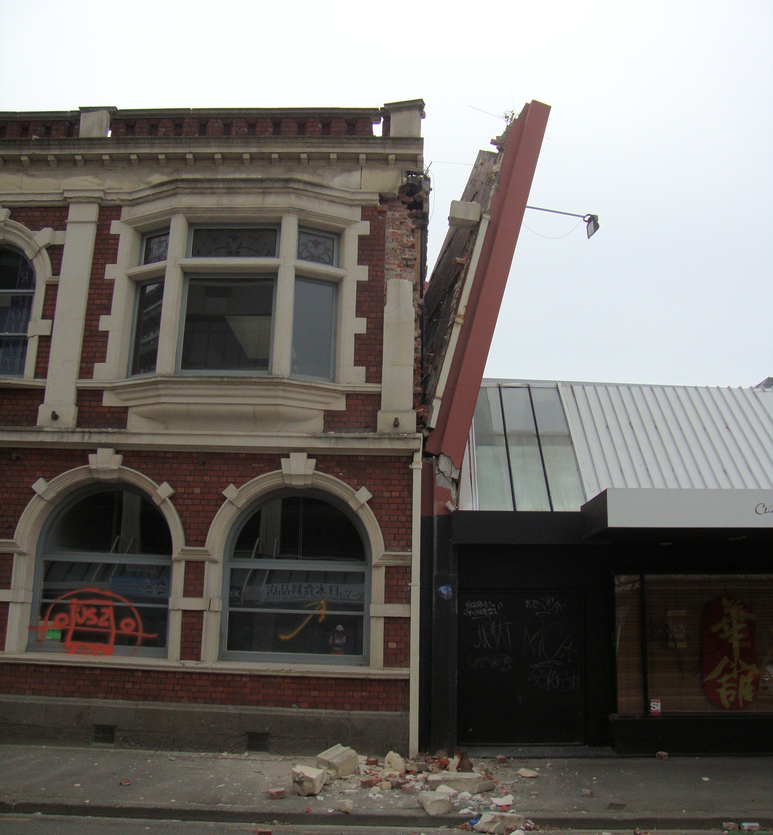
And thinking about what Colombo Street could have looked like on that day.

This is the earthquake strengthened building where my husband was having lunch at 1.51pm on 22 February 2011..

Correction/addition re paragraphs 38 and 39 of Council’s written submission

Since the Council made its written submission to the Select Committee, the High Court has delivered its decision on the appeal against the Environment Court decision referred to in paragraph 38, regarding an application for a resource consent to demolish am earthquake-prone heritage building that had been given a s124 notice to repair or demolish by 2027 (Lambton Quay Properties v Wellington City Council [2014] NZHC 878).

The High Court considers the Building Act requirements for earthquake prone buildings (and the issue of section 124 notices) can be reconciled with heritage protection aims in the Resource Management Act/District Plans. The Court found a degree of commonality between the overriding purposes and the public safety objectives of the Building Act and the RMA/relevant parts of the District Plan. The Court stated that public safety must always prevail, and sent the matter back to the Environment Court to:

“(1) give consideration to demolition of the building only if it is convinced that there is no reasonable alternative to total demolition.
(2) give consideration to the risk to public safety and surrounding buildings if the [building] remains as it is.”

Although this decision now provides better guidance for Councils there remains a tension between the protection of heritage and public safety. The financial burden of achieving both is too great for most building owners, Councils and/or other heritage agencies. The Government needs to confront this issue and continue to seek solutions.

