
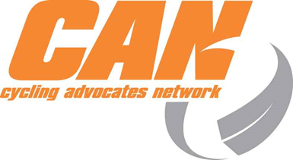


Cycle Friendly Awards 2014
Nomination Form
The Cycle Friendly Awards celebrate NZ achievements creating a more cycle-friendly environment.
We invite your company or organisation to nominate a project, facility or person that showcases cycling excellence and deserves national recognition. Self-nominations welcome!
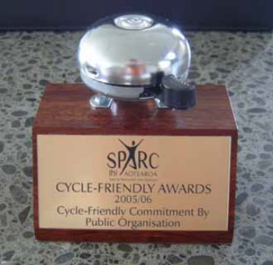
Winners of each category receive a much coveted bike bell trophy - very useful at reception!
Check out illustrious past entries.
Email entries to awards@can.org.nz - One nomination per email.
Entries must be received by Wednesday 25 June 2014.
All valid nominations received by Monday 26 May 2014 are entered into the “early bird” draw for a Cactus Subductor bag.
Nominations for cycling projects/ champions: 1 July 2011 - 30 April 2014.
Awards are presented on 29 October 2014 in Nelson at the 2WalkandCycle Conference.
Questions? Ask Dirk De Lu: (03) 337 1790 or awards@can.org.nz GOOD LUCK!
Details of Nominating Person
NOMINATOR’S NAME:

CONTACT PHONE NO:

CONTACT EMAIL:

RELATIONSHIP TO NOMINEE:
How did you find out about the Awards?
Award Category: (please type an X in one box) - See last page for info on Award Categories.
NZ Transport Agency Cycle Friendly Awards
Award Categories
Choose one category per nomination
 | Auckland Transport Best Joint Walking & Cycling Project
 | ViaStrada Cycle-Friendly Commitment by Public Organisation
 | Best Cycle Facility Project
 | Best Cycling Promotion
 | Cycle-Friendly Commitment by Business
 | Cycle Champion

Nominee: (Note: Where multiple agencies were involved in a project/promotion, only ONE organisation should be specifically nominated for the award, although others may be acknowledged.)
NAME OF PROJECT/ PERSON
(Please type this in the e-mail subject line when submitting)

NAME OF ORGANISATION

LOCATION & ADDRESS

CONTACT PERSON’S DETAILS (name, e-mail, & phone)

NOTES: PLEASE MAKE SURE YOUR ENTRY MEETS THESE CRITERIA
- The maximum entry size is a document of five A4 pages as a DOC, DOCX, RTF, or PDF file format. Any information beyond the five page limit will not be evaluated.
- Please attach high res photos/logos in standard formats. If files exceed 6 MB limit please send in separate emails with identical subject headings.
- Please send high resolution JPG files of logo/photo of nominated project/organisation/person. If these are not easily available please be prepared to obtain these upon request.
- Entries may include web links, but please note that these will only be referred to at judges’ discretion.
- Although the judging panel may independently seek additional information on nominated entries, it is in your best interests to provide as much detail in your entry within the five page limit (This opening page is not included in the limit).
- If alternative material/media is considered important as part of the submission, please contact the Awards Coordinator as early as possible.
- The Awards Coordinator reserves the right to determine the appropriate category for a nomination.
- All nominations must be in relation to a New Zealand project, promotion, or Champion.
- Nominations are for Champions/completed cycling projects/promotions from 1 July 2011 - 30 April 2014.
- Entries must be received by Wednesday 25 June 2014.
- All valid nominations received by Monday 26 May 2014 are entered into the “early bird” draw for a Cactus Witness bag. Winners announced: Awards Presentation 29 October 2014 at 2WalkandCycle Conference.

Please provide a 50 word summary description of the nominated project/organisation (note: this may be used for any subsequent publicity):

Please provide information on how the project/person meets the four main judging criteria, noting usage survey results if applicable. If a entry is a route, note connections to bus/rail, city/town centre, businesses, shops, schools, hospital, medical centres, places of worship, recreation spaces, etc. (Feel free to add as much information as necessary up to the 5 A4 page document limit):
Coverage, in terms of number of people (potentially) affected by this initiative/person:

Success to date of the initiative/person in encouraging cycling:

Potential widespread applicability of initiative to other locations or organisations/ Level of commitment demonstrated by person:

Relative uniqueness and innovation of this initiative/person’s actions in NZ:

The local/regional CAN cycling group must be given an opportunity to comment on the initiative/person nominated. If no response received please send your nomination form with a comment noting group contacted and no response.
Local/Regional Cycling Group Comments: adequacy of consultation; any audit remedial measures identified; commitment to be implemented
Please provide any additional supporting information (below or attached) that may be helpful for comprehension and subsequent publicity up to the 5 A4 page document limit.
THANKS TO OUR SPONSORS HELPING MAKE NZ MORE CYCLING FRIENDLY.




The Cycle Friendly Awards are an initiative of the Cycling Advocates’ Network www.can.org.nz
To sponsor the 2015 Cycle Friendly Awards please contact Awards@can.org.nz.
Information about Award Categories
NB: Nominations are open to cycling projects/cycling champions from 1 July 2011 to 30 April 2014.

Best Joint Walking & Cycling Project (Sponsored by Auckland Transport)

Category covers a project, facility, or promotion that contributes to enhancing both walking and cycling.
Nominations range from individuals, business, to government organisations.
Cycle-Friendly Commitment by Public Organisation (Sponsored by ViaStrada)
Category covers a public or government organisation that has made significant efforts encouraging and supporting cycling by its staff and public users in the past year.
Includes: central or local government agencies and organisations e.g. health boards, regional sports trusts, universities, or airports. E.g. cyclist parking/changing facilities, employee support and incentive programmes.
Best Cycle Facility Project: Category covers a transport infrastructure project that has had the most significant impact on promoting cycling and a cycle-friendly environment.
E.g. new cycle ways, cycle parking facilities, or general roading projects that assist and encourage cycling.
Nominations are typically received for projects undertaken by businesses or local or central government agencies.
Best Cycling Promotion: Category covers the education or encouragement project that had the most significant impact on promoting cycling and a cycle-friendly environment.
Nominations range from individuals, business, to government organisations. E.g. publicity campaigns, school education programmes, or promotional cycling events.
Cycle-Friendly Commitment by Business: Category covers the companies that have made significant efforts encouraging and supporting cycling by its staff, customers, and/or clients.
E.g. cyclist parking / changing facilities, employee support and incentive programmes, and company 'pool' bikes.
Cycling Champion: Category to recognise the outstanding contribution made by individual New Zealanders to the promotion of cycling.

