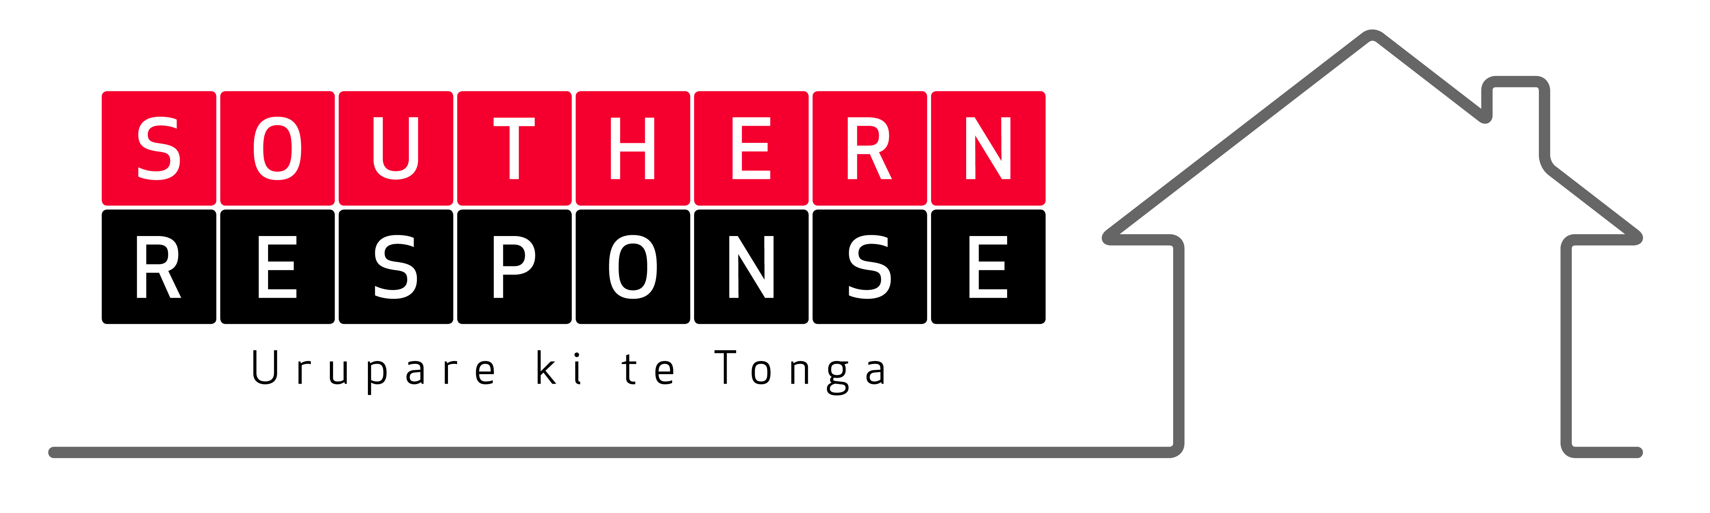
Disputes management system changes in train
The following changes are in train or in place within Southern Response’s Dispute Managament system:
- Resolution vehicles
  - Residential Advisory Service
Strengthening the role of RAS:
- Southern Response has requested and received agreement that RAS provides full “representative services” to our customers who seek them. By “representative services”, we would expect that to include robust interaction based on what RAS assesses to be the factual position. In that sense, the only stipulation is that we would expect RAS to keep its role amicable, constructive and reasonable.
- Southern Response’s customers with RAS will have access to necessary technical advice by way of their disagreements with us. We expect that the role played would generally be of peer review nature of any other advice either party holds, rather than an ab initio investigation. We will pay the full market cost of any technical services that are required by RAS and our customer to truly represent their interests. We would leave it to RAS to create the appropriate providers for those purposes, who, nevertheless would need to be acceptable to Southern Response.
- We will actively promote RAS as a dispute resolution pathway. We have offered technical advice (from our viewpoint) to RAS IA’s to provide a solid understanding of the MBIE foundation guides and how they are intended to be applied an example of the starting point; all to enhance its capabilities.
- We envisage its services may apply by way of a number of tiers
  - “fast track” where little preparation is required – principally the existing and increasing skill base of the parties and genuine interaction;
  - “researched service” which would likely require a level of research and agreed additional investigations prior to resolution attempts
  - “full service” that would include mediation.
  - Insurance and Savings Ombudsman’s Service
Changed approach to this service is:
- Voluntarily removing the $200,000 cap on access to the Insurance & Savings Ombudsman’s scheme to allow unfettered access by aggrieved customers on a 6-months trial basis;
- Customer access to the Insurance & Savings Ombudsman’s scheme for customers who believe that they have incurred loss due to unacceptable delay (in the context of a natural disaster) or poor decisions of Southern Response: reimbursement of costs incurred where the claim is justified; (this approach still being confirmed by ISO)
- Giving consent to customers to allow claimants to access the Scheme where
  - proceedings have already been brought in the Disputes Tribunal or Court which have not yet been heard,
  - mediation or facilitation by a third party has been attempted but which has not resulted in a concluded outcome and
  - where claimants have utilised the services of the Residential Advisory Service or facilitation through its multi party meeting process which has not resulted in a concluded outcome;
- Encouraging customers to use ISO to hear a complaint it has received and prior to deadlock the parties agree to utilise negotiation, conciliation, or mediation (or any combination of those methods) to assist Southern Response and the customer to resolve all or part of the subject matter by agreement. Where not resolved by this means, Southern Response agrees to the matter being deemed deadlocked.
In addition:
- Southern Response continues to support the use of ‘face-to-face’ meetings to be held in Christchurch for services provided by the Scheme. We will reimburse costs incurred by the Scheme to facilitate the provision of this level of service for our claimants.
  - Other resolution or mediation services
Southern Response is not discounting any other service that provides active opportunity to bring about resolution, other than those services that seek a contingency fee or a commission for outcome.
- Other policy changes
Southern Response is making a number of policy changes including modification to the disputes management policy to reflect a move towards accepting customers’ costings of individual items provided there is fair, reasonable and respectable evidence. There may be a qualitative easing of claims settlement policy (a level of flexibility provided to be able to negotiate variations to assessed value with sufficient credible and supportable evidence).

