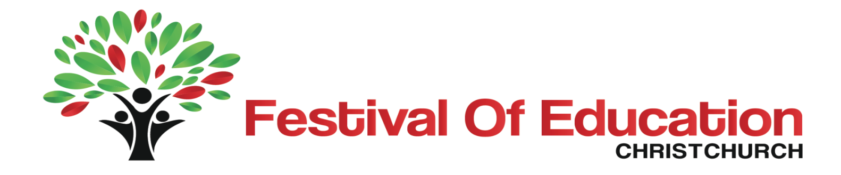
March 23 2014
Wigram Events Centre

Keynote Speakers
Michael Fullan is a worldwide authority on education reform. He has an extensive history and expertise in educational research. He has written widely on the topic and is universally recognised as a leader in the education field. In 2012, he was named an Officer of the Order of Canada for his achievements in the field of education reform, as a scholar, teacher, writer and adviser to governments in Canada and abroad. | Christian Long is the founder of the Wonder studio and Prototype Design Studio. He is a an educator, school planner, and passionate advocate for innovative learning communities. From his base in the USA, he is a regular international speaker. Themes include emerging trends in learning environments, innovative planning practices, and the contribution of children’s curiosity and wonder in educational design. | Hon Hekia Parata became the Minister of Education in 2011 after entering Parliament in 2008. She has had successful careers as a businesswoman and as a senior public servant. She ran a thriving policy consultancy with her husband, Sir Wira Gardiner, before entering Parliament and has held senior roles in a range of government departments. She has a Master’s degree from Waikato University. | Ian McKinnon is one of New Zealand’s most respected leaders in the education profession. He is the Chair of the New Zealand National Commission for UNESCO and Chancellor of Victoria University of Wellington. In 2013 he was appointed a Companion of the New Zealand Order of Merit for services to education and the community. | Jason Pemberton is the co-founder and General Manager of the Student Volunteer Army that made such a significant contribution to Christchurch following the earthquakes of 2010 and 2011. Jason spent time in Japan working with local students responding to the Great East Earthquake of 2011 and also spent three weeks on the ground advising New York-based NGO’s on their responses to Hurricane Sandy.

Performances
A range of student performances from schools around the region will be a highlight of the Festival

Panel Discussions and Workshops
The future of learning environments | ECE Matters | Looking after our environment
Christian Long provides a leading international perspective on the value of student collaboration in innovative school design. | Leaders in early childhood education and child development talk about the importance of early childhood education. Find out how developing key skills and positive dispositions are essential for lifelong learning, | Learn about environmental education in local schools and early childhood centres from a range of individuals and organisations committed to creating a new generation of people for whom sustainability will be the norm. Environmental education provides an excellent model for collaborative and integrated learning.
Rebuilding Christchurch schools | Effective teaching for a 21st century curriculum | The role of community in education
This session will focus on where we are heading in rebuilding Christchurch schools. Hear about innovative school environments and the trends in learning environment design from New Zealand and around the world. Join in the discussion about how modern learning environments can enhance learning. | The New Zealand Curriculum lies at the heart of teaching and learning in our schools. School leaders talk about reshaping their curriculum to better reflect their local contexts. | Authentic and effective community and whanau engagement in education contributes significantly to positive outcomes for children and young people. Two organisations share their experiences of developing connections and learning with their local schools.
Developing excellent teachers | Collaboration for success – He Kakano. | UNESCO’s role in Christchurch – an international involvement
What makes an excellent teacher? Is it an art or a science? This session will explore what excellent teachers do that is so important and what really makes a difference to students. | In this session school leaders talk about their collaboration and involvement in He Kakano. Learn about how together they achieved positive outcomes for Māori learners in three diverse communities. | Ian McKinnon will discuss UNESCO’s role in schools following the Christchurch earthquakes. He will explore the current and future opportunities for collaboration and innovation between Christchurch schools and international networks.
Change management and education | Pathways and transitions | Making a difference – teacher professional learning
Planning for change is demanding, particularly in our current climate. School leaders talk about their journey in establishing a vision for their schools, getting people on board and establishing sustainable outcomes for our school communities. | Vocational pathways support the transition for young people from learning to earning. Listen to local stories of opportunities and collaboration in Canterbury that provide relevant learning options for our young people. | Teachers share their stories of professional learning. Find out how their enquiries and research have had positive outcomes for students.
Collaboration and innovation in education | Global learning in local classrooms | From resilience to strength
Michael Fullan presents his latest work on school clusters. The opportunity and capacity building that collaboration between schools and early childhood centres affords Christchurch in these times of change and development will be examined along with a framework for implementation. | How do we prepare young learners for participation in an increasingly global community? Hear how leading organisations are contributing to a better understanding of our world, its complexity and opportunities available. | In the third year post earthquakes, we are still learning about supporting others and looking after ourselves. Community support networks lead a discussion on moving to a place of strength.
Learning with technology | Supporting all learners | Language and culture
How can digital technologies actually provide and support deep learning? Our highly digital panel offer a rich discussion of the way forward. | Inclusive and special education is an integral part of our education system. Outstanding practitioners share examples of success, including transitions from formal education to work. | Examples from local Rūnanga Tuahiwi and Taumutu of resources and activities with ECE centres and schools promoting Ngāi Tahutanga - Ngāi Tahu language, culture and identity.

