January-February 2014 Issued: 08 January 2014
Hold mouse over links and press ctrl + left click to jump to the information you require:
Overview
Regional predictions for the next three months:
Northland, Auckland, Waikato, Bay of Plenty
Central North Island, Taranaki, Wanganui, Manawatu, Wellington
Gisborne, Hawke’s Bay, Wairarapa
Nelson, Marlborough, Buller
West Coast, Alps and foothills, inland Otago and Southland
Coastal Canterbury, east Otago
Background
Contacts
Notes to reporters and editors
NIWA Outlook: January-March 2014
Overview
The equatorial Pacific Ocean continued in a neutral state (neither El Niño nor La Niña) in December 2013. International guidance indicates that ENSO-neutral conditions are very likely to persist for the next three months (January – March 2014). These ENSO-neutral conditions are also forecast to continue throughout the autumn and early winter, but El Niño development becomes increasingly likely by mid-year, reaching approximately 50 percent chance along with ENSO-neutral for July-October 2014.
For the coming three months as a whole, lower than normal pressures are forecast in the Tasman Sea, and over and north of New Zealand, while higher than normal pressures conditions are forecast to the southeast of the country. This circulation pattern is expected to be associated with a weak anomalous flow from the north-easterly quarter.
Sea surface temperatures are expected to remain above average around the whole of New Zealand for the coming three months.

Outlook Summary
January-March temperatures are most likely (50% chance) to be above average for North Island regions, and equally likely (40% chance) to be average or above average for South Island regions.
January-March rainfall is forecast to be equally likely (40% chance) to be normal or above normal in the north of the North Island, and normal or below normal in Nelson-Marlborough. In all other regions, the 3-month rainfall totals are most likely (45-50% chance) to be in the near normal category.
Soil moisture levels are most likely (40-45% chance) to be near normal in all regions, except for Nelson/Marlborough where below normal soil moisture is most likely (45% chance). River flows for the January-March 2014 period are most likely (45% chance) to be near normal in all regions, except for Nelson/Marlborough where river flows are equally likely (40% chance) to be normal or below normal.

Regional predictions for the January to March season
Northland, Auckland, Waikato, Bay of Plenty
The table below shows the probabilities (or percent chances) for each of three categories: above average, near average, and below average. In the absence of any forecast guidance there would be an equal likelihood (33% chance) of the outcome being in any one of the three categories. Forecast information from local and global guidance models is used to indicate the deviation from equal chance expected for the coming three month period, with the following outcomes the most likely (but not certain) for this region:
- Temperatures are most likely (50% chance) to be in the above average range.
- Rainfall totals are equally likely (40% chance) to be in the near average or above average range.
- Soil moisture levels are most likely (40%) to be in the near normal range.
- River flows are most likely (45%) to be in the near normal range for the January – March period as a whole.
Other outcomes cannot be excluded. The full probability breakdown is:
 | Temperature | Rainfall | Soil moisture | River flows
Above average | 50 | 40 | 30 | 25
Near average | 30 | 40 | 40 | 45
Below average | 20 | 20 | 30 | 30

Central North Island, Taranaki, Wanganui, Manawatu, Wellington
Probabilities are assigned in three categories: above average, near average, and below average.
- Temperatures are most likely (50% chance) to be in the above average range.
- Rainfall totals, soil moisture levels and river flows are all most likely (45% chance) to be in the normal range.
The full probability breakdown is:
 | Temperature | Rainfall | Soil moisture | River flows
Above average | 50 | 35 | 25 | 25
Near average | 30 | 45 | 45 | 45
Below average | 20 | 20 | 30 | 30

Gisborne, Hawke’s Bay, Wairarapa
Probabilities are assigned in three categories: above average, near average, and below average.
- Temperatures are most likely (50% chance) to be in the above average range.
- Rainfall totals, soil moisture levels and river flows are most likely (45% chance) to be in the near normal range.
The full probability breakdown is:
 | Temperature | Rainfall | Soil moisture | River flows
Above average | 50 | 35 | 25 | 25
Near average | 30 | 45 | 45 | 45
Below average | 20 | 20 | 30 | 30

Nelson, Marlborough, Buller
Probabilities are assigned in three categories: above average, near average, and below average.
- Temperatures are equally likely (40% chance) to be in the near average or above average range.
- Rainfall totals and river flows are equally likely (40% chance) to be in the near normal or below normal range.
- Soil moisture levels are most likely (45% chance) to be in the below normal range.
The full probability breakdown is:
 | Temperature | Rainfall | Soil moisture | River flows
Above average | 40 | 20 | 20 | 20
Near average | 40 | 40 | 35 | 40
Below average | 20 | 40 | 45 | 40

West Coast, Alps and foothills, inland Otago, Southland
Probabilities are assigned in three categories: above average, near average, and below average.
- Temperatures are equally likely (40% chance) to be in the near average or above average range.
- Rainfall totals, soil moisture levels and river flows are most likely (45-50% chance) to be in the near normal range.
The full probability breakdown is:
 | Temperature | Rainfall | Soil moisture | River flows
Above average | 40 | 25 | 25 | 25
Near average | 40 | 50 | 45 | 45
Below average | 20 | 25 | 30 | 30

Coastal Canterbury, east Otago
Probabilities are assigned in three categories: above average, near average, and below average.
- Temperatures are equally likely (40% chance) to be in the near average or above average range.
- Rainfall totals, soil moisture levels and river flows are most likely (45% chance) to be in the near normal range.
The full probability breakdown is:
 | Temperature | Rainfall | Soil moisture | River flows
Above average | 40 | 35 | 25 | 25
Near average | 40 | 45 | 45 | 45
Below average | 20 | 20 | 30 | 30

Graphical representation of the regional probabilities

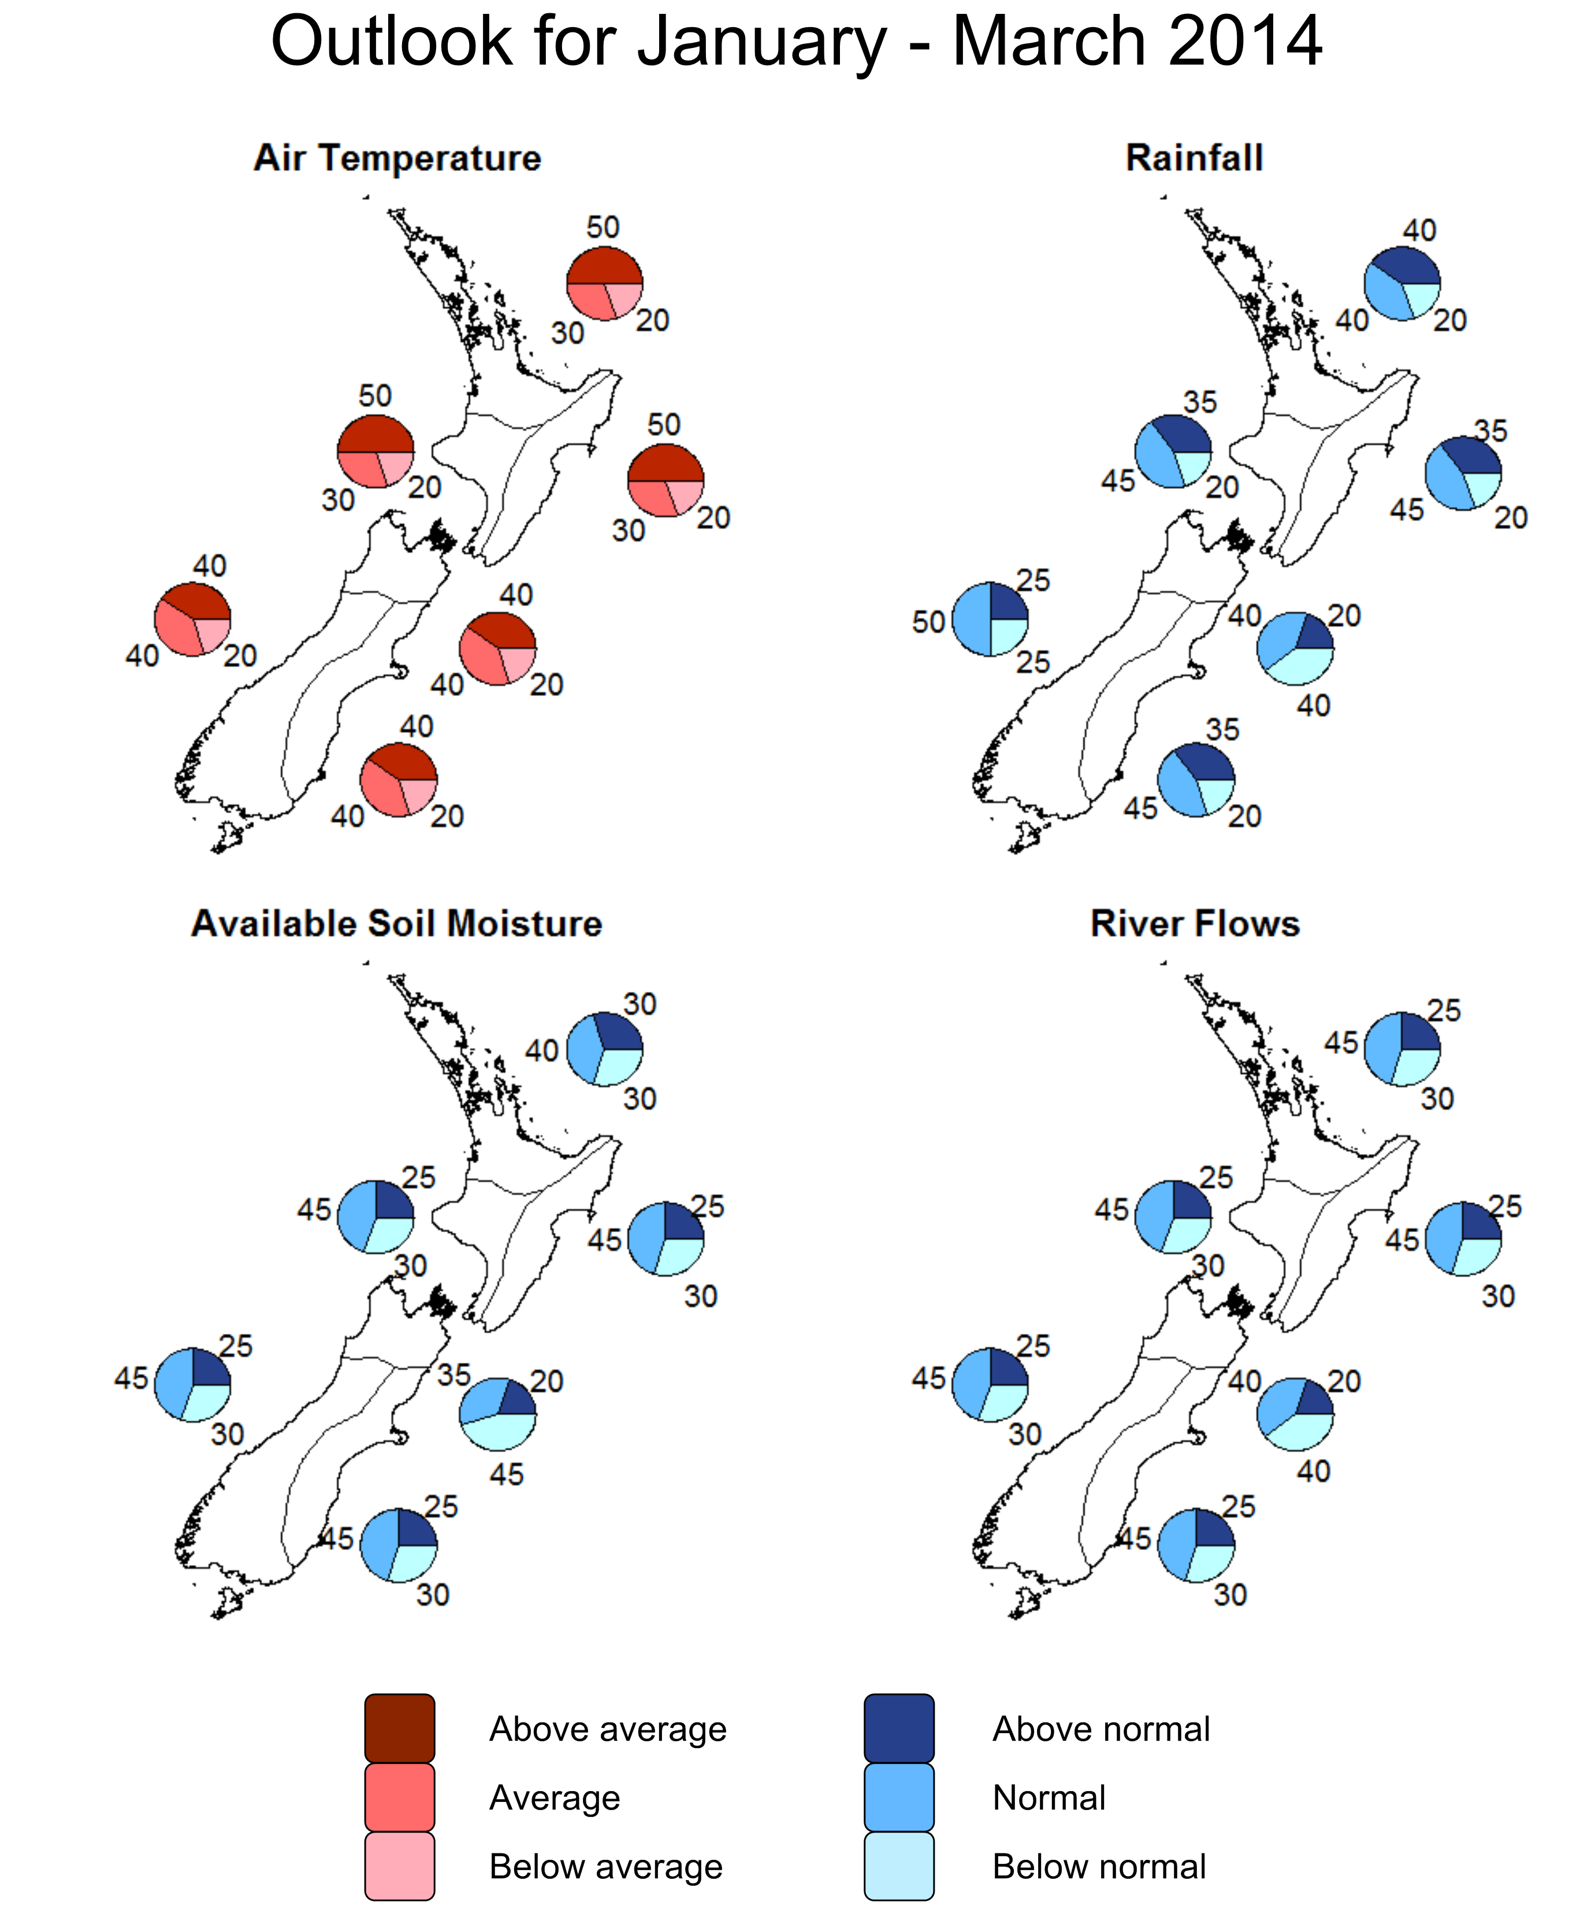

Background
The equatorial Pacific Ocean reflects ENSO-neutral conditions at the end of December 2013.The NIWA Southern Oscillation Index for December is -0.1. This brings the 3-month October-November-December average SOI to +0.1. International guidance indicates that the tropical Pacific Ocean is very likely (90% chance or above) to remain neutral over the next three months (January-March). Beyond this time, the probability of El Niño development starts to increase and, by late winter and early spring (July-September 2014), the probabilities of El Niño and neutral conditions are approximately equally likely (~ 50 % chance).
The monthly sea surface temperature (SST) anomaly for New Zealand was approximately +0.9°C in December. This is now the 12th consecutive month that SSTs have been warmer than normal around New Zealand, and is the highest monthly anomaly for the 2013 year. The large region of warmer-than-normal water to the east and southeast of New Zealand, which has been an unusually persistent feature of the SST field for much of 2013, has expanded to engulf New Zealand. Also, the warmer-than-normal SSTs have re-intensified northeast of New Zealand, between the North Island and Fiji. Sea surface temperatures are expected to remain above average overall for the coming three months around New Zealand.
The tropical cyclone season in the south-western Pacific has had a late start, with the first named storm occurring in the New Year, but we are now entering the period of maximum activity. During the remaining of the tropical cyclone season (ending April 2014), the risk of an ex-Tropical Cyclone (ETC) approaching New Zealand is expected to be close to normal. Based on the long-term record, ETCs come within 550km of New Zealand for 9 out of every 10 years. These systems typically occur during the latter part of the Tropical Cyclone season (February – April). For ENSO-neutral years (the current situation), any ETCs approaching the North Island are twice as likely to pass to the east of Auckland as to the west of the city.
Currently (as of the 7th of January 2014), soil moisture levels are significantly lower than normal in much of the Waikato (except for the Coromandel) and in western Northland. However, the soil moisture deficits are not as large or as widespread as those a year ago before the 2013 drought set in.

For comment, please contact

Dr Brett Mullan, NIWA Principal Scientist, Climate Variability & Change
Tel (04) 386 0508, Mobile (027) 294 1169

Mr Darren King, Environmental Scientist, NIWA National Climate Centre
Tel (09) 375 2086, Mobile (021) 399 637
Notes to reporters and editors
- NIWA’s outlooks indicate the likelihood of climate conditions being at, above, or below average for the season as a whole. They are not ‘weather forecasts’. It is not possible to forecast precise weather conditions three months ahead of time.
- The outlooks are the result of the expert judgment of NIWA’s climate scientists. They take into account observations of atmospheric and ocean conditions and output from global and local climate models. The presence of El Niño or La Niña conditions and the sea surface temperatures around New Zealand can be a useful indicator of likely overall climate conditions for a season.
- The outlooks state the probability for above average conditions, near average conditions, and below average conditions for rainfall, temperature, soil moisture, and river flows. For example, for winter (June–July–August) 2007, for all the North Island, we assigned the following probabilities for temperature:
· Above average: 60 per cent
· Near average: 30 per cent
· Below average: 10 per cent
We therefore concluded that above average temperatures were very likely.
- This three-way probability means that a random choice would be correct only 33 per cent (or one-third) of the time. It would be like randomly throwing a dart at a board divided into three equal parts, or throwing a dice with three numbers on it. An analogy with coin tossing (a two-way probability) is not correct.
- A 50 per cent ‘hit rate’ is substantially better than guesswork, and comparable with the skill level of the best overseas climate outlooks. See, for example, analysis of global outlooks issued by the International Research Institute for Climate and Society based in the US published in the Bulletin of the American Meteorological Society (Goddard, L., A. G. Barnston, and S. J. Mason, 2003: Evaluation of the IRI’s “net assessment” seasonal climate forecasts 1997–2001. Bull. Amer. Meteor. Soc., 84, 1761–1781).
- Each month, NIWA publishes an analysis of how well its outlooks perform. This is available online and is sent to about 3500 recipients of NIWA’s newsletters, including many farmers. See www.niwa.co.nz/our-science/climate/publications/all/cu
- All outlooks are for the three months as a whole. There will inevitably be wet and dry days, and hot and cold days, within a season. The exact range in temperature and rainfall within each of the three categories varies with location and season. However, as a guide, the “near average” or middle category for the temperature predictions includes deviations up to ±0.5°C for the long-term mean, whereas for rainfall the “near normal” category lies between approximately 80 per cent and 115 per cent of the long-term mean.
- The seasonal climate outlooks are an output of a scientific research programme, supplemented by NIWA’s Capability Funding. NIWA does not have a government contract to produce these outlooks.
Visit our media centre at: www.niwa.co.nz/news-publications/media-centre

