### Media release

9thDecember

**LVR changes starting to have an influence**

The latest monthly property value index shows that nationwide residential values for November have increased 9.2% over the past year, and 2.5% over the past three months. This means they are now 11% above the previous market peak of late 2007. When adjusted for inflation the nationwide annual increase drops slightly to 7.7% and values remain below the 2007 peak by 4.3%.

The Auckland market has increased 15.2% year on year and values are 25.4% above the previous peak. When adjusted for inflation values are up 13.7% over the past year and are 8.1% above the 2007 peak.



Jonno Ingerson, QV.co.nz Research Director said “While it is still too early to see any definitive effect on values from the LVR changes, there are signs of changes in the market. There are reports of fewer potential buyers at open homes, longer marketing periods, and fewer auctions selling on the day."

"In the last three months there has been an increase in the number of completed sales to first home buyers. Some of this activity will have been due to people trying to purchase before their pre-approval expired. While there is anecdotal evidence of far fewer first home buyers in the market this has yet to come through in the statistics."

"A slowdown in activity in Auckland may be due to people sitting back to assess the impact of the LVR caps on the market. There remains a fundamental imbalance between supply and demand, with an increasing population and not enough houses. This should continue to fuel activity so this current slowdown may be temporary."

"In areas of the country outside Auckland and Canterbury, where there is not as much of an imbalance between supply and demand, the LVR changes are likely to have a more marked impact. The reduction in first home buyers will lessen activity and the reduced demand should see values slow down."

"Christmas is usually a time of the year when property market activity slows down dramatically and people use the holiday period to reconsider their intentions. It should start to become clear by March which direction the market is heading."

**Auckland**

Values across Auckland are still increasing, with the supercity now up 15.2% above last year. Waitakere still has the fastest annual increase of 19%, with North Shore the next closest at 16.8%.

Over the past three months, growth has continued across the entire city, with Rodney in the north seeing the least growth at 3.5%, and Waitakere seeing the most at 6.8%. Papakura is next in line with 6.1% growth over the last three months, whilst North Shore is sitting at 5.6%, old Auckland City at 5.3% and Manukau at 5.0%.

Within these areas, North Shore Onewa is still performing strongly having seen a 6.5% increase over the past three months, with Auckland City East and Manukau East the best performing areas in their regions, both seeing a 5.3% increase over the past three months.

QV Valuer Bruce Wiggins said “Although there has not yet been any distinct impact of the LVR changes in the Auckland market, we are starting to see some changes with open home numbers decreasing and more sales by negotiation as opposed to auction. Investors are also in the market, however they are only progressing on properties where they will see good returns.”

**Hamilton and Tauranga**

Values in Hamilton are still steadily growing, now up 1.8% over the past three months, and 5.5% over the past year.

QV Valuer Richard Allen said “The LVR changes might be taking a slight toll in the western areas of Hamilton, which traditionally attracts first home buyers, as we have seen demand start to drop here.”

Tauranga remains patchy, with values now3.5% above this time last year and 1.5% over the past three months.

“Although interest from first home buyers is lacking, investors and holiday home buyers still appear to be in the market” said Richard Allen.

**Wellington**

Values across the Wellington area have been pretty flat with only a slight increase to see the region sitting 3% above this time last year.

Lower Hutt, Upper Hutt and Porirua continue to fluctuate, all having seen a 0.2% decline over the past three months. Annually, these regions are hovering around the 2-3% mark.

In the city, things aren’t much better with increases at their highest in Wellington East, which saw 1.8% growth over the past three months.

QV Valuer Pieter Geill said “Both the Wellington and Hutt Valley markets remain pretty flat, with buyers seemingly taking a lot of caution.”

**Christchurch and Dunedin**

Values in Christchurch still continue to grow, with fluctuations throughout the different suburbs. Values are now 12.4% above last year and 3.2% up over the past three months. Apart from Banks Peninsula, which is down 1.1% over the past three months, all other areas have increased with the Central and North area of the city seeing the highest increase of 3.6% increase.

QV Valuer Daryl Taggart said “The market remains active but the LVR changes have removed some of the hype, and this is best seen in the activity at auctions.”

Dunedin remains fairly steady, with values now 3.5% above last year having seen a 1.3% increase over the past three months.

QV Valuer Duncan Jack said “Although we are seeing an improvement in listing numbers, the LVR changes are potentially the reason behind the slight drop in first home buyers in the market.”

**Provincial centres**

Most of the provincial centres are still experiencing growth, although it is limited in some areas. In the North Island, Whangerei, Thames-Coromandel, Taupo, Rotorua, Gisborneand Palmerston North are all up over the past three months. Gisborne has seen the highest increase of those regions, having grown 2.9%.

In the South Island, nearly all regions seem to have experienced growth over the past three months, with one of the exceptions being Queenstown Lakes, with a 0.8% decline. Southland and Gore have seen some of the larger increases, with 4.4% and 3.9% increases respectively.

**For media enquiries and interviews, and for further information contact:**

JonnoIngerson

Research Director QV.co.nz

Tel: 04 802 1239

Mobile: 027 454 6642

Email: [jonno.ingerson@propertyiq.co.nz](mailto:jonno.ingerson@propertyiq.co.nz)

**For further specific comment on local areas:**

Auckland. Bruce Wiggins 027 291 4514

Hamilton and Tauranga. Richard Allen 027 230 7290

Wellington. Pieter Geill 027 230 7291

Christchurch. Daryl Taggart 027 304 9815

Dunedin. Duncan Jack 027 213 7618

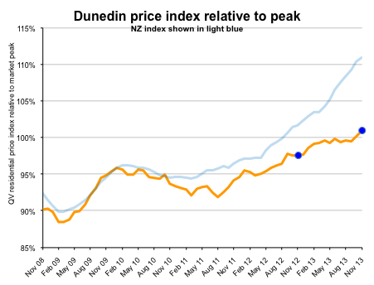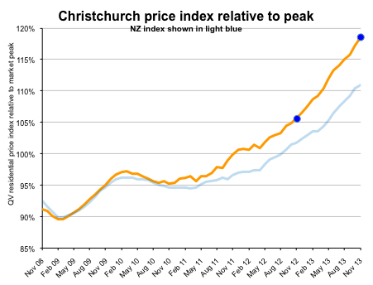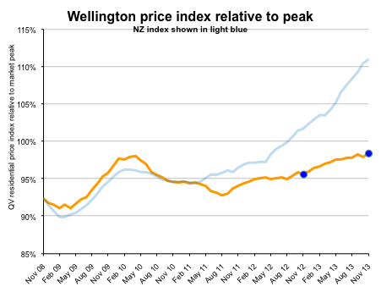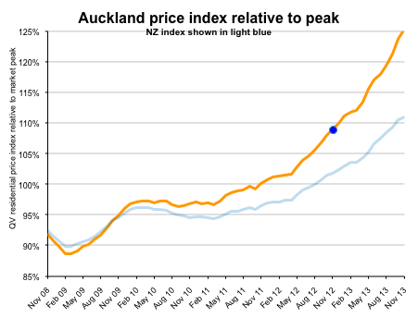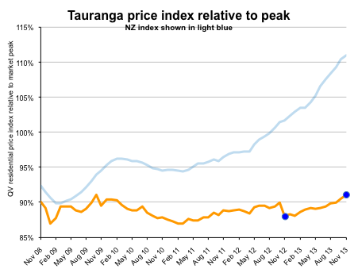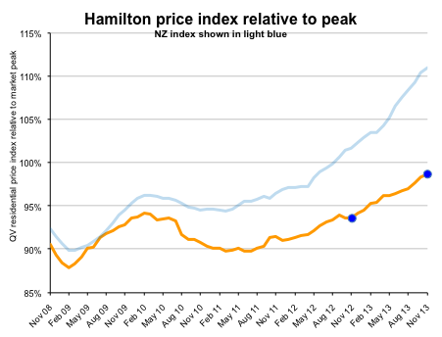

|  |  |  |  |  |  |
| --- | --- | --- | --- | --- | --- |
| **PropertyIQ Value Index - Residential Property** | | | | | |
|  |  |  |  |  |  |
| Time period: as at November 2013 | |  |  |  |  |
|  |  |  |  |  |  |
|  | **Territorial authority** | **Average current value** | **12 month change%** | **3 month change %** | **Since 2007 market peak change %** |
|  | Far North | 300,517 | -5.5% | -3.2% | -24.5% |
|  | Whangarei | 333,681 | 3.0% | 0.9% | -15.8% |
|  | Kaipara | 331,148 | 6.8% | 5.6% | -16.5% |
|  | Auckland - Rodney | 630,365 | 9.0% | 3.8% | 7.5% |
|  | Rodney - Hibiscus Coast | 626,233 | 8.2% | 3.9% | 6.6% |
|  | Rodney - North | 634,157 | 9.9% | 3.5% | 5.6% |
| #A | Auckland - North Shore | 813,154 | 16.8% | 5.6% | 26.0% |
|  | North Shore - Coastal | 934,022 | 16.3% | 5.7% | 24.0% |
|  | North Shore - Onewa | 655,243 | 18.3% | 6.5% | 32.1% |
|  | North Shore - North Harbour | 779,854 | 16.7% | 5.0% | 28.3% |
| #A | Auckland - Waitakere | 533,865 | 19.0% | 6.8% | 25.9% |
| #A | Auckland - City | 816,952 | 15.5% | 5.3% | 31.2% |
|  | Auckland City - Central | 726,728 | 12.5% | 5.0% | 27.6% |
|  | Auckland_City - East | 1,017,808 | 16.8% | 5.3% | 27.7% |
|  | Auckland City - South | 726,248 | 16.0% | 4.8% | 34.9% |
|  | Auckland City - Islands | 720,907 | 12.0% | 4.5% | 12.8% |
| #A | Auckland - Manukau | 564,045 | 15.0% | 5.0% | 23.2% |
|  | Manukau - East | 758,805 | 15.5% | 5.3% | 27.3% |
|  | Manukau - Central | 427,294 | 14.2% | 4.4% | 13.7% |
|  | Manukau - North West | 459,179 | 15.7% | 5.2% | 24.3% |
| #A | Auckland - Papakura | 409,843 | 14.4% | 6.1% | 13.9% |
|  | Auckland - Franklin | 433,265 | 9.6% | 2.4% | 9.5% |
|  | Thames Coromandel | 498,891 | 0.3% | 1.1% | -14.2% |
|  | Hauraki | 245,343 | 3.9% | 0.7% | -12.1% |
|  | Waikato | 278,887 | 6.0% | 3.8% | -7.9% |
|  | MatamataPiako | 263,661 | 1.2% | -0.5% | -9.6% |
| # | Hamilton | 356,829 | 5.5% | 1.8% | -1.3% |
|  | Hamilton - North East | 448,582 | 7.0% | 2.0% | -0.2% |
|  | Hamilton - Central & North West | 333,670 | 4.5% | 0.9% | -6.8% |
|  | Hamilton - South East | 329,169 | 4.8% | 2.1% | -5.8% |
|  | Hamilton - South West | 315,561 | 3.6% | 1.8% | -7.8% |
|  | Waipa | 326,425 | 3.0% | -0.1% | -0.8% |
|  | Otorohanga | N/A | N/A | N/A | N/A |
|  | South Waikato | *130,174* | *-2.4%* | *0.3%* | *-20.2%* |
|  | Waitomo | N/A | N/A | N/A | N/A |
|  | Taupo | 351,215 | 1.2% | 2.2% | -12.3% |
|  | Western BOP | 397,338 | -0.9% | -0.7% | -11.8% |
| # | Tauranga | 438,540 | 3.5% | 1.5% | -8.9% |
|  | Rotorua | 274,366 | 0.6% | 0.4% | -6.6% |
|  | Whakatane | 293,170 | -2.1% | -1.0% | -15.7% |
|  | Kawerau | N/A | N/A | N/A | N/A |
|  | Opotiki | *203,405* | *-6.5%* | *-4.1%* | *-28.4%* |
|  | Gisborne | 235,917 | 3.4% | 2.9% | -20.7% |
|  | Wairoa | N/A | N/A | N/A | N/A |
|  | Hastings | 300,855 | 2.9% | -0.5% | -3.5% |
| # | Napier | 322,922 | 2.1% | 0.3% | -5.1% |
|  | Central Hawkes Bay | *197,613* | *-6.3%* | *1.4%* | *-25.4%* |
|  | New Plymouth | 343,184 | 5.9% | 2.1% | 3.8% |
|  | Stratford | *199,605* | *1.4%* | *4.1%* | *-8.7%* |
|  | South Taranaki | 188,265 | 0.9% | 4.4% | -4.8% |
|  | Ruapehu | *140,618* | *-3.1%* | *0.1%* | *-22.0%* |
|  | Wanganui | 188,971 | -1.0% | 0.5% | -15.7% |
|  | Rangitikei | *148,392* | *2.6%* | *2.1%* | *-18.0%* |
|  | Manawatu | 237,219 | 3.8% | -1.3% | -6.7% |
| # | Palmerston North | 287,683 | 2.4% | 0.6% | -3.6% |
|  | Tararua | *153,221* | *1.4%* | *-1.6%* | *-13.1%* |
|  | Horowhenua | 203,201 | 3.6% | 1.7% | -14.6% |
|  | Kapiti Coast | 366,853 | 2.2% | 0.3% | -4.2% |
| #W | Porirua | 375,347 | 1.9% | -0.2% | -1.7% |
| #W | Upper Hutt | 335,828 | 3.2% | -0.2% | -4.4% |
| #W | Hutt | 371,398 | 2.7% | -0.2% | -5.4% |
| #W | Wellington | 529,888 | 3.1% | 1.0% | -0.5% |
|  | Wellington - Central & South | 537,462 | 3.2% | 0.8% | -4.1% |
|  | Wellington - East | 570,607 | 2.7% | 1.8% | -1.0% |
|  | Wellington - North | 465,017 | 2.8% | 1.0% | -0.2% |
|  | Wellington - West | 609,708 | 3.9% | 0.4% | 0.4% |
|  | Masterton | 240,726 | 0.5% | 1.4% | -15.8% |
|  | Carterton | *249,188* | *2.1%* | *-2.9%* | *-10.6%* |
|  | South Wairarapa | *293,496* | *3.4%* | *1.5%* | *-13.2%* |
|  | Tasman | 409,159 | 3.3% | 1.8% | 1.9% |
| # | Nelson | 399,827 | 3.6% | 0.7% | 4.4% |
|  | Marlborough | 345,206 | 2.1% | -1.2% | -11.5% |
|  | Kaikoura | N/A | N/A | N/A | N/A |
|  | Buller | *213,817* | *-4.8%* | *-4.4%* | *4.1%* |
|  | Grey | *219,012* | *-0.2%* | *0.6%* | *-10.4%* |
|  | Westland | *227,982* | *2.2%* | *0.0%* | *-5.0%* |
|  | Hurunui | *336,659* | *5.0%* | *0.8%* | *7.7%* |
|  | Waimakariri | 394,012 | 8.4% | 1.6% | 23.0% |
| # | Christchurch | 450,049 | 12.4% | 3.2% | 18.6% |
|  | Christchurch - East | 341,194 | 10.8% | 2.3% | 10.2% |
|  | Christchurch - Hills | 616,392 | 9.8% | 0.9% | 11.4% |
|  | Christchurch - Central & North | 521,717 | 13.2% | 3.6% | 17.8% |
|  | Christchurch - Southwest | 423,049 | 14.4% | 4.0% | 24.6% |
|  | Christchurch - Banks Peninsula | *486,248* | *3.1%* | *-1.1%* | *1.2%* |
|  | Selwyn | 486,612 | 11.7% | 2.7% | 30.5% |
|  | Ashburton | 310,411 | 8.1% | 2.2% | 10.9% |
|  | Timaru | 277,227 | 6.2% | 1.7% | 10.5% |
|  | MacKenzie | *290,124* | *9.2%* | *2.6%* | *1.3%* |
|  | Waimate | *191,084* | *10.1%* | *0.7%* | *1.3%* |
|  | Waitaki | 213,053 | -1.4% | 1.6% | -6.7% |
|  | Central Otago | 305,358 | 3.1% | 0.6% | -3.7% |
|  | Queenstown Lakes | 638,630 | 4.0% | -0.8% | -7.1% |
| # | Dunedin | 288,993 | 3.5% | 1.3% | 1.0% |
|  | Dunedin - Central & North | 300,967 | 5.0% | 2.2% | -0.2% |
|  | Dunedin - Peninsular & Coastal | *258,949* | *-0.3%* | *-3.0%* | *-4.3%* |
|  | Dunedin - South | 274,118 | 1.6% | 0.8% | -4.0% |
|  | Dunedin - Taieri | 299,464 | 4.0% | 1.6% | 1.9% |
|  | Clutha | 167,416 | 4.8% | 4.5% | -7.6% |
|  | Southland | 207,937 | 2.8% | 4.4% | -9.7% |
|  | Gore | *181,754* | *2.8%* | *3.9%* | *3.4%* |
| # | Invercargill | 205,273 | 0.1% | 0.4% | -6.9% |
|  |  |  |  |  |  |
|  | Auckland Area | 685,350 | 15.2% | 5.1% | 25.4% |
|  | Wellington Area | 448,325 | 3.0% | 0.6% | -1.6% |
| # | Main Urban Areas | 534,852 | 11.5% | 3.6% | 16.4% |
|  | **New Zealand** | 460,067 | **9.2%** | **2.5%** | **11.0%** |
|  | | | | | |
| **Notes on the above data:** | | | | | |
| 1. The information included in the above table is based on the monthly property value index. This index is calculated based on the sales data entered into PropertyIQ's system in the previous 3 month period. For example, information for the period ending June will be calculated based on sales entered between April 1 and June 30. | | | | | |
| 2. The average current value is the average (mean) value of all developed residential properties in the area based on the latest index. It is not an average or median sales price, as both of those only measure what happens to have sold in the period. | | | | | |
| 3. The percentage change over three months, twelve months and since the 2007 market peak are based on the change in the property value index between that time and the current. | | | | | |
| 4. Any of the statistical data shown in italics are calculated based on a sample set of data that is less than the recommended minimum. These results should be used with caution. Those showing N/A had too few sales to generate an index | | | | | |

With the relaunch of [QV.co.nz](http://qv.co.nz/) in July came a new way we calculated the statistics for Auckland Area.  Auckland Area is now calculated based on the super city, covering the entire Auckland region.  You can see all the historical data for Auckland Area and how it has tracked over time by using our [Monthly Residential Value Index](https://www.qv.co.nz/n/resources/phoenix-54) tool on [QV.co.nz](http://qv.co.nz/).