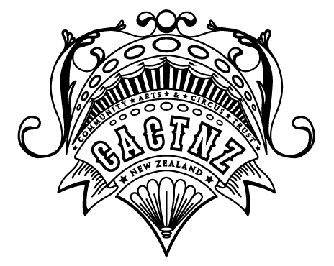

Community Arts and Circus Trust New Zealand Registered Charity Number: 2580487
T: 022 672 1018 / 04 476 4248 www.cactnz.weebly.com E: cactnz@gmail.com

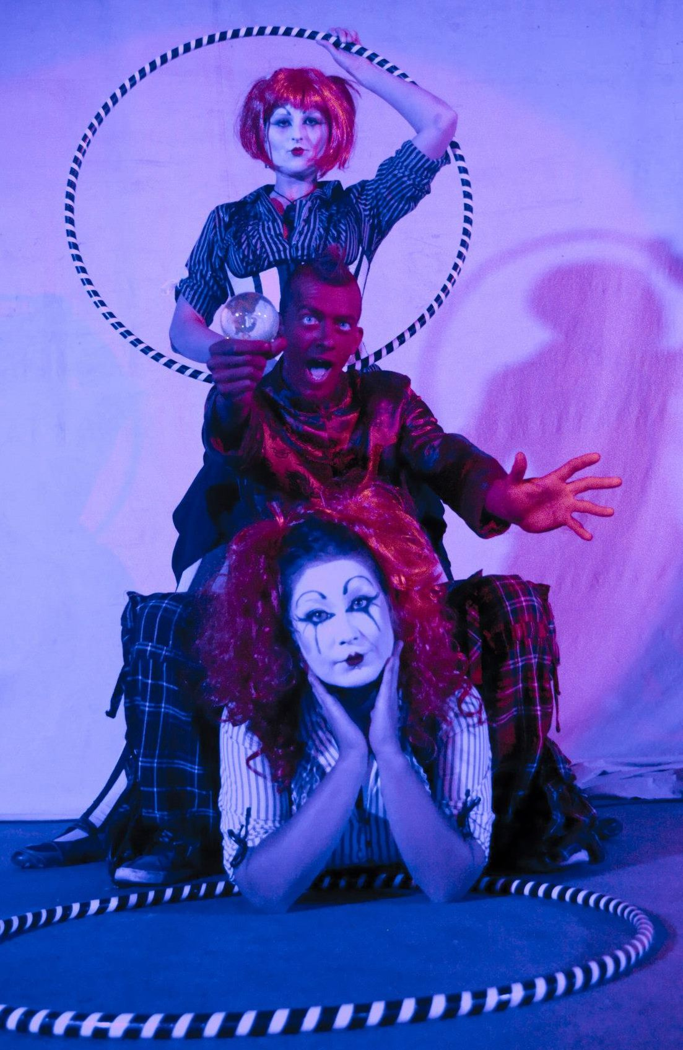
Cast Photo: (from top) Rohana Weaver, David French (He Who Is Red), Claire French (Frenchy Productions)
Taken By: Mariya Semyonnova
The Fire Within; A Fairy Tale Remix

Community Arts and Circus Trust New Zealand (CACTNZ) proudly present a firey theatrical tale. We invite you on a magical journey towards a young mans self acceptance. In collaboration with local young people and organisations, international fire artists and musicians. This outdoor show is koha (donation) based which goes back to the charaties involved. Expect spectacle, music, drama, mindbending prop manipulation, awe inspiring talent and LOADS OF FIRE!

When and Where?

Lower Hutt: The Dowse Square. 8pm on Friday 21st February with a weather contingency evening of Saturday 22nd February.

Wellington: Frank Kitts Park. 8pm on Friday 28th February with a weather contingency evening of Saturday 1st March.

Cost

The shows are Koha (donation) based – Proceeds go back to the charities involved. No booking is required – bring warm clothes!

What is it?

An outdoor fringe show involving industry professionals and local young people (including those at risk) and organisations. The show will have a theatrical feel and narrative with a story based on the 'Alice in Wonderland' theme with messages of bullying and how it is OK to be yourself. The show will involve collaboration with local groups including young people involved in the fire performance. The young people will be lead through a rehearsal and devising process which will include production of the fire equipment, safety briefs and costume and set making using a shop front through the About Space scheme.

The Story

The show is a contemporary remix/mash up of fairy tales turned into a theatrical fire and circus show that tells the story of a young man struggling with bullying and in turn self-acceptance of his difference.
Alex fakes a sicky from school because of his struggles with bullies and is given a family cure-all elixir from his grandmother to cure his ‘cold’. He is warned if he is not really ill strange things may happen… this elixir puts Alex into a dream state where he journeys to another world and meets many firey characters that aid him in his search for confidence and self-acceptance as he makes his way through the dream world and back to his own.

The Cast

Claire French (UK) – Frenchy – www.frenchyproductions.com – Director – Frenchy has 15 years’ experience of performing and running events and working with at risk young people in social services and Circus, Fire Arts and Manipulation. Claire works supporting young people within mental health.

Rohana Weaver (Christchurch) - Artistic Director – Roh has 10 years’ experience as a community artist, workshop coordinator in costume and arts and fire and circus professional who specialises in work with the intellectually disabled.

Reece Dunn (Aus) – Is an international Australian fire and circus performer, Reece is flying into Wellington especially for the Fringe show!

David French (UK) – He Who Is Red – http://www.youtube.com/user/hewhoisred - Is an international performer and street entertainer from Scotland, French will be in New Zealand this summer for the Fringe show before returing to the UK!

Who else is involved?

Lower Hutt
- Arohanui Strings
- About Space
- Volunteer Hutt

Wellington
- Just Youth
- Youthline
- Karori Youth Centre
- East Suburbs Youth Trust
- Local youth rock band – The Valve
- TBC - Richmond Services – Wellink Divison (young people with mental health issues)

The Trust

www.cactnz.weebly.com

’Creatively engaging, training, supporting, connecting and inspiring people from all walks of life through the medium of community arts and circus within New Zealand.
From at risk youth to industry professionals, we see and believe in the power and benefit of community arts and circus’

The Community Arts and Circus Trust New Zealand (CACTNZ) is a New Zealand based registered charitable trust. They combine their proffessional backgrounds in health and social care with their passion and talent for community arts and circus to create experiences for those who most need it most and to approach social change in a theraputic way.

This project will give the Trust the chance to do what they love best – to create a show that involves professionals, local groups and young people, to give the participants an experience they will never forget, and to bring fire arts and circus into the hearts of the community.

Contact

All media enquiries should be directed to Miss Claire French (director) – see contact details in header

