Appendices

Appendix 1 Key specifications for the incomes analysis in this report

Appendix 2 Choice of income sharing unit

Appendix 3 Equivalence scales: sensitivity of results to choice of scale

Appendix 4 Analysis unit: sensitivity of results to choice of household or individual for calculating medians and reporting poverty rates and inequality

Appendix 5 Incomes before and after deducting housing costs (BHC and AHC)

Appendix 6 Rationale for setting the low-income thresholds or ‘poverty lines’

Appendix 7 Indices used to adjust for inflation

Appendix 8 The bottom income decile: income often not a reliable indicator of economic wellbeing

Appendix 9 Decile and quintile means and shares (BHC)

Appendix 10 Summary of composition of poor children by ethnicity and selected household characteristics

Appendix 11 Supplementary poverty tables

Appendix 12 Supplementary OTI information

Appendix 1

Key specifications for the incomes analysis in this report

Decision point | Option used in this report | Comment
income sharing unit | household (HH) | see Appendix 2
income concept | equivalised disposable HH income (ie after-tax cash income, adjusted for HH size and composition)  - before deducting housing costs (BHC)  - after deducting housing costs (AHC) | see Appendix 5
housing costs | rent, mortgage (principal and interest) and rates on principal residence
equivalence scale | Revised Jensen 1988 | see Appendix 3 for sensitivity analysis using different scales
unit for presentation of results | individual | individuals are grouped by individual characteristics or by those of their HH or family (EFU)
types of low-income thresholds or ‘poverty lines’ | ‘moving line’ thresholds – set relative to the median for the survey year (REL)  ‘fixed line’ thresholds – set in a base year (1998) and kept at a constant value in real terms (CV) | the ‘fixed line’ approach is sometimes referred to in the literature as an ’absolute’ approach
setting of low-income thresholds or ‘poverty lines’ | REL thresholds set at 50% and 60% of the median HH income (BHC)  CV thresholds set at 50% and 60% of the 1998 median HH income (BHC), and adjusted forward and back by the CPI  AHC thresholds are set at 25% less than the corresponding BHC threshold | see Appendix 7 for a discussion of the rationales for the particular thresholds selected
adjusting for inflation | use the average CPI for the survey year | see Appendix 8
method for ranking the population and determining median | rank all individuals on the equivalised income of their respective HHs and identify the middle person (a ‘person-weighted’ approach) | some rank HHs and take the middle HH (a ‘HH weighted ‘ approach) – see Appendix 4
data set adjustments | negative incomes are set to zero  for poverty depth measures, adjustments are made for households with implausibly low incomes | See Appendix 8

Appendix 2

Income Sharing Unit

Estimates of rates of income poverty typically use the income of the household or some version of the (co-resident) family as the indicator of the individual’s resources and economic well-being. This assumes that all members of the income sharing unit (ISU) share equitably in the resources and experience a similar standard of living. Although this assumption clearly does not hold in all cases, it is defensible as an approximation to the complex reality of intra- and inter-ISU patterns of sharing (cf Bradbury, 2003:25). Some grouping of individuals is necessary for determining poverty status, if only because the alternative of using only individual income as an indicator of available resources or economic well-being is clearly highly unsatisfactory. For example, on an individual approach all dependent children would be classed as ‘in poverty’.

This report uses the household as the ISU, in line with international practice.

The reader is referred to the 2007 report for an extended discussion of the implications of the choice of ISU.

Appendix 3

Equivalence scales: sensitivity of results to choice of scale

Equivalisation reflects the two common sense notions that:
- a larger household needs more income than a smaller household for the two households to have similar standards of living (all else being equal)
- there are economies of scale as household size increases.

Most sets of equivalence ratios also assume that children cost less than adults.

Equivalising is a means of standardising household incomes in terms of household size and composition so that the relative material well-being of households of different sizes and compositions can be analysed. The adjustment also makes comparisons over time more realistic because it takes into account the changes over time in the composition and average size of households.

While considerable research has been undertaken to try to estimate appropriate values for equivalence scales, no universally accepted ‘correct’ set of equivalence ratios has emerged, even when household size and composition are the only factors being considered.

Ideally, equivalence scales would also take into account other factors such as the age of children, the costs of being employed, the extra costs of disability, the differing costs faced by people in different geographical locations, the different ratios needed for households of the same type but of different incomes, and so on. Such considerations further complicate an already fraught estimation process and the common practice is to settle for simpler scales as a rough-and-ready but better-than-nothing approximation.

The primary equivalence scale used in the analysis in this paper, the 1988 Revised Jensen Scale (RJS), is (by design) a mid-range scale. In practice it is very close to what has come to be known as ‘the modified OECD scale’ which is now used by EUROSTAT, Australia, the United Kingdom and others. This scale assigns the first adult a value of 1.0, the second and subsequent adults 0.5 and children 0.3. Canada uses a similar equivalence scale for its ‘Low Income Measures’ (LIMs), with second and subsequent adults assigned 0.4 and children 0.3.

For international comparisons the OECD and the Luxembourg Income Study (LIS) use a scale where children and adults are treated as if they costed the same. Economies of scale are taken into account by using an elasticity of 0.5, which implies much higher economies of scale than the RJS. The scale is sometimes known as the ‘square root scale’ as it is calculated by taking the square root of the number of people in the household.

None of the above scales are directly empirically based. For New Zealand, the best available empirically based scale is that developed by Michelini, although even its strongest advocate recognises that ‘there is a strong case for more effort to improve its estimation’ (Easton and Ballantyne, 2002).

These scales are compared in Table 3.1 below for different household types.

Table 3.1
Comparison of five equivalence scales
HH type | RJS 1988 | ‘Modified OECD’ | Michelini | Canada’s LIMs | ‘Square Root’ scale
(1,0) | 0.65 | 0.67 | 0.57 | 0.71 | 0.71
(1,1) | 0.91 | 0.87 | 0.83 | 0.93 | 1.00
(1,2) | 1.14 | 1.07 | 1.06 | 1.14 | 1.23
(2,0) | 1.00 | 1.00 | 1.00 | 1.00 | 1.00
(2,1) | 1.21 | 1.20 | 1.22 | 1.21 | 1.23
(2,2) | 1.41 | 1.40 | 1.45 | 1.43 | 1.42
(2,3) | 1.58 | 1.60 | 1.65 | 1.64 | 1.59
(3,0) | 1.29 | 1.33 | 1.38 | 1.29 | 1.23
Notes: 1 A (2,3) HH has 2 adults and 3 dependent children, and so on.
2 Some of the scales in the table make fine adjustments for the age of the child. This aspect is omitted to keep the comparisons straightforward.
3 The source for the Michelini ratios is Easton and Ballantyne (2002).

The five scales are very similar for their relative assessment of couple, two parent and three adult households. Where the most significant differences occur is in the implied relative costs for single person and single parent households. For example, the Michelini scale implies (relatively) lower costs for these latter households, which means that compared with the results using the Jensen scale the Michelini scale would lead to fewer people below the threshold from sole parent households and single person households, while having similar rates for couples and two parent households. This first principles ’thought experiment’ analysis is confirmed empirically by Easton and Ballantyne (2002) – see Table 3.2 below.

Table 3.2
Comparison of poverty rates by HH type
using the RJS 1988 and Michelini equivalence scales
and the BDL threshold (BHC)
 | RJS 1988 | Michelini
(1,0) | 12 | 7
(1,1) | 34 | 17
(1,2) | 61 | 48
(2,0) | 8 | 8
(2,1) | 16 | 16
(2,2) | 16 | 17
(2,3) | 22 | 25
(3,0) | 8 | 10
Children | 20 | 21
Source: Table 6.6 in Easton and Ballantyne (2002),

For the purposes of reporting on inequality and hardship using household incomes, overall trends are largely unaffected by the choice of equivalence scale from among the five scales above and those similar to them. Reported poverty levels at a point in time and the composition of those identified as poor can be affected by the choice of scale, but the high level findings as to the relative position of various sub-groups are robust to the choice of scale.

Figure 3.1 shows the trend in nominal medians from 1982 to 2004 using the RJS 1988, the modified OECD and the square root scales. The values using the RJS 1988 and the modified OECD scale are so close that the lines are coincident over most of the period. The square root scale gives a higher median in each survey because its assumption of greater economies of scale lead to a lesser change from the unequivalised household income for each household.

Figure 3.1
Sensitivity of medians to choice of equivalence scale (BHC incomes)
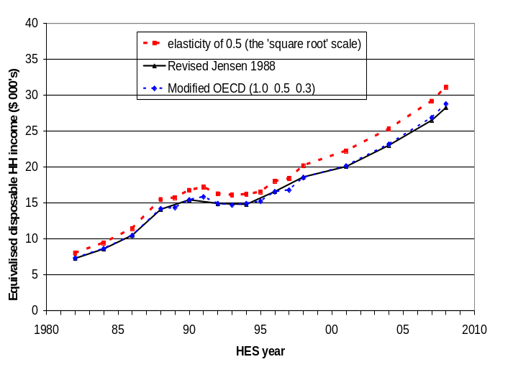

Figure 3.2 shows the similarity of the trends for the Gini coefficient using the RJS 1988 and square root scales.

Figure 3.2
Sensitivity of Gini coefficient to choice of equivalence scale (BHC incomes)
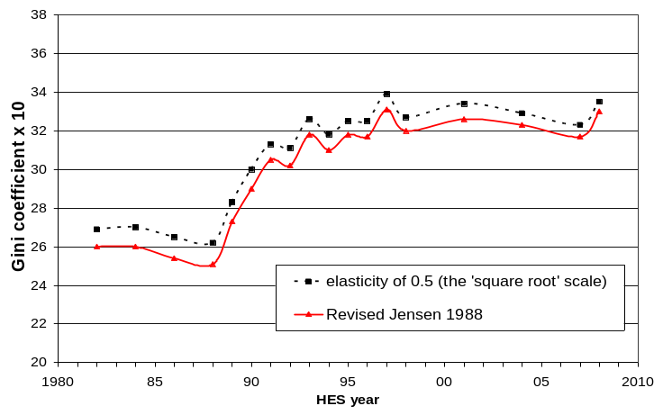

Figures 3.3 and 3.4 show trends in poverty rates for the whole population and for children respectively, using a 60% of contemporary median threshold (REL approach) and three different equivalence scales. Long-run trends are unaffected by the choice of scale, although relative changes between adjacent reporting years do vary a little.

Figure 3.3
Sensitivity of poverty rate to choice of equivalence scale:
whole population, using a threshold of 60% of the contemporary median (BHC)
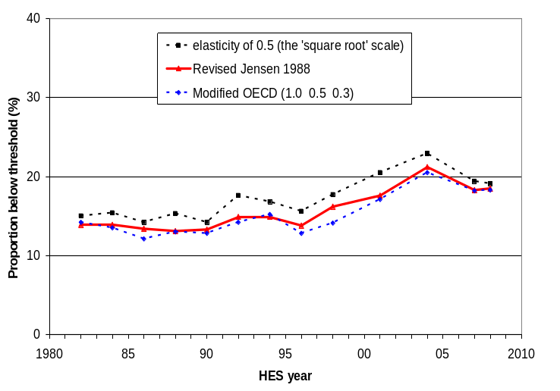

Figure 3.4
Sensitivity of poverty rate to choice of equivalence scale:
children (0-17), using a threshold of 60% of the contemporary median (BHC)
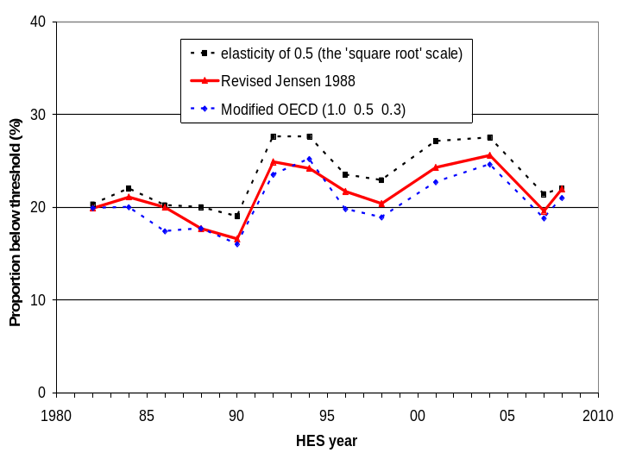

Figure 3.5 shows trends in poverty rates for children (0-17) using three different scales and the 50% of median REL measure. As expected, the modified OECD and RJS 1988 scales produce very similar results. The big difference in this case is the much higher rates produced by the square root scale in the first half of the 1990s. In relation to households with children the square root scale makes an implicit assessment of higher costs for sole parent families than do the other two. This will generally lead to higher reported child poverty rates using the square root scale, and in particular years, the REL threshold using the square root scale will move enough to just go above a large cluster of families whose sole income source is the Domestic Purposes Benefit together with other government transfers. This can lead to a blip in the relative trends.

Figure 3.5
Sensitivity of poverty rate to choice of equivalence scale:
children (0-17), using a threshold of 50% of the contemporary median (BHC)
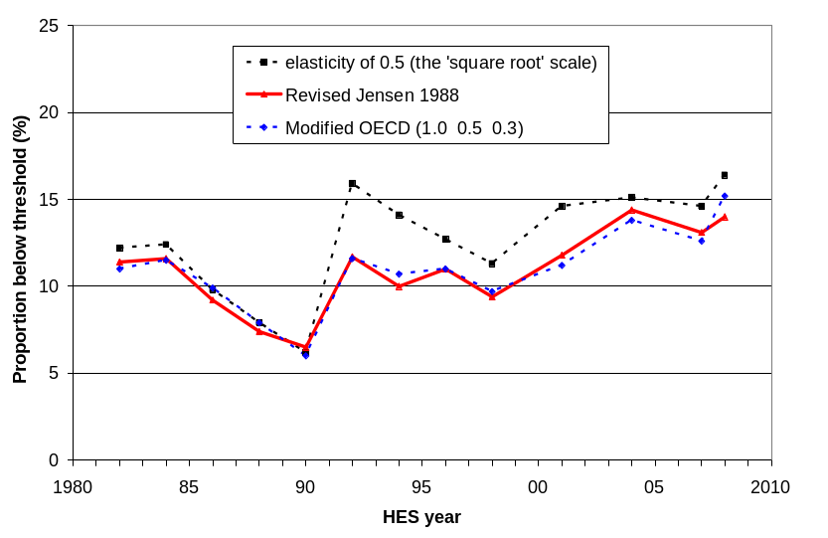
Choice of scale for AHC incomes analysis

This report uses the same equivalence ratios for AHC analysis as for BHC analysis. However, because there are greater economies of scale for accommodation than for other expenses, there is a case for using a different set of scales for AHC analysis than for BHC. The AHC scales should reflect the more limited scope for economies of scale when looking only at residual income after housing costs have been deducted (AHC).

The UK’s Households Below Average Income reports now use such a scale for their AHC analysis. Instead of attributing an extra 0.50 for second and subsequent adults as it does for the BHC case (Table 3.1 above, the modified OECD scale), it uses 0.72. This reflects the more limited scope for economies of scale for adults in non-accommodation costs. The child factor increases only slightly from 0.30 to 0.34. For the purposes of comparing scales it is easier to re-base them to a couple HH having a value of 1.00. This makes the first adult 0.58, second and subsequent adults 0.42 and children 0.20.

Table 3.3 below compares the BHC and AHC scales that the UK now uses (DWP, 2007).

Table 3.3
Equivalence scale used in the UK for AHC analysis
compared with the one used for BHC analysis and with the Revised Jensen Scale
HH type | RJS 1988 | ‘Modified OECD’ scale for BHC analysis | ‘Companion’ scale for AHC analysis
(1,0) | 0.65 | 0.67 | 0.58
(1,1) | 0.91 | 0.87 | 0.78
(1,2) | 1.14 | 1.07 | 0.98
(2,0) | 1.00 | 1.00 | 1.00
(2,1) | 1.21 | 1.20 | 1.20
(2,2) | 1.41 | 1.40 | 1.40
(2,3) | 1.58 | 1.60 | 1.60
(3,0) | 1.29 | 1.33 | 1.42

In adopting the ‘companion scale’ for AHC analysis, two sets of relativities are changed compared with staying with ‘modified OECD’ scale for AHC analysis too:
- those between singles and couples – the unequivalised income needed by a single-person HH to reach the same potential living standards as a couple is lower;
- those between sole parent and two parent households - the unequivalised income needed by a sole parent HH to reach the same potential living standards as a two parent HH is lower;

The consequence of this is that poverty rates for single-person households and sole parent households could be expected to reduce somewhat relative to those for couples and two parent households respectively, when using the companion scale. The lower panel in Table 3.4 confirms this. The table also shows that poverty structure remains much the same in that the those sub-groups with higher rates remain relatively high and those with lower rates remain relatively low.

While the theoretical purity of using an alternative scale for AHC analysis is attractive, in practice the difference is not so great as might be expected. This result gives reasonable support for the protocol adopted in this report – the same set of scales is used for BHC and AHC analysis – but points to the need to at least report the sensitivity of findings to the choice of a scale that recognises that on an AHC basis there is much less scope for economies of scale.

Table 3.4
Proportions below a 60% REL threshold, HES 2004:
comparisons using three different equivalence scales (AHC incomes)
 | RJS 1988 | ‘Modified OECD’ | HBAI ‘companion’ scale for AHC analysis
Total population | 20 | 20 | 19
0-17 | 28 | 27 | 26
18-24 | 23 | 23 | 24
25-44 | 19 | 20 | 19
35-64 | 15 | 14 | 14
65+ | 9 | 9 | 7
By household type
Single 65+ | 18 | 19 | 11
Couple 65+ | 5 | 4 | 4
Single < 65 | 30 | 30 | 26
Couple < 65 | 13 | 13 | 13
SP with children | 65 | 57 | 49
2P with children | 19 | 20 | 19
Other family HHs with children | 17 | 19 | 23
Other family HHs, adults only | 12 | 12 | 13
Non-family HHs | 25 | 25 | 26

Note: the AHC threshold is set the 60% of the BHC median, less 25% to allow for average housing costs.

Appendix 4

Analysis unit: sensitivity of results to choice of household or individual for calculating medians and reporting poverty rates and inequality

This report attributes the equivalised household income to each household member as an indicator of each individual’s ‘access to resources’ or material wellbeing. Individuals are then ranked on this income for division into deciles, establishing medians and counting numbers below poverty lines, and so on. This is standard practice internationally.

Before this approach became the standard, some of the literature ranked households rather than individuals. The median income was the middle household’s income and the number in ‘poverty’ were the number of households below a given line.

Figure 4.1 shows that the different ways of ranking make only a very minor difference for medians, whereas Figure 4.2 shows that there is a noticeable difference in the trends for population poverty rates (using the BHC 60% of median REL approach) depending on whether one counts households or individuals.

Figure 4.1
Median equivalised household incomes ($2008):
comparison using the middle individual and the middle household
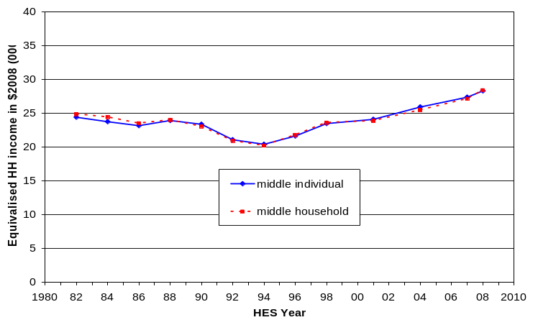

Figure 4.2
Proportions below the 60% REL threshold (BHC):
comparisons using individuals and households 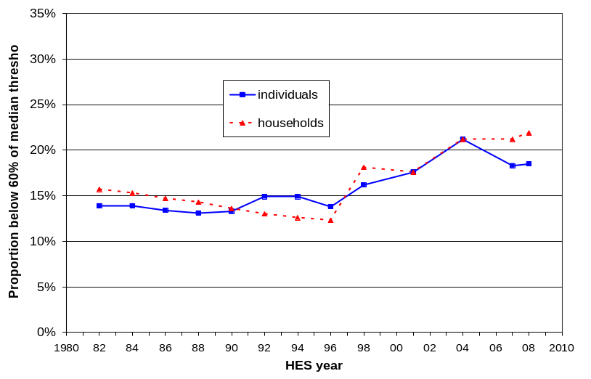

Appendix 5

Incomes before and after deducting housing costs (BHC and AHC)

The report provides information based on household income both before deducting housing costs (BHC) and after deducting housing costs (AHC).

Housing costs include all mortgage outgoings (principal and interest) together with rent and rates for all household members. Repairs and maintenance and dwelling insurance are not included. Any housing-related cash assistance from the state (eg Accommodation Supplement) is included in household income.

For reporting on overall trends in household income and on income inequality, there is value in seeing the similarities and differences between the two measures and in understanding the differing stories they tell.

For reporting on trends in income poverty over time and for comparing hardship across subgroups of the population, the report again reports on both BHC and AHC measures, but recommends the use of AHC measures as the preferred measure.

The use of BHC measures is generally taken as the self-evident starting point. They are important for assessing the adequacy of market and social assistance incomes for delivering a minimum acceptable standard of living. Their use also ensures that the material well-being of those on low incomes who choose to live where accommodation is less expensive (eg some rural areas) or who live in ‘cheap’ sub-standard accommodation is not left overstated (relatively) as the use of an AHC approach on its own can do.

The rationale for the report’s position that AHC analysis should also be reported, and that the AHC approach is preferable for sub-group comparisons in New Zealand is that:
- First, variations in housing costs do not correspond to similar variations in housing quality. Such variations can occur for housing in different regions, but is most significant when comparing the material well-being of age-groups. Many older individuals are in households that have good accommodation and relatively low housing costs (eg those living in mortgage-free homes). Many in an earlier part of the lifecycle have a similar standard of accommodation but relatively high accommodation costs. This variation in costs for the same or similar consumption is higher than for other budget items. This suggests that housing costs should be deducted from income to get a more reliable assessment of relative material well-being across different sub-groups.
- Second, many would argue that the theoretically most acceptable way of dealing with issues around incorporating housing benefits (direct and indirect) and housing costs is to add the imputed value of indirect housing benefits to the income measure and then on the basis of this fuller measure to calculate poverty rates and so on. However, apart from any conceptual or theoretical challenges faced by this approach, there is a practical difficulty in that the value of imputed rent of owner-occupied housing and of government housing subsidies is not often (reliably) available. For the purposes of comparing the economic well-being of different groups using an incomes measure, deducting housing costs from cash income (the AHC approach) can be seen as an approximation to the theoretically more comprehensive approach of estimating and adding imputed rent for homeowners. This rationale is in effect a variant of the first point made above.
- Third, once a household is committed to a particular residence, outgoings on housing costs cannot easily be adjusted or put off in ‘tight times’ as they can for other expenses like entertainment and recreation, and even to some degree for basics like food and clothing. The primary focus of this report is on trends in inequality and hardship and it is important to understand trends in ‘residual income’, taking housing costs as a given fixed cost in effect.
- Fourth, housing costs represent a very significant proportion of the total spending of many low-income households. These housing costs make up on average around a quarter of the budget for working-age low-income households. For many with low incomes, housing costs make up much more than a quarter of the budget. This is the key context for the first three points above.
- Finally, a unique characteristic of the New Zealand BHC income distribution is the very large ‘pensioner spike’ at around the value of New Zealand Superannuation. This occurs close to a 60% of median poverty line (BHC) and can lead to large variations in reported poverty rates for the 65+ group over time, leaving the misleading impression that there are significant changes in material wellbeing occurring for this group. In addition, the same issue can lead to similarly misleading comparisons with the relative wellbeing of other age-groups. An AHC approach avoids these issues and is more suitable as the primary measure (for New Zealand at least). This is further discussed in Section H.

The above arguments are generally seen as sufficient to justify at least the reporting on AHC measures alongside BHC ones. This report goes one step further and recommends the AHC approach for comparing poverty trends over time and especially for examining sub-group relativities, primarily because of the implications of the pensioner spike. Four counter-arguments are sometimes raised when considering the issue.

- First, some would argue that housing costs are like any other cost a household faces. Different households make different choices as to what to prioritise in the budget. It is argued that it is no more justified to deduct housing costs than, say, food costs, which can also vary between households of similar size and composition. One of the challenges to this view is already captured in the third point above – once a household is committed to a particular residence housing costs cannot easily be adjusted or put off in ‘tight times’ as they can for other items.

- Second, it can be argued that an AHC approach understates the relative standard of living of those whose material well-being is higher as a result of paying higher housing costs for better accommodation. The flip-side of this is that a BHC approach overstates the standard of living of those whose housing costs are high relative to the quality of their accommodation.

- Third, when considering changes over time, the AHC approach understates improvements in living standards when higher real housing costs do reflect improving standard of living. The flip-side of this is that a BHC approach may overstate the improvements in living standards when the Accommodation Supplement rises to offset higher rents. BHC income rises, but there is no commensurate rise in living standards.

- Fourth, for international comparisons a BHC approach is needed because that is the metric used internationally. This is true, but the updating over time is usually done on a ‘moving line’ (REL) approach, not on a ‘fixed line’ (CV) approach as this report and the Social Report use as the more fundamental approach.

None of the proposed counter-arguments appear conclusive. In addition, the AHC approach is well supported by the rationale outlined earlier above, and the issue of the ‘pensioner spike’ remains a very awkward one for a BHC analysis of income poverty trends for this age-group and for assessing sub-group relativities.

Figure 5.1 shows the difference it makes if the allowance for housing costs were increased to 30% instead of 25%. The reported poverty rate is lowered as there are fewer low-income households with OTIs >30% than with OTIs > 25%. The overall population rate is pulled down from 18% to 15% in 2011.

Figure 5.1
Proportions below the 60% REL threshold (AHC) using 25% and 30%

comparisons using individuals and households 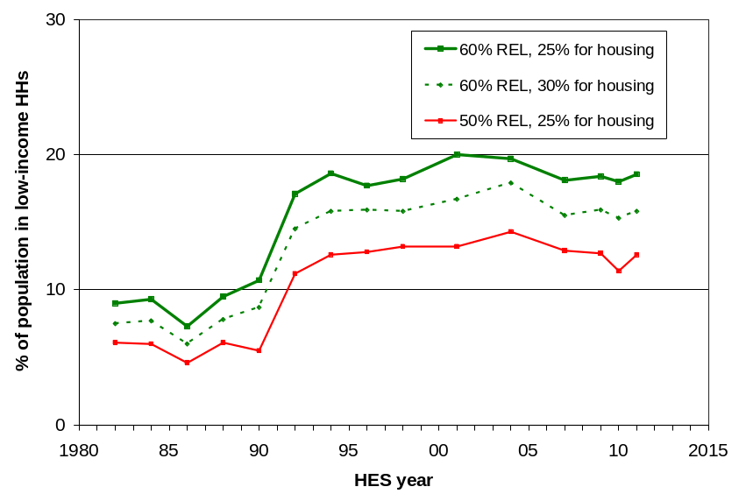

Appendix 6

Rationale for setting of low-income thresholds or ‘poverty lines’

Different countries and different researchers set low-income thresholds or poverty lines in a number of different ways. The two broad types of approach are to take proportions of the median or mean of the income distribution as the low-income thresholds (a distributional approach) or to use information from outside the distribution based on budget standards, expenditure data, ‘asking the people’, or a mixture of all three.

This report uses a distributional approach, based on 50% and 60% of median household equivalised income, drawing support for the decision from a range of considerations outside the income distribution. For updating thresholds over time, both ‘moving line’ (relative threshold) and ‘fixed line’ (constant-value threshold) approaches are used. The conceptual differences between the two are discussed in Section E.

BHC thresholds

The 60% of median threshold (BHC) has been formally adopted by EU member states as the EU’s primary measure of income poverty. It is also used by the UK as one of its three indicators in its composite official measure of child poverty. The OECD uses the 50% threshold for the bulk of its international comparisons but it also collects and uses analysis based on a 60% threshold.

Despite the reasonable consensus around the use of 50% and 60% thresholds there is an inherent arbitrariness about the choice of any particular percentage of the median. There are however some considerations that provide support for their use, for New Zealand at least.

First, the focus group research with low-income householders carried out by the New Zealand Poverty Measurement Project (NZPMP) found that budgets for minimum adequate income that allows a household to live independently without recourse, for example, to a foodbank, equated to around 60% of the median household income in the early 1990s. The research was not intended to imply that the 60% threshold was fixed for all regions and for all time. Indeed the NZPMP reports indicate that in Auckland for example the budget information suggests a higher threshold of around 66% of the median, with a lower figure for rural areas. More recent focus group work by the PMP team still points to minimum budget requirements on average of around 60% of the median.

Second, the 50% threshold is as low as is reasonable to go on the grounds that anything much under 50% is below social assistance levels which generally lie in the 50% to 65% range. Apart from the self-employed, there should therefore not be great numbers with reported incomes much under the 50% line.

Third, the 50% threshold is as low as is reasonable to go on the grounds that anything less than 50% takes the BHC threshold too far into the bottom decile where income is generally an unreliable indicator of access to resources. Even 50% itself is on the edge in this regard for some purposes. It is possible to devise a defensible rule for deleting or adjusting the most glaring cases for which there is evidence that the reported incomes are unreliable indicators of potential living standards, but this usually requires expenditure information which is not always available in surveys.

Fourth, NZS has ranged from 48% to 67% in the period 1982 to 2010. This suggests some sort of broad consensus that incomes in this ball-park are the minimum acceptable for older New Zealanders.

Fifth, the 1972 Royal Commission on Social Security operationalised the principle of ‘participation and belonging’ by defining a minimum-income level which came to be known as the Benefit Datum Line (BDL) (Easton, 1995a). When the BDL is adjusted by the CPI it is equivalent to 50% of the median for the 2004 HES. Given the general growth in affluence over the three decades following 1972 it would be unlikely that a poverty line lower than the BDL in real terms would command great support.

Sixth, readers are encouraged to look at the low-income thresholds noted in Tables E.3 and E.4 and to make their own call on the reasonableness of these as ‘poverty lines’. It is not likely that many would find them overly generous.

Finally, while the choice of threshold makes a significant difference for reported poverty levels at a given time, the choice very rarely makes a difference to the direction of trends and has very little impact on the identification of those groups most at risk of hardship.

Figure 6.1 shows the proportion of people in low-income (BHC) households for a range of thresholds set relative to the contemporary median (the ‘moving line’ approach). Note that the trend lines move in reasonable synch.

Figure 6.1
Proportion below median-based thresholds (BHC, REL)

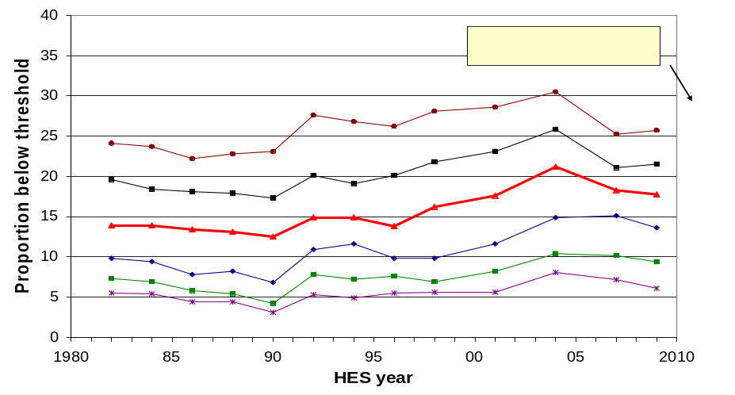

AHC thresholds

There are two (related) questions to consider in setting AHC thresholds:
- what concept of housing costs is to be used?
- what rationale is available to guide the setting of AHC thresholds?

Concept of housing costs

This report defines housing costs (HC) fairly narrowly to include mortgage outgoing paid by the household, rent, rates and other payments to local authorities. Repairs and maintenance items are not included. This makes the HC concept different from that used in the HES ‘housing group’ category which includes ‘property maintenance goods’ and ‘property maintenance services’. Dwelling insurance, heating, electricity and so on are possible candidates but are not counted either.

There are good arguments for both wider and narrower conceptualisations of housing costs for the purposes of reporting on hardship and inequality. There is however a very practical matter that directs us to the narrower HC concept: the new ‘incomes only’ HESs for the years in between the three-yearly full HESs (HES 2008 is the first of these) do not have any information on repairs and maintenance costs, as these are derived from the expenditure diary which will not be used for these surveys. If AHC poverty and inequality measures are to be produced each year from now on, then the narrower concept will have to be used.

The full Housing Group costs and the HC costs are distributed differently across the income distribution. Housing Group costs are around 24% of total expenditure for each gross income decile. On the other hand, rent, mortgage and rates (the HC concept) are a smaller proportion of outgoings for middle income households than for poorer households. This has implications for the way the AHC thresholds are set.

Rationale for setting AHC thresholds

On the basis of the consensus around the 50% and 60% thresholds for BHC analysis it would seem straightforward to simply use AHC thresholds set at 50% and 60% of the AHC median.

There are two sets of evidence that suggest an alternative approach needs to be considered.

First, AHC medians have been some 18% to 20% lower than BHC medians since 1996. This means that if we used a straight distributional approach to setting the AHC thresholds (eg 50% and 60% of the AHC median), then a given AHC threshold would also be 18% to 20% lower than the corresponding BHC one for the period. The implication of this is that a household with a BHC income just below 60% of the BHC median is declared AHC poor if its housing costs are anything more than 20% of its BHC income.

This (20%) is a very low proportion of income being spent on housing for a low-income household. It is unrealistic and does not square with a range of considerations which point to the use of 25% or 30% as reasonable figures. Some of these considerations are that:
- Lower-income working-age households on average spend proportionately more than middle-income households do on housing understood in terms of rent, mortgage and rates (around 25% compared with around 20%, since 1996).
- New Zealand’s income related rents policy uses a 25% setting.
- The entry thresholds for receipt of the Accommodation Supplement (AS) for renters are set at 25% of net household income. (Note that recipients generally pay more than 25% of their household income (including the AS) on housing as the AS does not fully cover the remaining amount).
- There is some rule-of-thumb international consensus that poorer households spending more than 25% to 30% of their BHC income on housing are AHC poor.

The second piece of evidence is that the NZPMP’s focus groups point not only to a BHC threshold of around 60% of the median, but also to a minimum of 25% of the BHC budget being required for housing costs. If the NZPMP research is to guide the choice of 60% for BHC analysis, then in the interests of internal coherence it should also guide for AHC thresholds.

These considerations provide a rationale for setting the AHC threshold equal to the BHC threshold less 25% (at least), rather than simply using a distributional approach based directly on the AHC median, which produces an AHC threshold only 15% to 20% lower than the corresponding BHC one, depending on the year.

The ‘deduct 25%’ approach also has the advantage of not being influenced by what happens to housing costs for middle-income households, which would be the case if a straight distributional measure were used. If the proportion that middle-income households spend on rent, mortgage and rates rises over time (as it has) then the distributional AHC poverty lines would fall over time and, all else equal, AHC poverty rates would be reported as falling even though nothing was changing for the poor. This is not a desirable property for a poverty measure.

Note also that the ‘BHC less 25%’ approach is very close to what would be obtained if the full Housing Group housing costs were used to generate the AHC income distribution, rather than just the narrower rent-rates-mortgage approach.

Those identified as poor on an AHC measure are overwhelmingly those in low-income households (BHC) with above average housing costs. There are a few who have modest BHC incomes and very high housing costs.

Figure 6.2 is Figure 6.1 repeated for AHC incomes using the above method of setting AHC thresholds and using a fixed line approach with thresholds based on the 1998 HES and held constant in real terms. Note how the trend lines are very similar in shape over a very wide range of AHC thresholds.

Figure 6.2
Proportions below constant-value thresholds (AHC, CV)

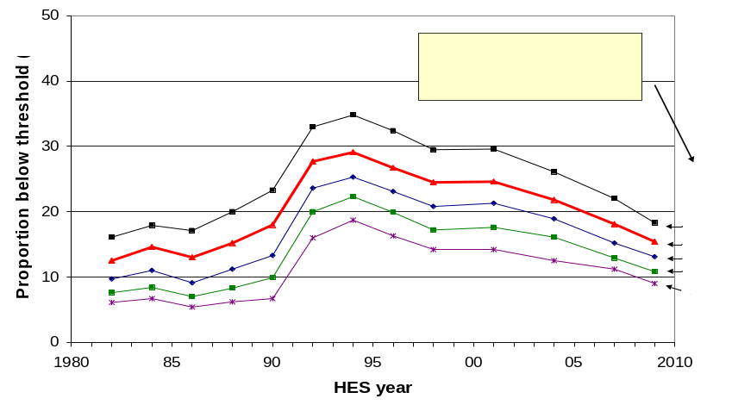

Using non-monetary indicators (NMIs) to illustrate the sorts of restriction on living standards experienced by low-income households

From 2007 the Household Economic Surveys have gathered NMI information from a subset of the items that make up the ELSI scale used in Section K.

The graph and table below use selected NMIs from the HES and from the 2008 Living Standards Survey (LSS) to illustrate some of the restrictions on day-to-day living standards experienced by low-income households. Of particular relevance to the theme of this Appendix (setting poverty thresholds) is the evidence they give for the actual experiences of many in the bottom quintile (AHC incomes). These low-income households:
- have quite significant restrictions on their day-to-day living standards compared with what is the typical experience of most of the rest of the population
- are excluded through lack of financial resources from many aspects of what society more generally would consider to be a minimum acceptable standard of living.
This is the essence of what ‘relative disadvantage’ is all about, as discussed in Section E.

Figure 6.3, based on NMI data from the 2010 HES, clearly shows the much greater risk of hardship for low-income households than for most of the rest of the population. The 11 items used are all either necessities or ones that are commonplace among the bulk of the population, or both. The graph shows the proportions reporting either an ‘enforced lack’ of an item because of the cost, or the decision to ‘economise a lot’ on the item so as to be able to pay for other basics. The lower two deciles stand out as being quite different in their risk of hardship compared with most of the rest of the population.

Figure 6.3
Proportion reporting not having / economising a lot on 4 or more of 11 basic items, because of cost:
all households, HES 2010
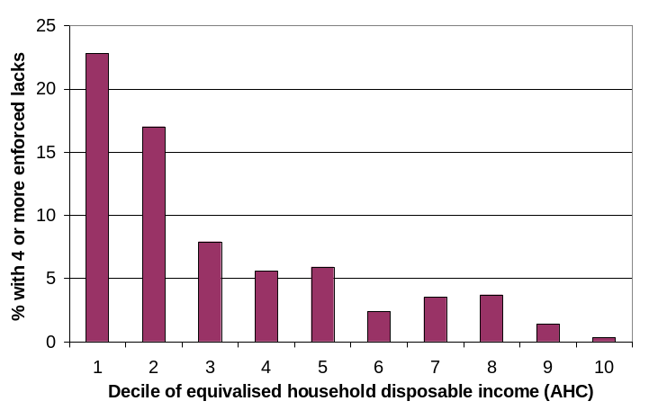

The 11 items used in Figure 6.3 are of two types:
- 7 ‘enforced lacks’ of basics that the respondent ‘wants’ but cannot have or do because of the cost:
- telephone
- good pair of shoes
- heating available in all main rooms
- contents insurance
- give presents to family or friends on special occasions
- have family or friends over for a meal at least once a month
- have a week’s holiday away from home each year
- 4 ‘economising’ items. The survey gives the option of ‘not at all’, ‘a little’ and ‘a lot’ as a response. The graph uses only the more stringent ‘ lot’ response:
- gone without fresh fruit and vegetables to help keep costs down (‘a lot’)
- put off buying new clothes for as long as possible to help keep costs down (‘a lot’)
- postponed or put off visits to the doctor to help keep down costs (‘a lot’)
- did not pick up a prescription to help keep down costs (‘a lot’)
The 2008 LSS had a wider range of questions compared with what is in the HES. This enables some useful detailed comparisons to be made across the income range. Table 6.1 shows the much greater chance for specific lacks or for hardships for low-income households with children. The deciles are deciles of AHC income for the whole population. Households with children are not evenly distributed across the full population deciles: for example, 25% of children come from households in the lowest quintile. The children are divided into five broad groups for Table 6.1:
- the low-income zone – deciles 1 and 2 (these deciles have similar numbers of children)
- those in households with incomes just above the usual poverty lines – decile 3
- middle-income households – deciles 4 to 6
- households with above average incomes – deciles 7 and 8
- high-income households – deciles 9 and 10

The point of Table 6.1 is to give an idea of the great difference in day-to-day life for those children in low-income households compared with those children in the bulk of the rest of the households across the income distribution, as well as to highlight some features of the low-income experience that are of concern in their own right.

Table 6.1
The day-to-day experience of children in low-income households compared with that of their better- off peers: proportions of financial stress and hardship items by AHC income decile (%), LSS 2008
Population household income decile (AHC) ➔ | 1 | 2 | 3 | 4 | 5 - 6 | 7 - 8 | 9 - 10
Proportion of children in each population decile ➔ | 13% | 13% | 7% | 13% | 22% | 19% | 14% | 100%
 | Low income |  | Just above usual pov lines | Middle income |  | Above avg income | High income | All children
Could not pay an unexpected expense of $500 within a month without borrowing | 58 | 52 | 34 | 16 | 15 | 5 | 2 | 25
Parent(s) borrowed money from family or friends to meet everyday living costs [more than once in the last year] | 42 | 44 | 27 | 11 | 12 | 6 | 2 | 19
Household received help in the form of food, clothes or money from a welfare/community organisation such as a church or foodbank [more than once in last year] | 20 | 20 | 9 | 3 | 3 | 2 | 1 | 8 (>once)  14 (once or more)
Parent(s) reported EL of a meal with meat, fish or chicken at least each second day | 10 | 5 | 2 | 2 | 2 | 0 | 0 | 3
Dampness or mould is a major problem | 32 | 30 | 23 | 13 | 17 | 9 | 9 | 17
EL for keeping the main rooms of the house adequately warm | 16 | 18 | 9 | 12 | 7 | 2 | 2 | 9
EL of home computer | 30 | 25 | 22 | 16 | 7 | 4 | 4 | 8
Child(ren) went without music, dance, art, swimming, or other special interest lessons because of the cost [a lot] | 20 | 14 | 15 | 6 | 7 | 2 | 1 | 9
Do not have a separate bed for each child | 23 | 13 | 11 | 7 | 6 | 2 | 1 | 8
Do not have enough bedrooms so that children over 10 of the opposite sex are not sharing a room | 30 | 27 | 15 | 16 | 16 | 7 | 5 | 17
Visits by parent(s) to the doctor for themsleves postponed [a lot] to keep down costs | 27 | 29 | 22 | 12 | 12 | 10 | 4 | 16
Postponed child visits to the doctor to keep down costs [a lot] | 3 | 7 | 3 | 5 | 0 | 0 | 0 | 2
Note: Three types of survey questions lie behind the information reported in Table 6.1:
- Enforced lacks (EL) – the respondent reported wanting the item but not doing / having it because of the cost
- Economising behaviour – respondent reported restricting consumption of a particular item [a lot] to keep costs down to help with the purchase of other basic items
- Do not have an item or have a major problem with a specific item.
Appendix 7

Indices used to adjust for inflation

Household incomes and low-income thresholds are adjusted for inflation at various places in the report. Incomes are converted to 2010 dollars for reporting on income trends in real terms. For the reporting on trends in income poverty based on a ‘fixed line’ approach, thresholds are based on proportions of the 2007 median and are held constant in real terms over other years.

The adjustments for inflation are carried out using CPI full year averages for a March year up to and including the 1998 survey and a June year from 2001. For BHC incomes Statistics New Zealand’s CPIQ.SE9A series are used – taking the average of the four quarters for the appropriate periods. AHC incomes and thresholds from 1989 are adjusted using the index from the ‘All Groups less Housing’ series (CPIQ.SE9NS1010) for the survey’s mid-point quarter. For 1982 to 1988 the AHC adjustments are based on the author’s extrapolation of the series. The reported trends in AHC incomes and the size of low-income populations are not sensitive to different assumptions within a plausible range for the index in the estimated years.

Table 7.1 contains the indices used in the report to adjust for inflation.

Table 7.1
Indices used to adjust incomes for inflation
HES year | BHC | AHC
1982 | 375 | 418
1984 | 455 | 503
1986 | 569 | 613
1988 | 740 | 782
1989 | 778 | 823
1990 | 828 | 857
1991 | 873 | 902
1992 | 888 | 918
1993 | 897 | 929
1994 | 910 | 935
1995 | 932 | 947
1996 | 962 | 972
1997 | 983 | 989
1998 | 994 | 993
2001 | 1044 | 1051
2004 | 1113 | 1107
2007 | 1213 | 1186
2008 | 1251 | 1219
2009 | 1292 | 1261
2010 | 1316 | 1283
2011 | 1366 | 1335

Appendix 8

The bottom income decile: income often not a reliable indicator of material wellbeing

While household income is far from perfect as a measure of material wellbeing it is generally a useful enough indicator. There are however some households for whom it would clearly be highly misleading to take their incomes as even a rough and ready indicator of their material living standards. This assessment is based on comparisons with information beyond the incomes reported in the survey:
- some households have implausibly low incomes, well below the minimum social support levels
- some have reported expenditures well above their reported incomes
- some meet both criteria.

Some of these households (whether with implausibly low incomes per se, or with expenditure well above reported income) will be declaring income from self-employment. This can legitimately be much lower than reported expenditure – the declared income may even be negative. Others will have accurately reported their incomes but will have had access to loans, gifts or savings in one form or other which have been used for purchasing goods and services. Others will have intentionally or unintentionally under-reported their incomes.

This Appendix provides an assessment of the significance of the impact of the issue on the key indicators used in the report, and concludes that with the exception of indicators of poverty depth the noise does not unduly compromise the results. To provide both a means of making the assessment and a means of mitigating the impact on poverty depth measures, the Appendix also outlines and applies a noise reducing protocol to modify the dataset.

Most of the unreliability is in the bottom decile

Households with implausibly low incomes are of course found only in the bottom decile (bottom tenth of the income distribution). The reported incomes of many at the bottom are less than the incomes provided by government cash benefits or New Zealand Superannuation. This points to mis-reporting or data entry errors.

Those reporting expenditure much higher than reported income are found in most parts of the income distribution but the bulk of them are found in the bottom decile.
- For example, of all those in households reporting expenditure which is more than three times their income, around 75% to 80% are in the bottom income decile in any survey year.
- In any survey year, around one quarter to one third of those in the bottom decile are in households with this high expenditure-to-income ratio. No other decile is like this in regards to expenditure so greatly exceeding income for so many.
- Average household expenditure for the bottom decile is typically around 2.5 times the average reported income and is more like the reported expenditure of the third and fourth income deciles;
- A sizeable proportion of those in the bottom decile (eg 50% in the 2004 HES) report expenditure higher than the incomes of households at the top of the second income decile.

There is therefore clear evidence that for many of the households in the bottom decile household income is a very unreliable indicator of access to resources and of material wellbeing. In other words, there is considerable ‘noise’ at the bottom end of the distribution. Whatever the explanation is, it would be misleading to assume that the bottom 10% on the income distribution also have the lowest living standards.

Impact of bottom decile noise on key indicators

All of this can have a significant impact on some of the key indicators used in this report. The most significant impact is on measures of poverty depth (see Section E), with a more moderate impact on reported income levels at the top of the bottom decile (P10 incomes). The impact on reported poverty rates at a point in time and on the relative composition of those identified as poor depends on the poverty line used, with the greater impact occurring for lower thresholds.

On the other hand, the noise in the bottom decile does not have a significant impact on the medians as the bulk of households in question remain below the median even if their expenditures were taken as better estimates of their actual income than what was reported as such. There is in general no significant impact on reported trends in inequality and poverty.

Table 8.1 below illustrates the differential impact of the ‘noise’ on various sub-groups and across different thresholds. It shows the proportion of various sub-groups whose household incomes put them below the income threshold in question, but whose expenditure is more than double the selected threshold. Note the large amount of noise when using a 40% threshold, and that even the 50% threshold is marginal on the criterion used.

Table 8.1
Proportions (%) of sub-groups in income poverty whose expenditure is more than double the selected low-income threshold, HES 2004 (BHC)
 | Poverty lines as a % of the 2004 median (BHC)
Sub-group | 40% | 50% | 60% | 70%
Self-employed | 59 | 42 | 30 | 26
0-17 | 29 | 11 | 7 | 4
18-24 | 68 | 55 | 37 | 14
25-40 | 50 | 25 | 17 | 11
41-64 | 50 | 26 | 14 | 9
65+ | 22 | 8 | 6 | 5
Two parent with any dep ch | 24 | 9 | 9 | 6
Sole parent with any dep ch | 51 | 18 | 5 | 2
HHs <65 with 2+ adults, no dep children | 68 | 59 | 38 | 21
Population overall | 46 | 24 | 13 | 8

The self-employed make up only around 5% to 6% of the poor, whichever threshold is used, and their poverty rates are around a quarter to a third less than the rest of the population. The self-employed are not therefore the main source of the noise at the bottom end of the distribution. The main source is working-age households with two or more adults and no dependent children, whatever their income source.

Bottom decile noise is a recognised problem

The unreliability of bottom-decile incomes as an indicator of living standards is not an issue that is unique to New Zealand.

Because of the problems with the bottom decile, the Australian Bureau of Statistics uses deciles 2 and 3 (rather than deciles 1 and 2) as their bottom quintile to encapsulate low income households (ABS, 2004). This is an extreme approach which makes the production of income poverty figures impossible.

In the United Kingdom, the Department for Work and Pensions warns in its Households Below Average Incomes publications that incomes in the bottom decile cannot be taken as a reliable guide to living standards. They follow through on this in their poverty tables by printing in italics the estimates based on a 50% of median threshold to remind the reader of the greater uncertainties using that threshold compared with using the 60% and 70% thresholds.

The Luxembourg Incomes Study (LIS) bottom codes to lift all household incomes to at least 1% of the mean equivalised household income.

The New Zealand Poverty Measurement Project (NZPMP) recognised the problem and sought to address it by deleting from the dataset those self-employed who declared losses and those whose expenditure was more than three times their income. The effect of this adjustment to the dataset is to slightly reduce reported poverty rates.

The approach used in this report to reduce the noise in the bottom decile

In selected circumstances this report uses the HES expenditure data to impute a more plausible income to households whose reported incomes are very low compared with their expenditure. All those households with reported expenditures of more than three times reported income are given a notional income equal to the average of their reported income and expenditure.

Figure 8.1 shows that this adjustment significantly reduces the noise at the lower end of the distribution as the imputed incomes more reasonably represent these households’ access to financial resources.

Compared with the option of removing the relevant households from the data set, this approach has the advantage of not impacting on the size and composition of the population and sub-population estimates using the standard Statistics New Zealand weightings.

Figure 8.1
‘Noise’ reduction using the modified dataset:
proportion of the population below selected thresholds and with expenditure > double the selected threshold (HES 2004)
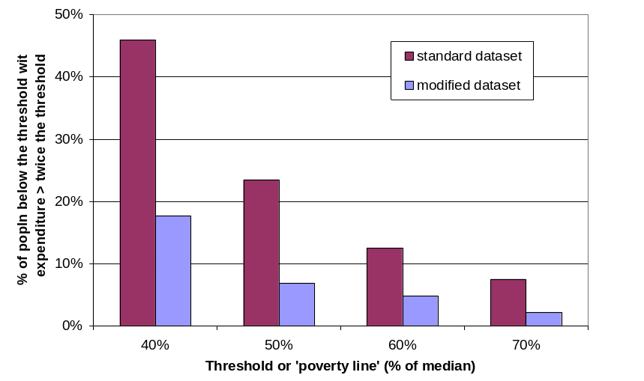
Note: In the modified dataset, all HHs with expenditure more than three times their income are assigned an imputed income equal to the average of their expenditure and income. 75% of these HHs come from the lowest decile and 84% from the lowest two deciles.

Table 8.2 repeats Table 8.1 to show how the imputation approach reduces ‘noise’ as indicated by the proportions of the poor from various subgroups who have expenditure more than double the selected income poverty line. Table B.1 uses the standard HES dataset. Table 7.2 uses the modified dataset.

Table 8.2
Proportions (%) of sub-groups in income poverty whose expenditure is more than double the selected threshold, HES 2004 (BHC) – modified dataset (see text)

 | Poverty lines as a % of the 2004 median (BHC)
Sub-group | 40% | 50% | 60% | 70%
Self-employed | * | * | 12 | 5
0-17 | 13 | 5 | 3 | 2
18-24 | * | 20 | 12 | 2
26-40 | 23 | 8 | 7 | 2
41-64 | 23 | 6 | 6 | 2
65+ | 0 | 0 | 3 | 2
Two parent with any dep ch | 21 | 5 | 5 | 3
Sole parent with any dep ch | 7 | 6 | 1 | 0
HHs <65 with 2 or more adults, no dep children | 25 | 21 | 13 | 3
Population overall | 18 | 7 | 5 | 2

Notes: An asterisk (*) in a cell indicates that the sample numbers are too small to provide reliable estimates for that cell

What indicators are changed most by reducing the noise at the bottom end?

For reporting on poverty depth the noise at the bottom has a significant impact. This can be seen from the results for the mean poverty depth in Table 8.3 below. The mean poverty depth figures are significantly different (lower) when the modified dataset is used. This is to be expected given that the mean depth is strongly influenced by the proportion of households with very low incomes.

Table 8.3
Comparison of poverty depth (%) using the standard and modified HES 2004 datasets (BHC)
 | Poverty lines as a proportion (%) of the median (BHC)
 | 40% |  | 50% |  | 60%
 | Std | Modified | Std | Modified | Std | Modified
Median poverty depth | 27 | 12 | 20 | 18 | 16 | 12
Mean poverty depth | 43 | 23 | 33 | 23 | 25 | 19

Figure 8.2 shows that estimates of the Total Poverty Gap are also considerably higher when using the standard dataset as so many decile one households having implausibly low low incomes.

Figure 8.2
Total Poverty Gap
(BHC, 60% 1998CV threshold):
estimates compared for standard and modified datasets
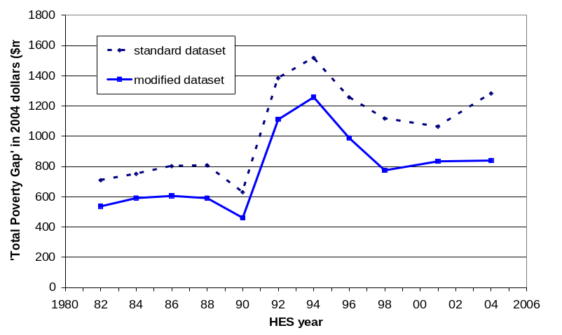

Table 8.4 compares the poverty rates for the various subgroups using the standard and modified datasets. Unsurprisingly the poverty rates using the modified dataset are all lower than when using the standard set. Note though that the reported poverty rates for the population as a whole and for sub-groups of special policy interest (children, those in sole-parent households and older New Zealanders) are not greatly changed by using the modified dataset. The largest differences are for those aged 18 to 24 and for working-age households with two or more adults and no dependent children.

Table 8.4
Comparison of poverty rates (%) using the standard and modified HES 2004 datasets (BHC)
 | Poverty lines as a % of the median (BHC)
 | 40% |  | 50% |  | 60%
Sub-group | Std | Modified | Std | Modified | Std | Modified
Self-employed | 4 | 1 | 8 | 5 | 15 | 12
0-17 | 6 | 5 | 15 | 14 | 26 | 26
18-24 | 9 | 4 | 14 | 8 | 18 | 13
26-40 | 5 | 4 | 10 | 8 | 16 | 15
41-64 | 5 | 4 | 9 | 7 | 16 | 15
65+ | 1 | 1 | 3 | 3 | 37 | 38
Two parent with any dep ch | 3 | 3 | 9 | 9 | 16 | 17
Sole parent with any dep ch | 12 | 10 | 34 | 31 | 60 | 59
HHs <65 with ≥ 2adults, no dep children | 6 | 2 | 10 | 4 | 14 | 8
Population overall | 5 | 4 | 10 | 9 | 21 | 20

The differences between the two sets of results would have been larger if an exogenously determined poverty line (eg “$13,000”) had been used and applied to both datasets. As it is, the modified dataset produces a slightly higher median and therefore the poverty thresholds are correspondingly higher (~2%). These higher thresholds (in dollar terms) offset to some degree the poverty-reducing effect of the imputed household incomes being higher than the reported incomes. Nevertheless, this preliminary analysis gives some assurance that the use of the standard dataset does not in the main produce misleading results, for the reporting of poverty rates using 50%, 60% and higher thresholds.
Figure 8.3 shows the difference the modifications make to incomes at the top of the bottom decile (P10). The P10 values over the 1982 to 2004 period are all higher using the modified dataset, as would be expected (around 2-4% higher). The trend is unchanged, except that in the 2004 HES, the noise at the bottom was such that the standard dataset shows a decline in real P10 incomes (‘the poor became poorer’) whereas the modified dataset shows a rise in P10 (‘the poor became less poor’). The difference in 2004 is 8%. In contrast the P20 trends are the same whether the modified or standard datasets are used.

Figure 8.3
Comparison of trends using the original and modified datasets for P10 and P20 incomes

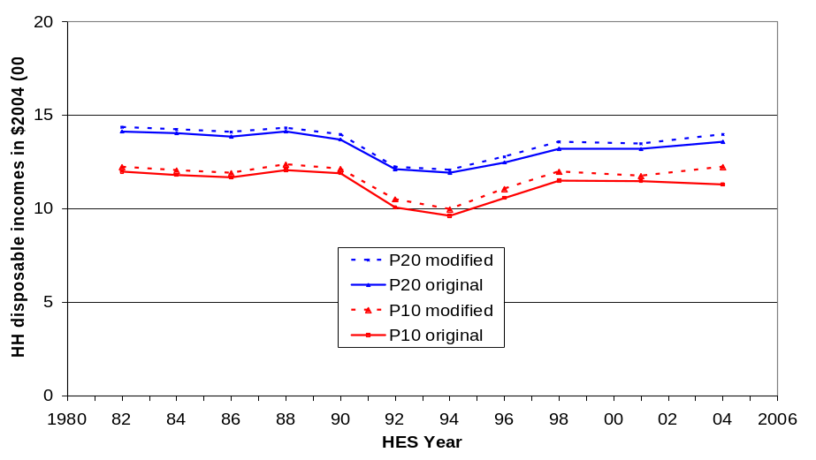

Further work

Further work is planned on the issue of noise at the bottom end of the distribution focussing on the implications for reporting on indicators of hardship and inequality. The results from this exercise will be noted in a future update of this report, and adjustments made as and if required.

In the meantime:

(a) the standard unmodified dataset will be used except for estimates of ‘poverty depth’ which use the modified dataset described above.

(b) a special Appendix is provided for better estimates of the means for the bottom decile in the years when expenditure data is available (see Appendix 9)
Appendix 9 [closely linked to Appendix 8]

Decile and quintile means and shares (BHC)

Different parts of the income distribution can show quite different relative movements over time. One way to show the differing changes is to divide the population into ten equal sized groups (deciles) and show the trends in real incomes for the median, the mean or top of each decile.

The main report uses the upper boundaries of deciles one to nine for this purpose. These correspond to the percentiles P10, P20, P30 and so on. Trends for P100 are not given for the top decile as these are simply the highest household income in the surveys. To give an idea of trends for the top decile, some information is given about changes in the top decile median (ie P95).

The upper boundary approach is used in the main report for two reasons:
- it fits well with the use of standard percentile ratios for summarising trends in inequality (eg the 90/10 and 80/20 ratios)
- it avoids the considerable difficulties that arise when decile medians or especially means are used for indicating trends for households reporting very low incomes (ie those in the bottom income decile

Reporting on trends in decile means (or medians) is nevertheless a common practice. This Appendix provides that information in the context of a discussion and a strong health warning regarding the uncritical use of bottom decile means (or medians) to indicate trends in the material wellbeing of low income households.

In the discussion that follows it is important to remember that this report is not simply about reporting on household incomes per se. Its purpose is to provide information on New Zealanders’ access to economic resources and (potential) living standards as indicated by their household incomes. While household income is far from perfect as a measure of material wellbeing it is generally a useful enough indicator. There are however some households for whom it would be very misleading to take their incomes as even a rough and ready indicator of access to economic resources. This is a particularly acute issue for the bottom income decile as can be illustrated by identifying households with expenditure much greater than their reported income. Those reporting expenditure much higher than reported income are found in most parts of the income distribution but the bulk of them are found in the bottom decile:
- Of all those in households reporting expenditure which is more than three times their income, around 75% to 80% are in the bottom income decile in any survey year.
- In any survey year, around one quarter to one third of those in the bottom decile are in households with this high expenditure-to-income ratio. No other decile is like this in regards to expenditure so greatly exceeding income for so many.
- Average household expenditure for the bottom decile is typically around 2.5 times the average reported income and is more like the reported expenditure of the third and fourth income deciles.

One of the groups of decile one households whose incomes are not even a rough and ready indication of access to economic resources is the group reporting zero or negative income for the year. In the sample for each survey there are typically 20 to 30 households who report zero or negative income out of around 250 households in the bottom decile (before grossing up to population estimates). This is not an insignificant group. Not only are these reported zero or negative incomes completely misleading indicators of access to economic resources (even though they may be quite legitimate and accurate responses to the income questions in the survey) they also lower the mean for the bottom decile, and pull it below the decile median.

The pulling down of the mean can be seen in Figure 9.1. The graph also shows how the difference between mean and median varies from survey to survey. In the 1986 HES and especially in the 1988 HES there were relatively large numbers of households reporting negative incomes – this brought the mean down quite low relative to the median for those years. In the 1990 HES the numbers with reported negative incomes was much smaller which brought the mean closer to the median. This is reflected in the Figure 9.1.

Figure 9.1
Bottom decile means and medians, 1982 to 2007 (2007 dollars)
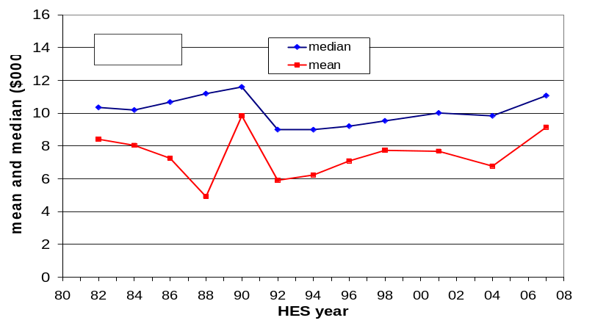

This difference between median and mean in the bottom decile does not occur in deciles 2 to 9. In decile 10 the reverse occurs – the mean is higher then the median because of a few very high incomes at the top of the distribution. These things are all illustrated in the HES 2007 analysis shown in Figure 9.2.

Figure 9.2
Decile means and medians: equivalised household incomes, BHC (2007 HES)
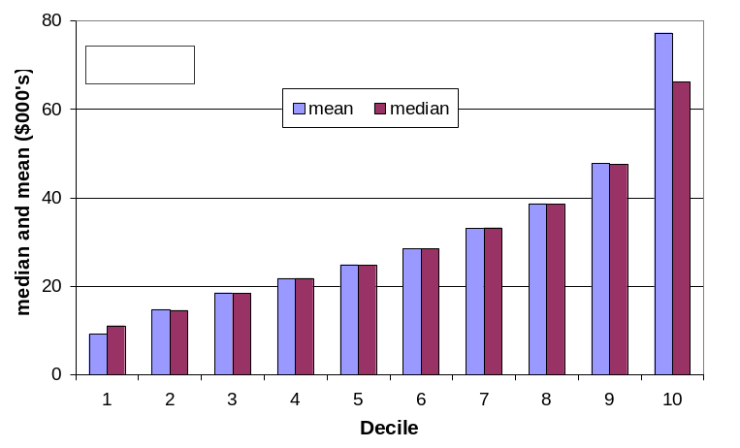

To alleviate the bottom decile issues, a range of approaches have been and are used:
- some use ‘bottom coding’ such as raising all household incomes to at least 1% of the overall mean (eg the Luxembourg Income Study), or re-setting all negatives to zero (as in the data sent to the OECD by statistical agencies)
- others modify the dataset by deleting various records – examples are:
- deleting records with negative incomes, or incomes less than or equal to zero
- deleting records with high expenditures relative to reported income or with negative self-employment income (the NZPMP uses expenditure of 3x income as an indicator of high expenditure)
- this report modifies the dataset by imputing an income that is an average of reported expenditure and reported income for households with high spending relative to their income (see Appendix 7 for this report’s use of this approach).

Figure 9.3 shows how each of four approaches impacts on the mean for decile 1, relative to the situation of ‘no deletions’ (bottom line in graph below). The NZPMP and the modified dataset approach used in this report have a fairly similar impact.

Figure 9.3
Impact on decile one means of selected dataset modifications $2007)
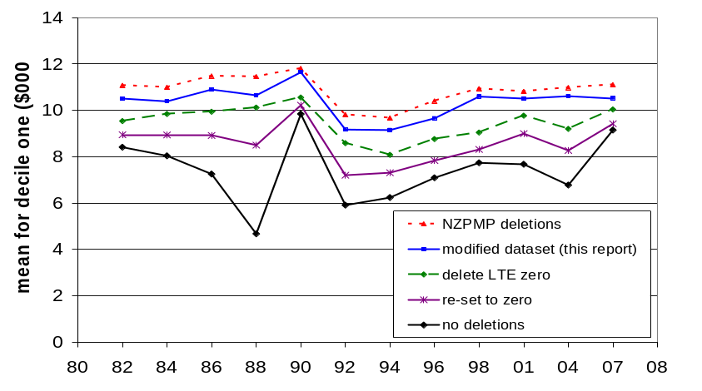

Figure 9.4 shows how in contrast to what happens for decile 1, each of the four approaches has a very limited impact on the mean for decile 2. The same holds for deciles 3 to 10.

Figure 9.4
Impact on decile two means of selected dataset modifications
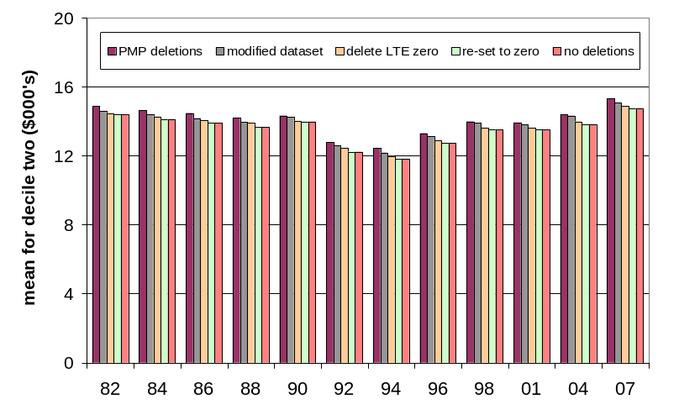

One of the main uses for information on decile means is to report on trends in their real values over time. Table 9.1 reports the changes in decile means for selected time periods using the reported income data and the four modifications to the income data used above.

Table 9.1
Percentage change in decile means (adjusted to $2007) by different dataset modifications
 | Low | 2 | 3 | 4 | 5 | 6 | 7 | 8 | 9 | High
2004 to 2007
No deletions | 35 | 7 | 15 | 13 | 8 | 4 | 2 | 2 | 5 | 7
Set negatives to zero | 14 | 7 | 15 | 13 | 8 | 4 | 2 | 2 | 5 | 7
Delete LTE zero | 9 | 6 | 15 | 13 | 8 | 3 | 2 | 2 | 5 | 7
NZPMP deletions | 1 | 6 | 14 | 11 | 7 | 2 | 1 | 2 | 5 | 7
Modified dataset (this report) | -1 | 5 | 13 | 11 | 7 | 2 | 1 | 2 | 5 | 7
2001 to 2007
No deletions | 19 | 9 | 19 | 21 | 16 | 11 | 11 | 10 | 10 | 7
Set negatives to zero | 5 | 9 | 19 | 21 | 16 | 11 | 11 | 10 | 10 | 7
Delete LTE zero | 3 | 9 | 19 | 20 | 15 | 11 | 11 | 10 | 10 | 7
NZPMP deletions | 3 | 10 | 19 | 19 | 14 | 11 | 10 | 10 | 10 | 7
Modified dataset (this report) | 0 | 9 | 19 | 19 | 14 | 10 | 10 | 10 | 11 | 9
1998 to 2007
No deletions | 18 | 9 | 21 | 24 | 18 | 16 | 16 | 14 | 16 | 14
Set negatives to zero | 18 | 9 | 21 | 24 | 18 | 16 | 16 | 14 | 16 | 14
Delete LTE zero | 11 | 9 | 21 | 23 | 18 | 16 | 16 | 14 | 16 | 14
NZPMP deletions | 2 | 10 | 20 | 21 | 16 | 15 | 15 | 13 | 16 | 13
Modified dataset (this report) | -1 | 9 | 20 | 21 | 16 | 15 | 14 | 13 | 15 | 13
1982 to 2007
No deletions | 9 | 3 | 10 | 12 | 12 | 12 | 14 | 16 | 22 | 49
Set negatives to zero | 5 | 3 | 10 | 12 | 12 | 12 | 14 | 16 | 22 | 49
Delete LTE zero | 5 | 3 | 10 | 12 | 12 | 12 | 14 | 16 | 22 | 49
NZPMP deletions | 0 | 3 | 10 | 12 | 12 | 12 | 14 | 16 | 23 | 49
Modified dataset (this report) | 0 | 3 | 11 | 13 | 12 | 12 | 14 | 16 | 23 | 47
1988 to 2001
No deletions | 56 | -6 | -7 | -5 | -1 | 3 | 5 | 9 | 15 | 41
Set negatives to zero | 1 | -6 | -7 | -5 | -1 | 3 | 5 | 9 | 15 | 41
Delete LTE zero | -8 | -7 | -7 | -5 | -1 | 2 | 5 | 9 | 15 | 41
NZPMP deletions | -10 | -7 | -7 | -4 | 0 | 3 | 5 | 9 | 15 | 41
Modified dataset (this report) | -6 | -6 | -6 | -4 | 0 | 3 | 6 | 9 | 15 | 39
1988 to 1994
No deletions | 27 | -18 | -18 | -18 | -17 | -14 | -11 | -8 | -4 | 10
Set negatives to zero | -18 | -18 | -18 | -18 | -17 | -14 | -11 | -8 | -4 | 10
Delete LTE zero | -24 | -18 | -18 | -19 | -17 | -14 | -11 | -8 | -4 | 9
NZPMP deletions | -20 | -17 | -19 | -18 | -16 | -13 | -11 | -7 | -3 | 10
Modified dataset (this report) | -18 | -17 | -19 | -18 | -17 | -13 | -11 | -7 | -3 | 8

stable, not sensitive to different modifications to the dataset
very unstable

Note: In 1988 there were more than the usual number of households reporting negative incomes and some reported some quite large negative incomes. This accounts for the incongruous 56% and 27% income growths for the bottom decile shown in the bottom two panels of Table 9.1. See also Fig 9.3.
The upshot of all this is that:
- it is misleading to use bottom decile means based on unadjusted income data as an indication of changes in access to economic resources for this part of the income distribution
- this is one of the reasons behind the use in the main report of the top of decile one as an indicator of trends for those with very low incomes (P10)
- when comparing changes in mean incomes for deciles 2 to 10, the impact of any of the approaches used to alleviate decile one issues is barely noticeable
- changes in means for deciles 2 to 10 and changes at the top of deciles 1 to 9 (main report) show similar patterns
- this report recommends the use of the ‘modified dataset’ approach for tracking changes in the mean for the bottom decile.

Table 9.2 gives the decile means when negative incomes are re-set to zero (as is the default protocol in the main report), and for the bottom two deciles for the ‘modified dataset’ used in the main report for poverty depth analysis and discussed further in Appendix 7.

Table 9.2
Decile means of equivalised household incomes (BHC), ($2010)
 | Modified dataset |  | Negatives set to zero
 | 1 | 2 | 1 | 2 | 3 | 4 | 5 | 6 | 7 | 8 | 9 | 10
1984 | 11,400 | 15,800 | 9,700 | 15,600 | 18,200 | 21,000 | 24,100 | 27,600 | 31,400 | 36,200 | 42,400 | 56,300
1984 | 11,300 | 15,600 | 9,700 | 15,300 | 17,900 | 20,500 | 23,400 | 26,800 | 30,600 | 35,400 | 41,700 | 56,100
1986 | 11,800 | 15,400 | 9,700 | 15,100 | 17,900 | 20,200 | 22,900 | 25,600 | 28,900 | 33,100 | 39,700 | 54,400
1988 | 12,100 | 15,900 | 9,700 | 15,600 | 18,100 | 20,600 | 23,500 | 27,000 | 30,800 | 35,100 | 40,900 | 55,500
1990 | 10,900 | 14,200 | 11,100 | 15,200 | 17,500 | 19,900 | 22,900 | 26,500 | 30,200 | 35,800 | 43,500 | 66,800
1992 | 10,000 | 13,700 | 7,800 | 13,300 | 15,100 | 17,400 | 20,600 | 23,900 | 28,000 | 33,000 | 40,500 | 60,600
1994 | 9,900 | 13,200 | 7,900 | 12,800 | 14,800 | 16,800 | 19,600 | 23,300 | 27,400 | 32,400 | 39,400 | 60,800
1996 | 10,500 | 14,200 | 8,500 | 13,800 | 15,700 | 17,900 | 20,900 | 24,700 | 28,600 | 34,300 | 41,700 | 68,800
1998 | 11,500 | 15,100 | 9,000 | 14,700 | 16,600 | 19,100 | 22,800 | 26,600 | 31,000 | 36,900 | 44,700 | 73,600
2001 | 11,400 | 15,000 | 9,800 | 14,700 | 16,800 | 19,600 | 23,300 | 27,700 | 32,400 | 38,200 | 47,000 | 78,100
2004 | 11,520 | 15,500 | 9,000 | 15,000 | 17,400 | 20,900 | 24,900 | 29,800 | 35,200 | 41,100 | 49,200 | 78,400
2007 | 11,420 | 16,400 | 10,200 | 16,000 | 20,100 | 23,600 | 27,000 | 30,900 | 35,900 | 41,900 | 51,800 | 83,900
2009 | - | - | 11,900 | 17,700 | 21,600 | 25,500 | 29,300 | 33,500 | 38,600 | 45,000 | 55,300 | 96,600
2010 | 13,000 | 18,300 | 11,500 | 17,900 | 22,200 | 26,200 | 29,700 | 33,700 | 38,800 | 44,900 | 54,400 | 91,200

this report advises against the use of this column for reporting on trends for low-income HHs

Notes: (1) the decile one means calculated with negatives set to zero (shaded column) are very unreliable indicators of the access to economic resources for the bottom decile – those from the ‘modified dataset’ (LH column) are better indicators
(2) in the ‘modified dataset’, up to and including 2007, households with reported expenditure of more than three times their reported income are assigned an imputed income equal to the average of their reported income and expenditure (see Appendix 8 for more detail)
(3) the full ‘modified dataset’ approach is not able to be implemented for the 2008 HES as this survey does not collect full expenditure information – the approach is approximated as discussed earlier in this Appendix - full information will be available again in the 2010 HES
(4) for deciles 2 to 10, similar trends and figures for a given year are produced by each approach
(5) the deciles in Table 8.2 are deciles of individuals assigned the equivalised incomes of their respective households (this is consistent with the main report’s approach to decilisation)
Income shares

Income shares by decile can be calculated from the information on decile means above and the overall means (Table D.1). For convenience, Table 9.3 reports decile shares for 1982 to 2010. The same issues apply to decile one shares as they do to decile one means, but the issue is much more muted in practice as the size of the share is very small anyway and the impact of the different changes to the dataset discussed above are not as obvious when using only one or two significant figures.

Table 9.4 gives quintile shares recalculated from the dataset rather than from simply adding the decile shares, to avoid the rounding errors that can occur with the latter.

Table 9.3
Decile shares (%) of equivalised household incomes (BHC)
 | Modified dataset |  | Negatives set to zero
 | 1 | 2 | 1 | 2 | 3 | 4 | 5 | 6 | 7 | 8 | 9 | 10
1982 | 4.0 | 5.5 | 3.4 | 5.5 | 6.4 | 7.4 | 8.5 | 9.8 | 11.1 | 12.8 | 15.0 | 19.9
1984 | 4.0 | 5.5 | 3.5 | 5.5 | 6.4 | 7.4 | 8.4 | 9.6 | 11.0 | 12.8 | 15.0 | 20.2
1986 | 4.3 | 5.7 | 3.6 | 5.6 | 6.7 | 7.5 | 8.6 | 9.6 | 10.8 | 12.4 | 14.9 | 20.3
1988 | 4.3 | 5.6 | 3.5 | 5.6 | 6.6 | 7.5 | 8.5 | 9.8 | 11.1 | 12.7 | 14.8 | 20.1
1990 | 4.3 | 5.2 | 3.8 | 5.2 | 6.0 | 6.9 | 7.9 | 9.2 | 10.4 | 12.4 | 15.0 | 23.1
1992 | 3.7 | 5.1 | 3.0 | 5.1 | 5.8 | 6.7 | 7.9 | 9.2 | 10.8 | 12.7 | 15.6 | 23.3
1994 | 3.8 | 5.1 | 3.1 | 5.0 | 5.8 | 6.6 | 7.7 | 9.1 | 10.7 | 12.7 | 15.5 | 23.8
1996 | 3.7 | 5.1 | 3.1 | 5.0 | 5.7 | 6.5 | 7.6 | 9.0 | 10.4 | 12.5 | 15.2 | 25.0
1998 | 3.8 | 4.9 | 3.1 | 5.0 | 5.6 | 6.5 | 7.7 | 9.0 | 10.5 | 12.5 | 15.1 | 25.0
2001 | 3.6 | 4.8 | 3.2 | 4.8 | 5.5 | 6.4 | 7.6 | 9.0 | 10.5 | 12.4 | 15.3 | 25.4
2004 | 3.5 | 4.7 | 2./8 | 4.7 | 5.4 | 6.5 | 7.7 | 9.3 | 10.9 | 12.8 | 15.4 | 24.5
2007 | 3.3 | 4.7 | 3.0 | 4.7 | 5.9 | 6.9 | 7.9 | 9.0 | 10.5 | 12.3 | 15.2 | 24.6
2009 | - | - | 3.2 | 4.7 | 5.8 | 6.8 | 7.8 | 8.9 | 10.2 | 12.1 | 14.8 | 25.8
2010 | 3.5 | 4.9 | 3.1 | 4.8 | 6.0 | 7.1 | 8.0 | 9.1 | 10.5 | 12.1 | 14.7 | 24.6

Table 9.4
Quintile shares (%) of equivalised household incomes (BHC)
 | Modified dataset | Negatives set to zero
 | Q1 | Q1 | Q2 | Q3 | Q4 | Q5
1982 | 9.4 | 9.0 | 13.9 | 18.3 | 23.9 | 34.9
1984 | 9.5 | 9.0 | 13.8 | 18.1 | 23.8 | 35.3
1986 | 10.0 | 9.3 | 14.2 | 18.2 | 23.2 | 35.2
1988 | 9.9 | 9.1 | 14.0 | 18.3 | 23.8 | 34.8
1990 | 9.5 | 9.1 | 12.9 | 17.1 | 22.8 | 38.1
1992 | 8.9 | 8.1 | 12.5 | 17.1 | 23.4 | 38.9
1994 | 8.9 | 8.1 | 12.4 | 16.8 | 23.4 | 39.3
1996 | 8.8 | 8.1 | 12.2 | 16.6 | 22.9 | 40.2
1998 | 8.7 | 8.0 | 12.1 | 16.7 | 23.0 | 40.1
2001 | 8.4 | 7.9 | 11.8 | 16.6 | 22.9 | 40.7
2004 | 8.2 | 7.5 | 11.9 | 17.0 | 23.7 | 39.8
2007 | 8.0 | 7.7 | 12.8 | 16.9 | 22.8 | 39.7
2009 | - | 7.9 | 12.6 | 16.7 | 22.3 | 40.5
2010 | 8.4 | 7.9 | 13.1 | 17.1 | 22.6 | 39.3

Appendix 10

Summary of composition of poor children by ethnicity and selected household characteristics

Table 10.1
Poverty rates and composition for children by their ethnicity and by characteristics of their households
Dependent children (0-17 yrs):  1,067,000 | Children in income-poor households |  | All children
Dependent children (0-17 yrs):  1,067,000 | What % of this category are poor? | What % of poor children are in this category? | What % of all children are in this category?
 | Poverty rate (%) | Composition of the poor (%) | Approximate composition for all children (%)
Household type
Sole parent HH | 54 | 46 | 18
Two parent HH | 14 | 47 | 69
Multi-adult family HH | 12 | 7 | 12
Family type
Sole parent families | 45 | 51 | 24
- in SP family on own | - 58 | - 44 | - 16
- within a wider HH | - 18 | - 7 | - 8
Two parent families | 14 | 49 | 76
# of children in the household
3+ | 28 | 48 | 37
1 or 2 | 18 | 52 | 63
Ethnicity
Maori | 30 | 34 | 24
Pacific | 28 | 13 | 10
Other | 28 | 14 | 12
Euro/Pakeha | 15 | 40 | 54
Tenure
HNZC | 46 | 19 | 9
Private rental | 33 | 49 | 33
Own home | 12 | 31 | 59
Main source of income for HH
Benefit | 59 | 60 | 22
Market | 12 | 40 | 78

Appendix 11

Supplementary poverty tables

In the main text the figures are rounded to the nearest whole number to avoid unwarranted impressions of precision. They are usually given here to one decimal place to assist with charts or rankings. The Jensen and modified OECD equivalence scales generally give similar figures (see also Table 3.1, p151).

Table 11.1
Income poverty rates using three relative thresholds (% of median) and three equivalence scales,
by age groups, BHC
 |  | 50% |  |  | 60% |  |  | 70%
Age gp | Year | sq rt | Jensen | m OECD | sq rt | Jensen | m OECD | sq rt | Jensen | m OECD
0-17 | 1995 | 10.8 | 9.4 | 9.4 | 22.1 | 19.5 | 19.4 | 36.3 | 32.9 | 34.0
 | 1998 | 11.3 | 9.4 | 9.7 | 22.9 | 20.4 | 18.9 | 37.9 | 36.5 | 36.5
 | 2001 | 14.6 | 11.8 | 11.2 | 27.1 | 24.3 | 22.7 | 38.7 | 35.6 | 36.2
 | 2004 | 15.1 | 14.4 | 13.8 | 27.5 | 25.6 | 24.6 | 37.6 | 36.6 | 35.8
 | 2007 | 14.6 | 13.1 | 12.6 | 21.4 | 19.6 | 18.8 | 29.1 | 27.6 | 27.9
 | 2010 | 13.5 | 12.6 | 11.7 | 21.0 | 20.2 | 19.4 | 29.6 | 29.9 | 28.2
18-64 | 1995 | 6.7 | 6.6 | 6.7 | 11.8 | 10.9 | 11.1 | 19.9 | 18.8 | 19.2
 | 1998 | 7.4 | 6.6 | 6.8 | 13.3 | 12.7 | 11.8 | 20.9 | 21.1 | 21.4
 | 2001 | 9.1 | 7.8 | 8.0 | 15.9 | 14.3 | 14.4 | 22.9 | 21.9 | 21.9
 | 2004 | 10.6 | 10.0 | 9.7 | 17.2 | 16.3 | 16.3 | 23.3 | 23.2 | 23.1
 | 2007 | 9.8 | 9.3 | 9.1 | 14.3 | 13.9 | 14.1 | 19.4 | 18.6 | 18.8
 | 2010 | 8.9 | 8.5 | 8.6 | 13.5 | 13.4 | 13.0 | 18.1 | 18.3 | 18.0
65+ | 1995 | 0.4 | 0.3 | 0.4 | 2.6 | 1.8 | 1.8 | 36.0 | 33.3 | 29.7
 | 1998 | 2.8 | 2.4 | 1.7 | 29.2 | 24.8 | 14.5 | 48.1 | 45.9 | 45.4
 | 2001 | 1.6 | 1.6 | 1.6 | 29.5 | 20.1 | 17.8 | 51.6 | 47.7 | 47.1
 | 2004 | 8.8 | 2.8 | 2.7 | 43.9 | 37.1 | 34.0 | 58.3 | 56.2 | 54.7
 | 2007 | 18.0 | 7.9 | 7.6 | 41.7 | 38.4 | 38.7 | 57.0 | 54.7 | 53.1
 | 2010 | 12.7 | 4.9 | 5.4 | 36.6 | 35.9 | 34.8 | 49.1 | 48.0 | 46.9
ALL | 1995 | 7.2 | 6.7 | 6.7 | 13.7 | 12.3 | 12.4 | 26.2 | 24.3 | 24.5
 | 1998 | 8.0 | 6.9 | 7.1 | 17.7 | 16.2 | 14.1 | 28.6 | 28.1 | 28.2
 | 2001 | 9.8 | 8.2 | 8.1 | 20.5 | 17.6 | 17.1 | 30.5 | 28.6 | 28.7
 | 2004 | 11.6 | 10.4 | 10.0 | 22.9 | 21.2 | 20.5 | 31.1 | 30.5 | 30.1
 | 2007 | 12.1 | 10.1 | 9.9 | 19.4 | 18.3 | 18.2 | 26.4 | 25.2 | 25.3
 | 2010 | 10.6 | 9.1 | 9.0 | 18.3 | 17.9 | 17.4 | 24.9 | 24.9 | 24.2
sq rt Square root scale (elasticity of 0.5), used by OECD
Jensen Revised Jensen Scale (1998), used in New Zealand
m OECD Modified OECD scale, used in EU and many countries (but not usually in OECD analysis)

Table 11.2
Child poverty rates using two relative thresholds (% of median) and three equivalence scales,
before and after taxes and transfers, BHC
 |  | 50% |  |  | 60%
Year |  | square root | Jensen | mod OECD | square root | Jensen | mod OECD
2004 | before | 26.6 | 25.9 | 26.1 | 29.7 | 29.6 | 29.3
 | after | 15.0 | 14.4 | 13.8 | 27.5 | 25.6 | 24.6
2007 | before | 25.8 | 25.5 | 25.8 | 29.9 | 30.3 | 29.8
 | after | 14.6 | 13.1 | 12.6 | 21.4 | 19.6 | 18.8
2010 | before | 29.0 | 29.2 | 29.8 | 34.2 | 33.7 | 34.2
 | after | 13.5 | 12.6 | 11.7 | 21.0 | 20.2 | 19.4
% reduction
 |  | 50% |  |  | 60%
Year |  | square root | Jensen | mod OECD | square root | Jensen | mod OECD
2004 |  | 77 | 80 | 89 | 8 | 16 | 19
2007 |  | 77 | 95 | 105 | 40 | 55 | 59
2010 |  | 115 | 132 | 155 | 63 | 67 | 76
Table 11.3
Child poverty rates using two relative thresholds (% of median) and two equivalence scales,
by number of children in the household, BHC
 |  | 50% |  | 60%
Year | # of children | Jensen | mod OECD | Jensen | mod OECD
2004 | 1 | 9.5 | 8.5 | 17.6 | 16.0
 | 2 | 9.5 | 7.8 | 17.4 | 15.1
 | 3+ | 20.8 | 21.2 | 36.2 | 36.5
2007 | 1 | 9.2 | 8.3 | 15.0 | 14.3
 | 2 | 9.1 | 9.1 | 16.4 | 15.6
 | 3+ | 19.8 | 19.4 | 25.8 | 25.5
2010 | 1 | 6.7 | 6.9 | 14.7 | 12.6
 | 2 | 8.4 | 8.1 | 14.7 | 14.4
 | 3+ | 20.5 | 18.5 | 29.5 | 29.2

Jensen Revised Jensen Scale (1998), used in New Zealand
mod OECD Modified OECD scale, used in EU and many countries (but not usually in OECD analysis

Table 11.4
Child poverty rates using two relative thresholds (% of median), by household type, BHC
 |  | 50% |  | 60%
Year | HH type | Jensen | mod OECD | Jensen | mod OECD
2004 | two parent |  | 10.8 |  | 20.6
 | sole parent |  | 28.6 |  | 48.2
 | other |  | 13.8 |  | 21.6
2007 | two parent |  | 9.1 |  | 11.0
 | sole parent |  | 22.1 |  | 50.1
 | other |  | 22.1 |  | 24.1
2010 | two parent |  | 11.0 |  | 16.0
 | sole parent |  | 18.4 |  | 39.2
 | other |  | 7.1 |  | 14.7
Jensen Revised Jensen Scale (1998), used in New Zealand
mod OECD Modified OECD scale, used in EU and many countries (but not usually in OECD analysis)
two parent HHs with two parents and at least one child (0-17 yrs) – there may be older siblings present
sole parent HHs with one parent and at least one child (0-17 yrs) – there may be older siblings present
other HHs where there are adults other than the parents or older siblings of the children (0-17yrs)

Table 11.5
Poverty depth for households with children (0-17 yrs):
gap between the poverty line and the median income of those in poor households with children (%),
using two relative thresholds (% of median) and two equivalence scales, BHC
 | 50% |  | 60%
Year | Jensen | mod OECD | Jensen | mod OECD
2004 | 17 | 18 | 18 | 18
2007 | 14 | 16 | 22 | 24
2010 | 15 | 16 | 19 | 19
Jensen Revised Jensen Scale (1998), used in New Zealand
mod OECD Modified OECD scale, used in EU and many countries (but not usually in OECD analysis)
Notes for Table 5:
(1) Poverty depth figures tend to bounce around from survey to survey, reflecting the changes from survey to survey in the number of households (with children) with unusually low incomes. Differences should be treated with caution until it is clear that a new pattern is established, averaging over two or three surveys. The 2007 figures in the Table (for the 60% poverty line) are high relative to those for 2004 and 2010. There are no known policy or wider economy factors that explain this. It illustrates the data issues involved in trying to measure poverty depth, especially for a population sub-group.
(2) The figures in Table 5 are for households with children rather than for children per se – the impact on the figures using this slightly different conceptualisation is likely to be very small in itself, and is certainly negligible compared with the uncertainties arising from the data issues noted above.
Table 11.6
Child poverty rates (%) using two relative thresholds (% of median), BHC,
by highest household educational qualification (ISCED classification)
Year | Highest qual | 50% | 60%
2007 | ISCED 0-2  (no school qual) | 35 | 52
 | ISCED 3-4  (school or post-school non-degree qual) | 13 | 20
 | ISECD 5-6  (degree or post-graduate qual) | 8 | 9
 | All children (0-17) | 13 | 19
2010 | ISCED 0-2  (no school qual) | 23 | 40
 | ISCED 3-4  (school or post-school non-degree qual) | 13 | 22
 | ISECD 5-6  (degree or post-graduate qual) | 8 | 10
 | All children (0-17) | 12 | 19
Notes for Table 6:
(1) The modified OECD equivalence scale is used to adjust household incomes.
(2) From the unit record data available, we are unable to precisely allocate between ISCED 3-4 and ISCED 5-6. This limitation affects only a few records however and the overall gradient and ‘message’ are not undermined.
(3) There are very few in the first category (ISCED 0-2). The reported poverty figures for this group are volatile, reflecting the high sampling error.
Appendix 12

Supplementary OTI information

Table 13.1 repeats Table C.1. Table 13.2 repeats Table 13.1 using the household as the unit of presentation rather than the individual. The only substantial difference between the two approaches is that the household approach gives a slightly different picture of the lower end of the distribution as households in Q1 tend to be larger on average than those in Q2.

Table 13.1
Proportion of individuals in households with housing cost OTIs greater than 30%, by income quintile
 | Q1 | Q2 | Q3 | Q4 | Q5 | ALL
1988 | 17 | 13 | 8 | 8 | 8 | 11
1990 | 24 | 16 | 12 | 9 | 8 | 14
1992 | 33 | 18 | 15 | 13 | 10 | 18
1994 | 52 | 21 | 12 | 11 | 10 | 22
1996 | 49 | 28 | 19 | 14 | 9 | 24
1998 | 48 | 29 | 21 | 15 | 12 | 26
2001 | 44 | 31 | 20 | 16 | 11 | 25
2004 | 39 | 28 | 18 | 12 | 9 | 22
2007 | 39 | 32 | 27 | 19 | 14 | 27
2009 | 40 | 34 | 30 | 19 | 16 | 28
2011 | 37 | 33 | 29 | 16 | 14 | 25

Table 13.2
Proportion of HHs with housing cost OTIs greater than 30%, income quintile
 | Q1 | Q2 | Q3 | Q4 | Q5 | ALL
1988 | 16 | 13 | 10 | 9 | 9 | 11
1990 | 20 | 14 | 14 | 13 | 10 | 14
1992 | 31 | 16 | 16 | 14 | 11 | 18
1994 | 48 | 21 | 14 | 14 | 13 | 22
1996 | 41 | 29 | 20 | 17 | 11 | 24
1998 | 41 | 29 | 23 | 16 | 13 | 24
2001 | 42 | 27 | 23 | 19 | 10 | 24
2004 | 34 | 27 | 21 | 14 | 12 | 21
2007 | 33 | 32 | 29 | 20 | 14 | 26
2009 | 33 | 34 | 30 | 19 | 18 | 27
2011 | 31 | 38 | 31 | 18 | 14 | 26

The ISU is sometimes referred to as the unit of income aggregation.
The scale is called the ‘modified’ OECD scale because there was an earlier scale which assigned 0.7 to each additional adult and 0.5 to each child which in 1982 the OECD suggested for possible use in countries which did not have their own equivalence scale. This came to be known as the ‘(old) OECD scale’ even though the OECD rarely used it. For its incomes analysis, the OECD uses neither the ‘old’ nor the ‘modified’ OECD scales, choosing instead the ‘square root scale’ noted above.
Throughout the rest of the report the one person HH is used as the reference for equivalising. This is done in part to have a reasonably sensible unit of ‘dollars per equivalent adult’. In Tables 3.1 and 3.2 the couple household is used as the reference to make the comparison of different scales over different HH types easier to grasp in these tables. The reference HH used makes no difference to any analysis.
The Michelini scale implies very limited economies of scale in going from a single person to a two person HH.
BHC income is the same as disposable or after-tax cash income. AHC income is sometimes referred to as income adjusted for housing costs, disposable income net-of-housing-costs, or ‘residual income’.
There is an argument for excluding repayment of mortgage principal from housing costs on the grounds that it is simply a form of near-compulsory saving. This report includes repayment of principal in housing costs on the grounds that for most mortgages there is little scope for adjusting principal repayments to help cope with ‘tight times’ and that it is in effect income not available to households in the short to medium term for other uses.
See Ritakallio (2003) and Fahey, Nolan and Mâitre (2004).
For many years 50% of the mean was commonly used as a poverty line or low-income threshold. 60% of the median is usually close to 50% of the mean.
Stephens et al (1995); Waldegrave et al (1996); Waldegrave et al (2003).
Personal communication with the NZPMP team (23 November 2006).
See Whiteford (2009: 49) for a similar observation regarding Australian income figures and some related discussion.
See Appendices 8 and 9 for further discussion of the matter of noise in the lowest decile.
If the BDL were updated by wage inflation it would be equivalent to a level much higher than 50% of the 2008 median.
See Bradshaw et al (2008) for a recent UK perspective based on ‘asking the people’.
The exception is older New Zealanders. Because a substantial proportion of those aged 65+ are in households receiving just NZS or NZS plus only a little more, the choice of BHC threshold relative to NZS makes a very large difference to reported poverty rates for this group. This is discussed in Section I.
For example, Australia’s Affordable Housing National Research Consortium sets a benchmark for ‘housing stress’ for the lower 40% of the household income distribution at 30%, and Canada’s Mortgage and Housing Corporation uses 30% in its ‘affordability’ measure. Auckland’s Regional Affordable Housing Strategy focuses on households with incomes in the bottom four deciles and uses a 30% rule. It notes that this definition is consistent with those used by a number of other countries. See CHRANZ (2004), ‘Housing Costs and Affordability in New Zealand’.
If a ‘deduct 30%’ rule were used, the effect would be to reduce reported poverty rates (AHC) by around 2 percentage points for the population overall. This is a smaller difference than what occurs in going from a straight distributional approach to the ‘deduct 25%’ approach.
Table 6.1 and Figure 6.3 also show that using income alone (even AHC income) does not perfectly identify all those experiencing financial stress or material disadvantage. They also underline that poverty and hardship exist along a continuum, rather than being precisely defined by a particular threshold or cut-off point. Hence the need for using more than one measure and for sensitivity testing using different thresholds.
‘ … results for the bottom decile … have no validity as a guide to the consumption possibilities of the poorest 10% of individuals’ (DWP, 2009:15)
See Stephens, Waldegrave and Frater (1995: 99) and Stephens and Waldegrave (2001: 81). Note that the removal of the identified records raises the median and therefore the threshold. This has an upward impact on the number below the threshold. The deletion of records naturally has a downward impact. The net reduction occurs because the latter factor is the stronger.
This imputation method may not capture all those whose incomes do not give a reasonable indication of material wellbeing. One such group is those who under-report both income and expenditure.
This adjustment is not possible in the new incomes-only HES (starting with HES 2008) as no expenditure diary is kept.
Poverty depth and the Total Poverty Gap are defined and discussed at the end of Section E.
The boundary analysis is sometimes described as ‘the upper boundaries of deciles one to nine’ and sometimes as ‘the lower boundaries of deciles two to ten’. These are the same thing.
See Table B.4 (p28) for an indication of incomes for different household types in decile one.
For 2001, 2004 and 2007, the mean incomes of those with reported negative or zero incomes were -$40,600, -$22,600 and -$5,800, while their reported spending was $39,700, $37,800 and $29,500.

