Media release
8th December 2011

Property values continue to climb

The QV residential property index for November shows that nationwide property values have continued to gradually increase. Values are now 1.7% above the same time last year and 4.0% below the previous market peak of late 2007.

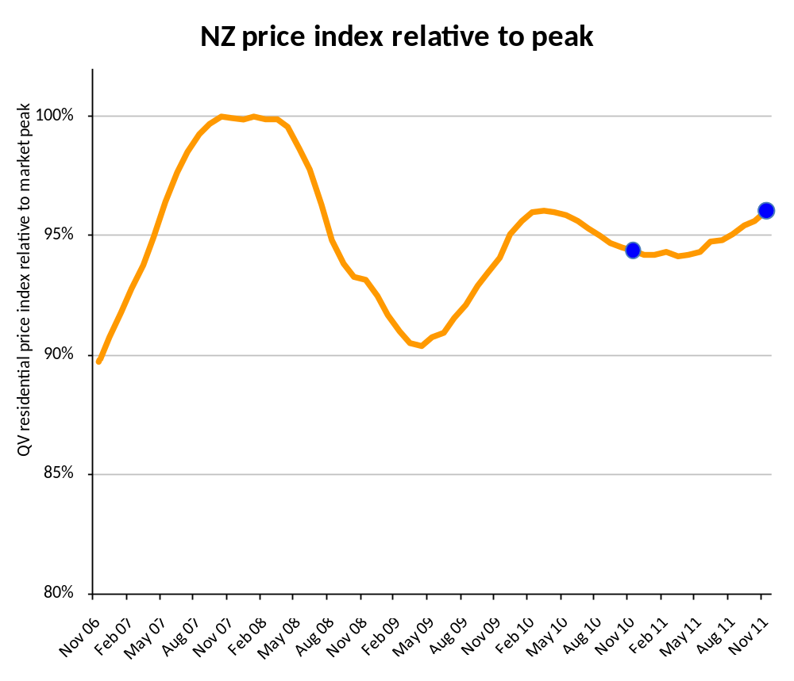

Jonno Ingerson, Research Director for QV.co.nz said “national property values have been gradually increasing since April, driven initially by Auckland and Christchurch. In the last three months values have now begun to increase across the rest of the main centres, as well as in many of the provincial and rural towns”.

“In most of the main centres there has been an increase in new listings as sellers who were waiting for the rugby world cup and election to pass are now putting their properties on the market. This potentially gives a greater choice for buyers, however many remain cautious in their decision making and are not rushing to purchase. First home buyers are remaining active and are driving the lower to middle range of the market” said Ingerson.

Across the Auckland Area values are up 3.4% compared to the same time last year, and are now at their highest ever level 0.6% above the previous peak of late 2007. Within the Auckland Area the greatest increase in value is coming from the old Auckland City which is up 4.7% annually, and 2.5% above the previous market peak.

Values have continued to edge up in Hamilton in recent months, recovering some of the losses from earlier in the year to now be 0.3% below last year. Tauranga values have also increased slightly in recent months to be 0.4% above last year. In both cities there is little sign of real strength in the property market, and both remain 11.0% below the market peak.

The property market in the Wellington area continues to show some signs of positivity. Values dropped from January to August, but since then have steadily rebounded and as a result are only 0.4% below the same time last year and 6.9% below the previous market peak.

Christchurch values continue to increase due to demand for undamaged houses, particularly in the northern and western suburbs. Values are now 3.6 percent above last year and only 1.7 percent below the 2007 market peak. The surrounding areas have also continued to increase in value with Waimakariri District up 6.9% and Selwyn up 5.3% over the past year. Both areas are now well above the previous market peak.

In Dunedin values have increased 2.4% in the past three months and are now only 0.2% below the same time last year and 6.1% below the previous peak.

Ingerson said “there looks to be a late spring surge in market activity which is likely to continue up until Christmas, then pick up again in earnest in February. The strength of this activity will depend to some extent on how economic events pan out in Europe”.

While unrelated to the QV index, and a less reliable measure of value change, the average New Zealand sales price over the last three months is $390,921.

Of the provincial centres Whangarei, Gisborne and Nelson have increased in value the most over the past three months. With the exception of Wanganui which is 6.3% below last year, most other towns are either close to or only slightly below last year’s value. The exception is Nelson where values are 3.2% above last year.
…ends/

For further information on property market activity contact:

Jonno Ingerson
Research Director – QV.co.nz
Tel: 04 802 1239
Mobile: 027 454 6642
Email: jonno.ingerson@propertyiq.co.nz
Auckland

QV’s Residential Price Index for November shows that property values in the Auckland region are 3.4% higher than the same time last year. Values are continuing to increase.
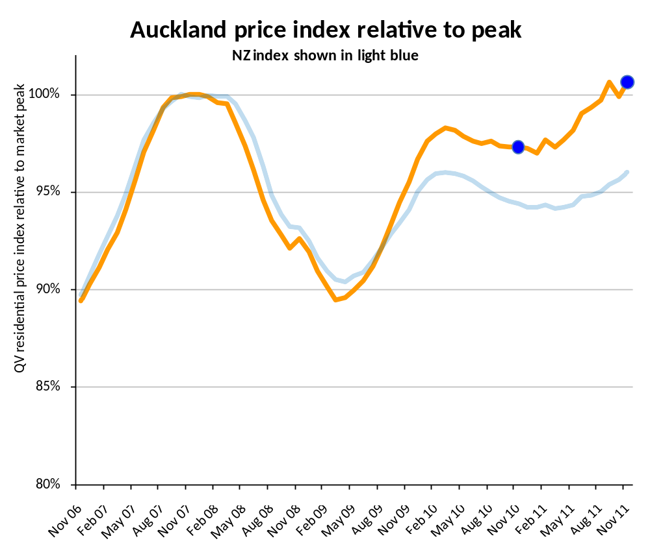
Ms Glenda Whitehead of QV Valuation said; “First home buyers are tending to be a sizable proportion of those active in the market. This is driving demand and value levels in the lower to middle value end of the market. Late spring listings have added more option for buyers but this means they need more time to look at the wider range available to them. This trend is evident on the North Shore, where the first home buyers market was buoyant before the election and has since slowed.”

“In the south east most entry level priced proprieties have been picked up by first home buyers rather than investors. In the past couple of weeks, there has also been a noticeable increase in listings which may help the supply and demand levels to balance out, and prices level off” Ms Whitehead said.

Ms Whitehead said “Demand continues to remain strong for well presented properties in good locations. They tend to sell within days or weeks of being listed. The fringe areas or those with challenging features such as being close to motorways, or in poorly presented streets, have shown more limited value movements.”

“Investors are starting to come back to the market, but they have very definite demands. Some are looking to buy, upgrade and on-sell at a healthy profit (the traders), often taking advantage of continued levels of mortgagee sales. Others require a definite positive cash flow return. The latter is often achieved by creating additional revenue from properties such as converting existing garages to sleep-outs or a further self-contained unit” Ms Whitehead said.

“In the West, there has been a noticeable increase in activity in recent weeks. Properties in the $280,000 to $420,000 range are now in demand. There also appears to be an increase in the level of subdivisions activity, with developers seeking Titles to individual sites to either sell now or build upon prior to selling” Ms Whitehead said.

QV’s Residential Price Index is calculated using sales data from the 3 months leading up to the month being reported. It is not the same as the average sales price, which fluctuates in line with the mix of properties selling in upper or lower price brackets. The average sales price for the Auckland region in November was $513,792.

Glenda Whitehead is a Registered Valuer working with QV in Auckland. You can contact Glenda on: 021 333 224

Hamilton

QV’s Residential Price Index for November shows that property values in Hamilton are 0.3% lower than the same time last year. Values have increased slightly in the last three months.
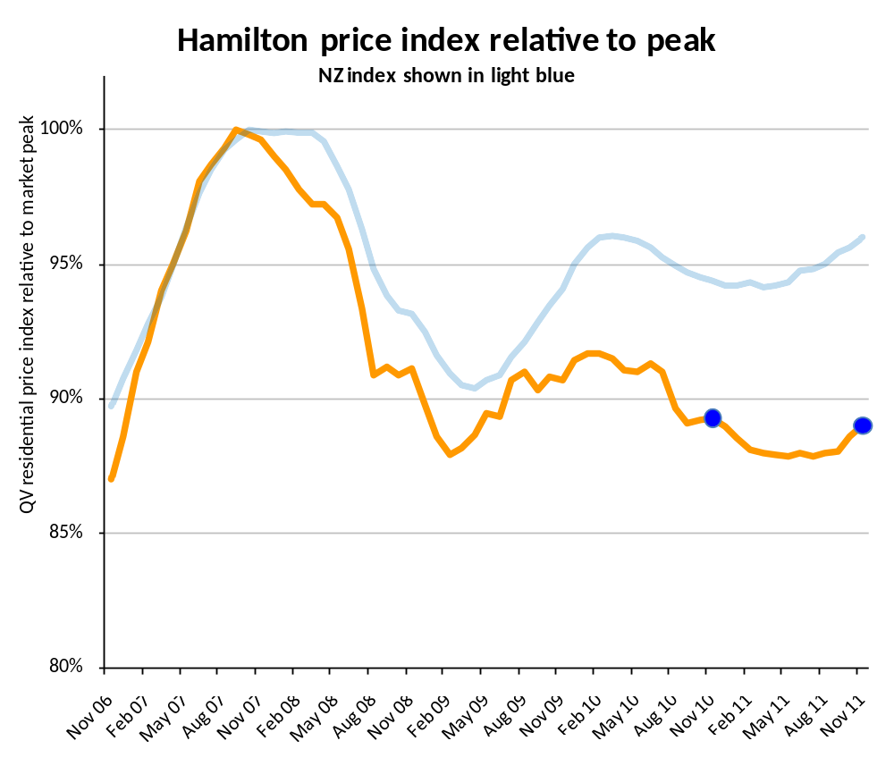
Mr Richard Allen of QV Valuations said “In comparison to last month all areas within Hamilton City, except the Hamilton South East region, moved in a positive direction. The Central City/North West and the South West areas have seen the biggest increases”.

“Although the residential property market in Hamilton may be improving, there is still nothing to suggest that this is a long term trend. Anecdotal evidence suggests in fact that it is still a buyer’s market as listings outweigh demand” Mr Allen said.

QV’s Residential Price Index is calculated using sales data from the 3 months leading up to the month being reported. It is not the same as the average sales price, which fluctuates in line with the mix of properties selling in upper or lower price brackets. The average sales price for Hamilton in November was $340,726.

Richard Allen is a Registered Valuer working with QV in Hamilton. You can contact Richard on: 0272 307 290

Tauranga

QV’s Residential Price Index for November shows that property values in Tauranga are 0.4% higher than the same time last year. Values have been flat for most of 2011 but are showing signs of gradually increasing in recent months.

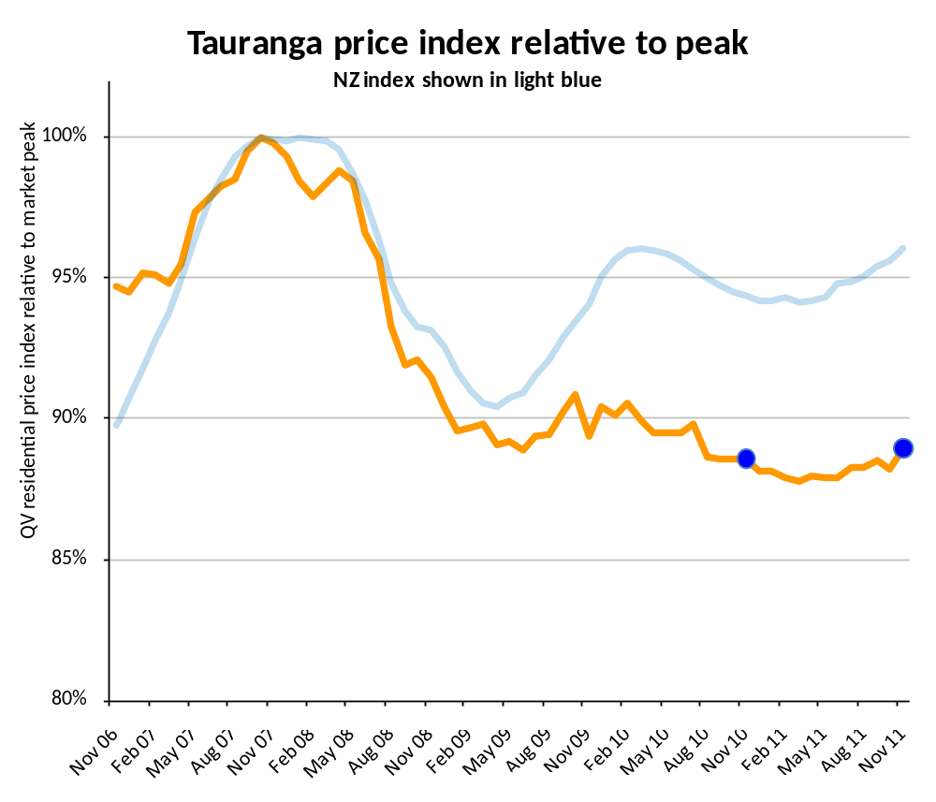
Mr Shayne Donovan-Grammer of QV Valuations said; “The Tauranga property market is steady with values overall holding. However, there is minimal traction in the market.”

“As is natural for this time of year, there appears to be an increase in listings” Mr Donovan-Grammer said.

“With interest rates easing this should alleviate some pressure off homeowners and give them more composure to make property decisions. Low medium term interest rates and competitive bank offers are likely to lure first home owners into the market as well as the odd investor” said Mr Donovan-Grammer.

QV’s Residential Price Index is calculated using sales data from the 3 months leading up to the month being reported. It is not the same as the average sales price, which fluctuates in line with the mix of properties selling in upper or lower price brackets. The average sales price for Tauranga in November was $383,699.

Shayne Donovan-Grammer is a Registered Valuer working with QV in Tauranga. You can contact Shayne on: 027 230 7321

Wellington

QV’s Residential Price Index for November shows that property values in the Wellington region are 0.4% lower than the same time last year. After falling for the first half of 2011, values in Wellington have picked up slightly in the last few months.
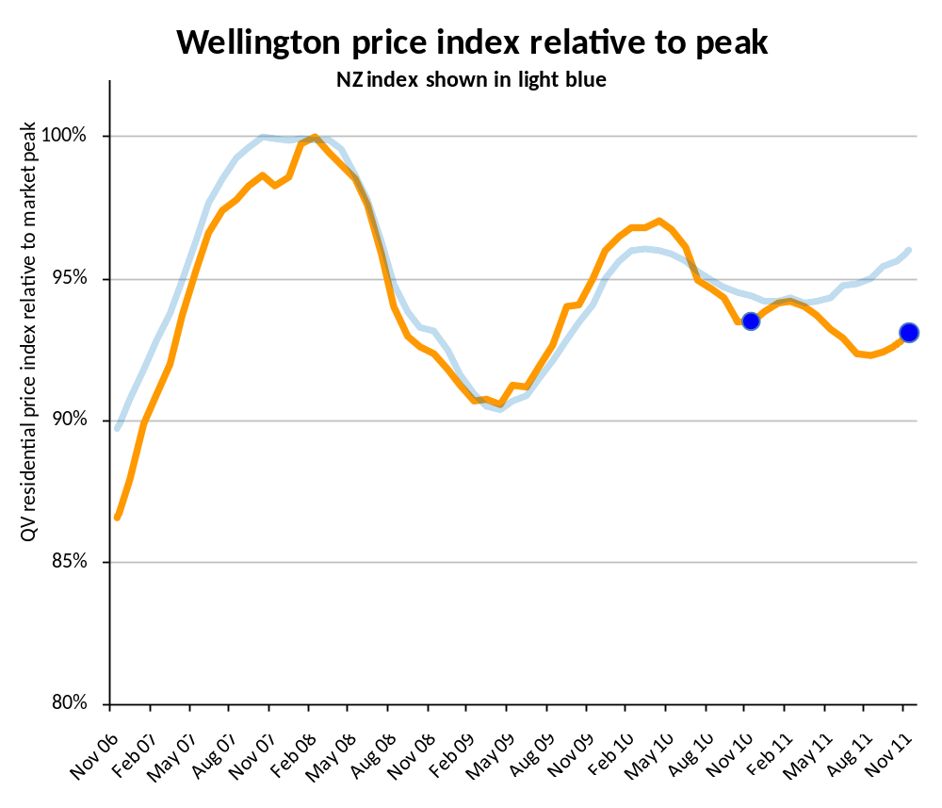
Mr Kerry Buckeridge of QV Valuations said; “The residential property market in the Wellington region is continuing to show some positivity.”

“There has been a noticeable upsurge in property listings over the last few weeks. This may be due to people getting back in the market now that both the Rugby World Cup and elections are over. However, the result is a severely shortened ‘spring selling season’ leading up to Christmas” Mr Buckeridge said.

Mr Buckeridge said “We are continuing to notice positive levels of activity in the first home buyer end of the market and also some good results at the top end. Those in the middle segment of the market continue to be cautious, however there are a number of examples where multiple offers are being made on good properties.”

“The apartment and unit titled property market is facing challenges at the moment after the Unit Titles Act 2010 and the Unit Titles Regulations 2011 came into force on 20 June 2011. The requirements of Body Corporates’ are now far greater, resulting in greater administration costs. As well, there have been substantial increases in the cost of insurance premiums for most apartment complexes. Combined these factors have resulted in large increases to Body Corporate Levies, to the extent sales volumes are beginning to be affected” Mr Buckeridge said.

QV’s Residential Price Index is calculated using sales data from the 3 months leading up to the month being reported. It is not the same as the average sales price, which fluctuates in line with the mix of properties selling in upper or lower price brackets. The average sales price for Wellington in November was $421,778.

Kerry Buckeridge is a Registered Valuer working with QV in Wellington. You can contact Kerry on: 021 476 287

Christchurch

QV’s Residential Price Index for November shows that property values in Christchurch are 3.6% higher than the same time last year. Values continue to increase, driven by activity in unaffected areas.
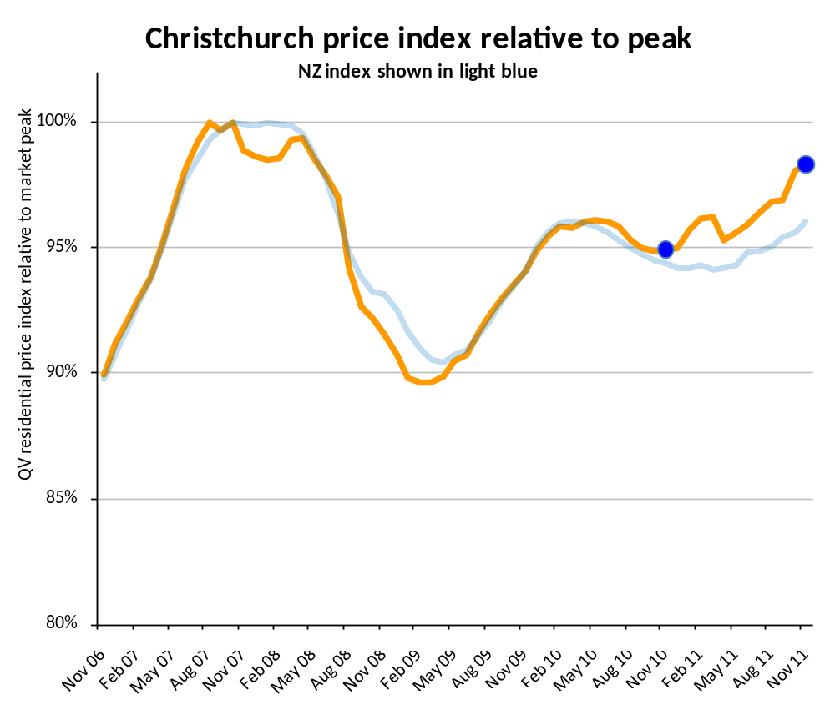

Mr Brendon Bodger of QV Valuations said; “Christchurch house prices continue to show a positive trend. The house price index for November is now only 1.7% below the peak of the market in 2007.”

“Demand and activity continues for property throughout the wider Christchurch area. As expected, it is stronger in the relatively undamaged suburbs, particularly in the South West to North West. Towards the end of spring we saw the number of property listings increase. Anecdotal evidence is that more people are attending open homes and there are multi offer situations, particularly at the entry level end of the market” Mr Bodger said.

“Strong demand continues for property in the wider Canterbury area, particularly for vacant sections and small lifestyle blocks. Values in the Selwyn District have risen 5.3% over the past year, and Waimakariri has seen a 6.9% annual increase” Mr Bodger said.

QV’s Residential Price Index is calculated using sales data from the 3 months leading up to the month being reported. It is not the same as the average sales price, which fluctuates in line with the mix of properties selling in upper or lower price brackets. The average sales price for Christchurch in November was $372,040.

Brendon Bodger is a Registered Valuer and Operations Manager working with QV in Christchurch. You can contact Brendon on: 027 491 7771

Dunedin

QV’s Residential Price Index for November shows that property values in Dunedin are 0.2% lower than the same time last year. While values have been volatile throughout the year they appear to have risen over the past three months.
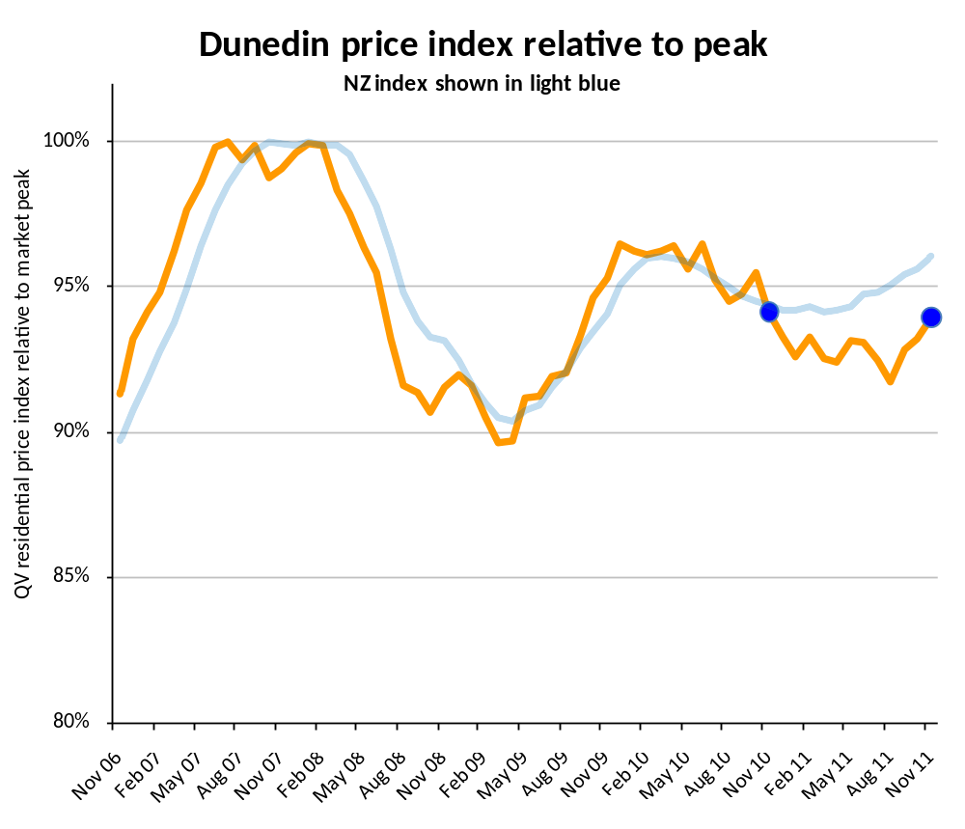
Mr Tim Gibson of QV Valuations said; “The Dunedin residential property market is starting to pick up traction. This follows the positive trends that Auckland has shown recently. In comparison to the property peak values are currently on average 6.1% below the level of July 2007.”

“Sales volumes and property values are both increasing. There has been a noticeable increase in demand for lower priced properties in the Dunedin City and South Dunedin areas. For the third consecutive month values have increased slightly in Dunedin City” Mr Gibson said.

Mr Gibson said “However, in the top end of the market there still appears to be some hesitancy. There were only twelve recorded sales in the past three months with a sale price over six hundred thousand dollars.”

“With good attendances being reported at recently held open homes it indicates that positive sales activity may be sustained as we head into the New Year” Mr Gibson said.

QV’s Residential Price Index is calculated using sales data from the 3 months leading up to the month being reported. It is not the same as the average sales price, which fluctuates in line with the mix of properties selling in upper or lower price brackets. The average sales price for Dunedin in November was $263,356.

Tim Gibson is a Registered Valuer working with QV in Dunedin. You can contact Tim on: 0211 51 2887

Residential Property – Annual Price Movement
Time period: as at November 2011
 | Territorial authority | Average sale price  Last three months | Property Value Growth  Over last 12 months  Based on the QV index
 | Far North | 352,207 | -7.6
 | Whangarei | 295,114 | -0.6
 | Kaipara | 300,045 | -5.2
 | Auckland - Rodney | 486,238 | 0.6
 | Hibiscus Coast | 484,271 | -0.8
 | Rodney (North) | 488,703 | 2.4
#A | Auckland - North Shore | 589,601 | 3.3
 | Coastal North Shore | 665,224 | 3.0
 | North Shore Onewa | 466,434 | 4.1
 | North Harbour | 640,074 | 3.5
#A | Auckland - Waitakere | 406,183 | 2.4
#A | Auckland - City | 577,774 | 4.7
 | Auckland City (Central) | 502,480 | 4.8
 | Auckland City (East) | 705,354 | 4.6
 | Auckland City (South) | 532,520 | 5.3
 | Islands | 565,446 | -1.5
#A | Auckland - Manukau | 451,827 | 2.1
 | Manukau East | 556,189 | 4.2
 | Manukau Central | 353,303 | 1.0
 | Manukau North West | 405,316 | 0.1
#A | Auckland - Papakura | 351,092 | 0.0
 | Auckland - Franklin | 384,270 | 1.8
 | Thames Coromandel | 374,336 | -3.6
 | Hauraki | 229,947 | -1.2
 | Waikato | 268,700 | -10.6
 | Matamata Piako | 272,333 | -4.3
# | Hamilton | 340,726 | -0.3
 | Hamilton North East | 407,803 | 0.3
 | Central City/North West | 305,485 | -2.2
 | Hamilton South East | 320,183 | 0.2
 | Hamilton South West | 288,980 | -0.5
 | Waipa | 336,502 | -3.6
 | Otorohanga | N/A | N/A
 | South Waikato | 160,575 | 0.9
 | Waitomo | N/A | N/A
 | Taupo | 351,395 | -3.1
 | Western BOP | 352,178 | -4.3
# | Tauranga | 383,699 | 0.4
 | Rotorua | 276,994 | -2.5
 | Whakatane | 317,686 | -3.5
 | Kawerau | N/A | N/A
 | Opotiki | N/A | N/A
 | Gisborne | 243,276 | -0.2
 | Wairoa | N/A | N/A
 | Hastings | 289,520 | -2.3
# | Napier | 312,982 | -1.8
 | Central Hawkes Bay | 214,108 | 1.2
 | New Plymouth | 316,600 | -2.7
 | Stratford | 209,550 | 4.6
 | South Taranaki | 195,074 | -0.1
 | Ruapehu | 141,026 | -10.9
 | Wanganui | 190,327 | -6.2
 | Rangitikei | 202,690 | 1.3
 | Manawatu | 221,323 | -4.4
# | Palmerston North | 283,414 | 0.3
 | Tararua | 151,429 | -0.5
 | Horowhenua | 219,323 | -2.6
 | Kapiti Coast | 359,265 | -0.8
#W | Porirua | 408,759 | -1.0
#W | Upper Hutt | 340,291 | -0.6
#W | Hutt | 374,985 | -1.4
#W | Wellington | 482,463 | 0.3
 | Wellington City & Southern Suburbs | 473,665 | 0.9
 | Eastern Suburbs | 496,121 | 0.7
 | North Wellington | 451,233 | -0.2
 | Western Suburbs | 580,109 | -0.6
 | Masterton | 242,216 | -0.6
 | Carterton | 246,969 | -0.5
 | South Wairarapa | 277,325 | -3.6
 | Tasman | 364,478 | 0.0
# | Nelson | 354,968 | 3.1
 | Marlborough | 316,673 | -0.6
 | Kaikoura | N/A | N/A
 | Buller | 209,520 | 3.7
 | Grey | 199,458 | 0.4
 | Westland | 212,381 | 2.5
 | Hurunui | 300,136 | 3.9
 | Waimakariri | 349,413 | 6.9
# | Christchurch | 372,040 | 3.6
 | East | 321,249 | 3.3
 | Hills | 444,410 | -1.1
 | Central City and North | 403,874 | 3.1
 | Southwest | 362,539 | 5.0
 | Banks Peninsula | 383,225 | 4.8
 | Selwyn | 406,565 | 5.3
 | Ashburton | 256,911 | 1.9
 | Timaru | 246,003 | 3.1
 | MacKenzie | N/A | N/A
 | Waimate | N/A | N/A
 | Waitaki | 210,202 | 3.5
 | Central Otago | 283,307 | -2.4
 | Queenstown Lakes | 566,203 | 1.0
# | Dunedin | 263,356 | -0.2
 | Central/Northern City | 257,951 | 0.8
 | Peninsular/Coastal Dunedin | 244,291 | 3.8
 | Southern City | 260,591 | -3.5
 | Taieri | 283,223 | 0.9
 | Clutha | 160,734 | 0.4
 | Southland | 206,555 | 2.4
 | Gore | 175,430 | 1.6
# | Invercargill | 208,243 | -0.1
 | Auckland Area | 513,792 | 3.4
 | Wellington Area | 421,778 | -0.4
# | Main Urban Areas | 430,811 | 2.4
 | Total NZ | 390,921 | 1.7
Notes on the above data:
1. The information included in the above table is calculated based on the sales data entered into QV's system for the previous 3 month period. For example, information for the period ending June will be calculated based on sales entered between April 1 and June 30.
2. Property Value Growth is the annual % change in residential property values, calculated using QV's House Price Index methodology. The residential sales entered into QV's system for previous 3 month period are compared to the same period of the previous year to identify the annual % change in residential property values. Average Sale Prices are calculated based on residential sales entered into QV's system for the previous 3 month period.
3. Any of the statistical data shown in italics are calculated based on a sample set of data that is less than the recommended minimum. These results should be used with caution. Those sowing N/A had too few sales to generate an index

