

Exploring wind-hydro correlation

Report to New Zealand Steel and the Major Electricity Users’ Group
5 September 2008

Preface
The New Zealand Institute of Economic Research (NZIER) is a specialist consulting firm that uses applied economic research and analysis to provide a wide range of strategic advice to clients in the public and private sectors, throughout New Zealand and Australia, and further afield.
NZIER is also known for its long-established Quarterly Survey of Business Opinion and Quarterly Predictions.
Our aim is to be the premier centre of applied economic research in New Zealand. We pride ourselves on our reputation for independence and delivering quality analysis in the right form, and at the right time, for our clients. We ensure quality through teamwork on individual projects, critical review at internal seminars, and by peer review at various stages through a project by a senior staff member otherwise not involved in the project.
NZIER was established in 1958.
Authorship
This report has been prepared by Johannah Branson and reviewed by Brent Layton.

Executive summary
In this report, we explore whether there is a significant correlation between the availability of wind and availability of water to generate electricity. The question prompting this analysis is whether wind power is a good complement to hydro power through wind flows enduring when lake levels are low, following low inflows. We examine the variations and correlations in average wind flows, wind power generation, lake levels and spot prices for electricity, at selected sites around New Zealand, for available data over the period 1990 to 2008.
We find that wind speeds do vary significantly, by month and by year, but lake levels more so. Wind power generation at Te Apiti has generally varied more than wind speeds at the sites we examined. Varying proportionately greatest have been spot prices for electricity, particularly between years, although this is exacerbated by the high prices of 2008 to date.
There is considerable overlap between the sites we examined in the time of year when wind speeds are highest, although the windiest period starts earlier at some sites and ends later at others. Hydro resources seem to be more diversified, with lake levels highest for three of the six catchments generally when lowest for the other three. Wind power generation at Te Apiti is highest in the period when wind speeds are also highest, although not significantly so at the 95% level of confidence. Despite the diversification of hydro resources, there remains a concentrated period in which spot prices are highest, which coincides with when wind speeds are lowest.
Our analysis finds that wind speeds are positively correlated between sites, for those we examined. There is positive correlation between lake levels in three catchments, which are negatively correlated with lake levels in the other three catchments. Wind speeds, as well as wind power generation, are therefore positively correlated with lake levels in some catchments and negatively correlated with lake levels in other catchments. There is negative correlation between spot prices and each of wind speeds, wind power generation at Te Apiti and the majority of lake levels.
Together, these findings imply some but not full complementarity between wind and hydro power – wind speeds tend to be higher when some lake levels are lower, but also when other lake levels are higher. This results in part from some existing diversification in hydro resources, whilst the sites for which we examined wind flows proved to have low diversification. Our findings confirm the role of wind and hydro power in suppressing spot prices, although the targeting of future wind power developments where wind speeds are positively correlated with current spot prices would be most profitable to their operators as well as most valuable to the country in easing shortages and pressure on prices.

Contents
1. Purpose 1
2. Wind flows 1
3. Wind power generation 5
4. Lake levels 7
5. Electricity prices 10
6. Correlations 12
6.1 Magnitude of variations 13
6.2 Timing of variations 15
6.3 Correlation coefficients 18
7. Conclusions 23

Figures
Figure 1 Wind speeds – weekly averages 3
Figure 2 Wind speeds – monthly averages 3
Figure 3 Wind speeds – annual averages 4
Figure 4 Wind power generation – weekly averages 6
Figure 5 Wind power generation – monthly averages 6
Figure 6 Wind power generation – annual totals 7
Figure 7 Lake levels – weekly averages 8
Figure 8 Lake levels – monthly averages 8
Figure 9 Lake levels – annual averages 9
Figure 10 Electricity spot prices – weekly averages 11
Figure 11 Electricity spot prices – monthly averages 11
Figure 12 Electricity spot prices – annual averages 12
Figure 13 Variation in monthly averages – range 13
Figure 14 Variation in monthly averages – average absolute variation 14
Figure 15 Variation in annual averages – range 14
Figure 16 Variation in annual averages – average absolute variation 15
Figure 17 Seasonal variations 16
Figure 18 Wind speeds and lake levels – variation in monthly averages 16
Figure 19 Wind speeds and lake levels – variation in monthly averages 17
Figure 20 Wind speeds and spot prices – variation in monthly averages 17

Tables
Table 1 Wind speeds – summary statistics 2
Table 2 Wind power generation – summary statistics 5
Table 3 Lake levels – summary statistics 7
Table 4 Electricity spot prices – summary statistics 10
Table 5 Correlation between weekly averages 20
Table 6 Correlation between monthly averages 21
Table 7 Correlation between annual averages 22

Purpose
This report explores whether there is a significant correlation between the availability of wind and availability of water to generate electricity. The question prompting this analysis is whether wind power is a good complement to hydro power through wind flows enduring when lake levels are low, following low inflows.
In Section 2 of this report, we examine wind flow data for its variation and any seasonal patterns or long-run trends. In Section 3, we look at wind power generation from Te Apiti, the only wind farm for which data are separately available (all others are embedded generation). In Section 4, we examine lake level data, as above, for its variation, seasonal patterns and long-run trends. We examine briefly the variation in electricity prices in the spot market in Section 5. In Section 6, we explore the correlations between wind flows, wind power generation, lake levels and spot prices.

Wind flows
To explore the variation in wind flows at a range of sites around New Zealand, we downloaded three hourly wind speed readings over the period January 1990 to July 2008 from NIWA’s National Climate Database for four weather stations:
- Manukau Heads 2 (station 1500) – at -37.05276 latitude, 174.54436 longitude and 237 metres above sea level
- Palmerston North Aero (station 3236) – at -40.327 latitude, 175.616 longitude and 45 metres above sea level
- Kaukau Top, Wellington (station 3375) – at -41.325 latitude, 174.777 longitude and 425 metres above sea level and
- Dunedin Aero Aws (station 7339) – at -45.929 latitude, 170.197 longitude and one metre above sea level.
Table 1 summarises the wind speeds recorded at these stations over the entire period.

Table 1 Wind speeds – summary statistics
Km/hr, from three hourly readings, 1990 to 2008
 | Manukau Heads¹ | Palmerston North² | Kaukau | Dunedin³
Minimum | 0.0 | 0.0 | 0.0 | 0.0
Maximum | 179.8 | 103.8 | 137.1 | 83.4
Mean | 27.6 | 17.3 | 42.3 | 12.4
Median | 25.9 | 16.7 | 40.8 | 9.3
Mode | 24.1 | 5.6 | 37.1 | 3.7
Lower quartile | 16.7 | 9.0 | 25.9 | 3.7
Upper quartile | 37.1 | 24.1 | 55.6 | 18.5
Standard deviation | 16.1 | 10.9 | 21.4 | 9.8
95% confidence interval | 27.3 to 27.8 | 17.1 to 17.4 | 42.1 to 42.5 | 12.3 to 12.5
Number of observations | 14,040 | 24,378 | 52,071 | 48,670

Notes: ¹ Data available to March 2005 only and for generally three readings per day
² Data available for October 1990 and from January 1995 and for generally five readings per day
³ Data available from November 1991
Source: NZIER; NIWA National Climate Database
As can be seen by comparing the 95% confidence intervals (the range in wind speed within which 95% of observations lie for each station), wind speeds differ significantly between these stations. The highest maximum wind speed was recorded at Manukau Heads, but wind speeds have been consistently highest at Kaukau. They have been consistently lowest at Dunedin.
Figure 1 to Figure 3 show the weekly, monthly and annual average wind speeds over this period.
Figure 2 suggests some seasonal variation in wind speeds at each of the four sites. We test whether this monthly variation is significant at the 95% level of confidence. Kaukau’s windiest months are June and September to December. Average wind speeds in these five months are significantly higher, at the 95% level of confidence, than wind speeds over the other seven months of the year. Manukau Heads has its windiest period slightly earlier in the year, over May to November. Average wind speeds in these seven months are significantly higher than wind speeds over the other five months of the year. In contrast, Palmerston North has its windiest period over September to March. Average wind speeds in these five months are significantly higher than wind speeds over the other six months of the year. For Dunedin, the windiest period is September to January. February and March have lower average wind speeds, but not significantly so at the 95% level of confidence. The remaining five months have significantly lower average wind speeds.

Figure 1 Wind speeds – weekly averages
Km/hr, from three hourly readings, 1990 to 2008
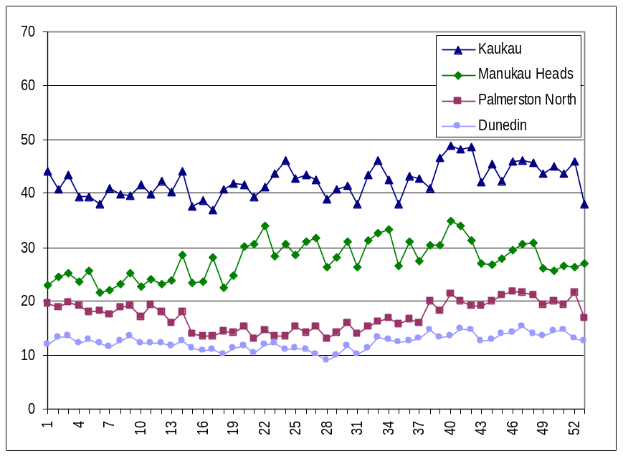
Source: NZIER; NIWA National Climate Database

Figure 2 Wind speeds – monthly averages
Km/hr, from three hourly readings, 1990 to 2008
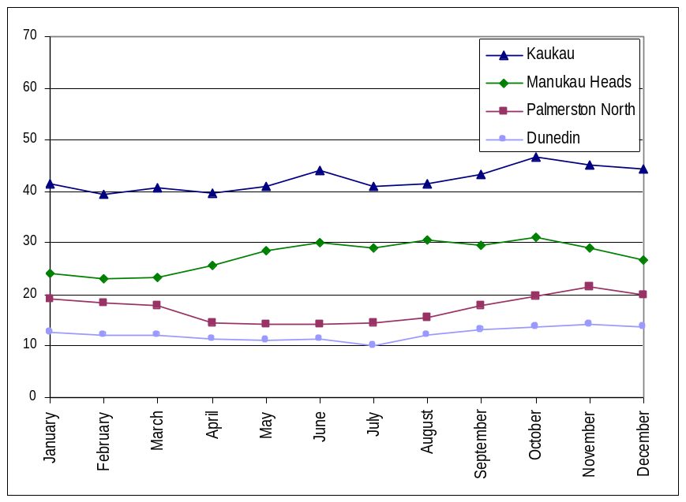
Source: NZIER; NIWA National Climate Database

Figure 3 Wind speeds – annual averages
Km/hr, from three hourly readings
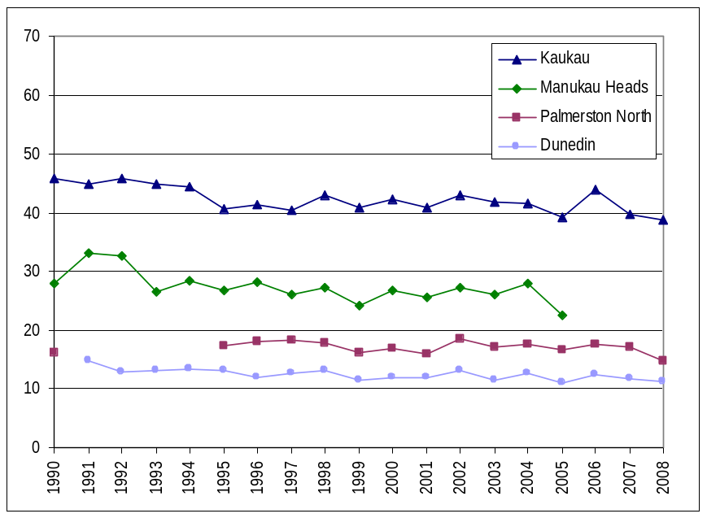
Source: NZIER; NIWA National Climate Database
For Kaukau, the monthly averages shown in Figure 2 range from 7% below to 11% above the average across all months (average absolute variation of 5%). This range is 16% below to 13% above for Manukau Heads (average absolute variation of 9%), 17% below to 25% above for Palmerston North (average absolute variation of 13%) and 18% below to 15% above for Dunedin (average absolute variation of 8%).
From Figure 3, there also seems to be a downward trend in average wind speed over the past 19 years. For Kaukau, six years in the 1990s but only two years since 2000 have recorded average wind speeds above the station’s annual average over the entire period. Similarly for the other stations – six years in the 1990s but only one year since 2000 for Manukau Heads; seven years in the 1990s but only three years since 2000 for Dunedin; even for the Palmerston North station, for which data are missing 1991 to 1994, four years in the mid to late 1990s but only three years since 2000 have recorded average wind speeds above the station’s long-run annual average. Wind speeds were significantly lower in the second decade than the first, at the 95% level of confidence. Relative to the 1990s, average wind speeds in the 2000s were 4.2% lower for Kaukau, 6.1% lower for Manukau Heads, 3.2% lower for Palmerston North and 5.6% lower for Dunedin.
For Kaukau, the annual averages shown in Figure 3 range from 8% below to 8% above the average across all years (average absolute variation of 4%). This range is 18% below to 20% above for Manukau Heads (average absolute variation of 7%), 14% below to 7% above for Palmerston North (average absolute variation of 4%) and 10% below to 20% above for Dunedin (average absolute variation of 6%).

Wind power generation
We also examine generation data for the Te Apiti wind farm, the only wind power generation not embedded in a distribution network, from July 2004 to June 2008. Table 2 summarises the daily average generation over the entire period.
Table 2 Wind power generation – summary statistics
GWh, daily averages, 2004 to 2008
 | Te Apiti
Minimum | 0.000
Maximum | 4.103
Mean | 1.655
Median | 1.490
Mode | 0.000
Lower quartile | 0.654
Upper quartile | 2.586
Standard deviation | 1.146
95% confidence interval | 1.596 to 1.713
Number of observations | 1,461

Source: NZIER; M-co
Figure 7 to Figure 9 show the average generation per week and per month and the total generation per year over this period.
Figure 5 illustrates the seasonal variation in wind power generation at Te Apiti. Generation is higher than average in the months of October to January, although only April is significantly lower at the 95% level of confidence. The monthly averages shown in Figure 5 range from 25% below to 27% above the average across all months (average absolute variation of 13%).
As shown in Figure 6, generation was lower in 2004 and 2008, but this is due to incomplete data for these two years (the data series runs from July 2004 to June 2008). The annual totals range from 53% below (in 2004) to 36% above (in 2007) the average across all years (average absolute variation of 38%), although these statistics are skewed by incomplete data for 2004 and 2008. Adjusting the annual totals for the number of observations for these two years to compare full years suggests annual totals that range from 24% below (in 2004) to 12% above (in 2007) the average across all years (average absolute variation of 10%).

Figure 4 Wind power generation – weekly averages
GWh, sum of daily averages per week, 2004 to 2008
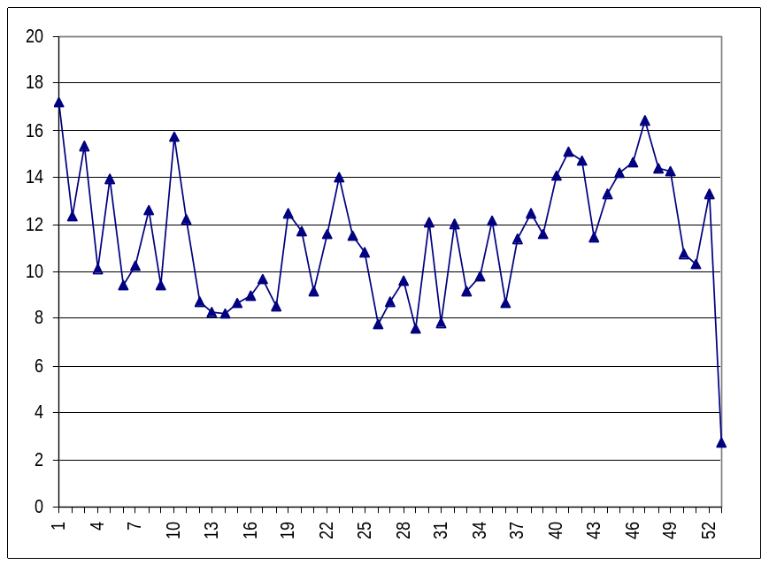
Source: NZIER; M-co

Figure 5 Wind power generation – monthly averages
GWh, sum of daily averages per month, 2004 to 2008
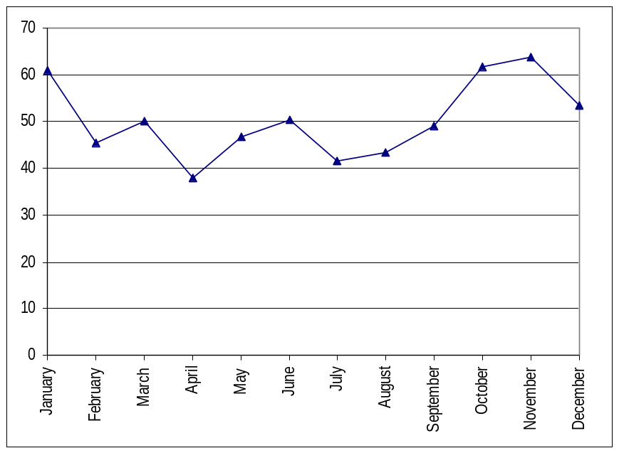
Source: NZIER; M-co

Figure 6 Wind power generation – annual totals
GWh, sum of daily averages per year
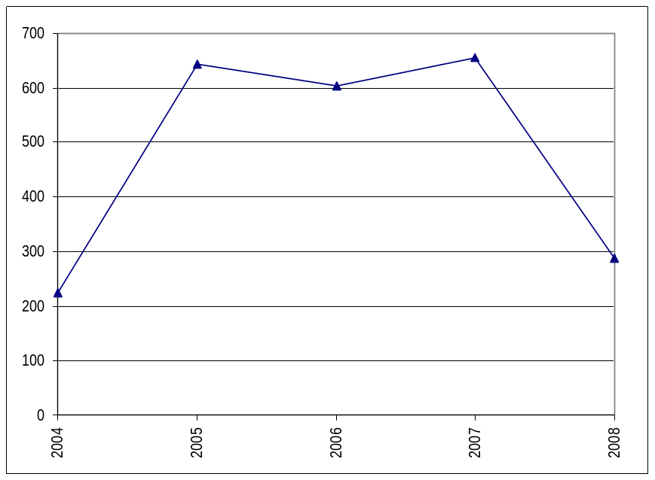
Source: NZIER; M-co

Lake levels
From M-co, we obtained weekly average lake levels by catchment, over the period January 1990 to July 2008. Table 3 summarises these weekly average lake levels over the entire period.
Table 3 Lake levels – summary statistics
GWh, weekly averages, 1990 to 2008
 | Waikato and Taupo | Rest of North Island | Waitaki | Clutha | Waiau | Rest of South Island
Minimum | 38.1 | 11.9 | 189.3 | 43.6 | 32.7 | 7.2
Maximum | 736.4 | 163.6 | 2,826.5 | 753.9 | 777.3 | 77.7
Mean | 373.6 | 85.6 | 1,591.1 | 283.8 | 314.3 | 40.0
Median | 381.7 | 87.2 | 1,645.9 | 291.1 | 302.1 | 38.4
Mode | 277.6 | 107.6 | 1,939.9 | 297.1 | 212.7 | 74.7
Lower quartile | 262.2 | 63.9 | 1,162.7 | 208.1 | 203.2 | 22.4
Upper quartile | 480.5 | 109.7 | 2,043.0 | 355.0 | 415.7 | 57.5
Standard deviation | 138.5 | 31.4 | 555.0 | 105.2 | 133.8 | 20.4
95% confidence interval | 365.0 to 382.2 | 83.6 to 87.6 | 1,556.5 to 1,625.8 | 277.2 to 290.4 | 306.0 to 322.7 | 38.7 to 41.3
Number of observations | 986 | 986 | 986 | 986 | 986 | 986

Source: NZIER; M-co
Figure 7 to Figure 9 show the weekly, monthly and annual average lake levels over this period.
Figure 7 Lake levels – weekly averages
GWh, from weekly averages, 1990 to 2008
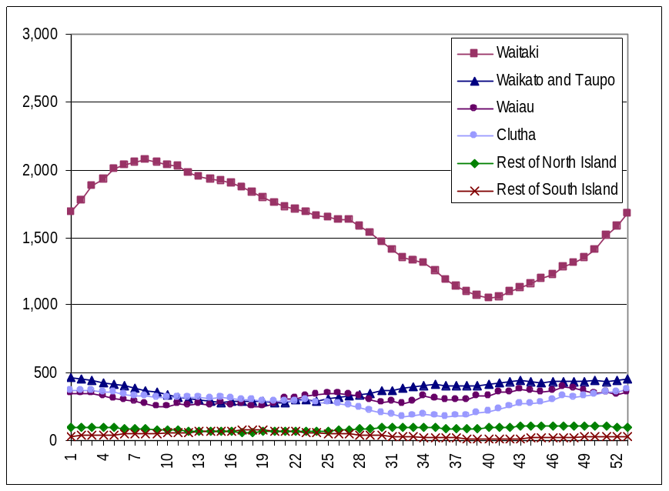
Source: NZIER; M-co

Figure 8 Lake levels – monthly averages
GWh, from weekly averages, 1990 to 2008
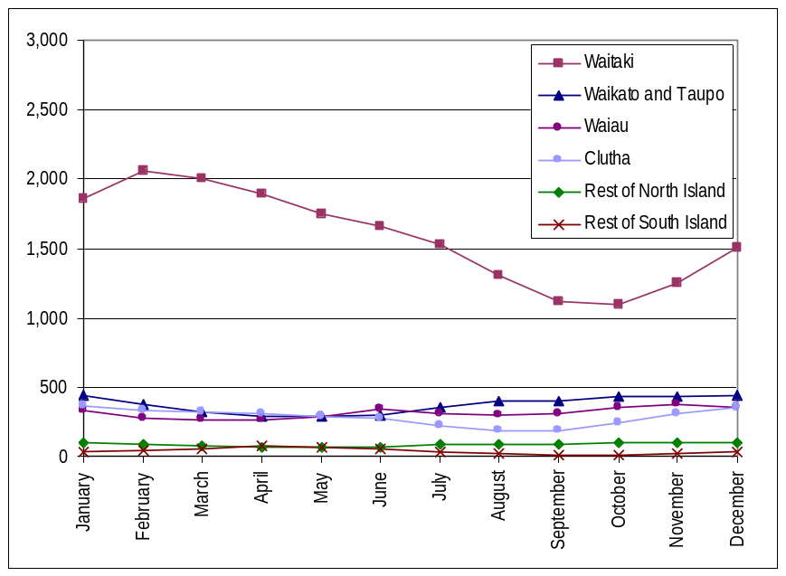
Source: NZIER; M-co

Figure 9 Lake levels – annual averages
GWh, from weekly averages
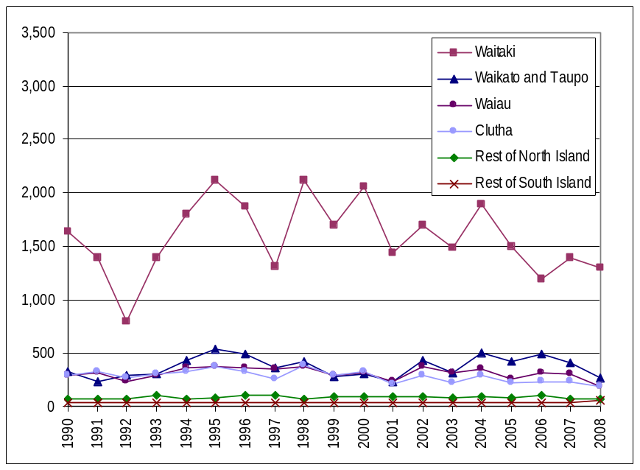
Source: NZIER; M-co
The seasonal variation in lake levels in the Waitaki catchment is clear in Figure 8. Lake levels in this catchment are highest over January to June, although July and December are not significantly lower than June at the 95% level of confidence. In contrast, for the Waikato and Taupo catchment, lake levels are highest over August to February, although July is not significantly lower at the 95% level of confidence. Waiau’s lake levels are highest in the months of June and October to January, although not significant lower, at the 95% confidence level, in May and July to September. For Clutha, lake levels are highest over November to May, and June is not significantly lower at the 95% level of confidence. Remaining North Island lake levels are higher than average over July to February, peaking in November and December, whilst remaining South Island lakes are highest over February to June.
For Waitaki, the monthly averages shown in Figure 8 range from 31% below to 29% above the average across all months (average absolute variation of 18%). This range is 23% below to 19% above for Waikato and Taupo (average absolute variation of 14%), 16% below to 19% above for Waiau (average absolute variation of 10%), 35% below to 28% above for Clutha (average absolute variation of 17%), 26% below to 22% above for the rest of the North Island (average absolute variation of 14%) and, most markedly for the smallest catchment, 73% below to 80% above for the rest of the South Island (average absolute variation of 44%).
Although not exhibiting long-run trends as in the wind speed data, lake levels have varied significantly between years. For Waitaki, the annual averages shown in Figure 9 range from 50% below (in 1992) to 33% above (in 1995 and 1998) the average across all years (average absolute variation of 17%). This range is 37% below to 43% above for Waikato and Taupo (average absolute variation of 22%), 39% below to 20% above for Waiau (average absolute variation of 13%), 36% below to 34% above for Clutha (average absolute variation of 16%), 24% below to 28% above for the rest of the North Island (average absolute variation of 13%) and 1% below to 33% above (for 2008 only, prior to which annual averages were fairly constant) for the rest of the South Island (average absolute variation of 3%).

Electricity prices
Given the influence of wind and hydro power generation on the wholesale market, when offered and selected for dispatch, we also explore the variation in spot prices.
From M-co, we obtained daily average spot prices at three nodes – Otahuhu Haywards and Benmore – since the wholesale market began operating in October 1996. Table 4 summarises these daily average spot prices over the entire period.
Table 4 Electricity spot prices – summary statistics
$/MWh, daily time weighted average half hour prices, 1996 to 2008
 | Otahuhu¹ | Haywards | Benmore
Minimum | 0.50 | 0.43 | 0.01
Maximum | 408.36 | 440.58 | 497.27
Mean | 61.49 | 59.30 | 56.79
Median | 50.57 | 45.88 | 42.85
Mode | 44.72 | 37.55 | 25.36
Lower quartile | 37.25 | 32.97 | 29.09
Upper quartile | 67.91 | 66.58 | 64.80
Standard deviation | 45.88 | 50.80 | 54.16
95% confidence interval | 60.12 to 62.86 | 57.79 to 60.82 | 55.18 to 58.40
Number of observations | 4,294 | 4,322 | 4,322

Notes: ¹ Prices for Otahuhu were not regularly published in the market until November 1996
Source: NZIER; M-co
At the 95% level of confidence, although the average price at Benmore is significantly lower than the average price at Otahuhu, prices do not differ significantly between Otahuhu and Haywards and between Haywards and Benmore. Both the lowest and highest prices were recorded at Benmore, but prices have been consistently highest at Otahuhu.
Figure 10 to Figure 12 show weekly, monthly and annual average prices over the period 1996 to 2008.
Figure 10 Electricity spot prices – weekly averages
$/MWh, from daily time weighted average half hour prices, 1996 to 2008
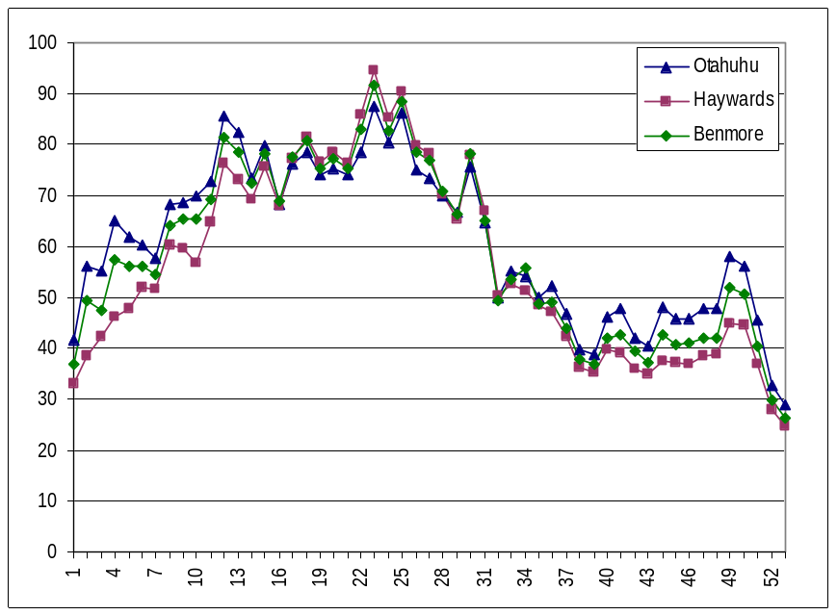
Source: NZIER: M-co

Figure 11 Electricity spot prices – monthly averages
$/MWh, from daily time weighted average half hour prices, 1996 to 2008
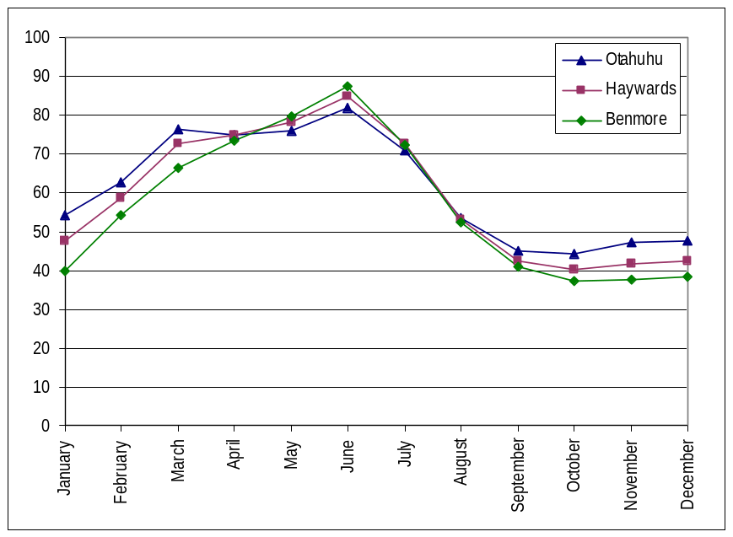
Source: NZIER: M-co

Figure 12 Electricity spot prices – annual averages
$/MWh, from daily time weighted average half hour prices
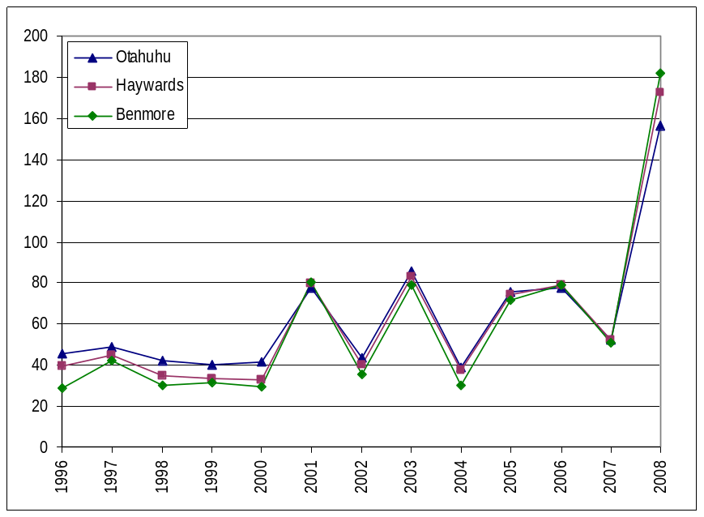
Source: NZIER; M-co
Figure 11 demonstrates the marked seasonal variation in spot prices. Prices are highest over March to July across all three nodes. At the Otahuhu node, the monthly averages shown in Figure 11 range from 28% below to 33% above the average across all months (average absolute variation of 21%). Monthly variation at Haywards and Benmore is slightly higher, from 32% below to 43% above (average absolute variation of 25%) at Haywards and from 34% below to 54% above (average absolute variation of 28%) at Benmore.
There is also significant variation in spot prices between years. For Otahuhu, the annual averages shown in Figure 12 range from 36% below (in 2004) to 155% above (in 2008 to date) the average across all years (average absolute variation of 38%). This range is 45% below (in 2000) to 191% above (in 2008 to date) for Haywards (average absolute variation of 46%) and 50% below (in 1996) to 220% above (in 2008 to date) for Benmore (average absolute variation of 52%).

Correlations
There are two aspects to correlations between wind flows, wind power generation, lake levels and spot prices – the magnitude and timing of variations. For example, do wind speeds vary less or more than lake levels and are they highest at different or similar times of the year?

Magnitude of variations
Earlier in this report, we identified the extent to which monthly averages have ranged below and above the average across all months, for each of wind speeds, wind power generation, lake levels and spot prices. We also indicated the average absolute variation. These are compared in Figure 13 and Figure 14. From these comparisons, it is clear that lake levels have varied more than wind speeds. Average monthly wind speeds vary most at Palmerston North. Average monthly lake levels vary most for the rest of South Island catchment, although this is the smallest catchment so likely to be most affected proportionately by changes in inflows. Average wind power generation per month at Te Apiti is generally more variable than wind speeds at the weather stations examined. With the exception of the rest of South Island catchment, spot prices have shown the greatest variability in monthly averages.
Figure 15 and Figure 16 compare the extent to which annual averages have varied from the annual average across all years. These suggest that lake levels are more variable than wind speeds not only between months but also between years. Although the most variable by month, the lake levels of the rest of South Island catchment vary least by year. The greatest variation between years is in spot prices, although this is exacerbated by the high prices of 2008 to date.
Figure 13 Variation in monthly averages – range
Relative to monthly average across all months
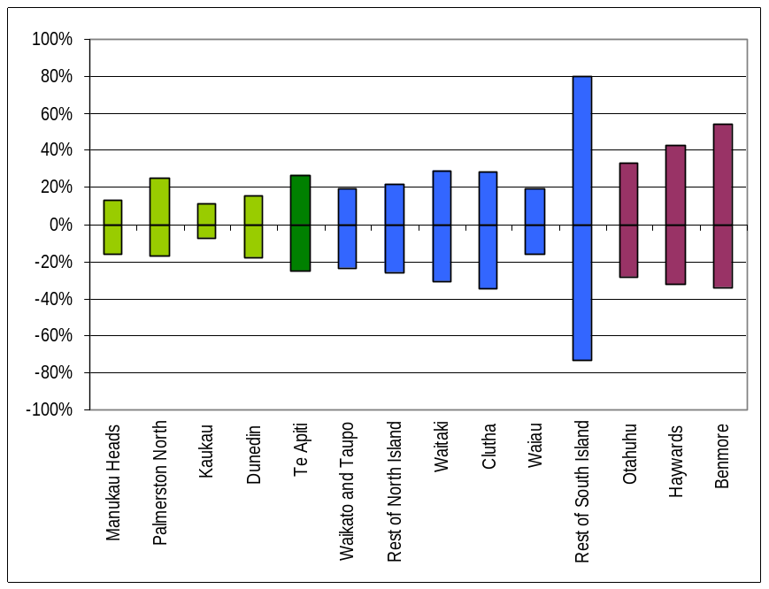
Source: NZIER

Figure 14 Variation in monthly averages – average absolute variation
Relative to monthly average across all months
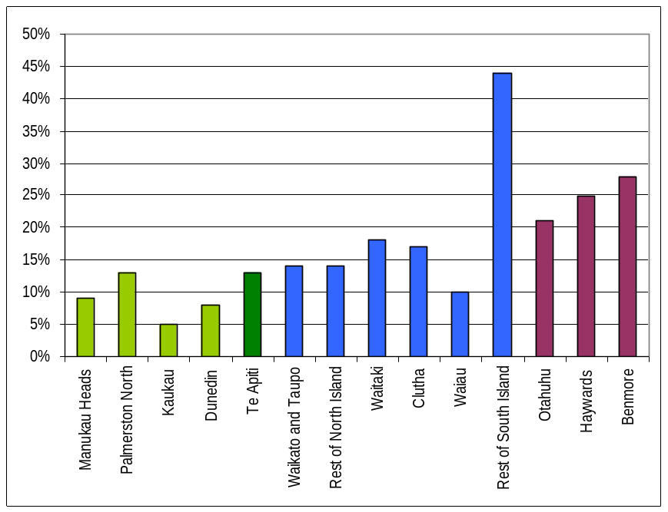
Source: NZIER

Figure 15 Variation in annual averages – range
Relative to annual average across all years
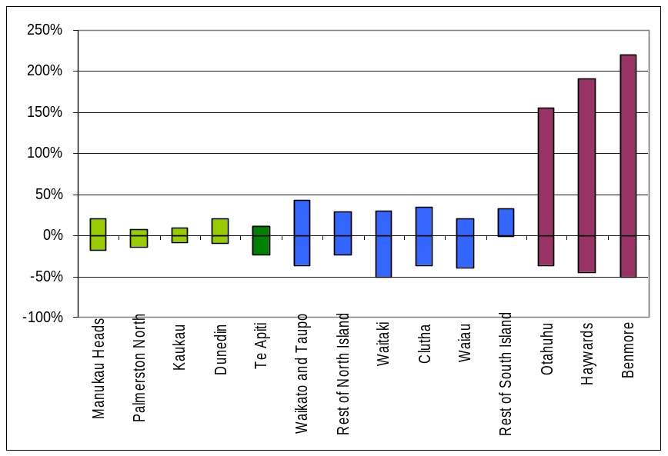
Notes: With adjustment to Te Apiti’s annual total generation for incomplete data in 2004 and 2008
Source: NZIER

Figure 16 Variation in annual averages – average absolute variation
Relative to annual average across all years
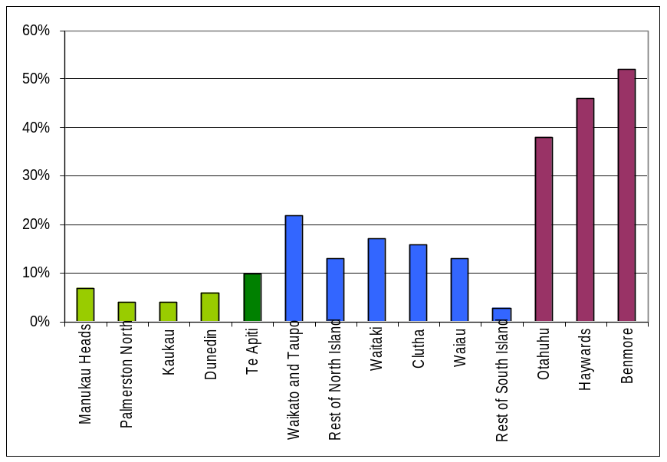
Notes: With adjustment to Te Apiti’s annual total generation for incomplete data in 2004 and 2008
Source: NZIER

Timing of variations
The shading of Figure 17 indicates the months in which wind speeds, wind power generation, lake levels and spot prices are highest.
There is considerable overlap in when wind speeds are highest, although the windiest period starts earlier for Manukau Heads and ends later for Palmerston North. New Zealand’s hydro resources seem to be more diversified, with lake levels highest for three of the six catchments generally when lowest for the other three. The seasonal variations in wind flows therefore coincide with those of three catchments and run counter cyclical to the other three, as highlighted in Figure 18 and Figure 19.
Wind power generation at Te Apiti is highest in the period when wind speeds are also highest, although not significantly so at the 95% level of confidence. Despite the diversification of hydro resources, there remains a concentrated period in which spot prices are highest, which coincides with when wind speeds are generally lowest, as highlighted in Figure 20.

Figure 17 Seasonal variations
Months in which higher than the average across all months
 | January | February | March | April | May | June | July | August | September | October | November | December
Manukau Heads
Palmerston North
Kaukau
Dunedin
Te Apiti
Waikato and Taupo
Rest of North Island
Waitaki
Clutha
Waiau
Rest of South Island
Otahuhu
Haywards
Benmore

Notes: Paler shading indicates not significantly lower at 95% confidence level
Source: NZIER

Figure 18 Wind speeds and lake levels – variation in monthly averages
Relative to monthly average across all months
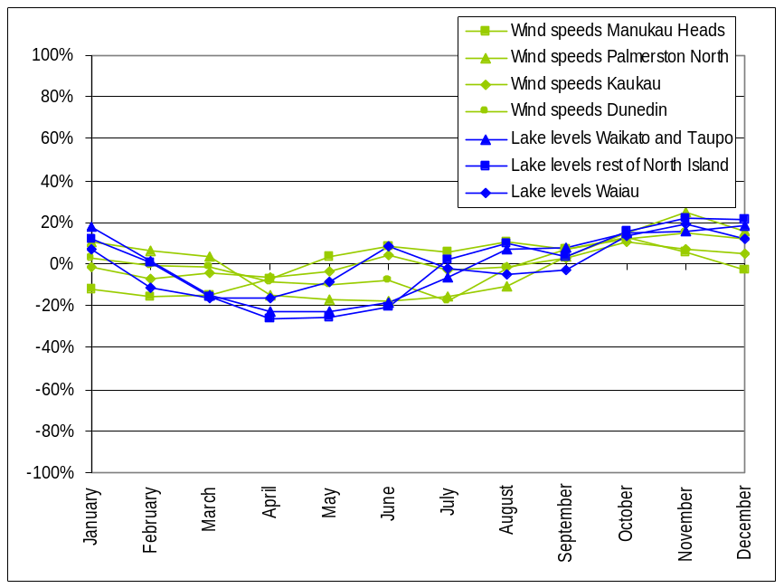
Source: NZIER

Figure 19 Wind speeds and lake levels – variation in monthly averages
Relative to monthly average across all months
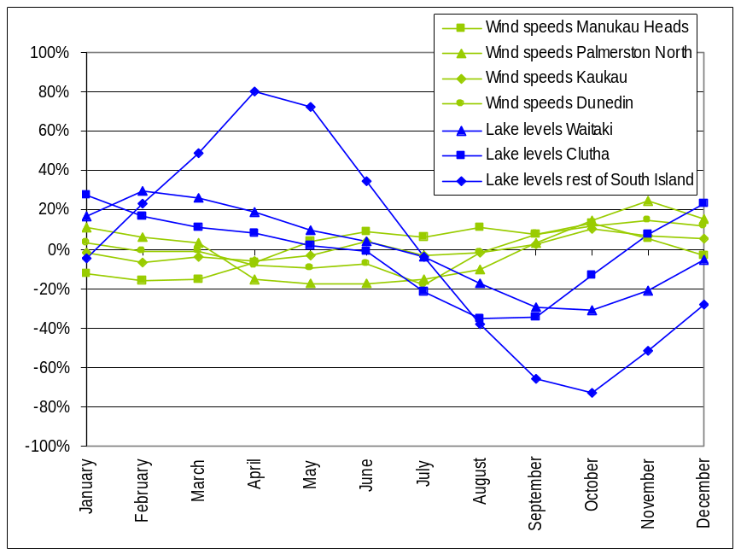
Source: NZIER

Figure 20 Wind speeds and spot prices – variation in monthly averages
Relative to monthly average across all months
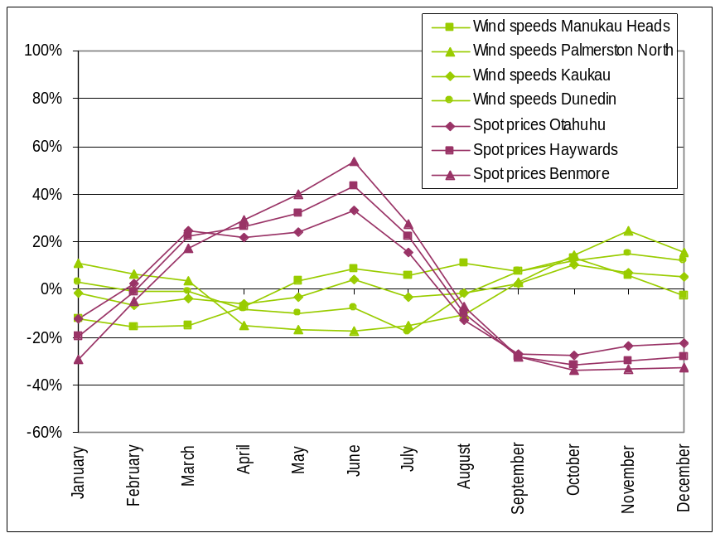
Source: NZIER

Correlation coefficients
We can examine the correlations between wind speeds, wind power generation, lake levels and spot prices more formally by calculating their correlation coefficients. A correlation coefficient of 1.00 (or -1.00) indicates perfect positive (or negative) correlation between two data series; as one series moves, so does the other (inversely, if negatively correlated). A correlation coefficient of zero indicates no discernable correlation between the two series. Note, however, that correlation coefficients do not prove cause, only concurrence.
Table 5 to Table 7 show the correlation coefficients between weekly, monthly and annual average wind speeds, wind power generation, lake levels and spot prices, for available data over 1990 to 2008. The threshold for “notable” correlation is fairly arbitrary. We have adopted a cut off of 0.50 in absolute value, with paler shading highlighting positive correlation and darker shading highlighting negative correlation. These correlation coefficients indicate:
- positive correlation between wind speeds (i.e. higher wind speeds at one site tend to coincide with higher wind speeds at others)
- positive correlation between wind power generation at Te Apiti and wind speeds for weekly and monthly averages, but negative correlation for annual averages; the latter may be due to the relatively short data series for Te Apiti (since 2004 only)
- positive correlation between lake levels in three catchments (Waitaki (the largest catchment), Clutha and rest of South Island (the smallest)), which are negatively correlated with lake levels in the other three catchments (Waikato and Taupo, rest of North Island and Waiau), although less so for annual averages than weekly and monthly averages (i.e. higher lake levels in one catchment coincide with higher lake levels in some and lower lake levels in others)
- positive correlation between wind speeds and lake levels for the Waikato and Taupo, rest of North Island and Waiau catchments, for weekly and monthly averages, plus Clutha for annual averages (i.e. higher wind speeds tend to coincide with higher lake levels)
- negative correlation between wind speeds and lake levels for the Waitaki, Clutha and rest of South Island catchments, for weekly and monthly averages, but not Clutha for annual averages (i.e. higher wind speeds tend to coincide with lower lake levels)
- positive correlation between monthly average wind power generation at Te Apiti and lake levels for the Waikato and Taupo, rest of North Island and Waiau catchments (i.e. higher wind power generation tends to coincide with higher lake levels)
- negative correlation between generation at Te Apiti and rest of South Island lake levels for monthly averages and with Waitaki and Clutha lake levels for annual averages (i.e. higher wind power generation tends to coincide with lower lake levels)
- negative correlation between spot prices and wind speeds (i.e. spot prices are higher when wind speeds are lower; or equivalently, but less favourably if applying to future wind farm prospects, wind speeds are lower when spot prices are higher)
- negative correlation between spot prices and wind power generation at Te Apiti for monthly averages (i.e. spot prices are lower when Te Apiti generates more power)
- negative correlation between spot prices and lake levels for Waikato and Taupo, rest of North Island and Waiau catchments for weekly and monthly averages and Waitaki, Clutha and Waiau for annual averages (i.e. spot prices are higher when lake levels are lower) and
- positive correlation between spot prices and Waikaki and rest of South Island lake levels for weekly and monthly averages and rest of South Island lake levels for annual averages. (i.e. spot prices are higher when lake levels are higher).

Table 5 Correlation between weekly averages
Correlation coefficient, weekly averages across all years, 1990 to 2008
 | Palmerston North | Kaukau | Dunedin | Te Apiti | Waikato and Taupo | Rest of North Island | Waitaki | Clutha | Waiau | Rest of South Island | Otahuhu | Benmore | Haywards
Manukau Heads | -0.01 | 0.54 | 0.22 | 0.09 | 0.04 | 0.10 | -0.66 | -0.59 | 0.33 | -0.41 | -0.19 | -0.10 | -0.01
Palmerston North |  | 0.49 | 0.83 | 0.54 | 0.75 | 0.72 | -0.30 | 0.28 | 0.48 | -0.61 | -0.65 | -0.73 | -0.78
Kaukau |  |  | 0.56 | 0.51 | 0.36 | 0.38 | -0.59 | -0.19 | 0.49 | -0.54 | -0.39 | -0.38 | -0.34
Dunedin |  |  |  | 0.52 | 0.68 | 0.63 | -0.44 | 0.12 | 0.47 | -0.62 | -0.62 | -0.67 | -0.70
Te Apiti |  |  |  |  | 0.39 | 0.37 | -0.28 | 0.09 | 0.36 | -0.36 | -0.29 | -0.33 | -0.35
Waikato and Taupo |  |  |  |  |  | 0.96 | -0.51 | 0.07 | 0.65 | -0.85 | -0.87 | -0.91 | -0.93
Rest of North Island |  |  |  |  |  |  | -0.56 | -0.01 | 0.65 | -0.86 | -0.81 | -0.85 | -0.86
Waitaki |  |  |  |  |  |  |  | 0.65 | -0.55 | 0.84 | 0.63 | 0.57 | 0.49
Clutha |  |  |  |  |  |  |  |  | 0.15 | 0.40 | 0.10 | 0.02 | -0.07
Waiau |  |  |  |  |  |  |  |  |  | -0.64 | -0.54 | -0.54 | -0.52
Rest of South Island |  |  |  |  |  |  |  |  |  |  | 0.83 | 0.82 | 0.79
Otahuhu |  |  |  |  |  |  |  |  |  |  |  | 0.99 | 0.95
Benmore |  |  |  |  |  |  |  |  |  |  |  |  | 0.99

Source: NZIER

Table 6 Correlation between monthly averages
Correlation coefficient, monthly averages across all years, 1990 to 2008
 | Palmerston North | Kaukau | Dunedin | Te Apiti | Waikato and Taupo | Rest of North Island | Waitaki | Clutha | Waiau | Rest of South Island | Otahuhu | Benmore | Haywards
Manukau Heads | -0.17 | 0.64 | 0.07 | 0.11 | 0.12 | 0.19 | -0.85 | -0.74 | 0.48 | -0.52 | -0.27 | -0.02 | -0.14
Palmerston North |  | 0.54 | 0.91 | 0.81 | 0.82 | 0.78 | -0.28 | 0.37 | 0.58 | -0.62 | -0.76 | -0.88 | -0.84
Kaukau |  |  | 0.69 | 0.74 | 0.56 | 0.57 | -0.78 | -0.15 | 0.87 | -0.72 | -0.60 | -0.50 | -0.56
Dunedin |  |  |  | 0.77 | 0.79 | 0.72 | -0.49 | 0.18 | 0.62 | -0.69 | -0.84 | -0.88 | -0.87
Te Apiti |  |  |  |  | 0.67 | 0.62 | -0.36 | 0.32 | 0.80 | -0.55 | -0.58 | -0.64 | -0.63
Waikato and Taupo |  |  |  |  |  | 0.97 | -0.53 | 0.03 | 0.67 | -0.86 | -0.93 | -0.95 | -0.95
Rest of North Island |  |  |  |  |  |  | -0.57 | -0.02 | 0.70 | -0.87 | -0.89 | -0.89 | -0.90
Waitaki |  |  |  |  |  |  |  | 0.66 | -0.61 | 0.85 | 0.69 | 0.50 | 0.60
Clutha |  |  |  |  |  |  |  |  | 0.08 | 0.42 | 0.16 | -0.05 | 0.05
Waiau |  |  |  |  |  |  |  |  |  | -0.67 | -0.59 | -0.53 | -0.57
Rest of South Island |  |  |  |  |  |  |  |  |  |  | 0.90 | 0.81 | 0.86
Otahuhu |  |  |  |  |  |  |  |  |  |  |  | 0.96 | 0.99
Benmore |  |  |  |  |  |  |  |  |  |  |  |  | 0.99

Source: NZIER

Table 7 Correlation between annual averages
Correlation coefficient, annual averages, 1990 to 2008
 | Palmerston North | Kaukau | Dunedin | Te Apiti | Waikato and Taupo | Rest of North Island | Waitaki | Clutha | Waiau | Rest of South Island | Otahuhu | Benmore | Haywards
Manukau Heads | 0.47 | 0.74 | 0.76 | -1.00¹ | -0.16 | -0.28 | -0.31 | 0.36 | 0.07 | 0.26 | -0.50 | -0.55 | -0.49
Palmerston North |  | 0.30 | 0.72 | -0.16 | 0.68 | 0.50 | 0.29 | 0.51 | 0.91 | -0.62 | -0.71 | -0.73 | -0.71
Kaukau |  |  | 0.73 | -0.30 | -0.15 | -0.10 | -0.17 | 0.41 | 0.15 | -0.38 | -0.46 | -0.47 | -0.47
Dunedin |  |  |  | -0.65 | 0.03 | -0.12 | 0.05 | 0.62 | 0.46 | -0.33 | -0.58 | -0.55 | -0.55
Te Apiti |  |  |  |  | -0.31 | -0.48 | -0.74 | -0.62 | -0.36 | -0.06 | 0.18 | 0.18 | 0.16
Waikato and Taupo |  |  |  |  |  | 0.23 | 0.46 | 0.34 | 0.66 | -0.25 | -0.40 | -0.41 | -0.38
Rest of North Island |  |  |  |  |  |  | 0.05 | -0.02 | 0.24 | -0.27 | -0.40 | -0.41 | -0.39
Waitaki |  |  |  |  |  |  |  | 0.69 | 0.64 | -0.20 | -0.60 | -0.62 | -0.61
Clutha |  |  |  |  |  |  |  |  | 0.73 | -0.44 | -0.75 | -0.76 | -0.76
Waiau |  |  |  |  |  |  |  |  |  | -0.55 | -0.79 | -0.81 | -0.79
Rest of South Island |  |  |  |  |  |  |  |  |  |  | 0.85 | 0.87 | 0.86
Otahuhu |  |  |  |  |  |  |  |  |  |  |  | 0.99 | 1.00
Benmore |  |  |  |  |  |  |  |  |  |  |  |  | 1.00

Notes: ¹ Data available for Te Apiti since 2004 only and for Manukau Heads to 2005 only, so very limited basis for correlation between the two
With adjustment to Te Apiti’s annual total generation for incomplete data in 2004 and 2008
Source: NZIER

Conclusions
Our examination of data on wind flows, wind power generation, lake levels and spot prices indicates that:
- magnitude of variation:
- wind speeds do vary significantly, by month and by year
- wind speeds vary less than lake levels, between months and between years
- wind power generation at Te Apiti has generally varied more than wind speeds at the sites we examined
- varying most have been spot prices for electricity, particularly by year, although this is exacerbated by the high prices of 2008 to date
- timing of variation:
- there is considerable overlap in when wind speeds are highest, although the windiest period starts earlier at some sites and ends later at others
- hydro resources seem to be more diversified, with lake levels highest for three of the six catchments generally when lowest for the other three
- wind power generation at Te Apiti is highest in the period when wind speeds are also generally highest, although not significantly so at the 95% level of confidence
- despite the diversification of hydro resources, there remains a concentrated period in which spot prices are highest, which coincides with when wind speeds are lowest
- correlation:
- wind speeds are positively correlated, for the sites we examined
- there is positive correlation between lake levels in three catchments, which are negatively correlated with lake levels in the other three catchments
- wind speeds, as well as wind power generation, are therefore positively correlated with lake levels in some catchments and negatively correlated with lake levels in other catchments
- there is negative correlation between spot prices and each of wind speeds, wind power generation at Te Apiti and the majority of lake levels.
Together, these findings imply some but not full complementarity between wind and hydro power – wind speeds tend to be higher when some lake levels are lower, but also when other lake levels are higher. This results in part from some existing diversification in hydro resources, whilst the sites for which we examined wind flows proved to have low diversification. Our findings confirm the role of wind and hydro power in suppressing spot prices, although the targeting of future wind power developments where wind speeds are positively correlated with current spot prices would be most profitable to their operators as well as most valuable to the country in easing shortages and pressure on prices.

These ranges and average absolute variations are compared pictorially in Section 6.1, below.

