Media Release

The Meridian Season of Don Quixote

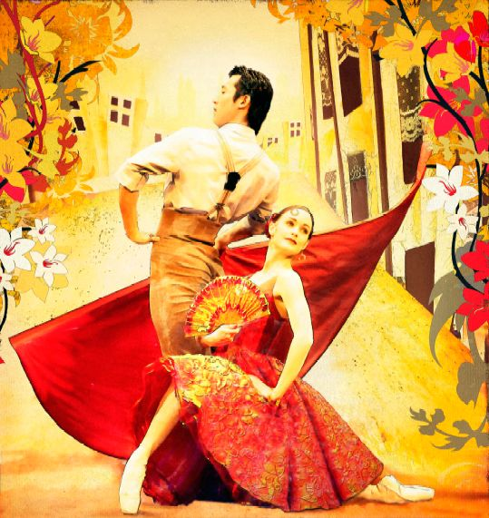

A star-studded family adventure

Sir Jon Trimmer is thrilled to be playing the lead role in the Royal New Zealand Ballet’s vibrant, new production of Don Quixote.

The ballet veteran and crowd-favourite is celebrating 50 years of performing with the RNZB this year, and says being offer the role of “The Don” is a dream come true.

“I was thrilled and honoured to be asked to play the role of Don Quixote. These days I tend to mainly play old ladies and witches so it will be nice to be the hero for once, even an aging, addled and confused one,” jokes the 69-year-old.

Sir Jon first joined the Royal New Zealand Ballet in 1958, just five years after the company was founded. Over the years his skills and dedication to dance have made him a household name.

“I hope I’m still going strong and performing when I’m 80,” Trimmer says.

He will be joined on stage in Don Quixote by special guest star and expat New Zealander, Marc Cassidy from The Australian Ballet and former RNZB principal dancer Shannon Dawson.

Designed by RNZB artist director Gary Harris, Don Quixote is a family-friendly ballet featuring the best of classical dance technique set to the sparkling melodies of revered composer Ludwig Minkus.

The story follows the confused and ageing Don, together with his young nephew Sancho, as they encounter the devious Gamache with his consort of rough and ready street dancers, the beautiful but feisty Kitri; her young, penniless lover Basilio; Kitri’s father – a pretentious café owner, and a tribe of wild gypsies.

A secret lover’s tryst, a robbery, visions and dreams, and a celebratory wedding add excitement to this fun adventure. Don Quixote is one of the great comedic ballets of all time, so join the Royal New Zealand Ballet for this fun night out.

Staging and Design: Gary Harris
Additional Choreography: Adrian Burnett (after Petipa)
Music: Ludwig Minkus
Lighting Design: Jon Buswell

For further information or images contact Robyn McLean, Communications Specialist on robyn@nzballet.org.nz or 04 381 9018 (Season Dates below)

The Meridian Season of Don Quixote performance dates

Wellington 31 October – 8 November

Featuring the Vector Wellington Orchestra
St James Theatre

Invercargill 11 – 12 November
Civic Theatre

Dunedin 15 – 16 November

Featuring the Southern Sinfonia
Regent Theatre

Christchurch 19 – 22 November

Featuring the Christchurch Symphony
Isaac Theatre Royal

Palmerston North 25 – 26 November
Regent Theatre on Broadway

Napier 29 – 30 November
Municipal Theatre

Auckland 3 – 7 December

Featuring the Auckland Philharmonia Orchestra
Aotea Centre at THE EDGE®

Hamilton 10 –11 December
Founders Theatre



National Sponsor of the Royal New Zealand Ballet

