

Turkey Stocktake

March 2008

AUTHORS
Ministry of Foreign Affairs and Trade
PO Box 18 901
Wellington
NEW ZEALAND

DISCLAIMER
The views, opinions, findings, and conclusions or recommendations expressed in this report are strictly those of the author(s). They do not necessarily reflect the views of the Ministry of Foreign Affairs and Trade.
The Ministry takes no responsibility for any errors or omissions in, or for the correctness of, the information contained in this report. The paper is presented not as policy, but with a view to inform and stimulate wider debate.

Contents
Foreword by Hon Phil Goff, Minister of Trade 1
1. Introduction 2
2. Economy 2
2.1 New Zealand Economy 2
2.1.1 Structure 2
2.1.2 Recent Economic Performance 3
2.1.3 Outlook 4
2.2 Turkish Economy 4
2.2.1 Structure 4
2.2.2 Recent Economic Performance 5
2.2.3 Outlook 7
3. Trade Policy 7
3.1 New Zealand Trade Policy 7
3.2 Turkish Trade Policy 8
4. Merchandise Trade 9
4.1 Overview 9
4.2 Turkey’s Trade Relations with the Rest of the World 9
4.3 New Zealand’s Trade Relations with the Rest of the World 12
4.4 Existing Bilateral Trade 15
4.4.1 New Zealand’s Exports to Turkey 16
4.4.2 New Zealand’s Imports from Turkey 21
4.5 Future Areas for Cooperation 21
5. Agriculture 22
5.1.1 Overview 22
5.1.2 Existing Bilateral Linkages 23
5.1.3 Future Areas for Cooperation 23
6. Services 25
6.1 Education 25
6.1.1 Overview 25
6.1.2 Existing Bilateral Linkages 25
6.1.3 Future Areas for Cooperation 25
6.2 Tourism 26
6.2.1 Overview 26
6.2.2 Existing Bilateral Linkages 26
6.2.3 Future Areas for Cooperation 26
6.3 Investment 27
6.3.1 Overview 27
6.3.2 Existing Bilateral Linkages 27
6.3.3 Future Areas for Cooperation 27
7. Conclusion 28

Appendices
Appendix A: For Further Information 30
Appendix B: Turkey Map 30
Appendix C: New Zealand’s Economic Data 31
Appendix D: Turkey’s Economic Data 32
Appendix E: New Zealand’s Top 50 Exports to Turkey, 2006 (HS4) 33
Appendix F: Turkey’s Top 50 Imports from the World, 2005 (HS4) 34

Figures
Figure 1: Composition of New Zealand’s GDP 3
Figure 2: Composition of Turkey’s GDP 2007 5
Figure 3: Foreign Direct Investment in Turkey 6
Figure 4: Turkey’s Top Ten Merchandise Imports and Percentage Share of Total Imports, 2007 11
Figure 5: Turkey’s Top 10 Merchandise Exports and Percentage Share of Total Exports, 2007 12
Figure 6: New Zealand’s Top Ten Imports and Percentage of Total Imports, 2007 13
Figure 7: New Zealand’s Top Ten Exports, and percentage of Total Exports, 2007 15
Figure 8: New Zealand's Merchandise Trade with Turkey………………………….. 16
Figure 9: New Zealand’s Top Ten Exports to Turkey, 2007 (HS4) 17
Figure 10: New Zealand’s Wool Exports to Turkey 18
Figure 11: New Zealand Exports to Turkey of 410221 – Raw Sheep and Lamb Skins (Without Wool) 20
Figure 12: New Zealand’s Top 10 Imports from Turkey, 2007 (HS4) 21
Figure 13: Turkish Visitors to New Zealand 26

Tables
Table 1: Turkey’s Key Import Partners 2007 10
Table 2: Turkey’s Key Export Partners 2007 11
Table 3: New Zealand’s Key Import Partners, 2007 12
Table 4: New Zealand’s Key Export Partners, 2007 14
Table 5: New Zealand’s Hides and Skins Exports to Turkey 19
Table 6: New Zealand’s Key Economic Indicators 31
Table 7: New Zealand’s Principal Exports and Imports 31
Table 8: Turkey’s Key Economic Indicators 32
Table 9: Turkey’s GDP and Principal Exports and Imports 32

Foreword by Hon Phil Goff, Minister of Trade

In December 2006 I visited Turkey to participate in the Joint Economic Commission meeting with then Deputy Prime Minister Abdulattif Sener. In that meeting, and in discussions with other Turkish Ministers, we agreed that New Zealand and Turkey enjoyed a warm political relationship. This had been boosted recently by an increase in high-level visits in both directions. Nevertheless, there was scope to expand the trade and economic dimension of the bilateral relationship.

During that visit I announced to an audience of business leaders in Istanbul that the Ministry of Foreign Affairs and Trade would carry out a ‘stocktake’ of New Zealand/Turkey trade and economic relations, updating a report produced by the Ministry in 1995, shortly after the establishment of resident Embassies in Ankara and Wellington.

Now completed, this report highlights the very good performance of the New Zealand and Turkish economies over the last few years. Our Government is committed to advancing the domestic Economic Transformation Agenda, and to maintaining a high degree of openness to international trade and investment. We applaud the progress that Turkey has made in recent years, and believe that external trade liberalisation is an essential component of the broader economic reform that Turkey needs to implement to secure continuation of strong economic growth, and rising standards of living.

Increases in the trade in goods and services between New Zealand and Turkey will be supported by removal of existing barriers, and by good growth prospects in both economies. Just as New Zealand has benefited from its greatly expanded linkages with the dynamic Asia-Pacific region, Turkey is benefiting from its connections to Europe, Central Asia and the Middle East. There is much potential for our companies to develop business partnerships and exploit opportunities not just in Turkey and New Zealand, but in the surrounding regions.

As we approach the end of the first decade of the twenty-first century the geographical distance between New Zealand and Turkey has never been less of an impediment to achieving much higher levels of trade and investment. I hope that publication of this report, in English and Turkish, will help spark interest among business communities to take a fresh look at the unrealised opportunities that undoubtedly exist.

Hon Phil Goff
Minister of Trade

Introduction
The solid political and people-to-people links between New Zealand and Turkey are founded in our shared experience of the World War I Gallipoli campaign. The two countries suffered horrific losses on the Gallipoli peninsula, but the campaign was also a turning point in the modern histories of both Turkey and New Zealand. For Turkey, the campaign saw the rise to prominence of the future leader of the Turkish Republic, Mustafa Kemal Ataturk. The generous spirit of reconciliation Ataturk showed towards his former foes established the warm relationship between the two countries in subsequent years. This has been bolstered by a recent series of visits in both directions by senior Turkish and New Zealand Ministers.
Turkey opened its Embassy in Wellington in 1992. The New Zealand Embassy in Ankara was established in 1993 (a trade office had been in place prior to the opening of the Embassy). At that time trade between the two countries was expanding rapidly. A study carried out in 1995 by the New Zealand Ministry of Foreign Affairs and Trade noted that the growth in trade in the early 1990s had been “phenomenal”. During the latter part of that decade, however, disruptions to Turkey’s economic progress, and changing patterns of regional trade following the collapse of the Soviet Union, resulted in a marked decline in New Zealand’s exports to Turkey.
Since 1991 there have been regular meetings of the ministerial-level New Zealand/Turkey Joint Economic Commission. The most recent meeting was held in Ankara, in December 2006, with Turkey’s delegation led by HE Abdullatif Sener, Deputy Prime Minister, and New Zealand’s delegation led by Hon Phil Goff, Minister of Trade. The two Ministers discussed how bilateral trade and economic linkages could be expanded. Minister Goff proposed that the New Zealand Ministry of Foreign Affairs and Trade should review the outlook for the two countries’ economies, and prospects for further development of business and economic activity. This ‘stocktake’ is the result.
The report assesses the strong performance in recent years of the Turkish and New Zealand economies, and looks at the two countries’ trade policies, and economic engagement with other countries. It provides a snapshot of the current bilateral economic relationship, and identifies sectors that have potential to grow in the future. The areas canvassed include merchandise trade, agriculture, services, tourism and investment. The report outlines a number of conclusions that point the way for further expansion of the trade and economic links between Turkey and New Zealand.

Economy

New Zealand Economy
New Zealand has a mixed economy which operates on free market principles. It has sizable manufacturing and service sectors complementing a highly efficient agricultural sector. The economy is strongly trade-oriented, with exports of goods and services accounting for around one third of real expenditure gross domestic product (GDP).

Structure
New Zealand’s GDP is dominated by services which represent 71 percent of production. The various components of GDP are illustrated in Figure 1.
Figure 1: Composition of New Zealand’s GDP
5%
2%
15%
2%
5%
8%
8%
11%
27%
5%
12%
Agriculture
Fishing forestry and mining
Manufacturing
Electricity gas and water
Construction
Wholesale trade
Retail trade accomodation cafes
and restaurants
Transport storage and
communication services
Finance insurance property and
business services
Government administration and
defence
Community and Personal Services

Source: Statistics New Zealand
Primary production represents seven percent of New Zealand’s output. Agriculture and fishing forestry and mining account for two percent of output.
The primary sector is an important export earner for New Zealand. In 2007, agriculture accounted for 53 percent of New Zealand’s merchandise exports.

Reforms
Over the last two decades, the New Zealand economy has changed from being one of the most regulated in the Organisation for Economic Cooperation and Development (OECD) to one of the most deregulated. The impetus for reforms came to a head in the early 1980s as New Zealand’s inflation, net public and foreign debt, wage stagnation and high unemployment threatened to spiral out of control.
To address the economic crisis, New Zealand instituted wide-ranging reforms in both the macroeconomic and microeconomic areas. These reforms emphasised the role of transparency, predictability of policy, the market mechanism, competition, and reduction of government intervention.
Although the reforms initially caused major disruptions to the New Zealand economy, by the early 1990s positive signs had started to emerge. Improved macroeconomic fundamentals positioned the New Zealand economy well and the reduction in tariffs, removal of import quotas and elimination of export subsidies transformed many industries and businesses (although there were considerable adjustment costs, especially in the agricultural sector.)
The New Zealand economy experienced strong growth following the reforms, with an annual average growth rate of 3.5 percent from the mid-1990s.

Recent Economic Performance
Since the earlier reforms, the New Zealand government has continued to improve the policy framework via the Economic Transformation Agenda (ETA). The ETA is working to turn New Zealand into a dynamic knowledge based economy, that is both innovative and creative. The ETA is, among other things, focussing on developing world class infrastructure in New Zealand and producing productive workplaces. This will not only be to the benefit of New Zealanders, but also to those countries engaging with New Zealand in the future.
Due to the reforms discussed above, the New Zealand economy is relatively free of distortions and was ranked second in the 2007 World Bank Survey on the ‘Ease of Doing Business’ and fifth in the World Heritage Foundation’s 2008 ‘Index of Economic Freedom’. New Zealand has a flexible labour market, as demonstrated by the historically low level of unemployment (currently 3.4 percent) and high levels of labour participation. Monetary and fiscal policy are relatively stable.
The economy is currently in a phase of moderate growth, with a year ended September 2007 growth figure of 2.7 percent.

Outlook
On 1 February 2008, the Economist Intelligence Unit predicted annual average growth of 2.0 percent for 2008 as households go through a period of consolidation before an expected export-led recovery leads to growth increasing to of around 2.7 percent in 2009.
Recent developments in the global economy may further weaken New Zealand’s growth outlook. New Zealand is, however, well-positioned to weather a global economic slowdown, with a relatively solid current economic position, and the prospect of continued high food prices driven by booming emerging economies.

Turkish Economy
Turkey is currently the 17th largest economy in the world, as measured by total GDP. Turkey’s GDP per capita has doubled since 2001, and is now approximately US$7,000. Turkey's State Planning Organisation predicted in its ninth development plan that GDP will continue to increase at an annual average rate of 7 percent during 2007-13, with a projected GDP per capita of US$10,100 by 2013. The IMF noted towards the end of 2007 that growth in GDP beyond 2009 would likely be between 5-7percent, depending on the macroeconomic policies implemented and progress on structural reforms.

Structure
Turkey's economy is made up of a mix of modern industry and commerce along with a traditional agriculture sector. It also has a strong and rapidly growing private sector, yet the state still plays a major role in basic industry, banking, transport, and communication. The IMF has recommended revival of the privatisation programme, which slowed in 2007, to assist in attracting new investment and boosting productivity (with the energy sector identified as a priority). Textiles and clothing make up a large proportion of Turkey’s manufacturing industry, and account for one-third of industrial employment. Automotive and electronics industries are also rising in importance within Turkey's export mix.
Figure 2 outlines the composition of Turkey’s GDP. Similar to the New Zealand economy, services represent the largest component.
Figure 2: Composition of Turkey’s GDP 2007
10%
30%
60%
Agriculture, forestry & fishing
Industry
Services
Source: Undersecretariat of Foreign Trade

Recent Economic Performance
Turkey suffered severe economic shocks in the early 1990s and a serious financial crisis in 2001. Its recovery and economic performance since 2001 have surpassed expectations. Turkey experienced sustained average GNP growth of 7.4 percent between 2002 and 2006, making it one of the fastest growing economies in the OECD. Sound economic policies pursued in partnership with the IMF have contributed to this strong performance, including: effective fiscal discipline; monetary policy restraint by an independent central bank; recapitalisation and enhanced supervision of banks, tax reforms and a privatisation programme. Further significant reforms are currently being progressed by the government, including reform of the tax and social security systems. Generally benign global economic conditions and political stability have also assisted in Turkey’s economic recovery. Increased business investment and household consumption have led to a steady increase in demand, while public consumption and investment have remained subdued under the strict fiscal consolidation programme.
Improvement of Turkey’s regulatory framework was noted in the World Bank’s 2007 ‘Ease of Doing Business Survey’, where Turkey was ranked 57. Improvements since the last survey included a cut in the corporate income tax (from 30 percent to 20 percent) and introduction of electronic customs procedures, reducing the time to export goods by 6 days and the time to import goods by 10 days.
The World Bank has demonstrated that equity returns on investments are highest in countries that are reforming the most (irrespective of their starting point), which would indicate that strong inward flows of foreign direct investment to Turkey are likely to continue, should the government maintain its current stated commitment to pursuing reform.
The large informal economy has been identified as a major risk. Regulatory hurdles in labour and product markets impact on the competitiveness of those companies operating in the formal economy, and act as a hindrance to increased employment. As a consequence many firms currently operate in the informal sector. The European Commission’s “Turkey 2007 Progress Report” noted that small and medium enterprises (SMEs), in particular, often operate in the ‘grey economy’, which is estimated to amount to 20-50 percent of Turkey’s gross national
product (GNP). Turkey’s government has identified reduction in the size of the informal economy as a priority issue. Foreign Direct Investment Inwards (FDI) to Turkey has increased significantly over the last ten years. Prior to 2005, FDI averaged less than US$1 billion annually; however in 2007 FDI was US$22 billion, as Figure 3 shows.
Figure 3: Foreign Direct Investment in Turkey
0
5
10
15
20
25
2002
2003
2004
2005
2006
2007
US$ billion
Source: Undersecretariat of the Prime Ministry for Treasury; Undersecretariat of Foreign Trade
The large increase in FDI in Turkey signals that foreign perceptions of the Turkish economy are improving, with overseas investors becoming eager to capitalise on Turkey’s strong growth prospects. Turkey has also been working hard to make its investment environment attractive to overseas investors and has developed incentive schemes aimed at increasing investment in under-developed parts of Turkey.
The key industries attracting FDI in Turkey are the banking, financial, communication and trade services sectors and the manufacturing sector.
Further economic and legal reforms and prospective European Union (EU) membership are expected to continue to boost FDI in the years ahead.

Turkey’s Regional/Economic links
Turkey is in the heart of a region with more than one billion people, accounting for almost one quarter of world’s output. Turkey has substantial economic links with the surrounding region and is a member of many regional cooperation organisations. These include: the South-East European Cooperative Initiative, the Euro-Mediterranean Partnership (Barcelona Process), the Economic Cooperation Organisation (with Iran and Pakistan - ECO) and the Black Sea Economic Cooperation. Turkey has embarked on a deliberate strategy of diversifying its trading relationships beyond traditional markets in the EU and US, and as part of that has focused in particularly on its neighbours and surrounding countries. Trade with most of Turkey’s neighbours is increasing and will continue to do so in the future.
Turkish businesses have well developed relationships in the Black Sea region, Caucasus and Central Asia. A number of foreign businesses use Turkey as a base to hub into surrounding regions. For instance, Coca Cola and Microsoft both market into Central Asia through Turkey.

Outlook
Turkey’s economic growth has eased to around 5 percent in 2007, and is forecast to fall to 3.7 percent in 2008 before recovering to 5.4 percent in 2009. However, the economy is not yet completely resistant to domestic and international disruptions. Further structural and institutional reforms should help to improve competitiveness and external balances, as well as enhance resilience to external shocks.

Turkey’s European Union Accession Prospects
Turkey’s EU accession process will continue to be an important driver of economic and political reform, progress on which will make Turkey an increasingly attractive market for third countries to do business in.
The EU agreed to start accession negotiations with Turkey at the end of 2005. The European Commission monitors Turkey's progress towards accession and produces a written report annually for presentation to the European Council. The Commission's 2007 report stated that Turkey continues to sufficiently fulfil the Copenhagen political criteria for EU membership and has continued political reforms. It noted that political developments in the middle of 2007 had reaffirmed the primacy of the democratic process in Turkey. While noting that the government formed after the July 2007 elections had presented an EU-oriented reform agenda, the report also highlighted a number of areas where little or no progress on reforms had been made in 2007, and where further action was required.
Business support for Turkey’s accession process is strong. There is some way to go, however, before accession will be achieved. Political developments in some EU member states and in Turkey itself will continue to impact on public support for the accession process on both sides. To date the Turkish government has made it clear that reforms will continue, irrespective of the speed with which progress is made on the accession process.

Trade Policy

New Zealand Trade Policy

Unilateral
New Zealand is one of the most open economies in the world. Tariffs have been systematically reduced and quantitative controls on imported goods eliminated. Currently around 95 percent of New Zealand’s imports of goods (by value) enter duty free.
New Zealand has begun to progressively reduce its few existing high tariff rates. These tariffs apply largely to clothing, footwear and carpets. This will present opportunities for Turkey’s exporters, as textiles are a key Turkish export.
New Zealand’s agriculture sector is the least assisted among OECD countries. Agricultural assistance (as measured by the Producer Support Estimate) in New Zealand was reformed in the 1980s and fell from a peak of 35 percent in 1983 to 9 percent in 1987; by the early 1990s the PSE was just 3 percent. What now remains is largely spending on general services such as inspection, quarantine, research and pest control.

Bilateral and Regional
New Zealand has promoted and entered into a number of bilateral and regional free trade agreements.
New Zealand’s Closer Economic Relations (CER) agreements with Australia provide a benchmark for next-generation free trade agreements (FTAs) and economic partnerships. New Zealand is also actively engaged in regional co-operation and liberalisation through membership of such fora as Asia Pacific Economic Cooperation (APEC) and the East Asian Summit.
New Zealand has free trade and economic partnership agreements in place with Singapore, Thailand, and with Singapore, Brunei and Chile. New Zealand is currently in negotiations with China, the Association of South East Asian Nations (ASEAN) and the Gulf Cooperation Council (GCC).

Multilateral
A successful outcome from the current Doha round of the WTO negotiations remains New Zealand’s number one trade priority. Openness to trade and competition is one of the cornerstones of economic success. It fuels economic dynamism and innovation, and ultimately raises productivity and standards of living.
No other outcome will give the same payoff across the range of world trade – in agriculture, in services, and in manufactured goods – and it is the only way large trade-distorting issues such as subsidies can be tackled. These benefits will not accrue to New Zealand alone – the global gains of a successful Round are likely to be very significant.

Turkish Trade Policy

Unilateral
In the context of its membership (from 1996) of the EU Customs Union, Turkey has implemented the European Union’s Common Tariffs. In 2001, Turkey’s tariffs on imports of sensitive products were equalized with the Common Tariffs. As a result, Turkey’s tariffs on goods covered by the Customs Union (i.e. industrial and processed agricultural products) have reduced to a greater extent than those of many other developing countries.
However, the average most favoured nation (MFN) tariff applied to imports of agricultural goods remains high. Using the WTO definition, the coverage is 47.6 percent on agricultural products, and 5 percent on non-agricultural goods. The average applied MFN tariff is substantially greater in agriculture (28.3 percent, up from 25 percent in 2003) than in manufacturing (10.9 percent, down from 11.1 percent in 2003), and in mining and quarrying (0.3 percent, against 0.2 percent in 2003). There are also import licensing requirements which complicate the export of agricultural goods to Turkey. Opening up Turkey’s agriculture sector would usefully expose its producers to competition and generate significant economic benefits to Turkey.

Bilateral and Regional
Turkey’s membership of the EU Customs Union means that industrial goods and the industrial component of processed agricultural goods can be exported from Turkey duty free to other members of the Customs Union (in line with EU Customs Union Rules of Origin requirements), and Turkey’s external tariffs on those products are aligned with those of the EU. Turkey has also signed a number of preferential trading arrangements with other countries. These arrangements are either with countries with which the EU also has a preferential trading arrangement, or are consistent in their content with Turkey’s EU Customs Union commitments. Arrangements have been concluded with: the Economic Cooperation Organisation (Turkey, Iran, Pakistan); Israel; Former Yugoslav Republic of Macedonia; Croatia; Bosnia Herzegovina; Morocco; the Palestinian Authority; Syria; Tunisia; and Egypt. Turkey is also a member of various other economic cooperation organisations (e.g. Black Sea Economic Cooperation - BESC), and has formalised Joint Economic Commissions (which involve regular economic consultations) with many more countries, including New Zealand.

Multilateral
Turkey joined the World Trade Organisation in 1995 and remains committed to the multilateral trading system. As an EU candidate, Turkey’s external trade policies are shaped by the EU Acquis Communitiare. Turkey attaches great importance to the Doha Development Agenda and considers that the successful conclusion of the negotiations is critical for all countries.
Turkey believes that the Doha Development Agenda negotiations provide an opportunity for the establishment of a more competitive and fair international trading system; and that a fair trading environment can only be established through the complete elimination of all kinds of export subsidies, as well as domestic supports that have trade-distorting effect on the international markets.
Turkey's aim is a successful and balanced outcome out of the negotiations, which will take into account the developmental concerns of the developing countries.

Merchandise Trade

Overview
As noted above, exports of goods and services make up over 30 percent of New Zealand’s GDP. Similarly, Turkey has become increasingly integrated in the world trading system, and global trade represented 55 percent of Turkey’s GDP in 2006.

Turkey’s Trade Relations with the Rest of the World

Imports
In 2007, Turkey’s merchandise imports from the world were US$170 billion.
Import penetration has been accelerating in Turkey, with imports increasing at an annual average rate of 13.3 percent since 1989. Domestic producers of many consumer goods and industrial inputs are facing growing import competition, and the trade deficit has widened. The share of imported consumer goods in total private consumption is estimated to have grown from 5.5 percent in 2001 to 8.5 percent in 2005, while the use of intermediate inputs in total industrial production also increased significantly.
Increased competition from China, India and other Asian countries is threatening the labour intensive segments of Turkish industry. In particular, the textile, clothing and leather industries, which represent one third of total manufactured exports and are important suppliers for domestic demand, have been heavily affected. Turkey was the first country to invoke a safeguard mechanism with respect to imports of textiles from China and the textiles industry is beginning to look towards more value added products to avoid competing with lower cost imports.
As Table 1 shows, Turkey’s most important sources of imports in 2007 were Russia, Germany, China and Italy. New Zealand accounted for 0.02 percent of Turkey’s total imports in 2007.
Turkey has developed a series of initiatives aimed at diversifying its trade and economic linkages beyond traditional markets. Strategies have been developed to increase links with its neighbours and surrounding countries; the Middle East; Africa and the Asia Pacific region. It has been predicted that Turkey’s trade with the Asia Pacific region could increase from its current level of 13 percent of total trade, to 30 percent of total trade in the near future.
Table 1: Turkey’s Key Import Partners 2007
Turkey Imports from: | US$ Billions | Share of Turkey’s Total Imports (%)
Russian Federation | 23.5 | 13.8
Germany | 17.5 | 10.3
China | 13.2 | 7.8
Italy | 10.0 | 5.9
USA | 8.1 | 4.8
France | 7.8 | 4.6
Iran | 6.6 | 3.9
England | 5.5 | 3.2
Switzerland | 5.3 | 3.1
Ukraine | 4.5 | 2.6
Top Ten Subtotal | 102.0 | 60.0
Total Imports from the World | 170.0 | 100

Source: Undersecretariat of Foreign Trade
As Figure 4 shows, Turkey’s key imports are fuel, machinery and vehicles, iron and steel, and chemicals.
Figure 4: Turkey’s Top Ten Merchandise Imports and Percentage Share of Total Imports, 2007
20%
16%
9%
9%
7%
6%
5%
5%
4%
4%
Mineral fuels
Machinery and transport
Non-electrical machinery
Vehicles
Iron and steel
Chemicals
Office machines
Plastics
Metalliferous ores & metal scrap
Electrical machinery
Source: Undersecretariat of Foreign Trade

Exports
In 2007 Turkey’s global exports were worth US$107.2 billion. As Table 2 shows, Turkey’s most important export destinations are Germany, England, Italy and France. Not surprisingly, seven out of Turkey’s top ten export partners are members of the European Union.
Table 2: Turkey’s Key Export Partners 2007
Turkey's Exports to: | US$ Billions | Share of Turkey’s Total Exports (%)
Germany | 12.0 | 11.2
England | 8.6 | 8.0
Italy | 7.5 | 7.0
France | 6.0 | 5.6
Russian Federation | 4.7 | 4.4
Spain | 4.6 | 4.3
USA | 4.1 | 3.8
Romania | 3.7 | 3.5
United Arab Emirates | 3.2 | 3.0
Netherlands | 3.0 | 2.8
Top 10 subtotal | 57.4 | 53.6
Total Exports to the World | 107.2 | 100

Source: Undersecretariat of Foreign Trade
As Figure 5 shows, Turkey’s key export sectors in 2007 were machinery and transport, vehicles, clothing and iron and steel.
Figure 5: Turkey’s Top 10 Merchandise Exports and Percentage Share of Total Exports, 2007
4.5%
4.8%
5.6%
8.3%
8.4%
8.9%
13.0%
14.5%
14.6%
Machinery and transport
Vehicles
Clothing
Iron and steel
Food
Textiles
Electrical machinery
Mineral fuels
Non-electrical machinery
Source: Undersecretariat of Foreign Trade

New Zealand’s Trade Relations with the Rest of the World

Imports
New Zealand imported NZ$41.9 billion worth of goods in the year ended December 2007. Australia, China, the United States and Japan are New Zealand’s most important import partners.
Table 3: New Zealand’s Key Import Partners, 2007
New Zealand Imports from: | NZ$ billions | Share of NZ's total imports (%)
Australia | 8.6 | 20.6
China | 5.6 | 13.3
United States | 4.1 | 9.7
Japan | 3.9 | 9.4
Singapore | 2.1 | 5.1
Germany | 2.0 | 4.7
Korea, South | 1.2 | 2.8
Malaysia | 1.1 | 2.7
Thailand | 1.1 | 2.7
United Kingdom | 1.1 | 2.6
Top ten subtotal | 30.9 | 73.7
Total imports from the world | 41.9 | 100.0

Source: Statistics New Zealand

In 2007 New Zealand’s primary imports were mineral oil and fuel (14.4 percent), machinery (12.8 percent) and vehicles (12.2 percent).
Figure 6: New Zealand’s Top Ten Merchandise Imports and Percentage Share of Total Imports, 2007
1.9%
2.1%
2.4%
2.5%
2.7%
3.7%
8.9%
12.3%
12.8%
14.4%
Mineral Fuel and Oil
Machinery
Vehicles
Electrical Machinery
Plastic
Optical and medical
instruments
Pharmaceuticals
Paper, Paperboard
Aircraft, Spacecraft
Ships And Boats
Source: Statistics New Zealand

Exports
In 2007 New Zealand’s total merchandise exports were worth NZ$36.6 billion. New Zealand’s most important export destinations are Australia, the United States, Japan and China. A large proportion of New Zealand’s goods are exported to the Asia-Pacific region.

Table 4: New Zealand’s Key Export Partners, 2007
New Zealand Exports to: | NZ$ billions | Share of NZ's total exports (%)
Australia | 8.0 | 21.9
United States | 4.2 | 11.5
Japan | 3.4 | 9.2
China | 2.0 | 5.3
United Kingdom | 1.6 | 4.5
Korea, South | 1.3 | 3.6
Indonesia | 0.8 | 2.1
Taiwan | 0.8 | 2.1
Germany | 0.8 | 2.1
Singapore | 0.7 | 1.9
Top ten subtotal | 23.5 | 64.3
Total exports to the world | 36.6 | 100.0
Source: Statistics New Zealand

New Zealand’s most valuable exports in 2007 were dairy products, meat and wood. Twenty-one percent of New Zealand’s total exports were made up of dairy products, and 11.9 percent were made of meat exports, highlighting the importance of agricultural good exports to New Zealand.
Figure 7: New Zealand’s Top Ten Merchandise Exports and Percentage Share of Total Exports, 2007
20.7%
11.9%
5.7%
5.2%
4.2%
4.0%
3.5%
3.0%
2.9%
2.9%
Dairy
Meat
Wood
Machinery
Aluminum
Mineral Fuel and Oil
Edible Fruit And Nuts
Fish And Seafood
Albumins
Electrical Machinery
Source: Statistics New Zealand

Existing Bilateral Trade
Turkey was New Zealand’s 50th most important bilateral trading partner in the year ending December 2007, with total trade valued at NZ$150.9 million. This has increased significantly since 1990, when total trade was valued at NZ$54 million.
There has been a shift in our trading profile over the last fifteen years, as while New Zealand exports to Turkey used to account for most of bilateral trade, today New Zealand’s imports from Turkey make up a greater proportion of bilateral trade.
As Figure 8 shows, New Zealand’s exports to Turkey peaked in 1995 with high sales of raw sheep skins and hides. Exports in this sector have declined since then, and total exports were worth NZ$54 million in the year ending December 2007. Exports to Turkey account for around 0.15 percent of New Zealand’s global exports.

Figure 8: New Zealand’s Merchandise Trade with Turkey
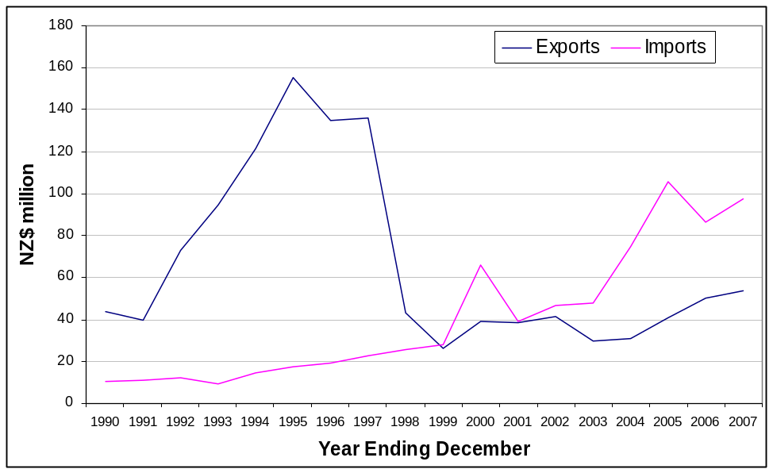
Source: Statistics New Zealand

New Zealand’s Exports to Turkey
New Zealand’s top ten exports at HS4 level to Turkey accounted for 87 percent of our total exports to Turkey. Therefore the export portfolio is quite narrow. Wool and raw sheepskins have been New Zealand’s principal export products for over 15 years, and were worth NZ$19.6 million and NZ$7.8 million respectively in 2007. The value of these exports has fluctuated a lot, which has influenced the peaks and troughs in New Zealand’s total exports, as seen in Figure 8.
As shown in Figure 9, the other goods that make up our top ten export portfolio are: machine tools; butter; cow and horse hides; electric transformers; sheepskin leather; medical equipment; medicaments; and pulley tackle and hoists. Trade in services, which does not show up in merchandise trade statistics, has been seen as an area of promise by New Zealand companies (see “Services” section below).
Figure 9: New Zealand’s Top Ten Exports to Turkey, 2007 (HS4)
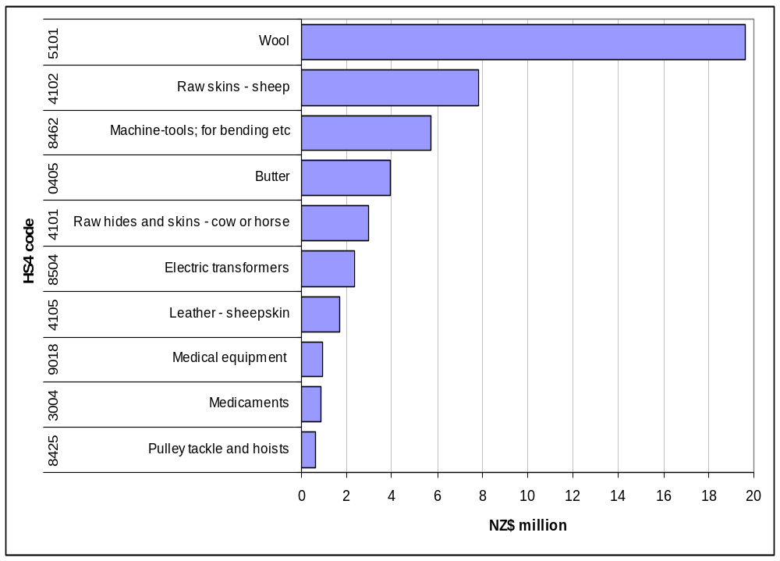
Source: Statistics New Zealand

Wool
Turkey’s vibrant textile sector is its largest manufacturing industry and largest export sector, and is a significant contributor to the Turkish economy. New Zealand wool, hides and skins are important imports of intermediate inputs for Turkey.
New Zealand’s most valuable export to Turkey at HS4 level is wool. New Zealand exports two key wool products: degreased shorn wool (HS 510121); and greasy shorn wool (HS 510111). Bound rates of customs duty on wool range between 2 and 8 percent.
Figure 10: New Zealand’s Wool Exports to Turkey

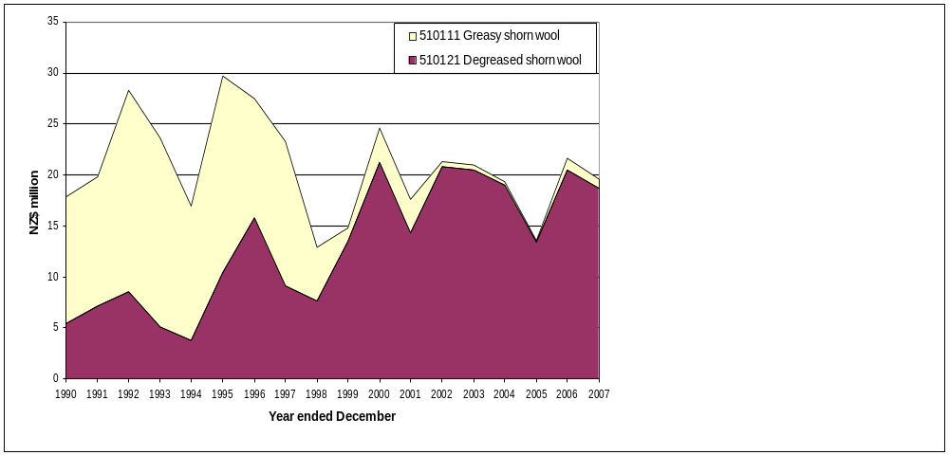

Source: Statistics New Zealand
New Zealand retains a significant place in the Turkish import market for degreased wool and accounted for 54 percent of Turkey’s imports of degreased wool in 2007. The Turkish import market for this product grew by 134 percent from 1992-2006, and New Zealand has retained its prominence in the market, with Turkish imports from New Zealand growing by 140 percent over the same period.
Turkey was New Zealand’s ninth most important destination for exports of degreased wool in 2007, and exports to Turkey accounted for 4 percent of our total degreased wool exports. Long term partnerships have been established with agents in Turkey and NZTE is investigating the scope to increase exports of high-tech wool products to Turkey.

Hides and Skins
Hides and skins were New Zealand’s second most important export to Turkey in 2007, and were valued at NZ$13 million.
New Zealand exported ten products under the “hides and skins” classification as Table 5 below shows. Raw sheep and lamb skins without wool on (410221; hereinafter “sheep and lamb skins”) and raw bovine hides and skins (410120) were the most important exports, valued at NZ$7.7 million and NZ$2.8 million respectively in 2007.
Table 5: New Zealand’s Hide and Skin Exports to Turkey

HS Code | Description | Exports to Turkey 2007 (NZ$ million)
41 | Total hide and skin exports | 12.851
410221 | Raw sheep or lamb skins, without wool on | 7.711
410120 | Raw bovine hides and skins - whole | 2.766
410530 | Sheep/lamb tanned or crust skins without wool - dry | 1.384
410510 | Sheep/lamb tanned or crust skins without wool - wet | 0.323
410390 | Raw hides and skins - other than sheep, lamb or bovine | 0.223
410190 | Bovine butts, bends and bellies | 0.195
411390 | Leather of animals other than goats, swine or reptiles | 0.135
410229 | Raw sheep and lamb skins - pelts | 0.059
410210 | Raw sheep or lamb skins, with wool on | 0.052
410711 | Leather of bovine - whole hides and skins | 0.002
Source: Statistics New Zealand

As Figure 11 shows, exports of sheep and lamb skins (410221) dominated New Zealand’s exports to Turkey in the mid-90s and peaked in 1995, valued at NZ$107.2 million. At that time Turkey was one of the top three buyers of New Zealand raw and semi-processed leather rawstock.
The bulk of these hides and skins were making their way into the so-called “suitcase trade”, into the former Soviet Union. When that trade collapsed in the late 90s, it had a serious impact on New Zealand’s trade in hides and skins with Turkey.

Figure 11: New Zealand Exports to Turkey of 410221 – Raw Sheep and Lamb Skins (Without Wool)
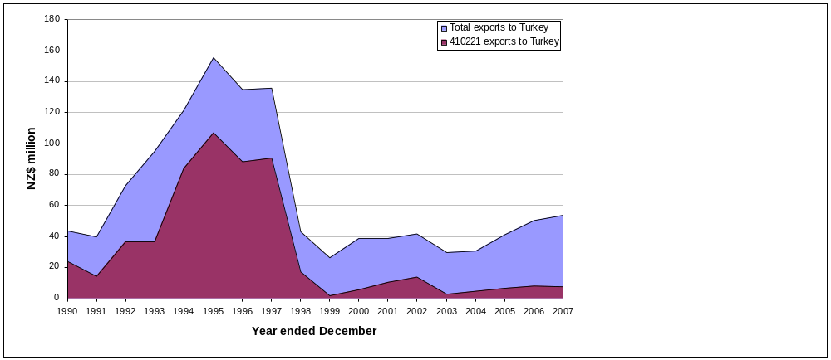
Source: Statistics New Zealand
New Zealand was Turkey’s second largest source of sheep and lamb skin imports in 2007 and accounted for 20 percent of Turkey’s imports of this product. This is a moderate drop from the previously high levels in the mid-90s where New Zealand accounted for 45 percent of Turkey’s sheep and lamb skin imports. Turkey remains New Zealand’s fourth largest export market for sheep and lamb skins, and accounts for 9 percent of our total sheep and lamb skin exports.
New Zealand’s second most valuable hide and skin export to Turkey is whole, raw bovine skins and hides. These exports to Turkey re-commenced in 2006, having previously been traded only in 2002. In 2007, exports of this product grew by 70% to $2.8 million, making Turkey New Zealand’s third largest export market for the product.
New Zealand’s third most valuable hide and skin export to Turkey is dry sheep and lamb crusted skins. Trade in this product began in 2002 and Turkey was New Zealand’s most important destination for this export in 2007, accounting for 60 percent of total exports. Exports of sheep and lamb crusted skins to Turkey have steadily increased over the last five years, reaching a peak of NZ$3.3 million in 2006, and falling to NZ$1.4 million in 2007.

Dairy
Butter was New Zealand’s fourth most important export item to Turkey in 2007, valued at NZ$3.9 million. This followed an isolated spike in exports of NZ$5.8 million in 2006, and Turkey is not a market that New Zealand consistently exports butter to.
Turkey’s dairy imports have increased by an annual average rate of 6.8 percent since 1992. Butter accounts for 19 percent of Turkey’s total dairy imports. Turkey is a significant consumer of dairy products, and the OECD’s Agricultural Outlook has predicted that Turkey’s dairy product consumption (butter, milk powder and cheese) will increase over the next ten years. That could represent a good opportunity for the expansion of New Zealand’s exports. The key obstacle facing New Zealand’s dairy exports currently, however, is Turkey’s high tariff rates of between 50 and 100 percent.

New Zealand’s Imports from Turkey
Turkey was New Zealand’s 38th most important source of imports in 2007, accounting for 0.2 percent of total imports. Imports from Turkey have grown at an average annual rate of 14.4 percent since 1990 (when they represented only 0.06 percent of our total imports), which is double the 6 percent annual average growth rate of total merchandise imports.

Key Imports
In 1990 imports from Turkey consisted mainly of fruit and textiles; however today the range of New Zealand’s imports from Turkey has expanded to include fruit, food preparations, vehicles, textiles and machinery. As Figure 12 below shows, the most valuable import from Turkey in 2007 was motor vehicles for the transportation of goods (NZ$19.2 million), followed by grapes (NZ$8.4 million), nuts and dried fruit (NZ$5.8 million) and chromium oxides (NZ$5.1 million).
Figure 12: New Zealand’s Top 10 Imports from Turkey, 2007 (HS4)
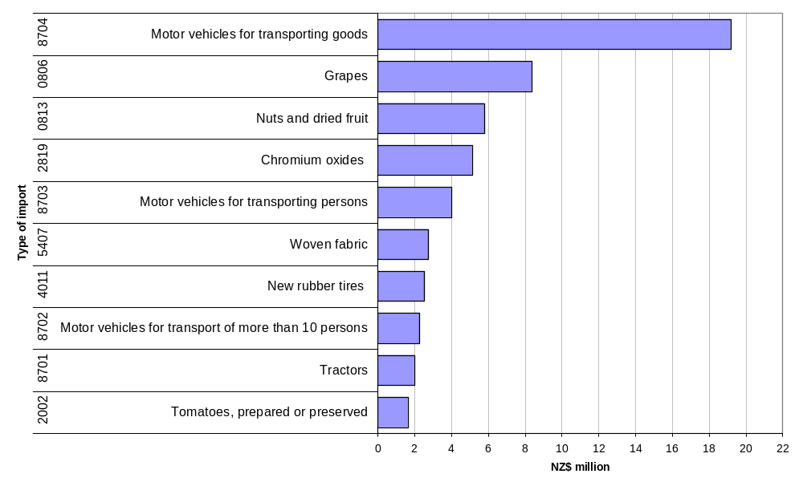
Source: Statistics New Zealand
ur

Future Areas for Cooperation
Although reforms related to EU accession may assist with opening the Turkish market, barriers to trade in New Zealand’s agriculture products may not be removed in the short-term. This means that the area of greatest potential for New Zealand in the Turkish market is likely to be in less traditional service sectors, high technology and specialised manufacturing. Producers of specialised manufactured products in New Zealand have had some success in the Turkish market. The number of New Zealand companies setting up representative offices in Turkey remains small. Creative approaches, such as marketing alliances between Turkish and New Zealand companies, or arrangements for manufacturing New Zealand designed products in Turkey, may also provide new opportunities.

Earthquake Engineering
New Zealand, like Turkey, is earthquake prone. Developing expertise to enhance the safety of structures for people and communities has been a priority for New Zealand.
The Earthquake Engineering New Zealand Cluster (EENZ) has been active in the Turkish market. The cluster is a network of professional consultants, device manufacturers, researchers and educators able to deliver the world’s best practice in earthquake engineering, seismology and related services. Members of the cluster working with Turkish partners and agents, have been successful in undertaking consultancy projects and supplying technology used in the construction or retro-fitting of buildings to protect them against earthquakes.

Information and Communications Technology
There is a growing market for ICT products in Turkey, due to its large population, and its increasing desire to utilise new technologies. For example, GSM usage is high in Turkey. The number of subscribers to Turkcell – Turkey’s largest cellular service provider - alone is nearly 20 million. Given this background, international telecommunications hardware and software producers are interested in Turkey.
As part of its agenda for economic transformation, New Zealand has diversified into new areas to complement the strong primary sector base. ICT is one of two areas where capabilities are flourishing and a number of New Zealand ICT companies are interested in supplying their tailor-made products to the Turkish market. One example is that software for weather and information presentation products, including weather forecasting graphics, is being used by Turkey’s CNBCA television channel.

Specialised Manufacturing
Niche specialised manufacturing is a sector assuming greater importance in the New Zealand economy. The Turkish market is responding positively to some specialty New Zealand products.
For example, Fisher & Paykel Healthcare produces innovative devices which are used in respiratory care, the treatment of sleep disordered breathing and in neonatal care. Fisher & Paykel has set up a representative office in Turkey, and sees good prospects for continuing to supply its manufactured products to Turkey. Further examples of New Zealand specialised manufactured products experiencing success in the Turkish market include: trays for the rear of utility vehicles; automated oven production lines; energy saving motors for Arcelik (a leading whiteware manufacturer in Turkey); and ‘soft starters’, which improve pumping operations by adjusting the motor’s operation to take compensate for the behaviour of fluids; and electricity specialists manufacturing goods such as converters.

Agriculture

Overview
As noted above, one reason for the low level of New Zealand’s merchandise exports to Turkey is the high tariffs on agricultural goods and also non-tariff barriers (such as import licensing requirements for some products. However, there are some areas where opportunities have increased. Some changes in import licensing requirements for wine have enabled some smaller importers to begin bringing in New Zealand product, albeit in fairly limited amounts.
While New Zealand is a key agricultural exporter, Turkey is a large agricultural producer and has a strong political incentive to protect its domestic sector. Agricultural production in Turkey increased by 75 percent between 2002 and 2006, with exports of agricultural products increasing from US$4 billion to US$9 billion over the same period. A severe drought in 2007 has, however, underlined the need for Turkey to modernise this sector, and move towards more efficient use of resources. Reform efforts are underway – the World Bank has US$1.6 billion in loan financing directed to this sector – but the challenges are great (see box).

Turkey’s high tariffs and other protections on agricultural goods act as a brake on efforts to reform and modernise this sector. The barriers to trade noted above have served to insulate Turkish agriculture producers from foreign competition. There is little recognition in Turkey that it is consumers and downstream industries who pay the price of this protection.

Existing Bilateral Linkages
Turkey currently imports very little beef or sheep meat (one of New Zealand’s most important exports), however there are opportunities with respect to dairy products, as has been discussed above.

Future Areas for Cooperation
As Turkey progressively introduces agricultural reforms and progress is made towards EU accession, tariff reduction will necessarily follow. This will create openings for New Zealand’s primary produce exporters in addition to the opportunities already available to New Zealand in other sectors.
New Zealand also has technology and expertise in the agriculture sector that Turkey could take advantage of as it seeks to modernise agricultural production, and become more competitive. One example was the provision of New Zealand-made electric fencing, which was used in a trial farm. New Zealand breeding stock might also be used to increase the productivity of dairy farms (agreed health certification for both live animal imports and semen imports is already in place).

Learning From Each Other: Agricultural Reform
The OECD’s most recent economic review of Turkey has confirmed that Turkey’s agricultural sector is in need of reform. While recognising that this won’t happen rapidly, the OECD has identified some key changes that would help the reform process gather momentum. New Zealand, having experienced significant economic reform in the agricultural sector, has a lot to offer to Turkey in this respect.
Some of the key lessons from New Zealand’s experience of reform that would be relevant as Turkey embarks on a similar reform process in the agricultural sector are:
- Agricultural market support does not lead to sustainable increases in farm and rural incomes. Insulating farmers from market signals leads to inefficiencies and loss of competitiveness. Protection/support merely tends to delay the inevitable adjustment that farmers need to make in response to longer-term changes in resource use, technological change and social and demographic trends. The longer the delay, the higher the economic costs.
- Wide ranging and deep reforms are feasible, and rural areas can develop without subsidies. Farmers and rural communities are more adaptable than sometimes imagined.
- However, adjustment costs need to be recognised as adjustment to reform is neither painless nor instantaneous. Well-targeted safety net programmes tailored to the specific needs of rural communities might be necessary to mitigate the transitional costs of adjustment.
- The sequencing of reforms is important. In New Zealand the lowering of tariffs on manufactured goods did not proceed as rapidly as the removal of support for farmers, causing farmers to bear much of the initial adjustment costs without benefiting much from lower imported input prices. Farmers also suffered from falling output prices some years earlier than they were to experience the benefits (in terms of lower costs) of labour market reforms in the primary processing sector, for example.
- The credibility and sustainability of reforms over time are essential for successful adjustment. Farmers and other economic agents (firms and consumers) must be sure that there is no chance of policy U-turns. Uncertainty around any proposed changes will lead to increased adjustment costs.

EU Accession
EU accession will also force Turkey to confront the inefficiencies in its agriculture sector. The percentage of the population employed in agriculture is already decreasing, with movement in jobs especially towards the services sector. Nevertheless, it still accounts for an estimated 30 percent of employment. There has been some movement, however, and issues such as the privatisation of government-owned farms are now being addressed.

Sanitary Cooperation Arrangement
New Zealand’s Ministry of Agriculture and Forestry, and Food Safety Authority, have agreed on a Sanitary Cooperation Arrangement with Turkey’s Ministry of Agriculture and Rural Development. This Arrangement will provide the framework for deepening relations between the relevant agencies, and ensuring smooth cooperation in the sanitary field.

Services

Education

Overview
The education relationship between New Zealand and Turkey is steadily developing and a number of institutional linkages have been developed between New Zealand and Turkish universities. There is some scope for Turkey to become an increasingly important source country for international students, particularly given capacity limitations in Turkey’s higher education system.

Existing Bilateral Linkages
New Zealand tertiary institutions have entered into institutional cooperation arrangements with Turkish counterparts to promote closer engagement and student flows. In 2006, 28 Turkish students studied in New Zealand at the tertiary level. Following the recent extension of the New Zealand International Doctoral Research Scholarships Scheme to Turkey, two doctoral students from Turkey have commenced studies under this scheme.

Future Areas for Cooperation

Turkish Government Scholarships
The Turkish tertiary system currently lacks sufficient capacity to accommodate all the Turkish students who wish to pursue higher study. Nearly two million students take the YOK (Higher Education Authority) university entrance exam each year but only just over 450,000 of those seeking places in Turkish Universities will be able to enter Turkish institutions. Turkey therefore needs to look overseas to educate its young people – a critical issue if it wants to transform its economy. Typically around 70,000 Turkish students study abroad each year. While most Turkish students study in the United States and the United Kingdom - and to a lesser extent in France and Germany - the Turkish Government is looking to diversify the destination countries for Turkish students. In this context the Turkish Government announced a scholarship initiative that will allow 1,000 Turkish postgraduate students per year for five years to undertake postgraduate study abroad. In July 2006, the Turkish Government announced that up to 100 scholarship places (10 per cent of the total scholarship pool) were open to students seeking to study in New Zealand. Since then two Turkish students have taken advantage of these scholarships to study in New Zealand.

Education Cooperation Arrangement
New Zealand and Turkish education officials have developed an Education Cooperation Arrangement following an expression of interest from the Turkish Government in entering into an arrangement with New Zealand. The Arrangement provides a framework for closer policy engagement and information exchange between the two countries and is expected to be agreed in 2008.

Promoting New Zealand Education Services
The New Zealand Turkey Education Export Network (NZTEEN), supported by New Zealand Trade and Enterprise (NZTE) and the New Zealand Embassy in Ankara, has actively promoted the services of New Zealand education providers in Turkey during recent years. A successful outcome of these efforts was the inclusion of New Zealand as a “developing destination” in the YOK handbook.
Aside from attracting Turkish students to New Zealand schools, tertiary institutions and English language providers, there are other areas of potential in Turkey for New Zealand companies specialising in the delivery of non-traditional education related services. In the past trainers in technical or specialist English, and companies with internet-based training tools, have explored the possibilities in this market.

Tourism

Overview
Turkey and New Zealand both have significant tourism industries. In 2006 foreign tourists’ spending in Turkey was around US$25 billion. New Zealand’s tourism industry is one of the largest single sources of foreign-exchange earnings and generated around NZ$6.6 billion in 2006.

Existing Bilateral Linkages
From a low base, the number of Turkish visitors to New Zealand has shown a significant increase over the last four years, from 283 in 2002, to 879 in 2006.
Figure 13: Turkish Visitors to New Zealand
0
100
200
300
400
500
600
700
800
900
1000
2002
2003
2004
2005
2006
Source: Statistics New Zealand
The annual Gallipoli commemorations attract large numbers of New Zealand tourists to Turkey. Each year an estimated 3,000 New Zealanders attend the commemorations. New Zealand visitor numbers at other times of the year are also high. In 2006 17,869 New Zealand visitors came to Turkey, and 8,863 visited in the first six months of 2007.

Future Areas for Cooperation

Working Holiday Scheme
New Zealand and Turkey are currently discussing a Working Holiday Scheme between the two countries. This would allow young people from Turkey and New Zealand to holiday, and work in, each others’ countries for up to a year. It is hoped that the Scheme can be finalised and implemented in 2008.

Air Services Agreement
Turkey and New Zealand are currently discussing a bilateral air services agreement.

Turkish Airlines joining the Star Alliance
Turkish Airlines will become a member of the Star Alliance on 1 April 2008. The Star Alliance netowork has noted that Turkish Airline’s fleet of 101 aircraft and network covering destinations in the USA, Europe, Asia and Africa would allow the Star Alliance network to offer customers more than 17,500 daily flights serving 927 airports in 162 countries. Istanbul would in future become Star Alliance’s main hub at the crossroads of Europe and Asia, and act as a gateway to new destinations in Turkey and provide connections, especially to Central Asia and the Middle East. Given New Zealand’s flagship carrier, Air New Zealand, is already a Star Alliance member, this development should lead to an improvement in services available for travellers between New Zealand and Turkey.

Investment

Overview
As discussed above, both Turkey and New Zealand have policy settings that are conducive to foreign investment. The potential for increased investment flows between Turkey and New Zealand is high, whether through one off projects or longer term joint ventures.

Existing Bilateral Linkages
Due to the small amounts of investment between Turkey and New Zealand to date, Statistics New Zealand’s data is labelled confidential in order to prevent commercially sensitive information being divulged. The Turkish Industrialists and Businessmen’s Association (TUSIAD) has identified US$60,000 of New Zealand FDI in Turkey. The investment is spread over seven firms, three of which are involved in real estate, three involved in trade and services and one involved in construction.
TUSAID has also identified eight of its members that are doing business in New Zealand. Three of these companies are large holdings covering a diverse range of sectors including automotives, tyres, finance and banking, food and retailing, cement, textiles and energy among other sectors.

Future Areas for Cooperation
New Zealand Trade and Enterprise has a programme in place that aims to attract Turkish Investment to New Zealand which is run by its subsidiary ‘Investment New Zealand’. Turkish businesses interested in investment opportunities in New Zealand are encouraged to utilise the resources Investment New Zealand offers. NZTE also has a representative based in Ankara to help foster New Zealand investment in Turkey. NZTE is able to facilitate the process of developing networks and contacts for particular companies. Turkey has recently reformed its investment support structures, with a view to facilitating even more FDI.
One example of Turkey/New Zealand cooperation is the strategic partnership recently entered into by Fisher and Paykel and Turkey’s third-largest home appliance manufacturer Arcelik. The partnership will enable distribution of Fisher and Paykel branded appliances through Arcelik’s extensive Eastern European and Middle Eastern networks. Arcelik will take advantage of Fisher and Paykel’s distribution networks in regions where it less well represented (e.g. the Asia Pacific). The two companies will also engage in technical cooperation.
This partnership relies on exploitation of existing complementarities between two companies which are both strong in their sector in different parts of the world. It seems likely that there is further potential for strategic partnerships of this kind between New Zealand and Turkish companies. As noted above, Turkey’s private sector has strong links to the Black Sea region and Central Asia, unlike New Zealand companies. Markets in the regions around Turkey have
traditionally been difficult for New Zealand exporters, due to language barriers and unfamiliar business practises. Turkey’s private sector may gain similar advantages from working with New Zealand companies that are more familiar with the Asia Pacific region.
One example of a sector where synergies could be developed is apparel. Turkey is a potential manufacturing base for mid to high range products in New Zealand’s increasingly high-end fashion industry. Although it cannot compete on labour costs alone, its ability to produce quality goods at a competitive price, good infrastructure, and location (near to European, Central Asian and Middle Eastern markets) all work in its favour. Turkey is also a member of the EU Customs Union, which means that goods produced in Turkey are treated as European goods within the Union.

Conclusion

- Turkey’s future growth prospects and strategically advantageous location mean that it is likely to be an increasingly important partner for New Zealand in the years ahead. Turkey is an important gateway to the surrounding Black Sea, Eastern European, Central Asian and Middle Eastern regions.
- The EU accession process will continue to be an important driver of economic reform in Turkey. The Turkish government has indicated that reform will continue, irrespective of the speed with which progress is made on the accession process.
- The Turkish government and private sector interests are increasingly focussed on developing economic and commercial linkages with the Asia-Pacific region.
- New Zealand also has good growth prospects. The New Zealand market is very open, and New Zealand scores highly in international surveys measuring the ease of doing business (consistently second in the World Bank’s ‘ease of doing business’ survey). With its well-developed economic linkages in the Asia-Pacific region (underpinned by an expanding network of free trade and economic partnership agreements) New Zealand can be a stepping-off point for Turkish companies wishing to do business in the Asia-Pacific region.
- New Zealand-Turkey bilateral trade is under-developed. New Zealand exports a narrow range of goods to Turkey. By comparison the range of Turkish exports to New Zealand is wider, and Turkish exports have grown strongly in recent years.
- Realising the potential for increasing the economic linkages between Turkey and New Zealand will require persistent efforts by the private sector in both countries. Turkey can be perceived as a hard market for New Zealand companies to penetrate. Although Turkey’s performance in the World Bank’s ‘ease of doing business' survey continues to improve, its ranking of 57 in 2008 reflects the fact that local bureaucratic procedures are a complication for those unfamiliar with the market. Combined with language barriers, this would suggest that working with a well-qualified local partner may be the best approach to developing and sustaining a market presence.
- Access for New Zealand agricultural products to the Turkish market is restricted. Efforts are underway to reform and modernise Turkey’s agriculture sector. Progress with reform, and tariff reductions as a result of progress towards EU accession and multilateral trade liberalisation, will provide new opportunities in Turkey for New Zealand companies.
- In the short term the areas of greatest potential for New Zealand companies in the Turkish market are likely to be services, high technology and specialised manufacturing.
- Driven in part by the capacity limitations of the Turkish tertiary education system, and recognition of high educational standards in New Zealand, there has been a steady increase the number of Turkish students attending New Zealand educational institutions. There are good prospects for developing further trade in education services.
- Already significant numbers of New Zealand tourists visit Turkey each year. Rising income levels in Turkey and the availability of more convenient and cheaper air services will see continuation of the trade of increasing numbers of Turkish tourists visiting New Zealand.
- Strategic partnerships between New Zealand and Turkish companies (including marketing alliances, and arrangements for manufacturing New Zealand-designed products in Turkey) would support growth in bilateral trade, and trade with countries in surrounding regions.
- In recent years Turkey has received substantial amounts of foreign investment. Investment from New Zealand to Turkey, and vice versa, has so far been very limited. Regulatory regimes that encourage foreign investment and good growth prospects in both countries mean there is scope to expand two-way investment in the years ahead.
- New Zealand and Turkey enjoy an excellent political relationship, which has been strengthened by an increased frequency of high-level visits This provides a good platform for action at the government-to-government level to boost cooperation, and raise awareness of business opportunities, in New Zealand and Turkey. The two governments are also actively working on practical measures to facilitate business activity between Turkey and New Zealand. An example is current discussions towards negotiating a Double Taxation Agreement.

For Further Information
OECD Economic Review of Turkey 2007, www.oecd.org
Economic Intelligence Unit, www.eiu.com
World Trade Organisation (Turkey Trade Policy Review), www.wto.org
International Monetary Fund, www.imf.org
World Bank, www.worldbank.org
New Zealand Ministry of Foreign Affairs and Trade, www.mfat.govt.nz
New Zealand Chambers of Commerce, www.nzchamber.co.nz
New Zealand – Middle East Business Council, +64 9 309 2999
New Zealand Trade and Enterprise (including Ankara office), www.nzte.govt.nz
New Zealand Embassy, Ankara, Turkey, www.nzembassy.com/turkey, email: nzembassyankara@ttnet.net.tr
Ministry of Foreign Affairs of Turkey, www.mfa.gov.tr
Foreign Trade Undersecretariat of Turkey, www.dtm.gov.tr
DEIK (Foreign Relations Economic Board of Turkey), www.deik.org.tr
TOBB (Turkish Union of Chambers and Commodity Exchanges), www.tobb.org.tr
TUSIAD (Turkish Industrialist's and Businessmen's Association), www.tusiad.org.tr

Turkey Map

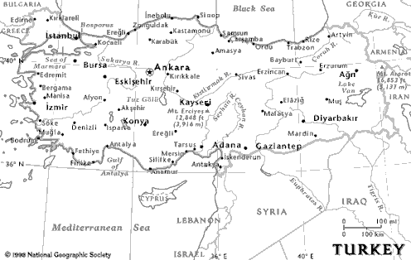

New Zealand’s Economic Data
Table 6: New Zealand’s Key Economic Indicators

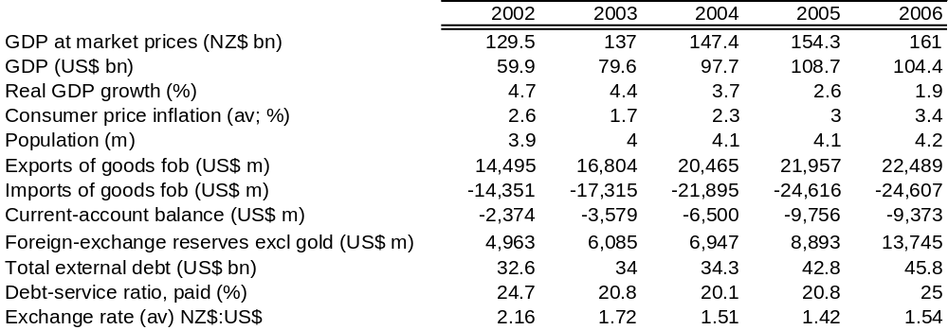
Source: Economist Intelligence Unit
Table 7: New Zealand’s Principal Exports and Imports

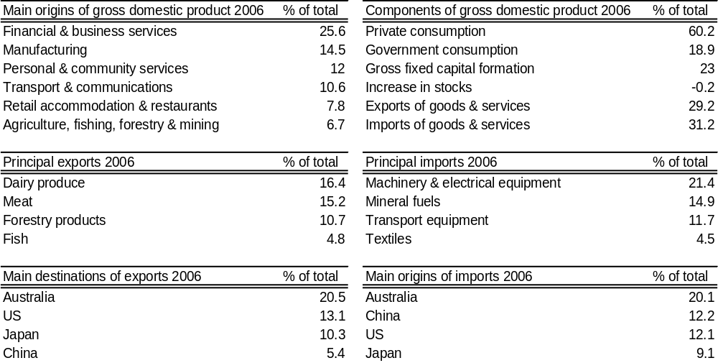
Source: Economist Intelligence Unit

Turkey’s Economic Data
Table 8: Turkey’s Key Economic Indicators
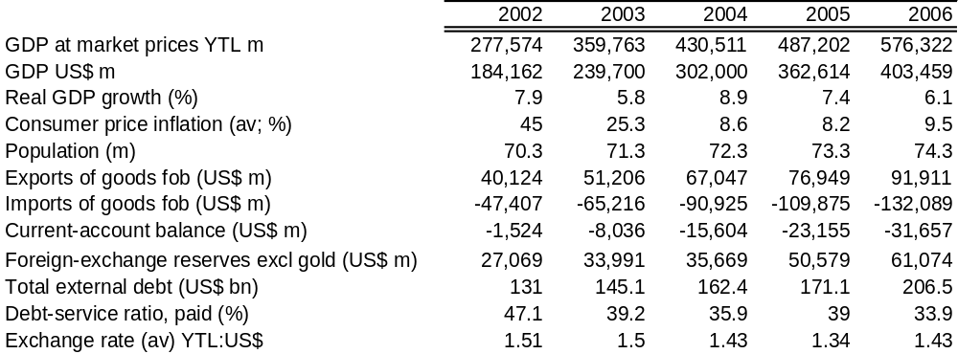
Source: Economist Intelligence Unit
Table 9: Turkey’s GDP and Principal Exports and Imports
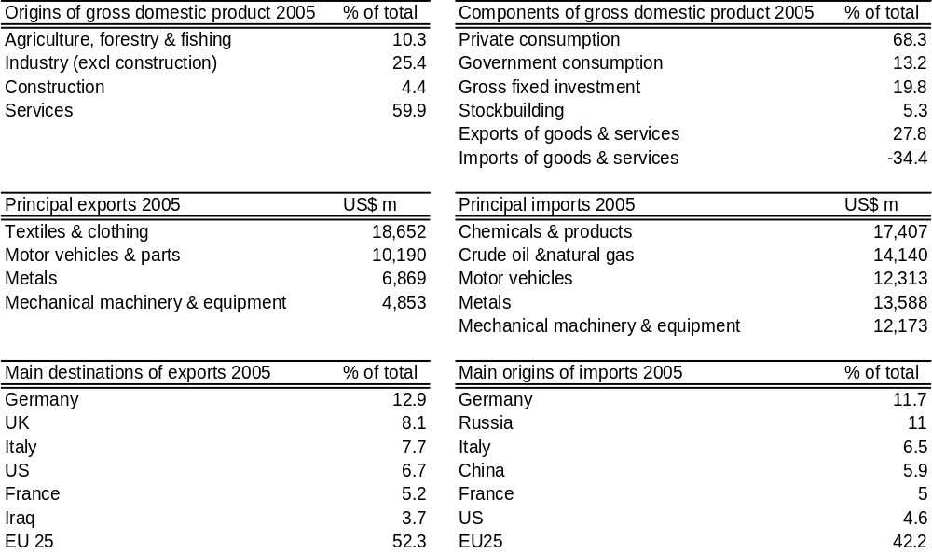
Source: Economist Intelligence Unit

New Zealand’s Top 50 Exports to Turkey, 2007 (HS4)
Rank | HS 4 | Description | 2007, NZ$ Million | % Share
1 | 5101 | Wool | 19.59 | 36.57
2 | 4102 | Sheep skins - raw | 7.82 | 14.60
3 | 8462 | Machine Tools For Forging, Bending etc | 5.72 | 10.67
4 | 0405 | Butter | 3.92 | 7.32
5 | 4101 | Cow or Horse Raw Hides | 2.96 | 5.53
6 | 8504 | Electric Transformers | 2.31 | 4.31
7 | 4105 | Leather - Sheep | 1.71 | 3.19
8 | 9018 | Medical equipment | 0.95 | 1.77
9 | 3004 | Medicaments | 0.89 | 1.66
10 | 8425 | Pulley Tackle & Hoists | 0.64 | 1.20
11 | 0303 | Fish, Frozen | 0.51 | 0.94
12 | 8541 | Diodes, Transistors etc | 0.49 | 0.91
13 | 1209 | Seeds, Fruit And Spores, For Sowing | 0.34 | 0.64
14 | 6815 | Stone | 0.31 | 0.57
15 | 8412 | Engines And Motors | 0.30 | 0.55
16 | 4302 | Tanned Or Dressed Furskins | 0.28 | 0.52
17 | 2309 | Preparations Used In Animal Feeding | 0.28 | 0.52
18 | 8426 | Derricks, Cranes etc | 0.27 | 0.50
19 | 9019 | Mechano-therapy, massage devices | 0.27 | 0.50
20 | 8434 | Milking Machines & Dairy Machinery | 0.24 | 0.45
21 | 3002 | Animal Blood, Vaccines and Toxins | 0.24 | 0.44
22 | 4103 | Raw Hides and Skins | 0.22 | 0.42
23 | 3920 | Plates, Sheets, Film Etc | 0.21 | 0.39
24 | 8708 | Motor Vehicles; Parts | 0.19 | 0.35
25 | 7326 | Iron and steel articles | 0.16 | 0.30
26 | 8422 | Dishwashing machines | 0.15 | 0.28
27 | 4113 | Processed Leather, of Other Animals | 0.14 | 0.25
28 | 9033 | Machines and Appliances | 0.13 | 0.25
29 | 0202 | Frozen Beef | 0.13 | 0.24
30 | 8517 | Telephone equipment | 0.13 | 0.23
31 | 9405 | Lamps and Lighting Fittings and Parts | 0.12 | 0.22
32 | 4703 | Chemical Woodpulp | 0.10 | 0.18
33 | 5112 | Wool Fabrics | 0.10 | 0.18
34 | 0802 | Nuts | 0.09 | 0.18
35 | 7601 | Aluminum, Unwrought | 0.09 | 0.17
36 | 1604 | Caviar | 0.08 | 0.14
37 | 6006 | Knitted Or Crocheted Fabrics | 0.07 | 0.13
38 | 8483 | Transmission Shafts | 0.07 | 0.12
39 | 8474 | Machinery For Sorting etc | 0.06 | 0.11
40 | 0806 | Grapes | 0.06 | 0.10
41 | 6306 | Tarpaulins, Awnings etc. | 0.05 | 0.10
42 | 8443 | Printing Machinery | 0.05 | 0.10
43 | 3101 | Fertilisers, Animal or Vegetable | 0.05 | 0.10
44 | 3507 | Enzymes | 0.05 | 0.10
45 | 8542 | Electronic Integrated Circuits | 0.05 | 0.09
46 | 9027 | Instruments for Physics, Chemistry | 0.05 | 0.09
47 | 9402 | Furniture: Medical, Surgical, Dental, Vet | 0.05 | 0.09
48 | 3304 | Cosmetic and Toilet Preparations | 0.05 | 0.09
49 | 4810 | Paper & Paperboard | 0.04 | 0.08
50 | 8543 | Electrical Machines and Apparatus | 0.04 | 0.08
 |  | Top 50 Subtotal | 52.8 | 98.5
 |  | Total Exports to Turkey | 53.57 | 100.0

Turkey’s Top 50 Imports from the World, 2005 (HS4)
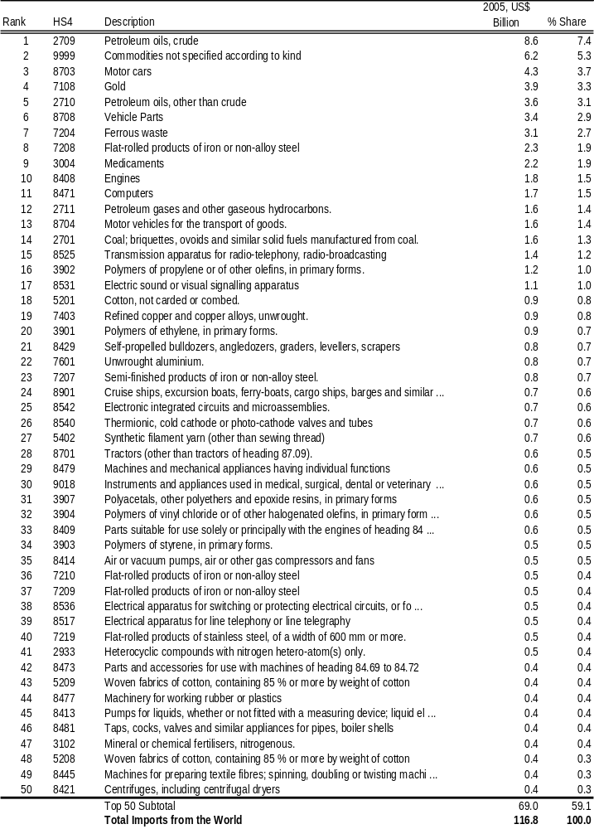

Turkish Undersecretariat of Foreign Trade
European Commission, Turkey 2007 Progress Report.
Undersecretariat of Foreign Trade.
Economist Intelligence Unit Turkey Country Report.
Undersecretariat of Foreign Trade.
Statistics New Zealand
Undersecretariat of Foreign Trade
This figure includes the Open University and private universities.
TUSAB
The data in Appendices C and D are supplied by the Economist Intelligence Unit. As the EIU’s latest confirmed statistics are for the year ended 2006, some figures in Appendices C and D may vary from those cited in the body of this report.

